Amartya Kumar Sinha  
PPHA 39930  
Assignment 2  
January 31, 2024

**Q1.** Refer to attached working document for code behind all figures and plots

**Q1. a)** 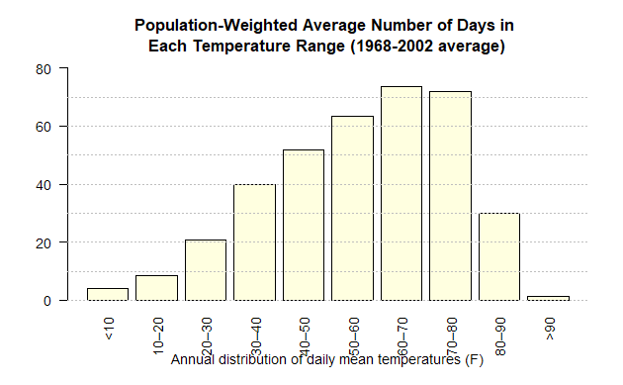

**Q1. b)** Based on the data provided, we see that the average number of days above 90⁰F per year expected as a population weighted average across the US is just over a day at **1.21 days**.

**Q1. c)** **Yuma county** in Arizona has the highest number of days above 90⁰F, at almost 100 days (99.54 days to be precise). On average over the sample period of 1968-2002 in the dataset, the **number of counties that experienced no days above 90⁰F per year are 115 counties** out of a total of 2988, or about 3.85%.

**Q2.** **a)** As of 2021, the age-adjusted death rate in the United States was 879.7 deaths per 100,000 population. This represents an increase of 5.3% from the previous year, which had a death rate of 835.4 deaths per 100,000 population. [Data is from the CDC](https://www.cdc.gov/nchs/products/databriefs/db456.htm).   
Based on the our data, **the national average over-65 mortality rate is 5365.07 deaths per 100,000 population**. This is **about 6 times higher than the 2021 age-adjusted death rate**.

**Q2. b)** The total number of deaths recorded from 1968-2002 in the data is **50,830,306, or about 50.8 million deaths**.

**Q3. a)** 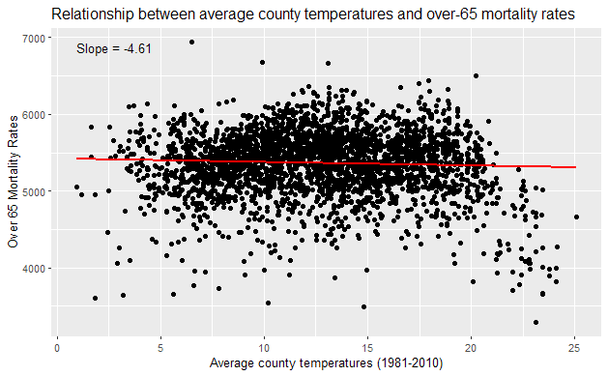

We see that the slope is -4.61. The pattern that emerges is that there is a slight downward trend as the average county temperature increases. This means that with an increase in temperature by 1⁰F, the over-65 mortality rate decreases by 4.61 deaths per 100,000 population.

**Q3. b)** Based on the graphs for hot and hotter days, we see that the mortality rate is negatively correlated with increasing number of both hot and hotter days. However, most of the points on the scatter plot are concentrated around a relatively small set of values. Based on the R-squared values, we see that there is really no correlation in either of the graphs.

The concentration of scatter points between 0 and 75 days for the hotter days graph shows that most people over 65 live in counties which do not experience temperatures higher than 80⁰F for most of the year. Similarly, the concentration of scatter points between 0 and about 200 shows that out of people aged over 65, most of them live in counties which experience days with temperatures higher than 70⁰F from anywhere between less than a month to most of the year.

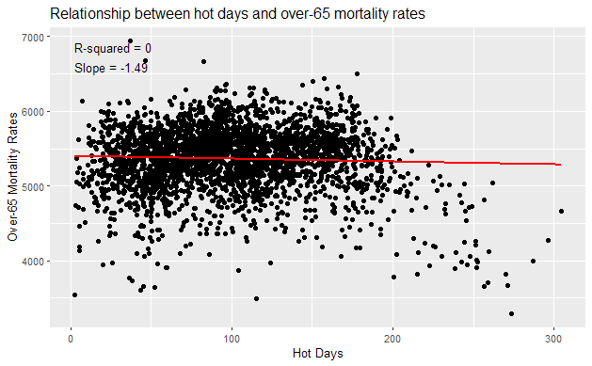 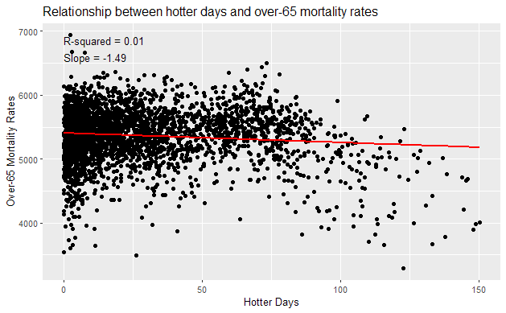

**Q3. c)** The patterns observed above might occur because people over 65 might prefer to live in places with more comfortable temperatures. As a result, the number of points in the hotter days graph seems to suggest that fewer people live in places with hotter days than those who live in places with hot days. This is also evident from the scale of X-axis in both graphs, where the range for the hot days graph is more than 300, compared to only around 150 for hotter days. The decrease in over-65 mortality rate in both cases is not really correlated due to the extremely low R-squared value, but the decreasing slope is likely explained by people over 65 preferring to live in places with less extreme temperatures. Hence, the decrease in slope is likely more indicative of the fact that there are fewer numbers of people over-65 per 100,000 in places with extreme temperatures, rather than indicating that hotter temperatures reduce mortality rate.

**Q4. a)** 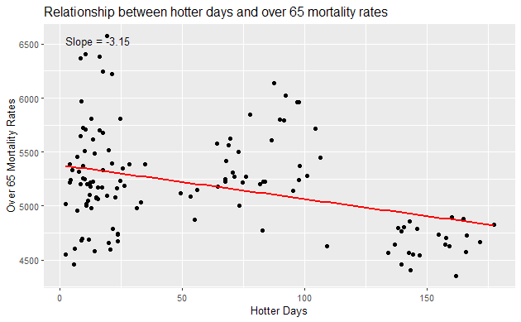

The scatter plot shows a negative correlation between the number of hotter days and the over-65 mortality rates in the selected counties, as indicated by the negative slope of -3.15. The relationship one can conclude from this is that as the number of hotter days (temperature hotter than 80°F) increases, the over-65 mortality rate tends to decrease. However, the data points are quite scattered, indicating a high degree of variability and suggesting that other factors may also be influencing the mortality rate. However, without the r-squared value and taking into account other factors, it would be erroneous to make the above conclusion.

**Q4. b)** 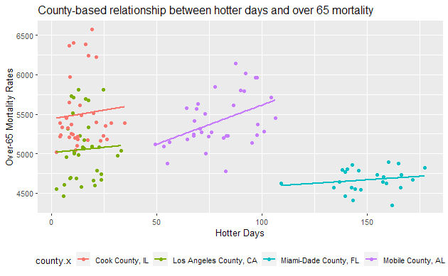

The relationship is much more clear now, since the points on the scatter plot have been grouped by county type. In each county, it is obvious that as the number of hotter days increase, the mortality rate of people over 65 also increases. I would be much more confident in drawing this conclusion from this plot than the conclusion from the plot above because it did not take into account the factor of location when accounting for mortality rate plotted against number of hotter days. In other words, this graph shows us how each county’s over-65 mortality rate is affected by an increase in number of hotter days, rather than lumping together likely disproportionate ratios of population aged over-65 to total population.

**Q5.** See attached log file for creation of regression and methodology for creating graph.   
*Disclaimer*: Made use of Bing Chat/Microsoft Copilot and ChatGPT (GPT-4 version) in creating graph for Q5 a). All other code is original and is either untouched by AI or has simply been formatted as per R-coding best style practices using Bing Chat/Microsoft Copilot

**Q5. a)** 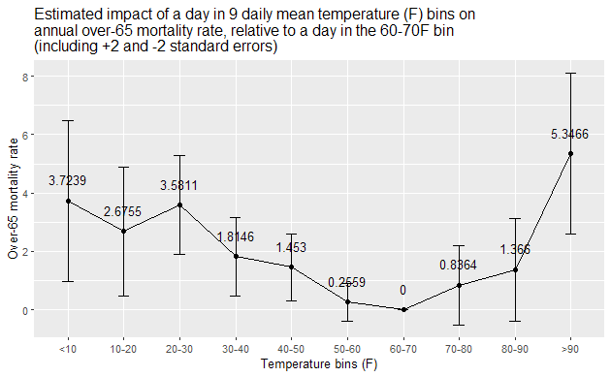

From the graph, we see that for temperature bins below 60°F, mortality rate increases as the temperature decreases. This suggests that colder temperatures are associated with higher mortality rates among individuals over 65 years old. For temperature bins above 70°F, the mortality rate increases as the temperature increases, with the highest mortality rate observed for the >90°F bin. This suggests that extremely hot temperatures are also associated with higher mortality rates among individuals over 65 years old. The graph shows a similar U-shaped curve as the original paper.

Hence, both extremely cold (<10°F) and hot (>90°F) temperatures are associated with higher mortality rates for people over 65 years old, based on a reference temperature bin of 60-70⁰F as a zero mortality rate. This U-shaped relationship between temperature and mortality is also consistent with findings from epidemiological studies, which show that older people have higher mortality rates in extreme temperatures.

**Q5. b)**

The fixed effects αc and γst’s play a vital role in isolating impacts of variables on mortality rates by accounting for latent and confounding variables.

Fixed effects denoted by αc serve to regulate unobservable, county-specific, and time-stable determinants of mortality rates within each age group. These factors encompass county-specific and age-dependent elements that remain constant over time. In addition to the given examples of differences in permanent hospital quality and overall healthiness of the local age-specific population, two other examples of such factors could be 1) socioeconomic factors such as local poverty levels or education levels, and 2) local environmental conditions such as water quality, air pollution etc; both of these are factors that usually don’t change rapidly over time for a specific county.

State-by-year effects manage time-evolving distinctions in the dependent variable shared among counties within age groups within a state. These effects encapsulate factors undergoing temporal changes which affect all counties within a state uniformly. The given example for this effect was changes in state Medicare policies. Additional examples for this effect can include 1) changes in state-level legislation, such as regulations or policies affecting health or safety, which could in turn affect different age groups in various ways, and 2) economic changes on a statewide level, which would affect access to healthcare for different age groups in different ways.

**Q5. c)**

The coefficient on the hottest day term is 5.347. This implies that compared to the baseline mortality rate in the 60-70⁰F temperature bin, the mortality rate in the 90⁰F temperature bin is about 5.347% higher. While this may initially appear to be a smaller number, 5% of 100,000 is 5,000. In other words, about 5,347 more people in the 65+ age group would die in the higher temperature bin compared to the baseline temperature bin simply due to the temperatures being higher.  
Based on the above, this number seems very large to me.

**Q6.** An extension of this analysis could be seeing rates of migration for people aged 65+. For example, one could see where people who are currently aged 65+ actually lived most of their life vs where they choose to spend their lives once they cross a certain threshold (be it 60 or 65 or another number). This would help in understanding whether people, as they get older, understand the adverse effects of climate change and move across locations to adapt to the same.   
Existence of towns/localities with better temperatures compared to the national average with a higher than average population ratio of older people could also be evidence of people adapting to these changes.

In essence, we would expect to see a few key patterns as people age – while at younger ages people may be okay living in counties with hotter areas, leading to a higher mix of younger people as they are attracted to these places for reasons such as better jobs, lower cost of living, etc, as people grow older, they may start moving to places with better temperatures. Another pattern to watch out for, which may seem to be a consequence of the above but may not necessarily be the only reason for it, is that in counties with lower wealth and/or higher poverty rates, the ratio of younger people to older people may increase due to higher mortality rates of older residents and a result of not being able to relocate.

**Q7.** If I had been able to access data only for average temperatures and mortality rates (or simply temperatures and mortality in a single year), it would have appeared that there is a negative correlation between mortality rates for ages over 65 and higher temperatures – ie, as temperature increases, mortality rate decreases.   
However, the results in question 5 make it clear that the above is not the case. Grouping data based on location and time period shows us that mortality rate only increases as temperature increases, and that there is a disproportionate increase at extreme temperatures compared to a baseline, resulting in a U-shaped mortality rate curve.

The implications of results from Q5. are quite significant – apart from the obvious increase in mortality rates, it also decreases the human resources available to the nation. It would also lead to a total reduction in life expectancy, and may also lead to increased healthcare costs. These increased healthcare costs will affect not only the larger economy, but they will disproportionately affect people with lower income/wages. This may then lead to higher poverty/lower wealth as people get older, further harming the economy and reducing quality of life. As the US warms, other effects such as increased violence rates may also become visible.