WEEK 1 PROJECT REPORT

Network Maintenance
and Monitoring Setup
Hands-on Virtual Network Simulation

Student Name: ______________________________
Course / Department: ________________________
Roll Number: _______________________________
Submission Date: ____________________________

Software used: Cisco Packet Tracer (or equivalent network simulator)

1. Introduction
For this task, I planned a small office network in a virtual environment so that I could practise the basic work of a network support technician. The aim was not only to connect devices, but also to check whether the network was working, notice common faults, and restore communication after a problem. I used a simple design with one router, one switch, two client computers and one server. This keeps the setup easy to understand while still covering the main requirements of the task.

2. Objectives
- Create a small virtual network containing a router, a switch and at least two end devices.
- Assign suitable IP addresses and configure the network devices.
- Use basic monitoring commands such as ping, tracert/traceroute and device status commands.
- Introduce a controlled network fault, identify its cause and apply a fix.
- Record the design, configuration, test results and troubleshooting process in one report.

3. Software and Tools Selected
Tool | Purpose
Cisco Packet Tracer | To build and test the virtual network without physical networking equipment.
ping | To test whether one device can reach another device.
tracert / traceroute | To view the path taken by packets towards a destination. In this small LAN, the path is short.
show ip interface brief | To check router interface status and assigned IP addresses.
show interfaces / show interfaces status | To inspect interface condition and switch-port status.
show mac address-table | To check which device MAC addresses have been learned by the switch.

Packet Tracer is suitable for a beginner because devices can be connected visually and their command-line interfaces can be used for realistic practice. The exact menu names may vary slightly between software versions.

4. Network Topology Design
The network uses a star-style layout. Router R1 connects to Switch S1. The switch connects the two client PCs and a server. All devices are placed in the same IPv4 subnet, 192.168.10.0/24. The router acts as the default gateway. The server is included as an additional end device for testing and future monitoring services.
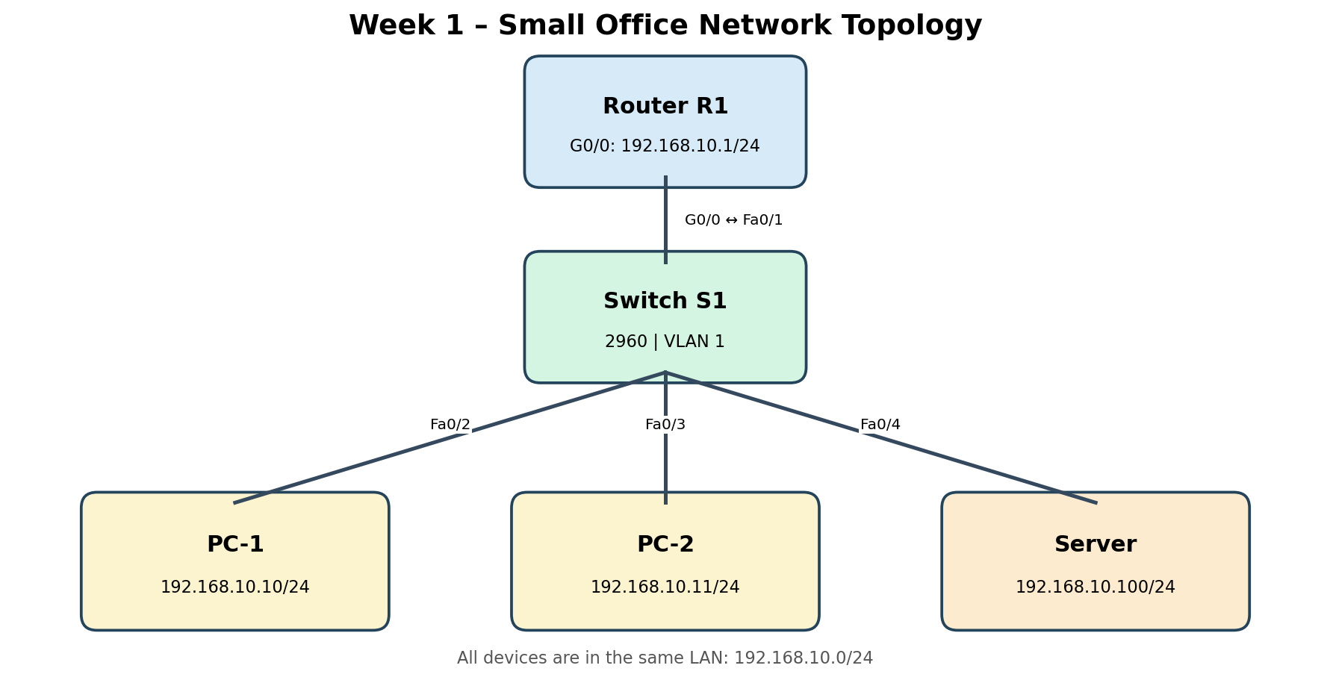
Device | Interface | IP address | Subnet mask | Default gateway
Router R1 | G0/0 | 192.168.10.1 | 255.255.255.0 | —
Switch S1 | VLAN 1 (management) | 192.168.10.2 | 255.255.255.0 | 192.168.10.1
PC-1 | FastEthernet | 192.168.10.10 | 255.255.255.0 | 192.168.10.1
PC-2 | FastEthernet | 192.168.10.11 | 255.255.255.0 | 192.168.10.1
Server | FastEthernet | 192.168.10.100 | 255.255.255.0 | 192.168.10.1

5. Implementation and Configuration

5.1 Physical / logical connections
- Place one router, one 2960 switch, two PCs and one server in the Packet Tracer workspace.
- Connect Router R1 G0/0 to Switch S1 Fa0/1.
- Connect PC-1 to Fa0/2, PC-2 to Fa0/3 and the server to Fa0/4.
- Use copper straight-through cables where required by the simulator. Wait for the link indicators to become active.

5.2 Router configuration
Open the router CLI and enter the following commands. If the router uses a different interface name, select its connected LAN interface.
enable
configure terminal
hostname R1
interface gigabitEthernet 0/0
ip address 192.168.10.1 255.255.255.0
no shutdown
exit
end
show ip interface brief
show running-config

5.3 Switch management configuration
enable
configure terminal
hostname S1
interface vlan 1
ip address 192.168.10.2 255.255.255.0
no shutdown
exit
ip default-gateway 192.168.10.1
end
show ip interface brief
show interfaces status
show mac address-table
The switch management IP is used to reach the switch for administration. The switch can still forward local traffic even if a management IP has not been configured; the management address makes remote checking easier.

5.4 End-device IP configuration
On each PC and the server, open Desktop → IP Configuration and enter the IP address, subnet mask and default gateway from the addressing table. Keep the DNS field blank for these basic connectivity tests.

6. Network Monitoring and Testing
After configuring the devices, I would test the network in stages. Testing from a nearby device first makes it easier to locate a fault. The following checks form the basic monitoring routine.
Test | Command / action | Expected result
Check local TCP/IP settings | ipconfig (on a PC) | The PC shows the planned IP address, mask and gateway.
Check the default gateway | ping 192.168.10.1 | Replies are received from the router.
Check PC-to-PC communication | ping 192.168.10.11 from PC-1 | Replies are received from PC-2.
Check server connectivity | ping 192.168.10.100 | Replies are received from the server.
View route | tracert 192.168.10.100 (Windows PC) | The route is displayed; in this same LAN, the destination is reached directly.
Check router interface | show ip interface brief | G0/0 should be up/up with 192.168.10.1.
Check switch ports | show interfaces status | Connected ports should show connected.
Check learned devices | show mac address-table | The switch should learn MAC addresses on active ports.

For a visual check, Packet Tracer's Simulation mode can be used to observe packet movement. The user can send a simple PDU between two devices and inspect whether it is delivered or dropped. If the installed Packet Tracer version provides an SNMP service and MIB browser, SNMP can be configured as an additional monitoring activity; it is not required for the basic ping and interface checks above.

7. Fault Simulation and Troubleshooting
To demonstrate maintenance, I used a controlled fault scenario: the switch port connected to PC-2 (Fa0/3) is administratively disabled. This represents a simple port shutdown or an accidental configuration change. The fault should interrupt communication with PC-2 while the other devices remain connected.

7.1 Fault creation
S1> enable
S1# configure terminal
S1(config)# interface fastEthernet 0/3
S1(config-if)# shutdown
S1(config-if)# end
S1# show interfaces status

7.2 Symptoms and checks
- From PC-1, run ping 192.168.10.11. The test should fail or show request time-outs while the port is disabled.
- Check the switch using show interfaces status. Fa0/3 should show disabled or not connected, depending on the simulator version.
- Check the cable and the selected switch port to make sure the PC is connected to Fa0/3.
- Compare the result with a ping to 192.168.10.100. The server should still respond if its port is working.

7.3 Resolution
S1> enable
S1# configure terminal
S1(config)# interface fastEthernet 0/3
S1(config-if)# no shutdown
S1(config-if)# end
S1# show interfaces status
After enabling the port again, wait for the link to become active and repeat ping 192.168.10.11 from PC-1. Successful replies confirm that connectivity has been restored. The troubleshooting method is to identify the affected device, check the physical/logical link, inspect interface status, correct the configuration and test again.
Stage | Observation
Before fault | PC-1 can ping PC-2 and the server.
During fault | PC-1 cannot ping PC-2; switch port Fa0/3 is disabled.
Action taken | Enabled Fa0/3 with the no shutdown command.
After repair | PC-1 can ping PC-2 again; the port is active.

8. Evidence and Screenshots to Include
The report should contain screenshots captured from the student's own Packet Tracer session. The following evidence list shows exactly what to capture. Do not use sample or internet screenshots as proof of your own test.
- Screenshot 1 – Complete topology showing R1, S1, PC-1, PC-2 and Server with visible connections.
- Screenshot 2 – Router CLI showing show ip interface brief and G0/0 up/up.
- Screenshot 3 – PC-1 command prompt showing successful ping to 192.168.10.1 and 192.168.10.11.
- Screenshot 4 – Switch CLI showing show interfaces status and active ports.
- Screenshot 5 – Fault condition: Fa0/3 disabled and failed ping to PC-2.
- Screenshot 6 – Recovery: Fa0/3 enabled and successful ping to PC-2.
Evidence no. | Paste your screenshot here
1. Network topology | [Insert screenshot 1 here]
2. Router interface status | [Insert screenshot 2 here]
3. Successful connectivity test | [Insert screenshot 3 here]
4. Switch port status | [Insert screenshot 4 here]
5. Fault detected | [Insert screenshot 5 here]
6. Network restored | [Insert screenshot 6 here]

9. Results and Discussion
The planned network provides a simple way to practise device configuration and routine monitoring. The IP addressing table gives every device a unique address in the same subnet. Ping checks basic reachability, while router and switch commands help narrow down where a problem may exist. The disabled-port scenario demonstrates why checking interface status is important: a device may have correct IP settings and a working cable but still be unreachable because its switch port is shut down.
The test results should be confirmed in the simulator before submission. Replace the expected results in this report with the actual observations if they differ. Record any packet loss, error message or unexpected interface state rather than changing the result to match the expected outcome.

10. Routine Network Maintenance Checklist
- Check that router and switch interfaces are up and that no unexpected port is disabled.
- Run periodic ping tests to important devices and record packet loss or response delays.
- Review interface counters for errors or unusual traffic.
- Keep a copy of the working device configuration.
- Use clear device names, IP-address records and port labels.
- Change default passwords in a real deployment and restrict management access.
- Document every configuration change and verify connectivity after maintenance.

11. Estimated Work Plan (30–35 Hours)
Activity | Estimated time
Research Packet Tracer and basic network concepts | 3 hours
Plan topology and IP addressing | 3 hours
Build the network and connect devices | 4 hours
Configure router, switch and end devices | 5 hours
Perform ping, traceroute and interface monitoring | 5 hours
Create a fault and troubleshoot it | 5 hours
Capture screenshots and verify results | 3 hours
Prepare and proofread the report | 3–5 hours
Total | 31–33 hours

12. Conclusion
This hands-on task helped me understand the basic process of setting up and maintaining a small computer network. I practised connecting network devices, assigning IP addresses, checking network interfaces and testing communication. I also saw how a small configuration issue, such as a disabled switch port, can stop a device from communicating. By checking the symptoms, inspecting the port and applying the correct command, the connection can be restored. These are useful first steps towards real network administration and troubleshooting.

13. References
- Cisco Networking Academy – Cisco Packet Tracer learning resources.
- Cisco IOS command references for show, interface, shutdown and no shutdown commands.
- Course notes and classroom material on IP addressing, routers, switches and network troubleshooting.

— End of Report —

