Abstract

The internet is a vast channel for dissemination of information that includes publication and image to convey ideas for mass communication. Now-a-days internet is not only used for the purpose of entertainment and fun, but also for wide range of applications, such as E-commerce, E-Banking, E-Governance etc. Hence there is an obvious need to keep certain information unknown to public or to anyone unauthorized. So that it becomes intangible to anybody except who is intended. It is also expected that the information that the
User receives must be free from errors so for this purpose we use different error correction algorithm.

There are various techniques used for this purpose, each of them provide different degree of secrecy. The conventional method is using both these techniques
separately.

A cryptcoding is a method that performs both functions of encryption/decryption and error correction coding as a single cryptographic primitive. It consist of pair of algorithm (E:D),where E is called encryptcoding algorithm, where encryption and encoding is perform and D is called decryptcpding algorithm where decryption and decoding is performed.

AKNOWLEDGEMENT

We take the opportunity to express the gratitude to Prof. Amar Palwankar Department- Information Technology, Finolex Academy of Management And Technology. Who was the driving force during our project work. His personal guidance encouragement and inspiration throughout the various phases of this project kept us on our toes; all throughout the job without his advice, guidance and co-operation we would not have succeeded so far. He has helped us as a friend, philosopher and in all possible ways.

Also we are thankful to the other staff members and non teaching staff of I.T Dept. who have directly and indirectly contributed to our project and encouraging us to bring this project in its present.
.

From,
XYZ
ABC
PQR

Project Report

On

“Cryptcoding”

By

A B C
P Q R
M N O

Guided by

Mr. Amar. R. Palwankar
(Internal Guide)



Department Of Information Technology

FINOLEX ACADEMY OF MANAGEMENT AND TECHNOLOGY

University of Mumbai

2020-2021

FINOLEX ACADEMY OF MANAGEMENT AND TECHNOLOGY
RATNAGIRI.

INFORMATION TECHNOLOGY DEPARTMENT

This is to certify that project report entitled

“Cryptcoding”

Has been carried out by,
A B C
P Q R
M N O

Students of third year B.E. (Information Technology) under our supervisions &

guidance & submitted in partial fulfillment of the
Requirement for the award of degree of
“BACHELOR OF ENGINEERING”
in Information Technology of the Mumbai University
during academic year 2020 - 2021

Prof. A. R. Palwankar Prof. Dr. V. A. Bharadi Dr. Kaushal Prasad

Project Guide H.O.D. I.T. Principal

External Examiner

INDEX

SR. NO. | TOPICS | PAGE NO.
1. | Introduction  1.1. Existing System  1.2. Definition
2. | Motivation  - Cryptography  - symmetric Key Cryptography  - Asymmetric Key Cryptography
3. | Requirement Analysis
4. | Project Planning
5. | Technologies Used  5.1. Hardware  5.2. Software
6. | Project Design  6.1. Project Workflow
7. | Implementation Details  General Introduction  Feature Extraction
8. | Test Cases
9. | Project Timeline
10. | Task Distribution
11. | Future Scope
12. | Appendix
13. | References

1

INTRODUCTION

INTRODUCTION:

In our day-to-day life there are many situations where we need security. Let’s take simple example; we use lock to provide security to our home; but what about the personal data, like credit card numbers, transaction data etc. when two parties decide to communicate with each other using any communication channel without any interference of third party for that we use encryption. Other than security we also require that the information must be error free. For this we use various types of error correction techniques.

  - Existing System:
There are many situations when both information security and error-correction are needed or required. In that case a combination of cryptographic algorithms and error-correcting codes, which basically means encryption, decryption, encoding and decoding, is realized by a sequential execution of two separate algorithms, one for encryption/decryption and the other one for coding/decoding.
.
Encoding
Decryption with key k
Decoding
Encryption with key k
Channel with error
Plaintext
Plaintext

1.2. Definition:

Cryptcoding is a procedure in which encryption/decryption and error-correction coding/decoding are performed in a single step

Encryption
+
Encoding
Decryption
+
Decoding
Channel with error
Plaintext
Plaintext

2

MOTIVATION

MOTIVATION

Because of all this reason In 1997, the National Scientific Foundation (NSF) of USA recognized the needs to bring together the two research communities in order to address mutual problems, challenges, future development, research and practice of cryptography and codes.

To our knowledge only three different realizations of cryptcoding can be found in literature: the McEliece's public key encryption system using Goppa codes, the Kak's joint encryption and error-correction coding using D-sequences and the recently developed quasigroup random error-correcting codes.

In this project we re-open a 25 years old question of joint encryption and error-correction coding, named here as Cryptcoding.

2.1.Cryptography

In simple terms, Cryptographic method uses the technique of encrypting and decrypting the messages, so that it cannot be understood by any body except the sender and the intended recipient.

In technical terms:

Encryption: The process of encoding message.

Plain text: The message in its original form.

Cipher text: The message in encrypted form.

Decryption: The process of transforming an encrypted message back to its normal, original form.

Encryption key: The secret word using which the message is encrypted.

Decryption key: The secret word using which the message is decrypted.

The knowledge of the key is crucial for the decoding process. Anyone who knows this key (and the applicable method) is able to restore the original data.

Plaintext
Cipher text
Encryption
Decryption
Original Plaintext
ENCRYPTION-DECRYPTION PROCESS

The formal notation used to describe the transformation between plaintext and cipher texts in Cryptography are as follows:

- Plaintext P is written as P={p1,p2,…….,pn}.

- Cipher text is written as C={c1,c2,……,cn}.

- Encryption of plaintext will result into cipher text, this can be represented by: C=E(P).

- Similarly Decryption of cipher text will result into plaintext, which is represented by; P=D(C).

Where E is encryption rule & D is decryption rule.

What we seek is a cryptosystem for which P=D(E(P)).

Key is denoted by ‘K’.

Thus key based Encryption can be represented by: C=E(K,P).

Depending upon the method of using Encryption-Decryption key there are mainly two types of cryptography:

- Symmetric key Cryptography.

- Asymmetric key Cryptography.

2.1.1.Symmetric key Cryptography:

In this type of Cryptography Encryption key and decryption key are same.

So P=D(K,E)(K,P)).

This form is called symmetric cryptosystem, since here encryption and decryption keys are mirror images of each other.

SYMMETRIC CRYPTOSYSTEM
K1
Plaintext
Cipher text
Encryption
Decryption
Original Plaintext

2.1.2. Asymmetric Key Cryptography:

In this type of cryptography encryption and decryption key are different, and they come in pair. Here decryption key KD is invert of the encryption of key KE.

So P=D(KD,E(KE,P)).

This forms called Asymmetric key Encryption because converting C back to P involves a series of steps and a key of D and key of E are different from each other.

ASYMMETRIC CRYPTOSYSTEM
Plaintext
Cipher text
Original Plaintext
Decryption
Encryption
K1
K2

Types of cryptographic methods adapted today are Symmetric key cryptography, public key cryptography, Digital Signature systems, Digital Certificate etc.

  - Error correcting codes:

In this age of information, there is increasing need not only for speed, but also for accuracy in the storage, retrieval, and transmission of data. This channels over which messages are transmitted are often imperfect. Machines do make mistake can turn otherwise flawless programming into worthless, even dangerous, trash. just as architects design building that will stand even through an earthquake , their computer counterparts have come up with sophisticated techniques capable of counteracting digital manifestation of Murphy’s Law(“If anything can go wrong, it will go ”).Error Correcting Code are the kind of safety net the mathematical insurance against the vagaries of an imperfect digital world.

Error Correcting Code, as the name suggest, are used for correcting errors when messages are transmitted over the nosy channels or stored data is retrieved. The physical medium through which the messages are transmitted is called a channel (e.g. a telephone line, a satellite link, a wireless channel used for mobile communication etc.)different kinds of channels are prone to different kind of noise, which corrupt the data being transmitted, the noise could be caused by lighting, human errors, equipment malfunction, voltage surge etc. because these error correcting codes try to overcome the detrimental effect of noise in the channel, the encoding procedure is also called channel coding. Error control code are also used for accurate transfer of information from one place to another, for example storing the data and reading it from a compact disk (CD). In this case the error code be due to a scratch on the surface of the CD. The error correcting scheme will try to recover the original data from the corrupt one.

The basic idea behind error correcting codes is to add some redundancy in the form of extra symbol to message prior to its transmission through a noisy channel. this redundancy is added in control manner . the encoded message when transmitted might be corrupted by noise in channel. At the receiver, the original message can bi recovered from the corrupted one if the numbers of errors are with in the limit of which the code has been designed. The block diagram of digital communication system is illustrated in fig . note that the most important block in the figure is that of noise, without which there will be no need for the channel encoder.

Use of Information
Channel Decoder
Demodulator
Information source
Channel Encoder
Modulator
CHANNEL
Noise
DIGITAL COMMUNICATION SYSTEM

The objective of a good error control coding scheme are

- error correcting capability in term of the number of errors that it can rectify.
- Fast and efficient encoding of the message.
- Fast and efficient decoding of the received message.
- Maximum transfer of the information bit per unit time(i.e. fewer overcome in term of redundancy)

  - Cryptcoding

Cryptcoding is a procedure in which encryption/decryption and error-correction coding/decoding are performed in a single step

Decryption with key k
+
Decoding
Encryption with key k
+
Encoding
Channel with error
Plaintext
Plaintext

Disadvantages of cryptography method:

  - Traditional approach has higher computational cost of first encryption and then encoding is usually bigger than cryptography

  - Redundant bit are not chosen arbitrarily.

Advantages of cryptcoding method:

Cryptcoding can significantly increase the performance such as communication

- Cost
- Speed
- Accuracy

2.4. Applications:

FACECERTS

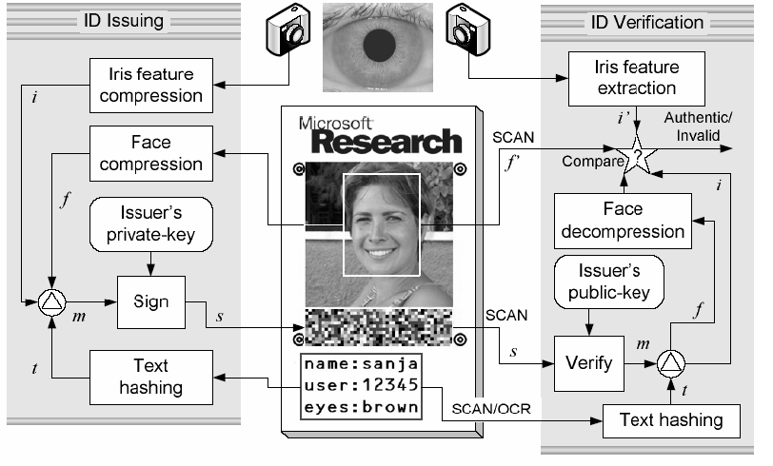
FaceCert s, a simple, inexpensive, and Cryptographically secure identity certification system. A FaceCert is a printout of person’s portrait photo, an arbitrary textual message, and a 2-D color barcode which encodes an RSA signature of the message hash and the compressed representation of the face encompassed by the photo. The signature is created using the private key of the party issuing the ID. ID verification is performed by a simple off-line scanning device that contains the public key of the issuer. the ID does not need to be printed by a trusted or high-end printer, it can be printed anywhere, anytime, and potentially by anyone. The ID verifier uses a single scan process which does not require the use of displays.

Biomatrics:

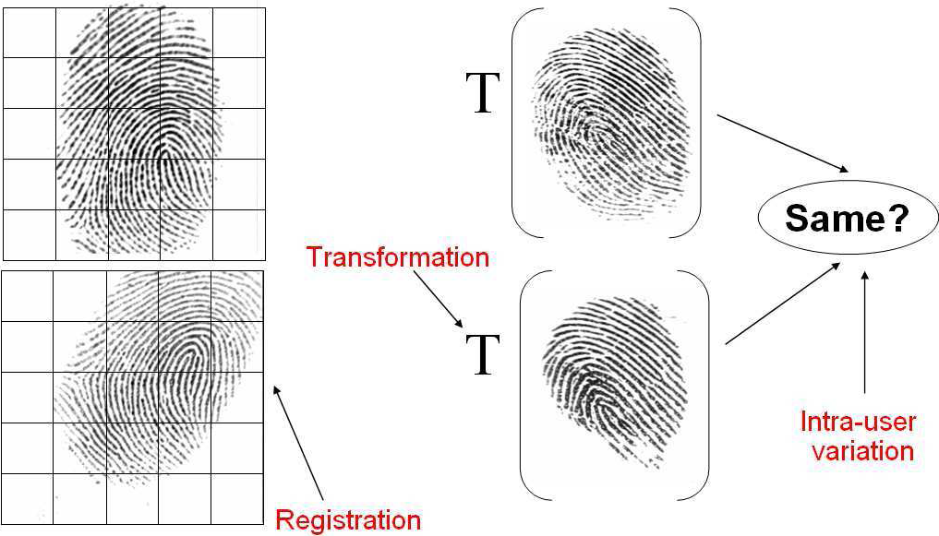

2. Secure Notarization of Paper Text Documents

Authentication of digital data is a well-studied problem in computer science [8], but many important, long-lived documents are still available only on paper. Paper is traditionally authenticated either through elaborate printing techniques (as in money) or through trusted signatures and stamps (as in wills or contracts). Current technology, however, has made it easier to counterfeit paper documents. This method deals with how to use digital methods to authenticate paper documents, and introduce concepts that could be used for other cases of authenticating analog data.
Current technology presents a method to notarize a paper document. This method computes a set of features from the page, inputs these features into a hash function, digitally signs the output, and then prints the resulting signature on the page. The notarized document is self-contained: verification does not require reference to online information.

3

REQUIRMENT ANALYSIS

REQUIRMENT ANALYSIS

Cryptography is method used for encryptcoding & decryptcoding of messages. In traditional method, both operations that is encryption & error correction (encryption + encoding) performed separately. Thus for long messages process become lengthy, time consuming & complex & costly.

Thus to overcome drawbacks of existing system we perform both operations in single step here name as Cryptcoding.

Since the user in our project can be any common man. Our aim is to develop a user friendly project which can be handled by any one &it should deliver an appropriate & efficient output. Thus our goal is to select software which would help us in achieving our aim. We gathered information from internet & various other sources & come to a conclusion that C++will be most efficient software for our project because it includes many tools & function for various operations. MATLAB
provides a very good GUI.

In Cryptcoding, following are the requirements:

- Traditional method provides us with less speed which must be overcome by this technique.

- In new technology cryptcoding, encryption and encoding & Decryption and decoding are perform in single step. So Cost

- Provide more accuracy than traditional approach cryptcoding

4

PROJECT PLANNING

PROJECT PLANNING

The planning and conception of the project commenced in September, when our Internal Guide Prof.S.V.Jadhav (H.O.D-I.T.) suggested us the project- CRYPTCODING, in which encryption/decryption and error-correction coding/decoding are performed in a single step. We decided to implement it as project.
The phase of our initial investigation involved a deep theoretical study of topics covering the features of communication.

Project Plan

1. Investigation Aug 2008 - Sep 2008

2. Analysis Sep 2008 - Dec 2008

3. Design Dec 2008 - Dec 2008

4. Coding Dec 2008 - Feb 2009

5. Initial Testing Feb 2009 - Mar 2009

6. Final Implementation Mar 2009 - Mar 2009

7. Final Report Apr 2009 - Apr 2009

During the projected Phases, we covered the following areas:

Phase 1: Initial Investigation:

The initial investigation phase covered a deep theoretical study of topics covering the types of document, its features and the study of topics required for implementation of the project.

Phase 2: Analysis:

The selected project was tested for its feasibility. The test included the study of the project as technical, economical and operational feasibility study. This phase used the documents prepared in investigation phase and we decided whether the project is acceptable or not.

Phase 3: Design:

This phase started with technical design preparation and generalized program flow for practical implementation of the project. The design phase used, the knowledge we got in the phase of the investigation and analysis. We designed theoretical algorithm of encryption and decryption. We decided to go for C++ as coding language and decided to store the intermediate file as text file. we will also be using MATLAB as GUI tool.

Phase 4: Coding:

This phase is an attempt to practical and actual implementation of the design in a efficient software code. We started for coding using C++.

Phase 5: Implementation:
This phase was concentrated on removing any bug or defect from code and integration of advanced features if any suggested or noticed in testing phase.

Phase 6: Testing:
In this phase, the code was tested for all possibility of errors. The aim of the testing phase was to find errors.

Phase 7: Final Report:
This phase will lead to the preparation of the final report.

5

TECHNOLOGIES USED

TECHNOLOGIES USED

5.1 Hardware:

- Computer/Processor: P4+

- RAM 256+

5.2 Software:

MATLAB 7.0

MATLAB® is a high-performance language for technical computing. It integrates computation, visualization, and programming in an easy-to-use environment where problems and solutions are expressed in familiar mathematical notation. Typical uses include

- Math and computation
- Algorithm development
- Data acquisition Modeling, simulation, and prototyping
- Data analysis, exploration, and visualization
- Scientific and engineering graphics
- Application development, including graphical user interface building

MATLAB is an interactive system whose basic data element is an array that does not require dimensioning. This allows you to solve many technical computing problems, especially those with matrix and vector formulations, in a fraction of the time it would take to write a program in a scalar no interactive language such as C or Fortran.

C++
C++ is programming language is usually classified by level & orientation. C++ is refers to as high level language. It was developed by Bjarne stroustrup at AT & T Bell laboratories in murry Hill,New jersey,Usa in 1980’s.
C++ is support of C. Most of what we already know about C applies to C++ also. Therefore almost all C programs are also C++ program. The most important facilities that C++ adds on to C classes are inheritance, function, overloading & operator overloading. These features enable creating of abstract data types; inherit properties from existing data types & support polymorphism thereby making C++ truly object oriented language.

Applications of C++:

C++ is versatile language for handling very large programs. It is suitable for virtually any programming task including development of editors, compliers, databases, communications system & any complex real life application system. Some applications are:

- Since C++ allows us to create hierarchy related object, we can build special object oriented libraries which can be used later by many programmer.
- While C++ is able to map the real world problems properly,( the part of C++ gives the language) the ability to get close to the machine level details.
- C++ programs are easily maintainable & expandable. When anew future needs to be implemented it is very easy to add to the existing structure of objects.
- It is expected that C++ will replace C as a general-purpose language in newer future.

6

PROJECT DESIGN

PROJECT DESIGN

There is an obvious need to communicate or to keep certain information unknown to the public or to anyone except those, who are intended to know that information. This can be achieved by changing the form of original information so that it becomes unintelligible for anybody except, who are intended. There are various techniques used for this purpose.

Block Diagram of Cryptcoding:

Network
Plaintext
Encryption
+
Encoding
Cipher Text
Plaintext
Decryption
+
Decoding
Cipher Text

6.1 Workflow

Steps:-

- The data to be transmitted over the network is first encrypted using the key, provided by sender. At the same time error correction will be done.

Secret Data
Encrypted Data
+
Encoding

- Then error free data will be transformed over channel.

Encrypted Data
+
Encoding
Network

- When data is transmitted over the channel, error will get introduced into it. Hence decryption and decoding is performed at the same time to remove error and to obtain original data.
Decryption
+
Decoding

Original secrete data

Flow Diagram:

Here is simple flow of how Cryptcoding works:

Secrete Data
(Data to be transmitted)
Key
Encrypted data
(Data to be transmitted)

Encryptcoding
Sender side
Network
Encrypted Data with errors
Key
Actual data which was transmitted
Decryptcoding
Receiver side

7

Implementation Details

Implementation Details:

Algorithm for encryptcoding:

Steps:
  - Read 1 byte from file to be Encrypted.

  - Perform ASCII to BINARY conversion.

  - Depending upon key form Generator Matrix.

  - Multiply Generator matrix with message bits.

  - Write generated code to another file.

  - Repeat steps 1 to 5 until the end of file to be Encrypted is reached.

Algorithm for Decryptcoding:

Steps:
- Read 16 bytes from Encrypted file.

- Depending on the key from generator matrix.

- Using generator matrix from H-Matrix.

- Using H-Matrix & codeward calculate syndrome matrix.

- If error is present perform error correction.

- Perform Binary to ASCII conversion.

- Write generated code to the file after decryption.

- Repeat step 1 to 7 until end of file is reached.

8

Test Cases

Test Cases:

We have covered the following methods of testing:

- Unit Testing
- Integration Testing
- System testing

Unit testing:-

In unit testing, we test each and every module or component for correctness and proper functioning. In our project, first we tested that input file is read by program correctly or not, conversion of ASCII to binary format, process of formation of generator matrix depending on the key as well as saving of encrypted file and decrypted file is done properly or not.

Integration Testing:-

In integration testing, we test each module; if it works fine then we integrate it with the next module under test and test the combination of those two modules. This process is continued till we integrate all the modules to build the whole system.
In our project, we tested encryptcoding and decryptcoding process, then we tested both process with provided message & key as a whole.

System Testing:-

System testing deals with the testing of the whole system with all the functions, components, modules. We see whether the system as a whole functions properly or not.
In our project, we tested the whole system to check whether the desired output is obtained or not.

9
PROJECT TIMELINE

GANTT CHARTS FOR PROJECT CRYPTCODING
 |  |  | August 2008 |  |  |  |  |  |  |  |  | September2008
 |  |  | W1 |  | W2 |  |  | W3 |  | W4 |  | W1 |  | W2 |  | W3 |  | W4
 | 1) Requirement Gathering
 | a) Info. Related to features cryptography
 | b) Info. gathered from Internet
 | c) Info. gathered from books
 | Milestone:- Requirements are gathered
 | 2) Requirement Analysis
 | a)Analysis of info. related to error correction
 | b) Analysis of info. related to features of cryptography
 | c) Analysis of info. gathered from internet
 | d) Analysis of info. gathered from books
 | e) Analysis of various algorithms for encryptcoding & decryptcoding
 | Milestones: Requirements are identified and defined
 |  | October2008 |  |  |  |  |  |  |  |  | November2008
 |  | W1 |  | W2 |  |  | W3 |  | W4 |  | W1 |  | W2 |  | W3 |  | W4
3) Problem Definition
a) Meet Internal Guide
b) Identify Project Constraints
c) Establish Project Statement
Milestone:- Problem Statement is defined
4) Feasibility
a) Economical Feasibility
b) Technical Feasibility
c) Behavioral Feasibility
Milestone:- Feasibility Study complete

 | December2008 |  |  |  | January2009
 | W1 | W2 | W3 | W4 | W1 | W2 | W3 | W4
5) Planning
a) Scheduling of Tasks
b) Time Allocation
c) Effort Allocation
d) Resource Allocation
Milestone:- Goals are defined
6) Designing
a) Algorithms is build
e) Designing of GUI
Milestones: Designing required for the project are completed

 | February2009 |  |  |  | March2009
 | W1 | W2 | W3 | W4 | W1 | W2 | W3 | W4
7) Coding
a) coding of Encryptcoding
b) Coding of Decryptcoding
Milestones: Coding is completed

 | March2009 |  |  |  | April2009
 | W1 | W2 | W3 | W4 | W1 | W2 | W3 | W4
8) Implementation Details
a) Linking GUI and Project files
Milestone:- Implementation Completed
9) Testing
a) Unit Testing
b) Integration Testing
c) System Testing
Milestone:- Testing completed successfully
10) Evaluation
a) Project Evaluation
b) Documentation Review and Recommendation
Milestones: Project Approved and Objective Achieved

11

FUTURE SCOPE

FUTURE SCOPE:

- We have implemented this using symmetric key; this can be further enhanced by using asymmetric key.

- The error correcting capacity can be increased by using error correcting technique which has greater error correcting capacity.

GLOSSARY

Cryptography: the technique of encoding and decoding the messages.

Encryption: The process of encoding message.

Plain text: The message in its original form.

Cipher text: The message in encrypted form.

Decryption: The process of transforming an encrypted message back to its normal, original form.

Encryption key: The secret word using which the message is encrypted.

Decryption_key: The secret word using which the message is decrypted.

Symmetric_key Cryptography: In this type of cryptography encryption and decryption key are same.

Asymmetric_key Cryptography: In this type of Cryptography Encryption and decryption are different.

Cryptcoding: Cryptcoding is a procedure in which encryption/decryption and Error-correction coding/decoding are performed in a single step.

Encryptcoding Algorithm: E(K;M) = C : Encrypt coding step in which an error resistant cipher text C is produced using the encryption key K.

Decryptcoding Algorithm: Decryptcoding step in which the original message M is restored from the erroneous cipher text C0 after transmission.

12

APPENDIX

APPENDIX

Appendix A - User Manual:

1. How can I select the file for encryptcoding?
Ans: You can get the file after clicking the browser button in GUI & then you can select any file.

2. Is their any format for specifying key?
Ans: No.Accept null string.

3. Is any format for intermediate file?
Ans: You can specify any name for the file but it should have .txt as its extension.

4. Can only text file be encrypted?
Ans No. You can Encrypted any extension file i.e .exe, .com,.jpeg,etc.

5. What is the error correction capacity?
Ans It can correct one bit error per 8 bit.

6. Which file should be selected for Decryptcoding?
Ans: The file which you have specified as in intermediate file must be selected as file to be Decryptcoding.

7. Which key is to be used for Decryptcoding?
Ans: The key which you have used during Encryptcoding, the same key must be used during Decryptcoding.

Appendix B - Technical Manual:

13

REFERENCES

REFERENCES

Books:
- Cryptography
  - Ranjan Bose
- Let Us C
  - Yashavant Kanikatkar

Websites:
-
- http://en.wikipedia.org

- http://google.com

10

TASK DISRTIBUTION

Responsibility Matrix
P: Primary Responsibility Project Members: -
S: Secondary Responsibility AP: Amrapali Patil
A: must give approval GP: Gitanjali Patole
N: must be notified KC: Kavita Chavan
MJ: Mrunal Jadhav

Project Task or Activity | Project Manager (Mr.S.V.Jadhav)
Project Task or Activity | Requirement Engg. |  |  |  | Planning |  |  |  | Designing |  | Coding |  | Testing |  |  |  | Implementation |  | Documentation
Project Task or Activity | AP | GP | KC | MJ | AP | GP | KC | MJ | KC | MJ | AP | GP | AP | GP | KC | MJ |  | ST | KC | MJ
Requirement Gathering | S P S
Requirement Analysis | P S S
Identifying Problem |  |  |  |  | S S P
Problem Formulation |  |  |  |  | P S S
GUI Design |  |  |  |  |  |  |  |  | P S
Database Design |  |  |  |  |  |  |  |  | P S
Code to calculate RGB percentage |  |  |  |  |  |  |  |  |  |  | P
Code to calculate grey level percentage |  |  |  |  |  |  |  |  |  |  | P
Code to calculate the Shape Number |  |  |  |  |  |  |  |  |  |  | P
Code for comparison |  |  |  |  |  |  |  |  |  |  | P
Unit Testing |  |  |  |  |  |  |  |  |  |  |  |  | S S P
Integration Testing |  |  |  |  |  |  |  |  |  |  |  |  | S P S
System testing |  |  |  |  |  |  |  |  |  |  |  |  | P S S
Implementing Software |  |  |  |  |  |  |  |  |  |  |  |  |  |  |  |  | P S

