WAP to print your name and age

print("my name is Amar")

print('my age is',22)

my name is Amar

my age is 22

# We can use double quotes or single quotes // single line comment in python

‘ ‘ ‘ No semicolon at end

Now endl or /n like in c/c++ for new line ‘ ‘ ‘ // multiline comment in python

## Variables in Python

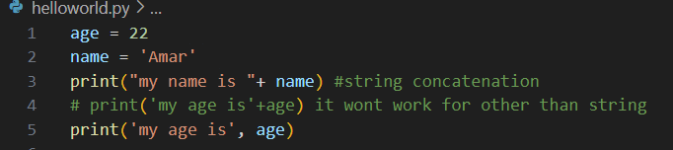

my name is Amar

my age is 22



my name is amar

i am from hyderabad

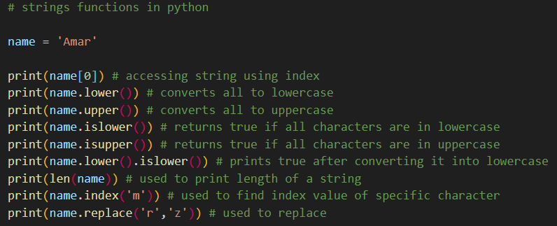

A

amar

AMAR

False

False

True

4

1

Amaz

------------------------------------------------------------------------------------------------------------------------------------------------------------

## Numbers in Python

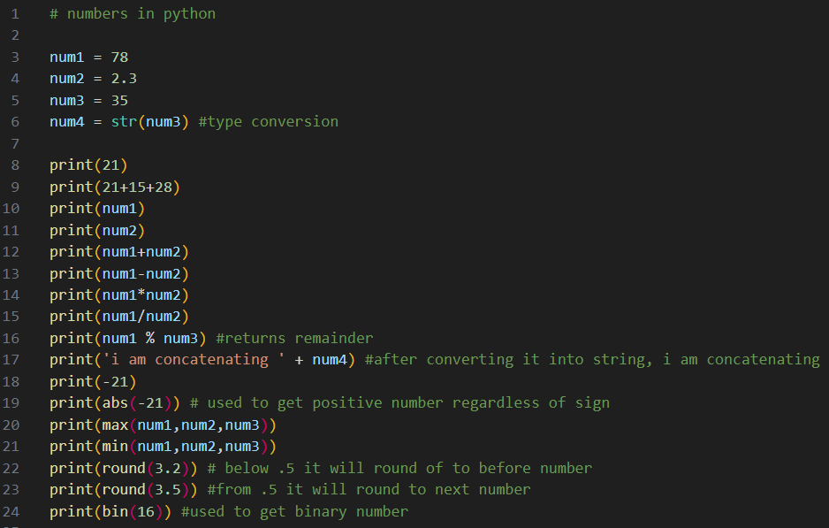

21

64

78

2.3

80.3

75.7

179.39999999999998

33.913043478260875

8

i am concatenating 35

-21

21

78

2.3

3

4

0b10000

For using more math functions like sqrt etc., we need (from math import *)

from math import *

print(sqrt(100))

10.0

## Getting user input

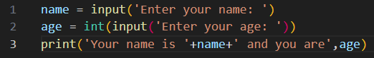

Enter your name: Amar

Enter your age: 21

Your name is Amar and you are 21

## Exercise

sentence = input('Enter your sentence: ')

print('your sentence is: '+sentence)

word1 = input('Enter word to replace: ')

word2 = input('Enter word to replace it with: ')

print(sentence.replace(word1 ,word2))

Enter your sentence: i am good guy

your sentence is: i am good guy

Enter word to replace: good

Enter word to replace it with: bad

i am bad guy

# List in Python

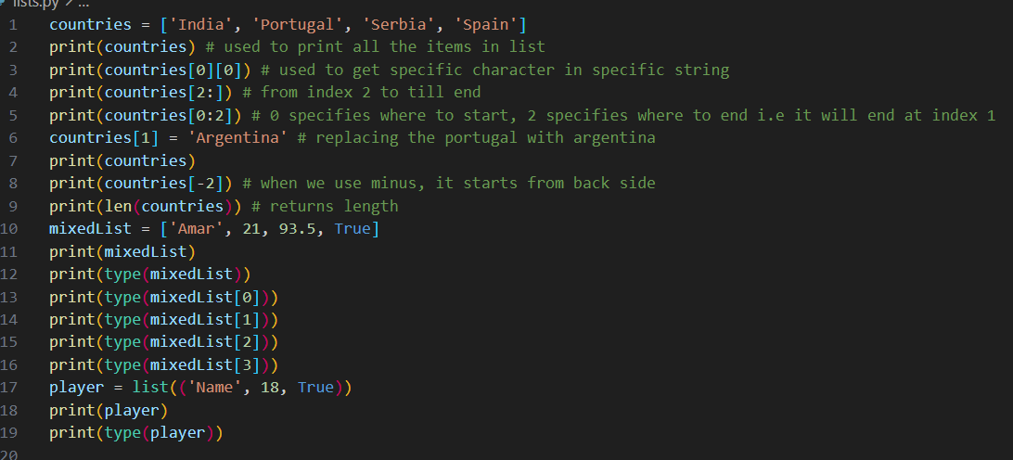

['India', 'Portugal', 'Serbia', 'Spain']

I

['Serbia', 'Spain']

['India', 'Portugal']

['India', 'Argentina', 'Serbia', 'Spain']

Serbia

4

['Amar', 21, 93.5, True]

<class 'list'>

<class 'str'>

<class 'int'>

<class 'float'>

<class 'bool'>

['Name', 18, True]

<class 'list'>

# List Methods in Python

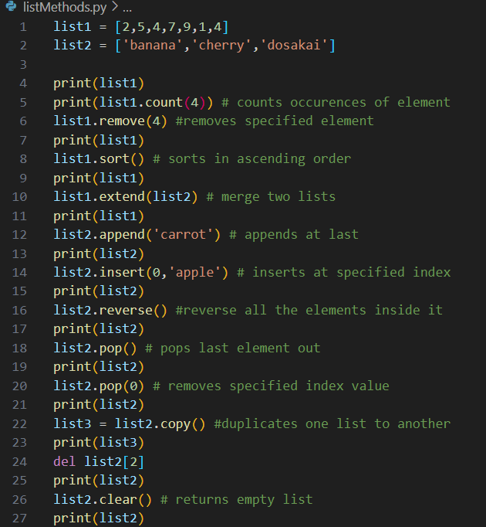

[2, 5, 4, 7, 9, 1, 4]

2

[2, 5, 7, 9, 1, 4]

[1, 2, 4, 5, 7, 9]

[1, 2, 4, 5, 7, 9, 'banana', 'cherry', 'dosakai']

['banana', 'cherry', 'dosakai', 'carrot']

['apple', 'banana', 'cherry', 'dosakai', 'carrot']

['carrot', 'dosakai', 'cherry', 'banana', 'apple']

['carrot', 'dosakai', 'cherry', 'banana']

['dosakai', 'cherry', 'banana']

['dosakai', 'cherry', 'banana']

['dosakai', 'cherry']

[ ]

## Tuples in Python

numbers = (1,2,3) # tuple initialization

print(numbers)

print(type(numbers))

# changing values are not entertained in tuples like numbers[1] = 4

# tuples are immutable

player = tuple(('Name', 18, True)) #another way of initializing using tuple constructor same as like list

# len,type all work same like list operations

print(player)

print(type(player))

(1, 2, 3)

<class 'tuple'>

('Name', 18, True)

<class 'tuple'>

# Functions in Python:

def greetings(): # function in python

print('Welcome to AmarVerse')

greetings() # function calling

Welcome to AmarVerse

def details(name,age):

print('Welcome '+name+' and you are '+str(age)+ ' years old')

details('Amar',22)

Welcome Amar and you are 22 years old

Both are same but we can also access like this

def details(name,age):

print('Welcome '+name+' and you are '+str(age)+ ' years old')

details(name = 'Amar', age = 22)

Welcome Amar and you are 22 years old

def fun(*names): # when * is used, it is going to have multiple values like tuple

print('Hi '+names[1]) # have to use index number to access from multiple values

fun('Amar', 'Teja', 'Koteswari')

Hi Teja

def details(name,age):

print('Welcome '+name+' and you are '+str(age)+ ' years old')

name = input('Enter your name: ')

age = input('enter your age: ')

details(name, age)

Enter your name: VV Reddy

enter your age: 48

Welcome VV Reddy and you are 48 years old

## Return Statement in Python

def add(num1, num2):

return num1+num2

num1 = int(input('Enter num1: ')) #if you don't specify int then it will consider it as string

num2 = int(input('Enter num2: '))

print(add(num1,num2))

Enter num1: 21

Enter num2: 28

49

## If elif else in python

number = int(input('Enter number: '))

if number%5 == 0:

print('Divisible by 5')

else:

print('Not divisible by 5')

Divisible by 5

## Dictionaries in Python

# stores data in key value pairs

# duplicates in keys are not allowed, unlike in list & tuple

my_dict = {

'name' : 'Amar',

'nationality' : 'Indian',

'age' : 22,

'isGenius' : True,

'weight':90.5,

'family' : ['Teja','Koteswari'] # we can have multiple types in dictionary

}

print(type(my_dict))

print(my_dict)

print(len(my_dict))

print(my_dict['nationality']) # accessing individually

<class 'dict'>

{'name': 'Amar', 'nationality': 'Indian', 'age': 22, 'isGenius': True, 'weight': 90.5, 'family': ['Teja', 'Koteswari']}

6

Indian

## While loop in Python

# wap to print natural numbers till 10

i = 1

while i<=10:

print(i)

i += 1 # unlike c,c++,java we don't have i++ here

## For Loop in Python

for letter in 'Amareswara':

print(letter)

A

m

a

r

e

s

w

a

r

a

mylist = ['sa', 're', 'ga', 'ma', 'pa']

for values in mylist:

print(values)

sa

re

ga

ma

pa

for values in mylist:

if values == 'ma':

break

print(values)

sa

re

ga

my_dict = {

'name' : 'Amar',

'nationality' : 'Indian',

'age' : 22,

'isGenius' : True,

'weight':90.5,

'family' : ['Teja','Koteswari']

}

for values in my_dict:

print(values) # it is printing only key values

name

nationality

age

isGenius

weight

family

for x in range(10):

print(x)

0

1

2

3

4

5

6

7

8

9

for x in range(5,10):

print(x)

5

6

7

8

9

### else in for loop:

for x in range(5,10):

print(x)

else:

print('Loop finished!..')

5

6

7

8

9

Loop finished!..

## 2D lists

mylist = [

[1,2,3],

[4,5,6],

[7,8,9]

]

print(mylist)

[[1, 2, 3], [4, 5, 6], [7, 8, 9]]

mylist = [

[1,2,3],

[4,5,6],

[7,8,9]

]

for column in mylist:

for row in column:

print(row)

1

2

3

4

5

6

7

8

9

## Try Except in python:

try:

x=int(input('enter value: '))

print(x)

except:

print('only int values are accepted..')

enter value: amar

only int values are accepted..

try:

x=int(input('enter value: '))

print(x)

except:

print('only int values are accepted..') # this will execute if try runs into error

else:

print('int value printed..') #this is executed if try runs perfectly

finally:

print('try except finished..') #irrespective to try and except it will execute at last

enter value: 21

21

int value printed..

try except finished..

## Reading files in Python

countriesList = open('countries.txt','r')

print(countriesList.readable()) #returns boolean value if it is readable or not

print(countriesList.readline()) # reads first line

print(countriesList.readline()) # reads next line sequentially

countriesList.close()

# print(countriesList.readlines()[0]) # using index to specify line

# print(countriesList.readlines()) # reads all lines

'''using for loop to read all countries

for lines in countriesList:

print(lines)

'''

## Writing files in Python

stateList = open('stateList.txt', 'w')

stateList.write('I had created a new file using write mode w in python')

'''stateList=open('stateList.txt','a')

stateLIst.write('using append mode we can add new lines or text')'''

## Class & Object in Python

class Myclass: # initialization of class

x=21

def __init__(self,name,age): # constructor in python

self.name=name

self.age=age

abc = Myclass('Amar',100) # object creation

print(abc.name)

print(abc.age)

print(abc.x) # accessing class properties

# del abc.name # we can delete that property

# del abc # we can whole object, after doing this, if we call then it will say not defined

Amar

100

21

## Inheritance in Python

oop.py file in same folder

class Myclass: # initialization of class

x=21

rollNo='2K19CSUN01119'

branch='CSE'

from oop import Myclass # oop is inherited file name, Myclass is class name we are going to inherit

class Abclass(Myclass):

pass

xyzObject = Abclass()

print(xyzObject.rollNo)

2K19CSUN01119

Modules in Python

new.py

def say_hi():

print('hiii')

module.py

#accessing new file in module.py by importing

import new # new is file name

new.say_hi()

hiii

We use pip to install packages