Enfinitus Newtech – Backend Services Requirements Specification

The backend is composed of coupled micro-services that communicate through a Kafka event stream and a few well-defined REST / GraphQL calls, yet persist their own data in isolated schemas of a shared PostgreSQL database.

Because every service owns its schema and emits outbox events, each one can be upgraded or scaled without touching the others while still meeting exactly-once consistency.

Enfinitus Newtech Backend – Service Catalog
- Pricing – imports ENET curves and grid charges, publishes tariff snapshots.
- Contract & Import – validates sign-ups, runs credit checks, emits ContractTable and CustomerTable.
- Customer Management – maintains the single customer record, contracts and meter reads.
- Energy Management – imports meter data, aggregates demand, calculates demand forecasts, calculates open positions and P/L.
- Billing – issues invoice, matches payments, exports data to Finance.
- Direct-Sales Settlement – calculates partner commissions from billed revenue.
- Market Communication Gateway – hands structured JSON to a clearing-house API, which delivers all GPKE, MaBiS and BKV messages over the required protocols.
- Messaging Service – sends e-mails, SMS and push notifications in response to backend events.

Pricing Service

Objectives
- Separate price-list API per sales channel (web funnel, call-centre, partners) delivering optimised prices based on channel-specific margin logic.
- Working price and fix fee for every tariff accurately reflect DSO grid fee and concession tax at ZIP-code, city, and district level.
- Daily price refresh driven by the standard load-profile–weighted wholesale price from the hourly price forward curve (HPFC).
- Architecture supports continuous improvement: pricing script lives in a Git repository, and GitHub CI/CD builds and ships a new OCI image which the scheduler can pull without downtime.

Key Constraints & Rules
- Uniqueness – Combination of ZIP Code + City + City District + TariffID + Date must be unique inside a campaign table.
- Price Integrity – When inserting rows the system must validate that Working Price lies within the minimum/maximum margin defined in the Tariff Data Table.
- Versioning – Creating a new CampaignID generates an immutable price version; existing rows are never overwritten, ensuring a complete price history.

Technical Description:
- The data basis for the applicable working prices for each unique combination ZIP-Code, City, City district and ensures we are charging the right fees and taxes on behalf of the grid provider. Each sales channel than gets its specific margin and, thus, pricing table.
- Given the margin and additional constraints, a pricing algorithm calculates the optimal price for each ZIP code, city, city district and channel.
- The algorithms are written in Python and packaged into a lightweight OCI image (pricing‑engine:<tag>).
- A dedicated Kubernetes CronJob (01:00 CET) or an on‑demand Job spins up a pod, runs the scripts inside a Docker container, then terminates.
- When the calculation is finished, the container POSTs the generated campaign tables to an internal endpoint POST /internal/pricing‑results (gRPC fallback available). The Pricing Service persists the payload and immediately emits a PriceVersionPublished event.
- Each sales channel, direct marketeers, and website should have its own API, since each should have its own pricing to achieve maximum revenue.

Pricing Architecture:
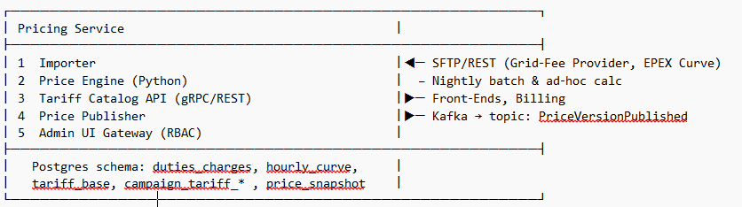

Pricing data schemas:
Table | Purpose | Key Columns | Operational Notes
Tariff Data Table | Holds master data for every tariff product. The parameters here apply globally, independent of time or location. | 1. TariffID – primary key  2. TariffName (string)  3. Min Contract Duration (months)  4. Minimum Margin / Maximum Margin – pricing corridor the engine must respect  5. Consumption Range – target annual-consumption band (e.g. 0-5 MWh)  6. Billing Method / Monthly Instalments (e.g. monthly, yearly)  7. End-Of-Contract Rule – renewal or cancellation logic | The pricing engine reads this table first. Every downstream price record must reference a valid TariffID and stay inside the defined margin corridor.
Campaign Table Dynamic Tariff | Stores the concrete working price for dynamic tariffs (price can change daily/weekly). | 1-4. ZIP Code, City, City District, Date – forms a unique geo-time key  5. TariffID – FK to Tariff Data Table  6. Working Price (ct/kWh)  7. Fix Fee (€/month)  8-9. Variable Bonus / Fixed Bonus – campaign incentives  10. CampaignID – groups all rows belonging to one price version | Updated as often as required (typically nightly). Sales front-ends query the current price from here.
Campaign Table Fix12 Tariff | Fixed-price product with a 12-month guarantee. Same schema as the Dynamic table. | Same as above | Separate table avoids mixing fixed and dynamic price versions.

Contract Service & Import Process

Objectives
Upon completion of the workflow each switching request results in:
- A fully Contract (row in ContractTable with status Active) linked to a validated tariff and campaign snapshot.
- A definitive entry of each customer with its corresponding market location (MaLo) data is stored in CustomerMaLo (a row in CustomerMaLo ) containing all market-location data required for billing and balancing.
- A correspondingly updated or newly created customer master record.
- A complete, immutable audit trail in ContractEvent allowing any regulator or internal auditor to replay the process end-to-end.

These outcomes guarantee that downstream services—Billing, Customer Management, and Energy Management—receive consistent and dependable data without manual rework.

Key Constraints & Rules
- 24 Hour Switching SLA – A signed contract must be submitted to the Distribution Grid Operator via GPKE ANMELDUNG (Lieferantenwechsel Anmeldung/ Supplier Switch Apllication) within 24 h.
- Data Completeness – A MaLo (market location) record with valid BDEW code and meter number is mandatory before the GPKE message is sent.
- Only customers with a positive respond message from the GPKE process are imported to activated customers
- Audit Trail – All status changes are immutable and timestamped in a contract event log.

Technical Description
- Import Request Logged – Sales funnel sends an authenticated POST /contracts/import with customer data, selected Campaign ID, and a link to the signed contract. The raw JSON payload persisted in the import_request table (idempotency key, timestamp). An optional previous-bill upload is stored in object storage and its URL is added to the same row.
- Contract Draft Creation – Using the CustomerID and Campaign ID, the service generates a unique ContractID and inserts a row in ContractDraftTable (status =Draft, pricing snapshot columns working_price, fix_fee).
- Validation & Enrichment – The Workflow Orchestrator an annual-consumption sanity check; results are patched into the existing ContractDraftTable row and a corresponding Contract_Event (type =ValidationPassed/Failed) is appended.
- Market-Location Mapping – The customer specific MaLo data (BDEW code, meter number, previous provider) is retrieved via the Market Communication Gateway and written to Malo_Draft, linked by ContractId.
- Manual Oversight & Audit – Ops edits to Malo_Draft, are stored as new versions; every change triggers a Contract_Event (type =ManualEdit) and must be confirmed via an admin flag in the same table.
- GPKE Switch & Activation – After sending ANMELDUNG the service waits for SwitchConfirmed. Upon success, it migrates the draft rows: ContractDraft → Contract_Table (status =Active) and MaloDraft → CustomerMalo; it also inserts the customer (if new) into the customer table. A final ContractEvent (type =Activated) is written and ContractActivated is published; failures move the draft to SwitchFailed

Contract Service & Import Process Architecture:
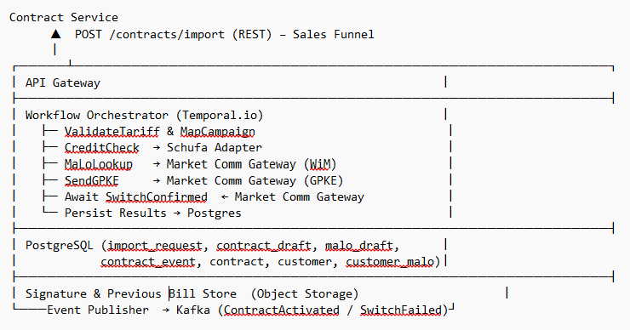

Contract Service & Import Process data schemas:
Table | Purpose | Key Columns (examples) | Operational Notes
ContractDraft | Temporary holding area for every new contract as soon as it is imported. Holds the full pricing snapshot and customer meta-data while the switch is in progress. | funnelId, customerId, ContractId, tariffId, workingPrice, fixFee, expectedConsumption, address fields, contractDraftDate, desiredContractChangeDate, expectedContractEndDate, schufaStatus, iban, sepaMandate, otherBillingInfo | Created by the POST /contracts/import call (status =Draft). Updated in place during validation, then either migrated to contract on success or flagged SwitchFailed.
MaloDraft | Staging table for market-location (MaLo) details that are required to launch the supplier-switch. Lets Ops amend data before it becomes final. | customerId, contractId, marketLocationIdentifier, hasOwnMSB (flag), meterNumber, previousProviderCode, previousAnnualConsumption, possibleSupplierChangeDate, schufaScoreAccepted, maloDraftStatus | Written after MaLo lookup via the Market Communication Gateway. Any manual edits create new row versions; admin approval toggles maloDraftStatus = Approved.
CustomerMalo | Definitive MaLo record once the GPKE switch is confirmed. Used by downstream services (Billing, Energy Mgmt) to link contracts and meters to the grid. | customerId, contractId, marketLocationIdentifier, hasOwnMSB, meterNumber, previousProviderCode, previousAnnualConsumption, possibleSupplierChangeDate, schufaScoreAccepted, changeProcessStatus

Customer Management Service

Objectives
- A single authoritative CustomerTable row per end‑customer, enriched with current address and contact data.
- Every active contract reflected in ContractTable and linked via ContractRefTable so that the total number of contracts is always consistent.
- All meter readings for each customer consolidated in MeterReadingTable, guaranteeing no orphaned meters.
- Up‑to‑date pricing snapshots and special conditions recorded in CustomerPricingTable
- A complete, append‑only CustomerEventHistory timeline for regulatory audits and customer support inquiries.
- All artefacts are stored exclusively in the PostgreSQL database—no additional object storage is required by this service.

Key Constraints & Rules
- Single Source of Truth – Each CustomerId is unique across all services.
- GDPR Compliance – Personal data must be deletable on request within 30 days.
- Meter–Contract Consistency – Every active contract must reference at least one meter; orphaned meters trigger alerts.

Technical Description:
- Contract Intake – The service subscribes to ContractActivated. For each event it inserts the new row into CustomerTable (if not present) and creates a ContractRefTable link to the owning customer.
- Meter Reading Processing – Listens to MeterReadingIngested. Validates that the meter belongs to the customer via CustomerMaloTable, then stores the reading in MeterReadingTable and updates rolling consumption aggregates.
- Pricing Snapshot Management – When PriceVersionPublished or special‑pricing updates arrive, resolves the active tariff for each contract and inserts a record into CustomerPricingTable if the working_price or fixed_fee changed.
- Profile Maintenance – CSR or self‑service API calls mutate name, address or contact fields; writes persisted to CustomerTable and an entry is appended to CustomerEventHistory (type = ProfileUpdated).
- Accounts Receivable Tracking – Consumes InvoiceIssued and PaymentReceived events. Updates billingStatus and arBalance columns in customer_table so support agents have real‑time payment status.
- Search Index Sync – After any write to customer_table or contract_table the change‑processor pushes a document into an ElasticSearch index, powering the Customer Base 2.0 UI.
- Notification Hub – On key events (SwitchCompleted, PaymentOverdue) the service triggers emails or SMS via the Notification Hub.
- GDPR and Compliance – A DeleteCustomer request anonymises PII columns in CustomerTable and cascades to ContactInfo while retaining surrogate keys for financial audit.

Customer Management Architecture:
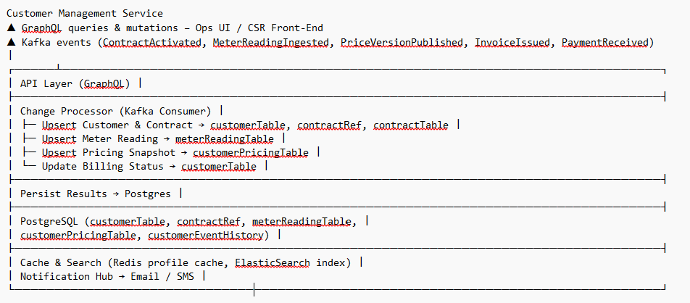

Customer Management – Data Schemas
Table | Purpose | Key Columns (examples) |  | Operational Notes
CustomerTable | Authoritative master record for each end-customer (B2C or B2B). |  | customerId PK, salutation,  firstName, lastName, companyName?,  addressStreet, addressPostalCode,  addressCity, addressCountry, email, phone, contactPrefsJson, schufaScorePct, nrContracts GENERATED*,  arBalanceCent, billingStatus  enum(Current,Overdue,Dunning,Blocked),  createdAt, updatedAt, deletedAt? | *nrContracts is a generated column counting ACTIVE ContractRef rows; helps enforce Single-Source-of-Truth rule. PII columns are encrypted at rest; on DeleteCustomer request they are anonymised and deletedAt is stamped (kept ≤ 30 days until purge).
Contract  Table | Stores every active retail contract. |  | contractId PK, tariffId, campaignId,  workingPriceCtKWh, fixFeeEURMonth, expectedConsumptionKWh, contractStartDate, contractEndDate, billingInterval enum(Monthly,Quarterly,Annual), contractStatus enum(Active,Suspended,  Terminated,SwitchInProgress), cancellationStatus enum(None,Requested,Confirmed), createdAt | Physical FK to ContractRefTable enforces that a contract belongs to at least one customer; triggers forbid delete while active.
Contract  RefTable | Maintains 1-N mapping between customers and contracts (landlord/tenant scenarios). |  | contractRefId PK, customerId FK, contractId FK, relationType enum(Owner,CoTenant,Former), activeFlag, createdAt | Drives nrContracts generated column; ON DELETE CASCADE to keep referential integrity.
CustomerPricingTable | Historic price snapshots incl. special bonuses. |  | pricingId PK, contractId FK, campaignId, priceValidFrom, workingPriceCtKWh, fixFeeEURMonth, variableBonusCtKWh, fixedBonusEUR, createdAt | Inserted only when price components change (checked hash-diff) – avoids write amplification.
MeterReadingTable | Consolidated meter reads per customer. |  | readingId PK, customerId FK, contractId FK, meterNumber, readingTimestamp, readingKWh, readingSource enum(IoTGateway,Upload,Estimate), importedAt | FK (meterNumber) REFERENCES CustomerMaloTable; a deferred constraint ensures meter belongs to contract owner, satisfying Meter–Contract Consistency. UNIQUE (meterNumber, readingTimestamp) prevents duplicates.
CustomerEventHistory | Append-only audit/event log for support & compliance. |  | eventId PK, customerId FK, eventTimestamp, eventType enum(ProfileUpdated,ContractActivated,MeterReadingIngested,PriceChanged,PaymentReceived,GDPRDelete), payloadJson, performedBy, correlationId | Stored directly in Postgres JSONB column (payloadJson); no external object store, meeting "PostgreSQL-only" artefact requirement. Retention = unlimited.
Note on Storage: All artefacts remain inside the PostgreSQL cluster—no S3/object storage dependency inside this service. Binary artefacts (e.g. invoice PDFs) are referenced but stored by Billing Service.

Energy Management Service

Objectives
- Ingest Data from ENET – capture hourly demand forecasts (SLP and day-ahead) and historic consumption series for every customer market location.
- Compute Current & Future Demand – aggregate real-time consumption and generate rolling forecasts (intraday, day-ahead, week-ahead, year-ahead) per grid area.
- Calculate Open Position – net contracted demand against hedged volumes and maintain a live, hourly-updated open-position ledger (MWh & EUR).
- Regulatory Reporting – automatically compile and submit all mandatory reports to the balancing responsible party (BKV) and MaBiS balancing-group authorities within statutory deadlines.
- Expose Insights to Front-Ends – stream the open position, forecast curves and alerts to trader dashboards and operations front-ends via Kafka topics and a GraphQL resolver.
- Update Financial Statements – derive energy P/L, imbalance costs and feed monthly & year-to-date results into the ProfitLoss table for Finance & B

Key Constraints & Rules
- Data Freshness – ENET demand forecasts and historic consumption must be ingested and persisted within 15 minutes of publication.
- Open-Position Discipline – Recalculate the net open position hourly; if unhedged exposure exceeds ±20 % of forecast demand (or > 5 MWh), an automated hedge order must be emitted.
- Regulatory Deadlines –
- BKV schedule nominations no later than 14:30 CET D-1.
- MaBiS balancing-group reports submitted no later than T + 7 working days.
- Financial Integrity – Post a P/L snapshot to the ProfitLoss table daily by 02:00 CET and the final month-close entry within 2 business days.
- Reliability – Service availability ≥ 99.7 % monthly, with automated retries on ENET/TSO API failures (exponential back-off, max 6 h)
Technical Description
The service consumes all forecast inputs exclusively from ENET:
- SLP profiles (static, yearly) for standard load categories.
- Intraday, day-ahead, week-ahead and year-ahead demand curves via ENET’s REST endpoints.
Historic and near-real-time meter data are received from DSO streams. After each ingestion cycle the service:
- Normalises ENET forecast payloads into the SlpDemandProfile, DayAheadDemandForecast and WeeklyDemandForecast tables.
- Aggregates realised consumption and calculates current demand plus rolling future demand horizons.
- Nets contracted volume against hedged trades to produce the OpenPosition (MWh & EUR) and stores it.
- Emits Kafka events: forecast.intraday, forecast.weekly, position.open, pl.statement for traders, Finance and dashboards.
- Generates and dispatches BKV schedule nominations (D-1 14:30 CET cut-off) and MaBiS balancing-group reports (T + 7 wd).
- Writes daily P/L snapshots to ProfitLoss and posts month-close entries for Finance.
Reliability mechanisms include automatic retries on ENET API failures with exponential back‑off (max 6 h) and compensation logic when DSOs deliver late actuals.

Energy Management Service Architecture
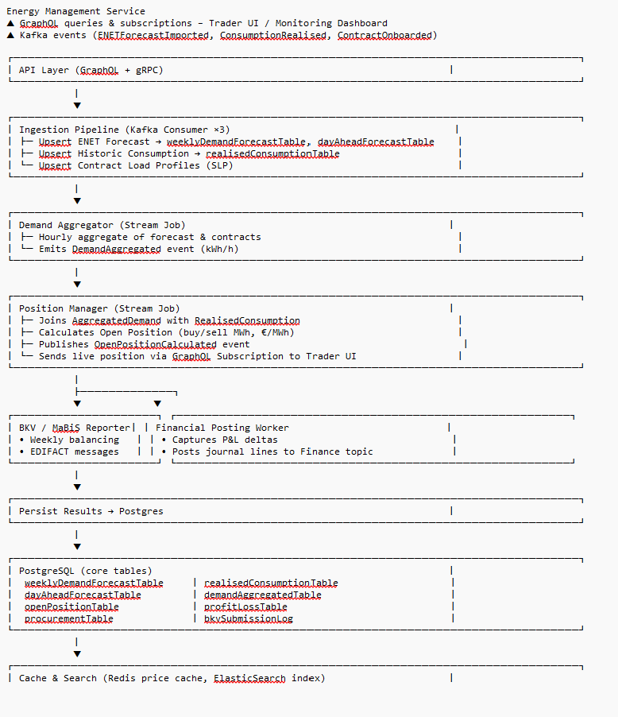

Energy Management Data Schemas
Table | Purpose | Key Columns | Operational Notes
SlpDemandProfile | Static load-profiles by category & hour. | profileCategory, hourOfYear, consumptionKWh | Loaded once per year from ENET.
WeeklyDemandForecast | Aggregated 168-h forecast for grid area. | forecastWeek (YYYY-WW) PK, gridArea, forecastKWh, basis enum(SLP,TSO,DSO), version, createdAt | New version inserted on every recalculation.
DayAheadDemandForecast | 24-h rolling forecast with price signal. | forecastDate, hour (0-23), gridArea, demandKWh, forecastPriceEURMWh, version | Joined with HPFC for margin planning.
RealisedConsumption | Actual load measured by DSOs. | datetime, gridArea, consumptionKWh, source, ingestedAt | Drives forecast-error analysis.
OpenPosition | Quantity still to hedge. | timestamp PK, qtyMWh, avgPriceEURMWh, status enum(Open,Hedged), hedgeOrderId? | Trader UI subscribes.
ProfitLoss | P&L snapshot for finance. | plId PK, period (YYYY-MM), purchasedQtyMWh, purchasedCostEUR, soldQtyMWh, soldRevEUR, imbalanceCostEUR, marginEUR | Written at month-close and whenever trades settle.

Billing Service

Objectives
- Bill every active contract on time and without errors.
- Keep invoices, credit notes, and journals audit-proof and immutable.
- Expose up-to-date billing status and A/R balance for each customer in near real-time.
- Automate payments (SEPA), matching, and dunning to minimise overdue balances.
- Store all billing data—including PDFs—only in PostgreSQL while meeting GDPR and tax-retention rules.
Key Constraints & Rules
- PostgreSQL is the sole source of truth – all other stores are read-through caches only.
- Exactly-once events – InvoiceCreated, PaymentReceived, and JournalPosted carry unique IDs enforced by DB constraints.
- Monotonic numbering – invoice & credit-note numbers increase within each calendar year and are never reused.
- VAT-aware rounding – line items to €0.01, totals “round half up,” always reconcile.
- Tariff immutability – any price change gets a new priceVersionId; past invoices never re-rate in place.
- SEPA lead time D-2 – direct-debit files are generated two banking days before collection.
- Retention & GDPR – financial records kept ≥ 10 years; PII anonymised within 30 days on DeleteCustomer.
- Service SLOs – p95 PDF render < 2 s, p99 payment match < 5 min, monthly uptime ≥ 99.7 %.
Technical Description
- Contract snapshot cache – when contract.onboarded arrives the Intake-Processor stores contract_id, campaign_id, tariff_id, customer_id in Redis and the billing.contract_cache table; this gives the InvoiceGenerator fast joins to campaignTable, tariffTable and customerTable inside Postgres.
- Price look-up – at rating time the InvoiceGenerator joins
- contract_cache → pricing.campaignTable (key: campaign_id + invoice_period_date) to pull the effective working-price ct/kWh and grid-fee €/month that were frozen when the contract was sold.
- Tariff metadata – the same query joins pricing.tariffTable (key: tariff_id) to read billing_frequency_months, advance_payment_mode (ABSCHLAG_MONTHLY, ABSCHLAG_QUARTERLY,ABSCHLAG_YEARLY) and any fixed bonuses; this drives when the Temporal scheduler fires MonthlyBillingWorkflow, QuarterlyBillingWorkflow, or YearlyBillingWorkflow.
- Customer enrichment – customer name, address and IBAN are fetched on demand from customerTable (FK customer_id) so that invoice PDFs contain correct recipient data and SEPA files have the mandate reference.
- Rating algorithm – energy-line items = kWh × working-price; grid-fee line = monthly grid fee from campaign; VAT rounding follows § 14 UStG. All numbers are written to invoice & invoice_line_item in one ACID TX together with an outbox row.
- Outbox → Kafka – Debezium streams the outbox row to billing.invoice.created; consumers (Settlement, Finance) can trust the prices because they stem from immutable campaignTable rows.
- Advance-payment (Abschlag) schedule – if the tariff says “12 monthly Abschläge + annual reconciliation” the Orchestrator instantly spawns 12 pro-forma invoices (type =ADVANCE) using the same campaign prices, and sets due_date = start_of_month + tariff.grace_days.
- SEPA generation – the Payment-Processor groups ADVANCE invoices with method = SEPA and creates a pain.008 in sepa_batch exactly D-2 before the due_date; mandate details come from customerTable.
- Re-rating safety – if Pricing later publishes a new campaignTable row, existing invoices are untouched; only new invoice periods will point to the new campaign_id / price_version_id (tariff immutability rule).
- Single-store guarantee – all joins (campaignTable, tariffTable, customerTable) happen inside the shared PostgreSQL cluster; Redis and Elastic remain read-through caches so legal record-keeping and GDPR deletion stay centralised.

Billing Service Architecture

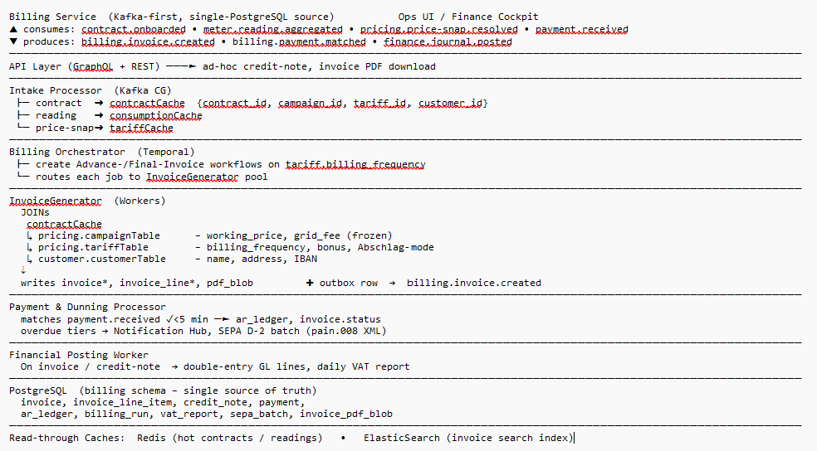

Billing Service data schemas
Table name | Primary key | Key columns (✓ = FK) | Purpose / notes
contract_cache | contract_id (UUID) | ✓customer_id, ✓campaign_id, ✓tariff_id, contract_start, contract_end, payment_method, iban_masked | Normalised snapshot of the contract as sold; joined at billing time so the rating logic never reaches across schemas.
invoice | invoice_id (UUID) | ✓customer_id, ✓contract_id, ✓campaign_id, ✓tariff_id, price_version_id, invoice_no, invoice_type (FINAL,ADVANCE,CREDIT), invoice_date, period_start, period_end, gross_total_eur, net_total_eur, vat_total_eur, billing_status (OPEN,PAID,DUNNING) | Immutable header; campaign_id + price_version_id freeze the working-price & grid fee that applied when the invoice was created.
invoice_line_item | line_id (UUID) | ✓invoice_id, charge_type (ENERGY,GRID,TAX,BONUS,FIXED_FEE), quantity_kwh, unit_price_ct, line_net_eur, vat_rate_pct, line_vat_eur | Detailed rating; sums must equal header totals (checked by DB trigger).
invoice_pdf_blob | invoice_id (PK & FK) | pdf_data (BYTEA), sha256_hash, generated_ts | Stores rendered PDF inside Postgres → single-datastore rule.
credit_note | credit_note_id (UUID) | ✓customer_id, ✓original_invoice_id, credit_no, credit_date, gross_total_eur, reason_code | Negative invoice; also inserted into invoice with invoice_type = CREDIT.
payment | payment_id (UUID) | ✓customer_id, ✓invoice_id, txn_ref_ext, method (SEPA,BANK_TX,REVERSAL), amount_eur, received_ts, match_status (MATCHED,SUSPENSE) | Raw cash movements imported from EBICS or bank CSV.
suspense_account | suspense_id (UUID) | ✓payment_id, reason_text, resolved_ts | Holds unmatched payments pending manual intervention.
ar_ledger | ledger_entry_id (UUID) | ✓customer_id, fiscal_year_month, doc_type (INV,CRN,PAY), doc_id, gl_account, debit_eur, credit_eur, posting_ts | Double-entry ledger for AR, revenue, VAT; feeds Finance.
billing_run | run_id (UUID) | run_type (MONTHLY,MOVE_OUT,RE_RATING), started_ts, finished_ts, contracts_billed, invoices_created, status | Tracks each batch for monitoring, retry & SLO metrics.
vat_report | vat_report_id (UUID) | period_year, period_month, vat_7_eur, vat_19_eur, generated_ts | Daily VAT totals handed to Finance by 09:00 CET.
sepa_batch | batch_id (UUID) | collection_date, generated_ts, pain_008_xml (BYTEA), status (PENDING,SENT,ACKED) | Direct-debit batches created D-2; XML kept for audit.

Market Communication Gateway – API Integration

Objectives
- Send every GPKE, MaBiS and BKV message indirectly by handing structured JSON to an accredited clearing-house API, which converts, signs and delivers over AS2/SMTP/SFTP. Our gateway only shapes the data, persists it, and tracks the provider’s acknowledgement

Key Constraints & Rules
- Provider-API contract – we speak REST/HTTPS, backward-compatible.
- Exactly-once – {message_type, market_location_id, sequence} is UNIQUE in gateway.outbox; retries are idempotent.
- Deadline assurance – GPKE < 24 h, BKV D-1 14:30 CET, MaBiS T+7 wd; provider SLA = “deliver or NACK within 30 min”, monitored via webhook.
- Immutable audit – original JSON, provider ticket-ID, and final EDIFACT hash are stored as BYTEA in PostgreSQL for ≥ 10 years; PII encrypted at rest.
- Failure isolation – if provider API is down, messages queue and retry with exponential back-off; no service-to-service DB writes are blocked

Technical Description
- Event intake – contract.activated, energy.bkv.schedule.ready, meter.mabis.dataset.ready land on Kafka; Change-Processor stores them in gateway.message_prepared.
- Outbox commit – same TX inserts into gateway.outbox; Debezium sends gateway.message.prepared topic (traceable).
- Send worker – picks rows in PENDING, POSTs JSON to the clearing-house REST endpoint; stores returned provider_ticket_id, sets status SENT.
- Webhook listener / poller – receives provider callbacks (DELIVERED, NACK, VALIDATION_ERROR), updates gateway.message.status and emits gateway.message.acked Kafka event.
- Internal consumers – Contract Service updates switch progress, Energy-Mgmt records BKV acceptance, Ops UI shows live status—all by subscribing to the ACK topic.
- Observability & SLOs – Prometheus tracks queued > 30 min or nack_rate > 1 %; alert pushes to PagerDuty. Postgres WAL replication gives RPO = 0, RTO ≤ 30 min.

Market Communication Gateway Service Architecture
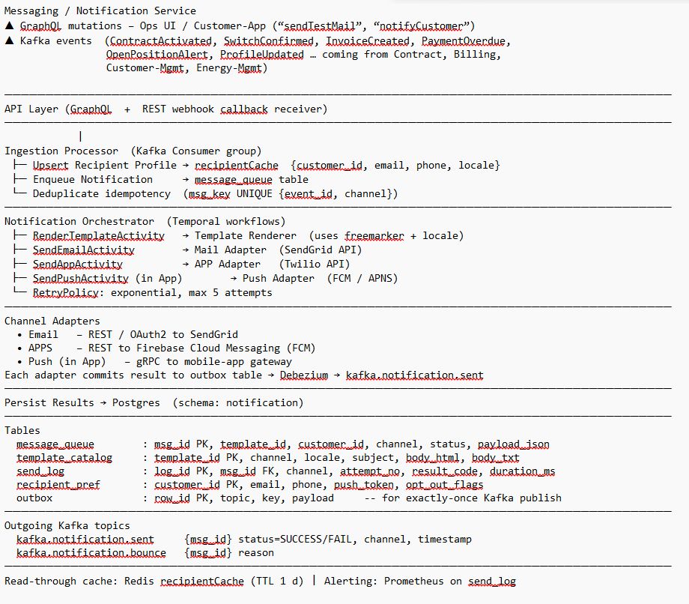

Market Communication data schema
Table | Primary key | Main columns* | Purpose / notes
recipient_pref | customer_id (UUID) | email, phone, push_token, locale (de-DE,en-US…), opt_out_email BOOL, opt_out_sms BOOL, opt_out_push BOOL, updated_ts | One row per customer; refreshed on every customer.profile.updated event and cached in Redis.
template_catalog | template_id (UUID) | channel (EMAIL,SMS,PUSH,SLACK), locale, version_no, subject, body_html, body_txt, valid_from, valid_to, created_ts | Versioned message templates; hot-reloaded by the renderer.
message_queue | msg_id (UUID) | ✓customer_id, ✓template_id, channel, status (PENDING,SENT,DELIVERED,BOUNCED,FAILED), payload_json (merged data model), scheduled_ts, attempts, next_retry_ts, provider_msg_id, created_ts | Work-queue row inserted by Intake Processor or API; Orchestrator picks PENDING rows.
send_log | log_id (UUID) | ✓msg_id, attempt_no, channel, provider_msg_id, result_code (202,4xx,5xx), http_status, duration_ms, sent_ts | Immutable per-attempt telemetry; drives Prometheus metrics and SLA reports.
outbox | row_id (bigserial) | aggregate_id (= msg_id), topic, key, payload_json, created_ts, processed BOOL DEFAULT false | Exactly-once bridge: same TX as message_queue/send_log; Debezium streams rows to Kafka (notification.sent, notification.bounce).

