*Localization and Classification*

Nayem Alam   
ECSE415 – Intro to Computer Vision  
McGill UniversityMontreal, Canada  
260743549

Thomas Philippon  
ECSE415 – Intro to Computer Vision  
McGill UniversityMontreal, Canada  
260747645Tristan Bouchard   
ECSE415 – Intro to Computer Vision  
McGill UniversityMontreal, Canada  
260747124

Shawn Vosburg  
ECSE415 – Intro to Computer Vision  
McGill UniversityMontreal, Canada  
260743167Alex Masciotra   
ECSE415 – Intro to Computer Vision  
McGill UniversityMontreal, Canada  
260746829

*Abstract*— The final project allowed us to learn and implement machine-learning related algorithms to analyze a specific dataset. The two problems that were addressed are classification and localization. The classification task required us to extract features to classify the type of object within an image. The localization task required us to pick objects of interest from a large image to classify them. The tools used in this project were a Jupyter Notebook with python3 programming language, and the MIO-TCD image dataset.

Keywords— Classifier, Localization, Machine-learning, SVM, Cross-validation

# Introduction

The purpose of this project was given to exercise the skills acquired from previous assignments to building a classification system using several algorithms, namely the SVM & K-Nearest-Neighbor classifier. The reason why these two methods were selected was because SVM was required by the project document & K-Nearest-Neighbor was implemented due to its simplicity. In order to initiate the project, students were paired in groups of 4-5, provided a source for acquiring a dataset [1] and implemented code within an open-source web application, Jupyter. Students were given 3 weeks to complete this project.

# Classification

## Part 2 – Data and Features

The dataset that was used is called the MIO-TCD-Classification set [1]. The dataset originally contained 519,194 training images, that were a part of 11 categories. These categories are different types of vehicles and modes of transportation, such as: 10,346 samples of an articulated truck, 5120 samples of a single-unit truck, 50,906 samples of a pickup truck, 10,316 samples of a bus, 260,518 samples of a car, 1982 samples of a motorcycle, 9679 samples of a work van, 2284 samples of a bicycle, 1751 samples of non-motorized vehicles, 6292 samples of pedestrian and 160, 000 samples of backgrounds.

However, we decided to select 2200 samples of each of the categories and selected all the samples for every category that contained less than 2200, in total we have 23,533 samples. This choice was made because it’s large enough to acquire enough details but not large enough to prolong runtime. Moreover, all the images were resized to dimensions of 128x128 pixels for them to all be uniformized as it helped in optimizing the code.

The extracted features were the gradients of the images and these features were extracted using the Histogram of Oriented Gradient (HoG) feature descriptor to train our SVM and K-Nearest-Neighbor (KNN). This feature was chosen because it’s amongst one of the most popular object detectors [3], it provides a compressed and encoded version of our images while also maintaining the general shape of the object. The HoG method investigates the gradients in several different directions to then computing a histogram of the resulting gradient change.

In order to detect precise edges within images, the feature extraction hyperparameters that were used were a cell size of 8x8 pixels, block size with 2x2 cells, and 8 angular directions (every 45° along a unit circle). Since our images are 128x128 pixels, our features size is 16x16x8 which is 2048 dimensions. These parameters were used because they provide sharp HoG features while keeping the size of the features low. We selected 8 directions because it generalizes every direction appropriately without the gradients being repetitive.

There were different types of vehicles, meaning the training images were not consistent, such as the backgrounds weren’t consistent, and the pixel intensities weren’t consistent. However, the general shapes remained consistent, for example, the shape of a bicycle resembles a bicycle but not the shape of a car. Hence, the HoG descriptor suited the needs for this criterion. A sample of our HoG feature extractor can be found on Appendix I.

## Support Vector Machine (SVM) Classifier

We used the Support Vector Machine (SVM) classifier. In brief, this algorithm takes labelled training data and outputs an optimal hyperplane separating classes [2]. The SVM was implemented using the scikit-learn library (machine learning library). Three important parameters to the SVM are the kernel type, gamma, and penalty parameter C.

The kernel calculates the distance between features on an image. The kernel type that was chosen was the Radial Basis Function (RBF), in order to measure the similarity between two sets of features. RBF basis its distance between two features exponentially, which allows for quick computation. Initially we considered another kernel type, linear, but its computation time took about two times more than the RBF kernel type which means that this increases the cost of doing validation. Also, since backgrounds contain a lot of noise, our dataset is not distributed linearly.

The gamma parameter defines how far the influence of a single training example reaches; if gamma has a low value, this means that every point has a further reach. Conversely, if gamma has a high value, this means that each training example has a closer reach [4]. This parameter was set to 1/n where n is the number of features. We chose to do this because we wanted gamma to be small in order to make the training data have the largest radius of influence, since the images were noisy to begin with.

The penalty parameter C describes the margin of error of the classifier (SVM). A higher C would entail a smaller margin of error in building the classifier, however, this would result in a higher runtime. Since our images were significantly noisy, we wanted a very small margin of error, thus we set C to 100.

## K-Nearest-Neighbor (KNN) Classifier

KNN was also acquired from the scikit-learn library and it calculates the label of its nearest neighbors while determining the mode of their labels. We used KNN due to its simplicity and its rapid building/predicting time. The parameter of KNN is the number of neighbors (n_neighbors) it observes to make a prediction. We selected 3 as the number of nearest neighbors, keeping the search radius small.

Initially we tried with n_neighbors = 11 (the number of categories), but for the categories that have lower number of data points (e.g. motorcycle), it would often get misclassified as a part of a category with more data points (e.g. background).

## Part 2.1 - Classifier Evaluation (Cross-validation)

In order to evaluate our classifiers, we used k-fold cross-validation which is dividing up our dataset into two sets, a training and a test set. The process is ideally dividing up a part of the dataset into 10 bins; 9 out of 10 are used as training and the remaining 1 is used as a test set. This process is repeated such that every bin is used as a test set once.

We performed k-fold cross validation by first randomizing the features’ order such that each bin contains about the same number of images of each category/label. Then a classifier (KNN or SVM) was trained with the k-fold cross validation process. By following this approach, it gave us a good idea of how the main classifiers, trained with all images in the dataset, will respond to input images that it has not seen yet.

To evaluate the performance, the following metrics were obtained: the average classification accuracy, precision and recall across validations including standard deviations can be found on Table I.

1. Classification Metrics

| Classifiers | Accuracy | Standard dev. | Precision | Recall |
| --- | --- | --- | --- | --- |
| SVM | 0.93677 | 0.00812 | 0.65053 | 0.64953 |
| KNN | 0.94658 | 0.01412 | 0.72876 | 0.70371 |

*Average classification accuracy across validations; standard deviation, precision and recall*

Notice, the precision and recall values are not consistent with accuracy because they are not evaluating the same statistics. Accuracy returns the percentage of true positives and true negatives of every prediction. As an example, this means that a car label that is actually a bicycle will return a true negative for a bus, driving up the accuracy percentage. The accuracy metric is erroneous since we can only return one label at a time. That is, for every bad prediction we obtain, there are at least 9 true negatives. The precision metric computes the actual percentage of an image belonging to a certain class given the fact that we predicted the image was of the same class. The recall metric does the complete opposite; given that the image actually belongs to a certain class, what is the percentage we can predict of that class.

Precision and recall are better than accuracy, since it removes the true negatives from the equation. These metrics use only the results when the predicted label or actual label relates to the class in question. For example, the calculation of precision and recall of the class “car” will only take results of the actual or the predicted label “car” into account. Precision and recall are therefore better at evaluating our classifiers than accuracy.

Is precision and recall more representative of the dataset? Why or why not?

Moreover, if we had more than two classes, then we can expect precision and recall being a better reflection of model performance than accuracy. This is because when you have more than two classes, your true negatives will be more amplified, making the accuracy a lot closer to 1. Whereas the precision and recall will not be taking in the amplified true negatives into account, as a result it will yield a better reflection of model performance.

A confusion matrix on a validation set can be seen in Fig. 1 for the SVM classifier and Fig. 2 for the KNN classifier.

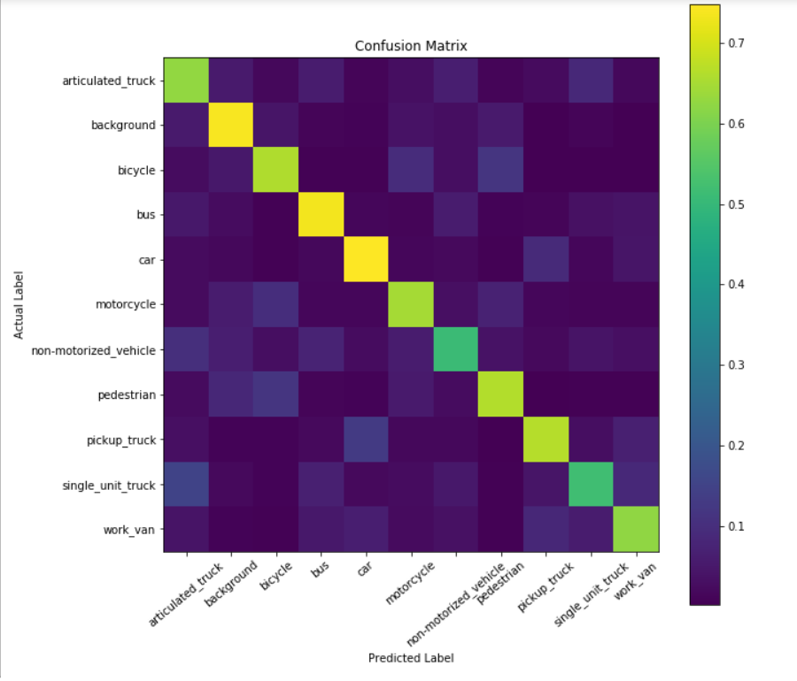

1. *Confusion Matrix of SVM.*

The confusion matrix demonstrates the accuracy and recall of the SVM validation on the training data. The y-axis represents the actual label of the training image, and the x-axis represents the label that we predict using our SVM. The values along the diagonal are probabilities, describing the chance for the SVM to correctly classify the image label.

Observing the results in the confusion matrix (Fig. 1), we can see that the SVM has difficulties identifying non-motorized vehicles, as it has the lowest recall value of correct identification, at 0.511. Also, it can be deduced that non-motorized vehicles are most often predicted as an articulated truck, when even to the human eye has very similar shape.

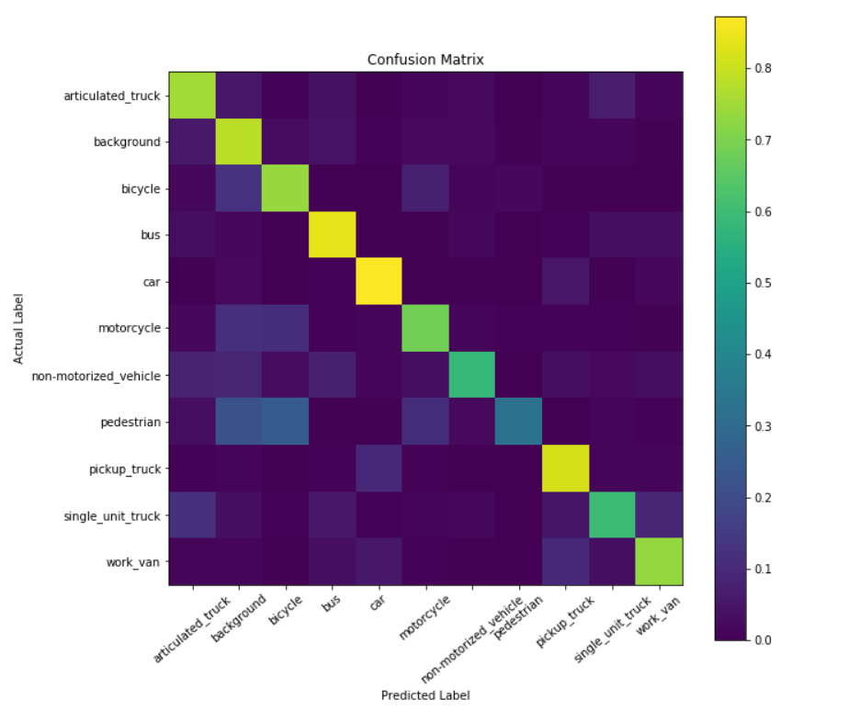

1. *Confusion Matrix of KNN.*

The confusion matrix of KNN shows us that it has trouble detecting pedestrians, as it classifies them as either background or bicycles. All three categories (bicycle, pedestrian, background) are categories that don’t show box shaped objects like cars, which would explain why they can be confusing to interpret. The general shape of a pedestrian is very similar to objects in a background (e.g. a pole); pedestrians can appear as a silhouette in background images. The shape of a human is also present in the bicycle images as a bicycle image intrinsically have a human in them.

To sum up our findings for the confusion matrices: the classes that are difficult for the SVM classifier are non-motorized vehicles and the classes that are difficult for the KNN classifier are pedestrians.

Moreover, to understand our cross-validation approach practically, we included a well-documented code along with this report.

# Localization

## Part 3 – Data and Localizer

In this part, we were asked to detect vehicles in several traffic images. Using a sliding window algorithm, HoG features were extracted from the traffic images and labeled via our classifiers from Part 2. The dataset for localization was different from the previous classification set. This dataset was called the MIO-TCD-Localization set. The localization dataset contained test and training images of 27,743 and 110,000 samples respectively. This gives a total of 137,743 samples in the localization set.

The approach taken to find a decent portion to train was implemented in two runs. The first run, we used the first 300 images of the entire training dataset because we assumed the data was randomized. The second run, we fetched the first 1000 images in the training set, then used the DICE coefficient to find the best 300 images. These are the images we decided to use, because we wanted to see what type of images best suit our localizer. The explanation and application for the DICE coefficient will be explained in Part 3.1.

The dataset was, this was done in two runs, we first used the first 300 images of the total dataset. For the first 1000, we then used the best 300 images

Describe the contents of the dataset (number of samples and bounding box size for each label, contents – **5pts**).

In order to identify where a vehicle was, we ran a sliding window through the images. We built our sliding window using three passes, a squared, a vertical rectangle (2:3) and a horizontal rectangle (3:2) window. This was done because some of the images, (e.g. bicycles) have more of a vertical aspect to them, whereas others (e.g. bus, articulated truck) have more of a horizontal aspect to them. Our sliding window has 60% overlap, an area of 3600 pixels squared with a scale factor of 1.4. We chose 60% overlap because we wanted our window to be computationally fast while maintaining the image information as much as possible. We chose an area of 3600 pixels squared for the smallest window (starting) because the smallest images in our training set through our classifiers had features around that size. We chose a scale factor of 1.4 because we wanted our sliding window to stay within the image’s boundaries while scaling the sliding window as it gets closer to the camera of an image.

The theory behind implementing our sliding window was that when analyzing the vehicles, the ones that are located at the top of an image (further in the image) seemed smaller in pixel space compared to vehicles at the bottom (closer) of an image, which seemed bigger. As a result, we scaled our sliding windows to grow proportionally along the y-axis.

The localizer was based on the intersection between the SVM classifier and the KNN classifier. For a given sliding window, if both of the classifiers return the exact same label, then we can assume that an object was present, and we would save the position and dimension of this sliding window to compare with the ground truth bounding boxes. The reason why we chose to do this is because individually both classifiers had a lot of false positives. However, if we analyze them together we were able to filter out the false positives and keep most of the true positives. This will yield a better result. Additionally, we decided to reject all background and pedestrian images. We rejected background images since they are not vehicles and pedestrian images because they are too noisy. Also, since pedestrian images look similar to background images, it gave too many false positives, even when using both classifiers. Reflecting on our project, we would have trained our classifiers with more background and pedestrian images in order to differentiate both of them accurately.

What localizer did we use (describe the localization method – **10pts**), why and how? **AND** describe the method from the input images to the set of output bounding boxes.

## Part 3.1 - Localizer Evaluation

We evaluated our localizer by computing the DICE coefficient for the predicted vs. true bounding boxes. DICE coefficient is a measure of overlap between two images; a predicted bounding box and the ground truth bounding box. This measure ranges from 0 to 1, where 1 indicates perfect and complete overlap [5]. Equation (1) can be used to compute the DICE coefficient. [! insert equation] and explain equation, parameters.

Moreover, the true bounding boxes were obtained from the csv file (gt_train) that was provided with the training images. This file contained labels and coordinates of all the predicted boxes for each image. We decided to compute 75 boxes (why 75?) in one image. For every predicted rectangle, we computed the DICE coefficient and compared it with all the possible combinations in the ground truth. In order to find a complete and perfect corresponding image between the ground truth and bounding box, we matched the combination that would maximize the mean DICE (how did we match?)

**(10pts)** Report the distribution of DICE coefficients over our validation sets. (make a graph and table)

**(10pts)** In order to evaluate our classifier, we used the localization predicted by our localizer. The following metrics were obtained: the accuracy, the prediction, and the recall of our localizer and classifier can be found on Table II.

1. Localization Metrics

| Images | Accuracy | Standard dev. | Precision | Recall |
| --- | --- | --- | --- | --- |
| Random 300 | 0.460 | 0.042 | 0.112 | 0.338 |
| Best 300 | 0.586 | 0.055 | 0.297 | 0.645 |

*Accuracy, prediction and recall of localizer + classifier*

Explain the values obtained above? (we should mention, where our localizer performs best on what type of images, what type of vehicle, what type of features, and why – maybe mention the time of day)

Next, compare values with the values in table I (is it classification data+classifier) – When comparing our localizer and classifier with the classification data and classifier (Table 1) …

* The accuracy of our localization and classifier was: …, whereas the accuracy of the classification data and classifier was: …
* The prediction of our localization and classifier was: …, whereas the prediction of the classification data and classifier was: …
* The recall of our localization and classifier was: …, whereas the recall of the classification data and classifier was: …

By analyzing our results, we can see that there is (or not) a difference between the accuracy, prediction and recall because … (why or why not?). Should the 'background' label of the classifier be included when evaluating the performance of the localizer, and why/why not?

We also used cross-validation (describe your cross-validation approach - **5pts**).

**Include well-documented code (5pts)**. Finally, to understand our localization approach practically, we included a well-documented code along with this report.

# Deep Learning (Bonus) – Part 4

* Schematic of architecture **(1pt)**
* Description of training **(2pts)**
* Evaluation of performance (as described in the relevant tasks’ section) **(1pt)**
* Description of validation **(3pts)**
* Comparison with the methods from Sections 2 and 3 **(1pt)**
* Code with a description of the environment **(2pts)**

# Conclusion

The following project allowed us to dive into machine learning by understanding how to train a program using a classification and localization algorithm. The initial part of this experiment was to train a support vector machine classifier (SVM) in order to classify given images to 11 categories. What did we find in classification, anything significant? Finally, we implemented a localization method, using ___ localizer. We were able to classify the images and localize the objects using bounding boxes. Our code is also included with the report for reference.

References

1. MIO-TCD. (2018). Retrieved from http://podoce.dinf.usherbrooke.ca/challenge/dataset/
2. Patel, S. (2018). Chapter 2 : SVM (Support Vector Machine) — Theory – Machine Learning 101 – Medium. Retrieved from https://medium.com/machine-learning-101/chapter-2-svm-support-vector-machine-theory-f0812effc72
3. Dalal, N. and Triggs, B., “Histograms of Oriented Gradients for Human Detection,” IEEE Computer Society Conference on Computer Vision and Pattern Recognition, 2005, San Diego, CA, USA.
4. RBF SVM parameters — scikit-learn 0.20.1 documentation. (2018). Retrieved from https://scikit-learn.org/stable/auto_examples/svm/plot_rbf_parameters.html
5. Jordan, J. (2018). An overview of semantic image segmentation. Retrieved from https://www.jeremyjordan.me/semantic-segmentation/#loss

Appendix

###### Appendix I: HoG Sample

