**How do I Complete this Project?**

This project is connected to the [Intro to HTML and CSS course](https://www.udacity.com/course/viewer#!/c-ud304-nd) but depending on your background knowledge of HTML and CSS you may not need to take the whole thing to complete this project. Here's what you should do:

1. Download the design mockup file from the Downloadables section to your lower right hand corner and review it.
2. Identify the various boxes you will need to build in order to recreate this design.
3. Write your HTML and CSS files, continue to iterate until your work is representative of the design mockup.
4. Take the time to personalize your portfolio with custom colors, additional content and your own images.
5. Validate your HTML and CSS against the [W3C's Validators](http://validator.w3.org/). *Note: the validators consider the following errors, whereas Udacity accepts these errors as acceptable:*
   * HTML5: **Bad value X-UA-Compatible for attribute http-equiv on element meta** when using the X-UA-Compatible meta tag.
   * CSS3: **Property *[some property here]* is an unknown vendor extension** when using vendor prefixed properties (like -moz-box-sizing).

## Evaluation

Your project will be evaluated by a Udacity Code Reviewer according to the rubric below. Be sure to review it thoroughly before you submit. All criteria must "meet specifications" in order to pass.

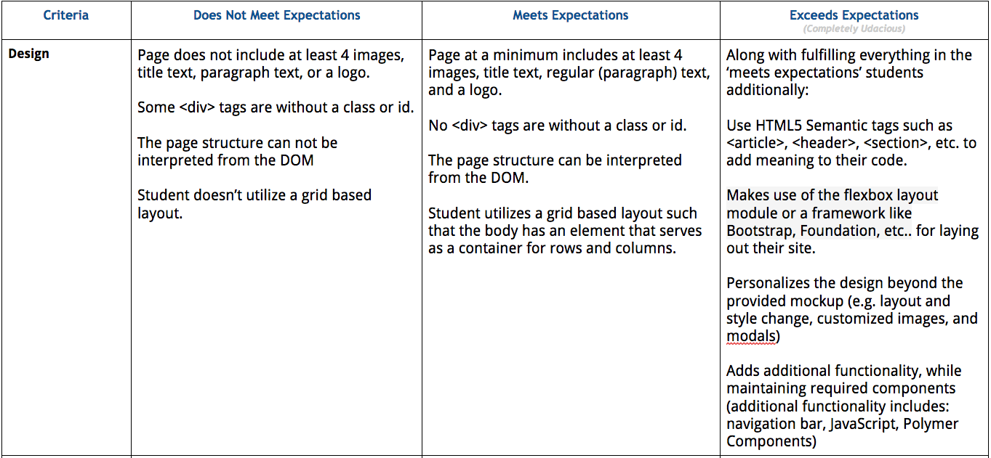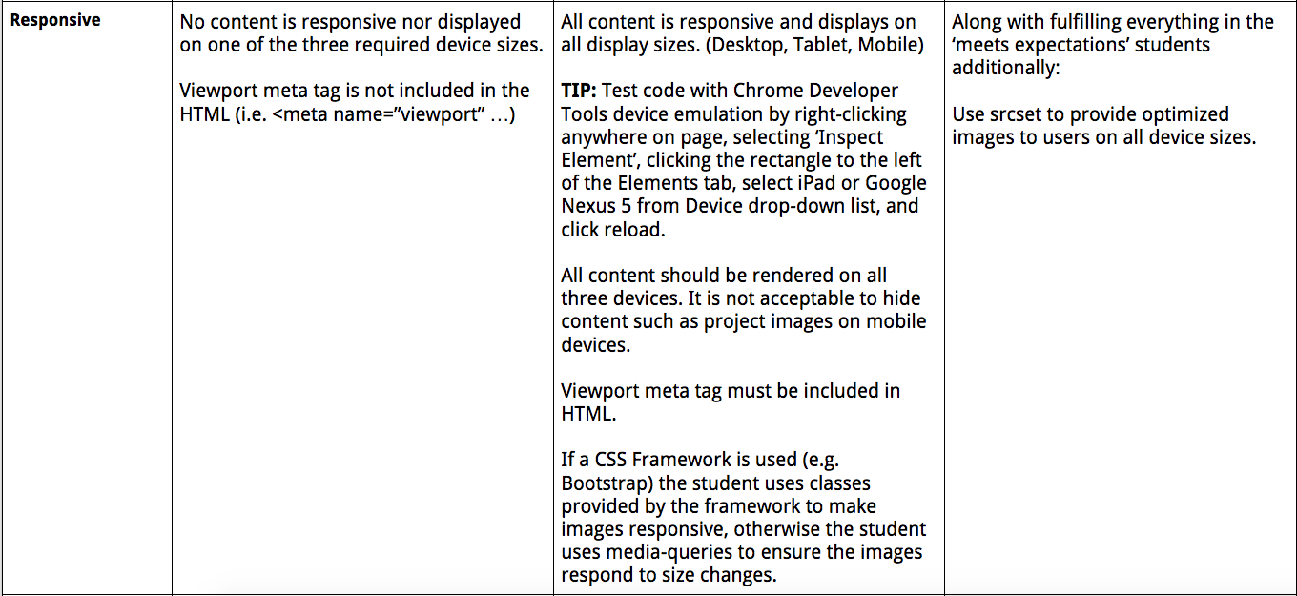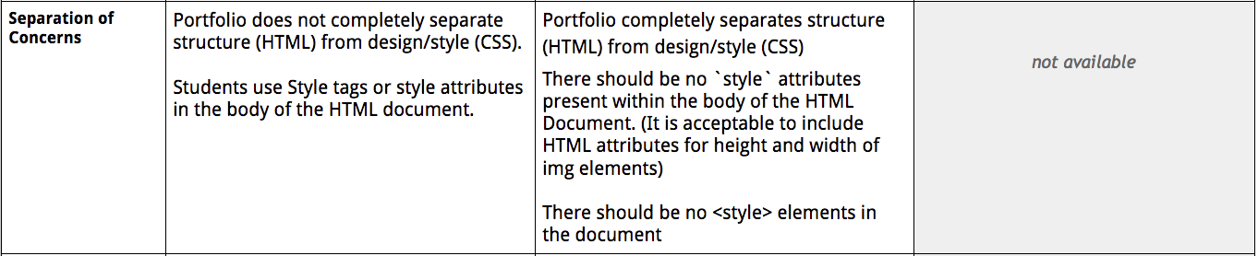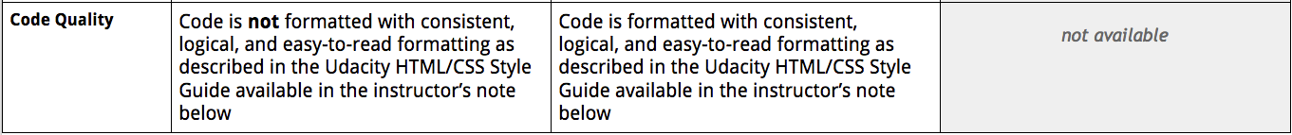

## Style Guidelines

### CSS REQUIRED Rules

* CSS - Use consistent indentation (tabs or spaces). (See: CSS General Formatting Rules-Indentation)
* CSS - Selectors, properties and property values (with the exception of strings) should be lowercase, including letters in hexadecimal color values. For example #f06c13 instead of #F06C13 and #ccc rather than #CCC. (See: CSS-General Formatting Rules-Capitalization.)
* CSS - Use IDs and class names that are meaningful or generic. (See: CSS-ID and Class Naming.)
* CSS - Use ID and class names that are as short as possible but as long as necessary. (See: CSS-ID and Class Naming.)
* CSS - Use Shorthand properties in all possible places for margin, border, padding, background. Examples:<https://developer.mozilla.org/en-US/docs/Web/CSS/Shorthand_properties>. (See: CSS Style Rules-Shorthand Properties.)
* CSS - Indent block content between curly braces. (See: CSS Formatting Rules-Block Content Indentation.)
* CSS - End all declarations with a semicolon. (See: CSS Formatting Rules-Declaration Stops.)
* CSS - Add single spaces after each property name’s colon (See: CSS Formatting Rules-Property Name Stops.)
* CSS - Remove trailing white spaces from code. (See: CSS General Formatting Rules-Trailing Whitespace)
* CSS - there should be a single space after each colon. (See: CSS Formatting Rules-Property Name Stops.)
* CSS - Include a single space before the opening curly brace. (See: CSS-Declaration Block Separation.)
* CSS - ID and class names should not be used with type selectors. (See Style Guide: CSS Style Rules-Type Selectors.)
* CSS - Separate style rules with a blank line. (See: CSS-Rule Separations.)

### CSS SUGGESTED Rules

* CSS - Remove units of measure after 0 values. (See: CSS Style Rules-0 and Units.)
* CSS - Use leading zeros for values in the code. (See: CSS Style Rules-Leading 0s.)
* CSS - Use 3 character hexadecimal notation for color in all possible places. For example #ccc rather than #cccccc. (See: CSS Style Rules-Hexadecimal Notation.)
* CSS - Separate words in ID and class names with a hyphen. (See: CSS Style Rules-ID and Class Name Delimiters.)
* CSS - Remove CSS hacks or user detection from code. (See: CSS Style Rules-Hacks.)
* CSS - Separate selectors and declarations with new lines. (See: CSS-Selector and Declaration Separation.)
* CSS - Use double quotes for all attribute selectors and property values. (See: CSS Formatting Rules-CSS Quotation Marks.)
* CSS - Identify groups of related style rules with section comments. (See: CSS Meta Rules-Section Comments.)

### HTML REQUIRED Rules

* HTML - Element and attribute names should all be lowercase. (See: Capitalization.)
* HTML - Use HTML5. (See: HTML Style Rules-Document Type.)
* HTML - Use UTF-8 as character encoding. (See: General Meta Rules-Encoding.)
* HTML - Place all block/list/table elements on a separate line and indent child elements. (See: HTML-General Formatting.)
* HTML - Use semantic tags. (See: HTML Style Rules-Semantics.)
* HTML - Provide alternate content for multimedia. (See: HTML Style Rules-Multimedia Fallback.)
* HTML - Remove trailing white spaces from code. (See: HTML - General Formatting Rules - Trailing Whitespace.)
* HTML - Use consistent indentation (tabs or spaces) (See HTML - General Formatting Rules - Indentation)

### HTML SUGGESTED Rules

* HTML - Use comments to explain the code. (See: General Meta Rules-Comments.)
* HTML - Mark action items with TODO. (See: General Meta Rules-Action Items.)
* HTML - Remove entity references. (See: HTML Style Rules-Entity References.)
* HTML - Remove type attribute from link and script elements. (See: HTML Style Rules-Type Attributes.)
* HTML - Use double rather than single quotation marks for attribute values. (See: HTML-HTML Quotation Marks.)

## Submission

When you're ready to submit your project go back to your [Udacity Home](https://www.udacity.com/me" \t "_blank), click on Project 1, and we'll walk you through the rest of the submission process.

If you are having any problems submitting your project or wish to check on the status of your submission, please email us at **frontend-project@udacity.com** or visit us in the [discussion forums](http://discussions.udacity.com/).

## What's Next?

You will get an email as soon as your reviewer has feedback for you. In the meantime, review your next project and feel free to get started on it or the courses supporting it!