**ΑΣΚΗΣΗ 1**

**Ερώτημα 1**

Οι πίνακες της βάσης δεδομένων και οι μεταξύ τους σχέσεις:

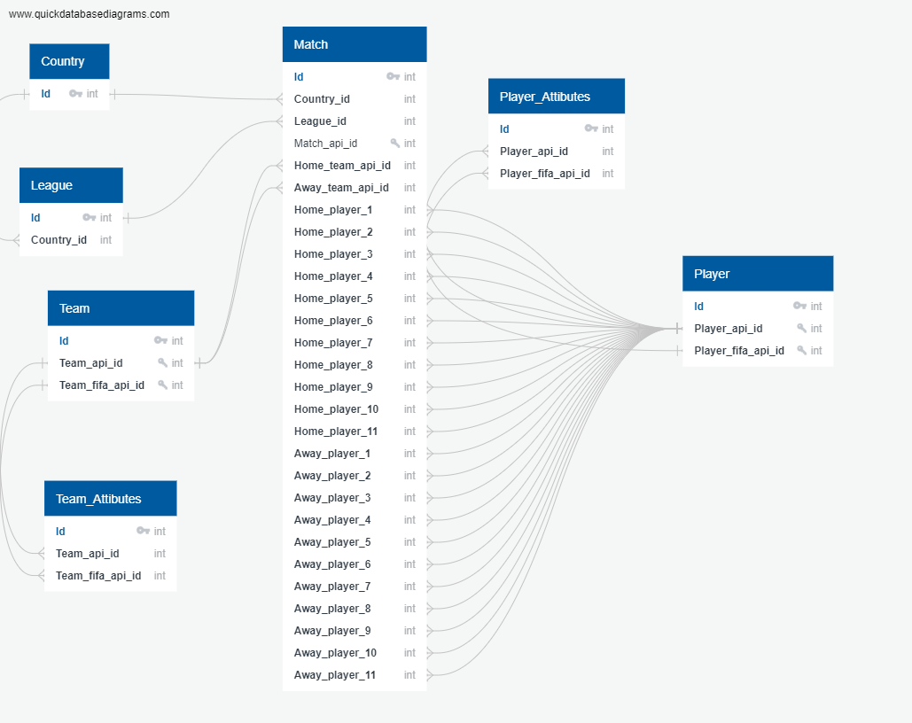

**Ερώτημα 2**

**a.** SELECT player_name, height, weight FROM Player WHERE height>160 AND height<180 ORDER BY weight DESC;

**b.** SELECT Match.date, Team.team_long_name AS home_team_name, Match.home_team_goal FROM Match JOIN Team ON Match.home_team_api_id=Team.team_api_id WHERE match_api_id=659039;

**c.** SELECT DISTINCT Team.team_long_name, Country.name FROM Team JOIN Match JOIN Country ON Match.home_team_api_id=Team.team_api_id AND Match.country_id=Country.id;