**VADs**

In current VADs, the blood comes into contact with the artificial surface thereby leading to problems like coagulation. A new VAD can be designed using the existing IABP(Intra Aortic Balloon Pump) by wrapping it around the heart.

**Using the IABP as a VAD**



Fig 1:The IABP coiled around to form a spiral

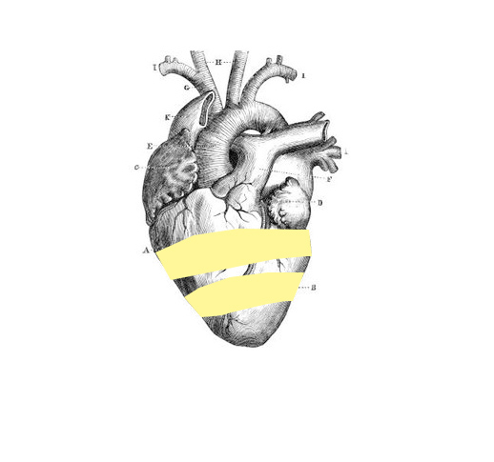

Fig 2:IABP wrapped around the ventricle in a spiral shape

The first step is to test the IABP by modifying it to function as a VAD.The IABP would be bent and coiled in a spiral manner around the weakened portion(ventricular region) on a model of the heart.It would then be expanded rhythmically in order to exert pressure and thereby contract the heart.This would improve the ejection fraction while not interfering with the circulation itself.

The next step is to ensure that the IABP expands in tandem with the heart.The rate of expansion would be programmatically controlled by synchronising it with a locally acquired ECG signal.

**Concerns:**

The fluid in the IABP must be biocompatible.

Should the IABP rupture,it should not cause an embolism.