Alberth Matos
17 March 2026
Lab 1 report
CYOP 300 - BUILDING SECURE WEB APPLICATIONS

Executive Summary
This lab consists of my attempt at creating a voter registration offer system, suitable for use via terminal to query the user for their age and nationality, and, if they are in the range 18 >= age <= 120, offer to register them. In the case where age is >= 100, but <= 120, we ask them to confirm their age. If age is > 120, we reject the registration attempt, and direct the user to a local official.
Full, detailed, test coverage for all modules are included in test_lab1.py, and were run using pytest.
No particular issues were encountered in the lab. The only 3rd party package used was pytest, which is specified in the lab’s requirements.txt.
Of note, the requirements did not state whether a full address should be captured. Accordingly, for the output, I chose a fictional street address and city.

Testing

Test Case Table
Test Cases | Description | Expected Output | Actual Output | Pass/Fail
Test Case 1 | Age: 16 | Message about user too young to register. | You are not yet old enough to vote. Please return when you are 18 years of age or older. | Pass
Test Case 2 | Age: 18  Nationality: USA  First Name: FirstName  Last Name: LastName  State: AK  Zip: 12345  Register: y | Registration confirmation printed, along with mailing label. | Your voter registration is as follows:  Name: FirstName LastName  Age: 18  State of residency: Alaska (AK)  Zipcode: 12345  Country of citizenship: UNITED STATES  Your voter registration has been submitted. You should receive your voter registration card within 3 weeks.  ********************************************************************************  The mailing label for your voter registration card is:  FirstName LastName  123 main street  Anytown, AK 12345 | Pass
Test Case 3 | Age: 101  Confirm age: y  Nationality: United States  First Name: First  Last Name: Last  State: me  Zip: 12345  Register: y | Registration confirmation printed, along with mailing label. | Your voter registration is as follows:  Name: First Last  Age: 101  State of residency: Maine (ME)  Zipcode: 12345  Country of citizenship: UNITED STATES  Your voter registration has been submitted. You should receive your voter registration card within 3 weeks.  ********************************************************************************  The mailing label for your voter registration card is:  First Last  123 main street  Anytown, ME 12345 | Pass
Test Case 4 | Age: 101  Confirm age: y  Nationality: uk | Message that as not a US citizen, user is ineligible to vote. | Sorry, you are not a US citizen. You are not eligible to vote. | Pass

Test Case Screenshots

Test Case 1

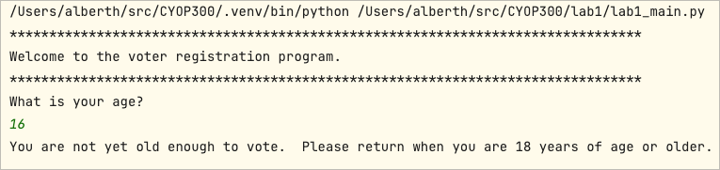

Test Case 2

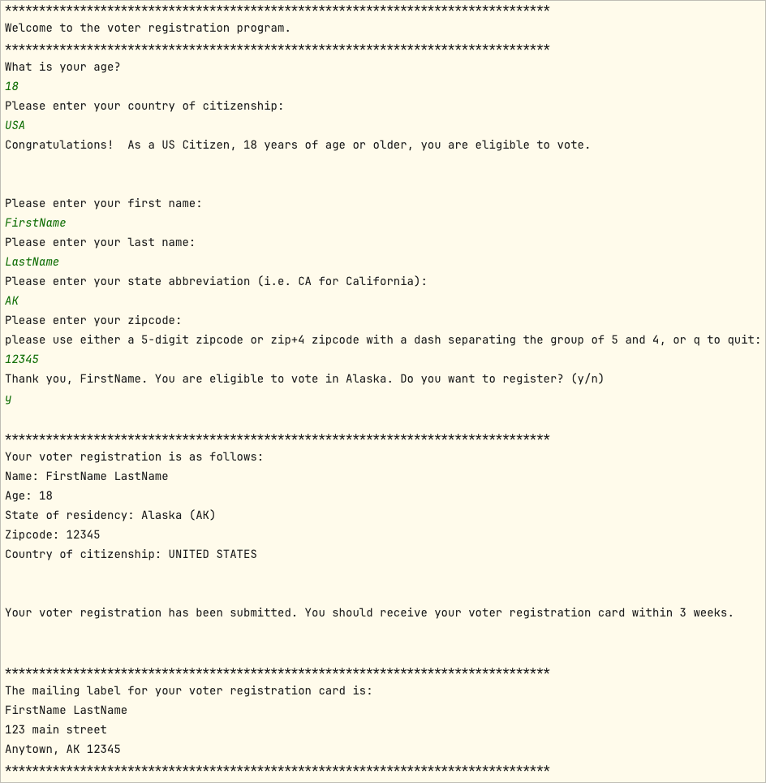

Test Case 3

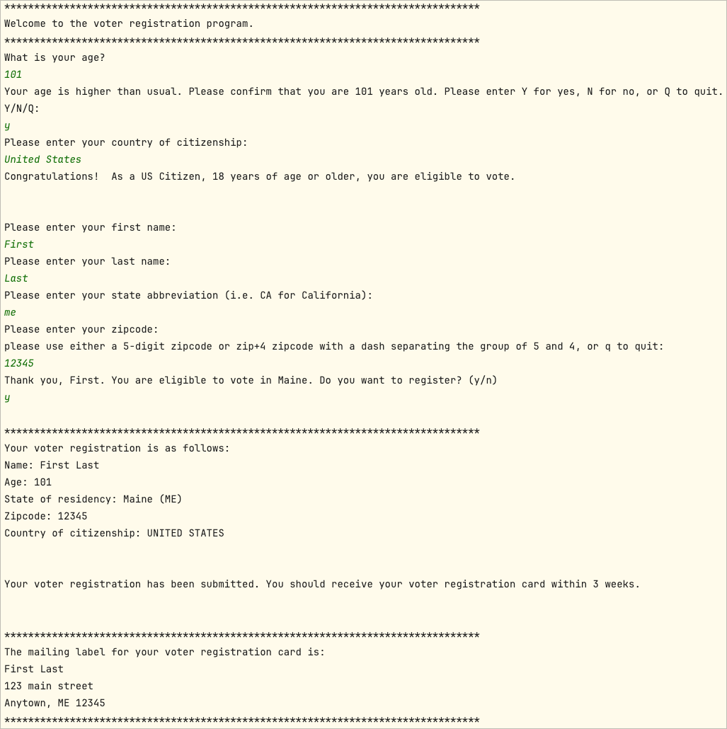

Test Case 4

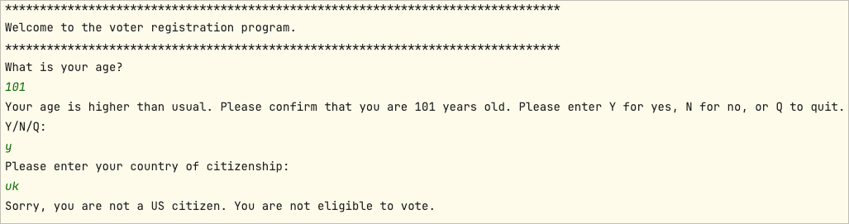

Pylint Results
