Alberth Matos
24 March 2026
Lab 2 report
CYOP 300 - BUILDING SECURE WEB APPLICATIONS

Executive Summary
Attached is my submission for lab 2. While no particular difficulties were encountered, there are a few items that I would like to discuss in my submission.
First, I included type hints throughout the project. In day-to-day work, I find that type hints help resolve questions before they turn into problems.
Second, I split out the sections of code that were more complicated from the main main.py code. These include a common methods package, the prompt user for input code, as well as the password generation code.
Third, I used a python module to handle presenting a menu and parsing user input.
For the calculation of the number of days from today to July 4th, 2025, I chose to present the text indicating that the date was in the past, formatted that it was X days ago. The code handles both dates that occur in the past, as well as future dates.
For the volume of the cylinder, I prompt the user for the numerical value, as well as the (metric) units. The result, however, is presented only in mm³.
Full unit tests were generated, and are included in the project zip file.

Testing

Test Case Table
Test Cases | Description | Expected Output | Actual Output | Pass/Fail
Test Case 1 | Generate password of:  Length -1  Upper y  Lower y  Digits y  Special y | Invalid password length | Invalid input: Password length is too short for the selected complexity. | pass
Test Case 2 | Generate password of:  Length 128  Upper y  Lower y  Digits y  Special y | Randomly generated password of desired length | Your secure password is: 4,5;Q<0Ycen.fDc:G7Yk!1{G(6U&w!2^E]uMwrglw=.6@{o&f&aJq,2si\]+9.hssYgt2mwiEmb3(!4'8F8y{Ye7x"21rb@BD>,Wt`R:;C5%~B1K0si`kD.RQ6+]ragg  Your password consists of:  24 upper characters  42 lower characters  22 digits characters  40 special characters
Test Case 3 | Generate password of:  Length 1025  Upper y  Lower y  Digits y  Special y | Randomly generated password of desired length | Your secure password is: JzJv3xz853>YS%$f;)Y'%K%0(F0,eyfbsz%1+w222CTENK|z5wU"vdqggpuju-|ei[{a;'<9~JwV=y9nc}?fOhKp;QW"]99$hur+>"bL8'dcg+pZ^&*&cd7Yx;#aEi',.p*g?1;k7%:KDqQCu^_q.jFkb|H|;@*,1%[3=!k{;+/)p"s6rM7._?EPuYm&#Rt%nmAEZg0=v0lZpr|}!&YV,/Ix6Y:R;aiJ_pOg&#?2y8c9o_nwt[Q2u#lVW+tu*<5<]7&=XKBzB%KrK7+s&xE?*E(n#F]'F{Aa%Ie_Z`^A]=#}]o[)g:T'~L&Z*@n;"n|hE}]PeRsYTX*XNL#$!;[p<KUS,qoF^1:NJzT#wKY=>36##4S:U=~+syHg|#OHdhhJ]?2C#<0YC.wf\|.f"_f_Z~?P7_2AP-$~jWEeV0MMqnv~wv-MuN;y5doyc<~JGgaooJ6G8U@o;?a-oxU\q=dS4CYkaPAe>Y+??GeDOwuRUP)#mP`H~[&Qf{jL0t<cfV%OzT=H>(QS8pRQ=**#c*ctY_^SrHmnU&0YCBusq"_wVw},O;,sKbAU.8gLySMZ4&O@y@EEl6g;YVVB)xl*4,%J'Oy!wOomj#ZM[3RtYS@f]u<CO1%tM)Qo/i[D%|L6uB.[tP*]D$z"9t$UJQJy;h.+}u%~r%]^FTgnMr(doy7Z~?|twCOIA:$&_{=M;s.#"iS>Uclt,99.qu6kbqfk+r2nCKX=j0V]_J",ta(bge=lJZfzm_Z)WG:{P<c+7Egy\AV.%L;WJv&^izPypvAxw\YD9<?!e%**z?kA5b^AbdRFf3^r@pj`ti!&hd[g)9:5[*//KhM,_5<fu}vRfcRq@~_Z>Zk/QZnp^Z3qRqFc77k?TB~^JGNS\:3+u+B+pm}rq15ePwG~Yww#u!VER7!KV/o[=IC:_,BPb^^;I$1C6>S%%xd1=3A`Dg/qfBk\9f>>*D>AGWrH\4?2JeYl),%Kk:mDw>a%WL~L<z>#x;|=;P:D,s*`mWu5r[#g*h|{bW7.JhL;n  Your password consists of:  267 upper characters  298 lower characters  86 digits characters  374 special characters
Test Case 4 | Generate password of:  Length 20  Upper y  Lower n  Digits n  Special n | Randomly generated password of desired length | Your secure password is: GSZKXJXLHYYAOEQGEAEQ  Your password consists of:  20 upper characters  0 lower characters  0 digits characters  0 special characters
Test Case 5 | Generate password of:  Length 20  Upper y  Lower n  Digits y  Special y | Randomly generated password of desired length | Your secure password is: I/_.|@A?F;|4<JG5H/$I  Your password consists of:  7 upper characters  0 lower characters  2 digits characters  11 special characters
Test Case 6 | Calculate percentage:  Numerator 59  Denominator 12  Decimal 4 | 59/12=4.9167, so, 491.6667% | 59.0/12.0 = 491.6667 %
Test Case 7 | Calculate percentage:  Numerator 0  Denominator 12  Decimal -4 | Error message that the number of decimal spaces cannot be negative | Error: Decimal places cannot be negative.
Test Case 8 | Calculate percentage:  Numerator 59  Denominator 0  Decimal 4 | Error message that the denominator cannot be zero | Error: Decimal places cannot be negative.
Test Case 9 | Days from 7/4/25 | 263 days ago | July 4, 2025 occurred 263 days ago.
Test Case 10 | Calculate triangle:  Leg 1: 15  Leg 2: 45  Angle: 50 | $$\sqrt{a^{2}+b^{2}-\left(2ab\cos{C}\right)}$$  = 37.18 | The length of the leg of the triangle is: 37.18
Test Case 11 | Calculate triangle:  Leg 1: 45  Leg 2: 45  Angle: 90 | $$\sqrt{a^{2}+b^{2}-\left(2ab\cos{C}\right)}$$  = 63.64 | The length of the leg of the triangle is: 63.64
Test Case 12 | Calculate triangle:  Leg 1: no value provided | Error message that a value is required. | Invalid input. Please enter a valid float.
Test Case 13 | Volume of right cylinder:  Radius: 1m  Height: 39cm | Calculated volume at 12.25 mm³ | The volume of the cylinder is: 12.25 mm^3
Test Case 14 | Volume of right cylinder:  Radius: 1km  Height: 39mm | Calculated volume at 1,225,221.13 mm³ | The volume of the cylinder is: 1225221.13 mm^3
Test Case 15 | Exit the program | Program exits with a thank you message.

Test Case Screenshots

Test Case 1

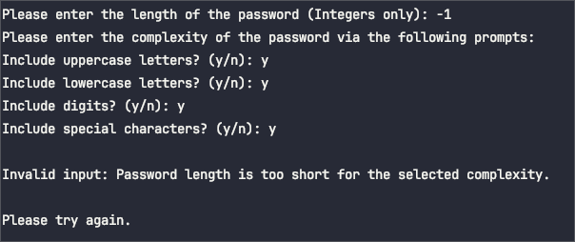Test Case 2

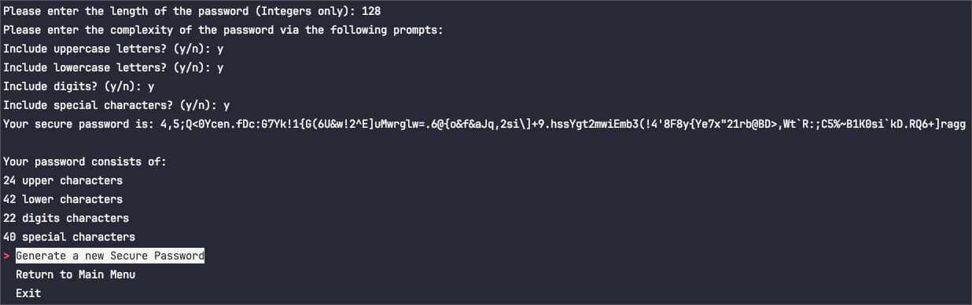Test Case 3

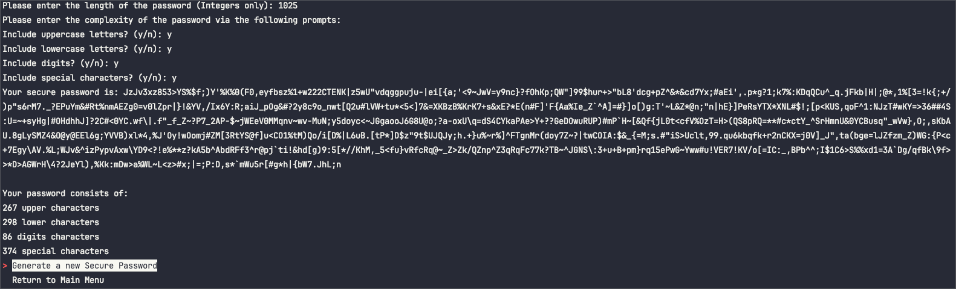

Test Case 4
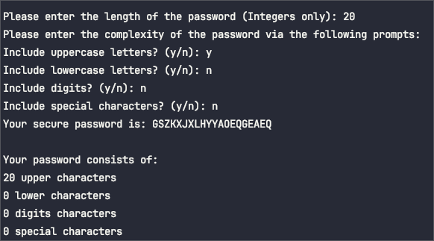

Test Case 5
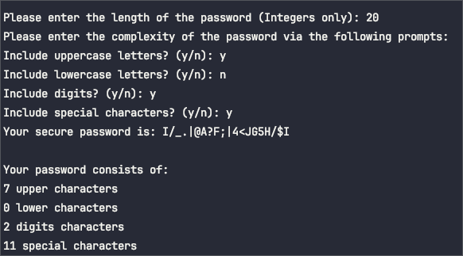

Test Case 6
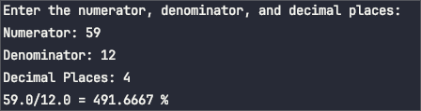

Test Case 7
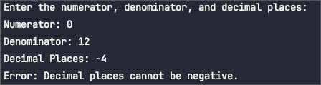

Test Case 8
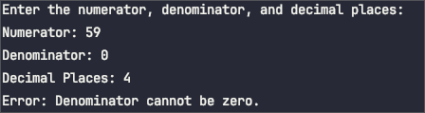

Test Case 9

Test Case 10
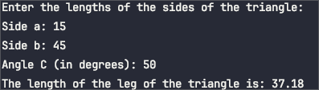

Test Case 11
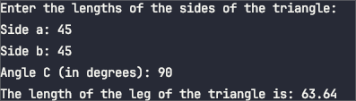

Test Case 12
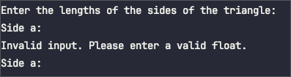

Test Case 13
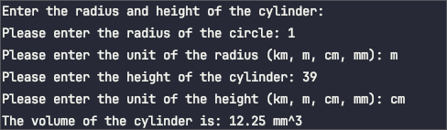

Test Case 14
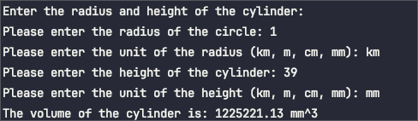

Test Case 15

Pylint Results
************* Module lab2.lab2prompt
lab2prompt.py:10:0: C0301: Line too long (155/100) (line-too-long)
************* Module lab2.main
main.py:41:4: W0105: String statement has no effect (pointless-string-statement)
main.py:80:4: W0212: Access to a protected member _Prompt of a client class (protected-access)
main.py:114:4: W0212: Access to a protected member _Prompt of a client class (protected-access)
main.py:147:4: W0212: Access to a protected member _Prompt of a client class (protected-access)
main.py:185:4: W0212: Access to a protected member _Prompt of a client class (protected-access)
main.py:214:4: W0212: Access to a protected member _Prompt of a client class (protected-access)
main.py:200:12: W0612: Unused variable 'radius_unit' (unused-variable)
main.py:201:12: W0612: Unused variable 'height_unit' (unused-variable)
main.py:252:4: W0212: Access to a protected member _Prompt of a client class (protected-access)
************* Module lab2.lab2passwd
lab2passwd.py:10:0: C0301: Line too long (155/100) (line-too-long)
lab2passwd.py:24:0: C0301: Line too long (101/100) (line-too-long)
************* Module lab2.lab2common
lab2common.py:10:0: C0301: Line too long (155/100) (line-too-long)
lab2common.py:54:0: C0301: Line too long (105/100) (line-too-long)
lab2common.py:55:0: C0301: Line too long (107/100) (line-too-long)
lab2common.py:57:0: C0301: Line too long (104/100) (line-too-long)
lab2common.py:61:0: C0301: Line too long (104/100) (line-too-long)
lab2common.py:70:8: R1723: Unnecessary "elif" after "break", remove the leading "el" from "elif" (no-else-break)
************* Module lab2.tests.test_lab2passwd
tests/test_lab2passwd.py:1:0: C0114: Missing module docstring (missing-module-docstring)
tests/test_lab2passwd.py:10:0: C0116: Missing function or method docstring (missing-function-docstring)
tests/test_lab2passwd.py:27:0: C0116: Missing function or method docstring (missing-function-docstring)
tests/test_lab2passwd.py:41:0: C0116: Missing function or method docstring (missing-function-docstring)
tests/test_lab2passwd.py:48:0: C0116: Missing function or method docstring (missing-function-docstring)
************* Module lab2.tests.conftest
tests/conftest.py:1:0: C0114: Missing module docstring (missing-module-docstring)
tests/conftest.py:10:4: C0116: Missing function or method docstring (missing-function-docstring)
tests/conftest.py:5:0: R0903: Too few public methods (1/2) (too-few-public-methods)
************* Module lab2.tests.test_lab2common
tests/test_lab2common.py:1:0: C0114: Missing module docstring (missing-module-docstring)
tests/test_lab2common.py:8:0: C0116: Missing function or method docstring (missing-function-docstring)
tests/test_lab2common.py:18:0: C0116: Missing function or method docstring (missing-function-docstring)
tests/test_lab2common.py:28:0: C0116: Missing function or method docstring (missing-function-docstring)
tests/test_lab2common.py:39:0: C0116: Missing function or method docstring (missing-function-docstring)
************* Module lab2.tests
tests/__init__.py:12:0: C0115: Missing class docstring (missing-class-docstring)
tests/__init__.py:13:4: C0116: Missing function or method docstring (missing-function-docstring)
************* Module lab2.tests.test_lab2prompt
tests/test_lab2prompt.py:1:0: C0114: Missing module docstring (missing-module-docstring)
tests/test_lab2prompt.py:6:0: C0116: Missing function or method docstring (missing-function-docstring)
tests/test_lab2prompt.py:7:4: C0115: Missing class docstring (missing-class-docstring)
tests/test_lab2prompt.py:11:8: C0116: Missing function or method docstring (missing-function-docstring)
tests/test_lab2prompt.py:7:4: R0903: Too few public methods (1/2) (too-few-public-methods)
tests/test_lab2prompt.py:16:13: W0212: Access to a protected member _Prompt of a client class (protected-access)
tests/test_lab2prompt.py:21:0: C0116: Missing function or method docstring (missing-function-docstring)
tests/test_lab2prompt.py:24:4: C0115: Missing class docstring (missing-class-docstring)
tests/test_lab2prompt.py:28:8: C0116: Missing function or method docstring (missing-function-docstring)
tests/test_lab2prompt.py:24:4: R0903: Too few public methods (1/2) (too-few-public-methods)
tests/test_lab2prompt.py:33:13: W0212: Access to a protected member _Prompt of a client class (protected-access)
tests/test_lab2prompt.py:39:0: C0116: Missing function or method docstring (missing-function-docstring)
tests/test_lab2prompt.py:46:8: W0212: Access to a protected member _Prompt of a client class (protected-access)
tests/test_lab2prompt.py:49:4: W0212: Access to a protected member _Prompt of a client class (protected-access)
tests/test_lab2prompt.py:54:0: C0116: Missing function or method docstring (missing-function-docstring)
tests/test_lab2prompt.py:61:24: W0212: Access to a protected member _Prompt of a client class (protected-access)
tests/test_lab2prompt.py:71:4: W0212: Access to a protected member _Prompt of a client class (protected-access)
tests/test_lab2prompt.py:1:0: W0611: Unused import pytest (unused-import)
************* Module lab2.tests.test_main
tests/test_main.py:1:0: C0114: Missing module docstring (missing-module-docstring)
tests/test_main.py:10:0: C0116: Missing function or method docstring (missing-function-docstring)
tests/test_main.py:23:8: W0212: Access to a protected member _Prompt of a client class (protected-access)
tests/test_main.py:36:0: C0116: Missing function or method docstring (missing-function-docstring)
tests/test_main.py:43:8: W0212: Access to a protected member _Prompt of a client class (protected-access)
tests/test_main.py:53:0: C0116: Missing function or method docstring (missing-function-docstring)
tests/test_main.py:60:8: W0212: Access to a protected member _Prompt of a client class (protected-access)
tests/test_main.py:70:0: C0116: Missing function or method docstring (missing-function-docstring)
tests/test_main.py:71:4: C0115: Missing class docstring (missing-class-docstring)
tests/test_main.py:78:8: W0212: Access to a protected member _Prompt of a client class (protected-access)
tests/test_main.py:87:0: C0116: Missing function or method docstring (missing-function-docstring)
tests/test_main.py:88:4: C0115: Missing class docstring (missing-class-docstring)
tests/test_main.py:95:8: W0212: Access to a protected member _Prompt of a client class (protected-access)
tests/test_main.py:104:0: C0116: Missing function or method docstring (missing-function-docstring)
tests/test_main.py:111:8: W0212: Access to a protected member _Prompt of a client class (protected-access)
tests/test_main.py:121:0: C0116: Missing function or method docstring (missing-function-docstring)
tests/test_main.py:126:8: W0212: Access to a protected member _Prompt of a client class (protected-access)
tests/test_main.py:137:0: C0116: Missing function or method docstring (missing-function-docstring)
tests/test_main.py:137:41: W0613: Unused argument 'monkeypatch' (unused-argument)
tests/test_main.py:146:0: C0116: Missing function or method docstring (missing-function-docstring)
tests/test_main.py:153:8: W0212: Access to a protected member _Prompt of a client class (protected-access)
tests/test_main.py:3:0: W0611: Unused import sys (unused-import)
-----------------------------------
Your code has been rated at 8.05/10
Run 2
************* Module lab2.lab2common
lab2common.py:10:0: C0301: Line too long (155/100) (line-too-long)
lab2common.py:54:0: C0301: Line too long (105/100) (line-too-long)
lab2common.py:55:0: C0301: Line too long (107/100) (line-too-long)
lab2common.py:57:0: C0301: Line too long (104/100) (line-too-long)
lab2common.py:61:0: C0301: Line too long (104/100) (line-too-long)
lab2common.py:70:8: R1723: Unnecessary "elif" after "break", remove the leading "el" from "elif" (no-else-break)
************* Module lab2.lab2passwd
lab2passwd.py:10:0: C0301: Line too long (155/100) (line-too-long)
lab2passwd.py:24:0: C0301: Line too long (101/100) (line-too-long)
************* Module lab2.lab2prompt
lab2prompt.py:15:0: E0401: Unable to import 'simple_term_menu' (import-error)
************* Module lab2.main
main.py:200:12: W0612: Unused variable 'radius_unit' (unused-variable)
main.py:201:12: W0612: Unused variable 'height_unit' (unused-variable)
-----------------------------------
Your code has been rated at 9.14/10
Run 3
************* Module lab2.lab2common
lab2common.py:82:8: R1723: Unnecessary "else" after "break", remove the "else" and de-indent the code inside it (no-else-break)
************* Module lab2.main
main.py:200:12: W0612: Unused variable 'radius_unit' (unused-variable)
main.py:201:12: W0612: Unused variable 'height_unit' (unused-variable)
------------------------------------------------------------------
Your code has been rated at 9.83/10 (previous run: 9.14/10, +0.69)
Run 4
************* Module lab2.main
main.py:200:12: W0612: Unused variable 'radius_unit' (unused-variable)
main.py:201:12: W0612: Unused variable 'height_unit' (unused-variable)
------------------------------------------------------------------
Your code has been rated at 9.89/10 (previous run: 9.83/10, +0.06)

