SLIDING PUZZLE

**A Classic 8-15 Puzzle Game**

# INSTRUCTIONS

**::: GAMEPLAY :::**

**Use mouse or keyboard keys (W, S, A, D) to move the puzzle tiles to the blank space.**

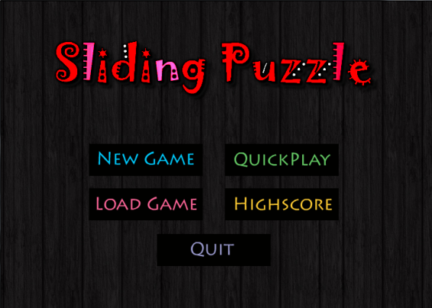

::: **Quick Play** :::

Difficulty level: VERY EASY

For absolute beginners; solve as many 3 x 3 puzzles as you can in 3 minutes.

**: SCORING SYSTEM FOR QUICKPLAY:**

**MOVE BONUS:** If a puzzle is solved in less than 10 moves, you’ll get move bonus 100.

**SCORE & TIME PENALTY**: If you get stuck, you can always get a new puzzle by using RESHUFFLE. However, that will cost you a time penalty of 10 seconds and minus 200 from your score.

::: **New Game** :::

It lets you choose from 3 different game modes.

No Time Limitations: Solve these puzzles at your own pace.

::: **3 x 3** ::: Difficulty level: EASY

::: **4 x 4** ::: Difficulty level: INTERMEDIATE

::: **5 x 5** ::: Difficulty level: HARD

::: **Load Game** :::

Loads the last saved game.

::: **Highscore** :::

Shows the top scores and timings for all games.

::: **Quit** :::

Ends the game.

*Happy Puzzling!*