## Exercise 1：

# Python requires far more than 4GB of RAM to process a 4GB list. This is because lists have many attributes, not just the values of the stored elements. A list will record the value, the data type, the reference number, and the position of the element in the list. Also, it is possible to creating backups of lists during the computing process. In addition, it is also possible that other software is taking up RAM. These are the possible reasons why RAM is running out.

I think the friend can use a computer with larger RAM or use a cloud server. And don't use list, use other data structures like array which only record values to store data.

For calculating the average, the code is modified to reduce RAM consumption by not using weights as variable to store value

## Exercise 2：

## Exercise 3：

First I expand the code to a binary tree and test the tree by using the given code.

文本

For sufficiently large in, n starts to flatten图表

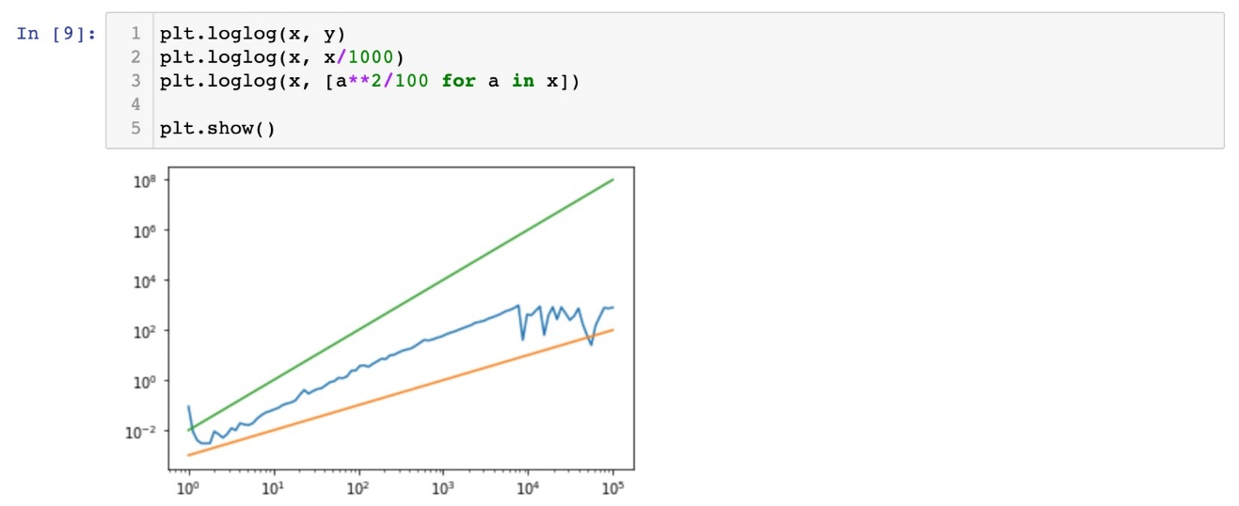

## Exercise 4：

Alg1 will change the position of a number when it is smaller than the previous one until the whole sequence is sorted.

Alg2 splits the entire array until there is only one smallest number in the list. Then two of the lists are compared and the smaller one is merged into the larger one. For the two lists that have been sorted, their minimum values are compared, and then the smaller one and the rest of the numbers are merged into the new list. By recursion, the whole array is sorted.

For data set 1, Algorithm 1 performs better when the data volume is small, but as the data volume becomes larger, Algorithm 2 outperforms Algorithm 1

For data set 2, Algorithm 1 performs better when data is sorted

For data set 3, Algorithm 2 performs better

Only on the ordered dataset, Algorithm 1 performs better. And on any data set, Algorithm 2 has stable performance, so for any other data set, I would prefer Algorithm 2.

Explanation of parallelization of alg2:

To parallelize alg2, we use the map function under multiprocessing. Pool (). After that, the data is divided into two parts and the two parts are sorted at the same time using parallel programming. Finally, we merge the two sorted sub lists together.

Implementation of merge sort in parallel:

# Code:

## Exercise 1:

## Exercise 2:

## Exercise 3:

