CANPiWi User guide

Putting the hardware together
[TODO: Ian document]

How it works

The CANPiWi is a module designed considering 2 major features:
- to allow the user control some aspects of the layout using the EngineDrive (ED) application without JMRI and using wireless connections.
- to allow other devices to interact with CBUS using the GridConnect protocol using wireless connections.

The module allows smartphones using EngineDrive or/and other devices using the GridConnect to connect to the module using the TCP/IP protocol. Once the devices are connected the module does the protocol translation from ED to CBUS and the other way around and also from GridConnect to CBUS in both directions.

The CANPiWi allows the connection via wifi in two modes:
- as access point mode (AP mode)
- or as client mode (WIFI mode)

In AP mode, the module is responsible to create a local TCP/IP network. Any device connected will be assigned a unique IP for that network via DHCP (Dynamic Host Configuration Protocol) service.

The module will announce the ED service on the IP 192.168.1.45, visible on the main ED screen.
In WIFI mode, the module has to connected to an existing router that will assign the module an ip address. The module will announce the ED service on that given ip.

The service announcement uses the Bonjour protocol. Bonjour is Apple's implementation of zero-configuration networking (zeroconf), a group of technologies that includes service discovery, address assignment, and hostname resolution.

Turning the module on
Once the module is powered, a red light will indicate that the module is energised and either the green led or the yellow led will be on. The green led on means that the module is in SLIM mode and is using the default configuration for node number and can id. The default values are:
node number = 4321
can id = 100

If none of the lights are on please check the troubleshooting section of this document.

If the module is proper powered and connected to a CBUS will generate an ON CBUS short event to indicate it is powered and operational. If the ED or GridConnect service is restarted it will generate an Off followed by an ON event.

Connecting
The connection changes depending on the mode the module is working. The module, by default comes with AP mode configured. To change that see the Configuration section.

AP mode
In AP mode the module will create a wifi ssid with name “CANPiWi” by default. The ssid name can be changed by modifying the configuration (see the configuration section). You should be able to see the ssid using any device that detects access point, like smartphone, tablets or PC/Laptops.
Use the device procedure to connect to a wifi network to connect to the “CANPiWi”. If the connection fails, try again, and if it still fails check the troubleshooting section.

Once connected you can open the ED in the smartphone. On the main screen of the ED there might be an entry for “MyLayout” on port 5555. See the image below.

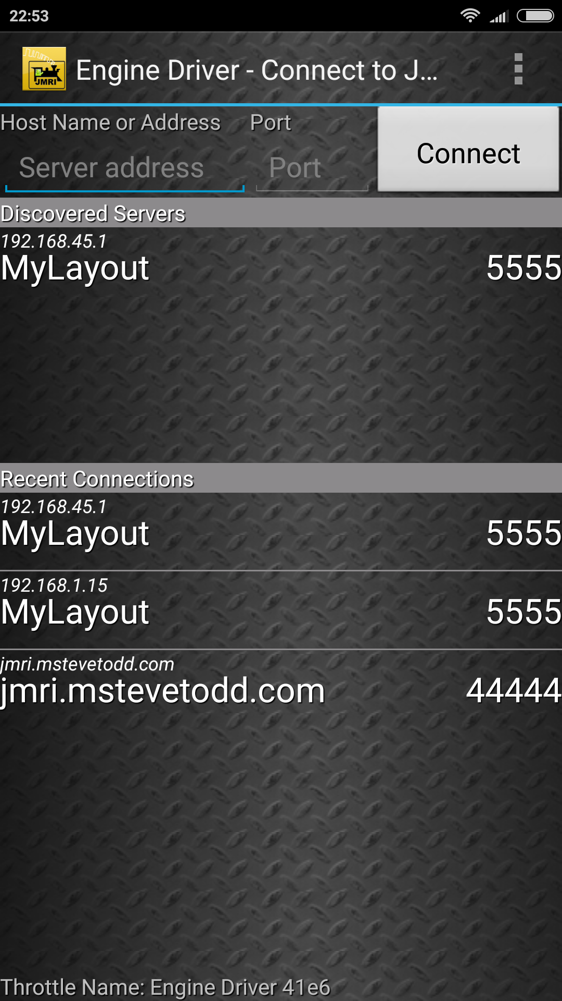

You can see it also shows the CANPiWi ip address. Click on item “MyLayout” and the ED will request a connection to the CANPiWi. Once the connection is done you can select an existing loco or enter a new one.

WifiMode
In WIFI mode the module needs to be connected to an existing wifi network. To allow that you need to change the configuration for WIFI mode and provide the ssid and the access password for the wifi network. The ssid and password have to be correctly informed, otherwise the module won’t be able to connect. If the connection does not work, then the module has to be reseted to AP mode and you can try again. See the section “Reset to AP mode” for more information.

If the connection is successfull you might the able to see the ED service advertised in the ED screen. If not please proceed to the troubleshooting section.
Once connected you can click on service advertised by in the ED screen and it proceed to connect to the CANPiWi.

[TODO: Add image]

Normally the home routers should not block the port 5555 for internal connection. If the connection does not work check if the firewall in the router is activated and if the port 5555 is open. If that is not the problem, check the troubleshooting section.

Configuration

The CANPiWi module provide several parameters for configuration. We divide there configuration parameters in:
- wifi parameters
- CBUS parameters
- general parameters

There are also 3 ways of configuring the module:
- using an embebeded webpage
- using the FCU
- manual editing

The configuration is stored in a file called canpi.cfg in the /home/pi/canpi directory in the SD card.

Parameters

This is a list of all parameters keys present in the canpi.cfg. A normal user should not need to change these file manually. Instead use the Webpage configuration or the FCU.

Parameter | Configuration type
canid | CBUS
node_number | CBUS
start_event_id | CBUS
button_pin | General
can_grid | General
candevice | General
cangrid_port | General
create_log_file | General
fn_momentary | General
green_led_pin | General
logappend | General
logfile | General
loglevel | General
service_name | General
tcpport | General
turnout_file | General
yellow_led_pin | General
orphan_timeout | General
shutdown_code | General
ap_channel | Wifi
ap_mode | Wifi
ap_no_password | Wifi
ap_password | Wifi
ap_ssid | Wifi
router_password | Wifi
router_ssid | Wifi

Wifi parameters
AP mode - ap_mode
This parameter indicates if the module has to work as an AP or connect to another wifi network.
If set, the module will work as an Access Point.
No password in AP mode - ap_no_password
If the module is in AP mode no password is required. It means the user just need to connect to the module ssid and no password will be required. If the property is set, then the “AP password” parameter has to be informed.
SSID - ap_ssid
The wifi network name that will be shown to another device. This parameter is the network name of the module. It is required if the module is in “AP mode”.
Password - ap_password
The password required to connect to the module when in “AP mode” and “AP mode without password” is not set.
Wifi channel - ap_channel
The wifi channel that the module will work. The channels are from 1 to 13. For more infomation see https://en.wikipedia.org/wiki/List_of_WLAN_channels
The non overlapping channels are:
- 1, 6, 11 or
- 2, 7, 12 or
- 3, 8, 13
The choice of the channel will depend on the presence of other access points (APs) in the same area. APs with the same channel may affect each other and jam the communication between the clients and the module. The module value by default is 6 [TODO: check].
Router SSID - router_ssid
The ssid of the router that the module will connect to when in “WIFI mode”. It has to be exactly the value advertised by the other router. This property is not set via FCU.
Router Password - router_password
The password of the router that the module will connect to when in “WIFI mode”. It has to be exactly the value expected by the other router. This property is not set via FCU.

CBUS parameters

Can Id – canid

This specifies what is the can id used by the module. Default value is 100. When in FLIM mode the module perform the auto enumeration and get the next canid available in the layout. Avoid changing this value manually, because it can create inconsistencies on the CBUS layout if 2 nodes use the same can id.

Start event id - start_event_id

This parameter indicates the short event number that will be generated when the ED and GridConnect service starts. An ON event will be triggered on start and an OFF event will be triggered id the service gracefully stops.

Node number - node_number

The module node number. This value is changed on by doing the request node number procedure common to all Merg CBUS modules. A manual change can clash with other modules and make the CBUS instable.

General parameters
Some general parametes are not available for configuration in the FCU or in the webpage, because they are for internal usage:
- candevice
- yellow_led_pin
- green_led_pin
- button_pin

Bonjour service name - service_name

The service name announced to EDs. This is the name that will show in the first screen of ED when connected to the same network of the CANPiWi.

ED Throttle Service port - tcpport

The tcp port that the ED service accepts connection. This value will be displayed in the ED screen. Default value is 5555.

Grid connect Service port - cangrid_port

The tcp port that the GridConnect service accepts connection.
Default value is 4444.

Can grid enabled - can_grid

Enable or disable the GridConnect service to run.

Turnouts - turnout_file

A file name stored inside the CANPiWi with the turnout definition. See the section Configuring the turnout file [TODO]. The default file name is “turnout.txt”.

Log file - logfile

The log file name stored inside the CANPiWi. This file is mostly used for debug purpouse. It is reseted every time the module starts. In case the module stay on for several time without reset, the file will be splited in 10 files of 5Mbytes size using a file rotation system.

Log level - loglevel

Indicates the granularity of the information present in the log file. The possible levels are:
- INFO
- WARN
-DEBUG

DEBUG level is the most verbose mode of them.

Creates log file - logappend

Indicates if the log file should be created.

Fns momentary - fn_momentary

Specifies which Fn key has the momentary behaviour by default. The standard value is 2. The values can be a list of comma separated values. The user also can create values that are specific for locomotive numbers. See “Fn configuration” section for more information.
Example entry : “2,5,6”

Orphan timeout - orphan_timeout

This parameter is used to set the maximum time in seconds that a session will be maintained alive in case the ED client is disconnected. The values are between 1 and 120 seconds.

Shutdown code - shutdown_code

The CANPiWi can be shut down by an ASON event (short event). This parameter indicates the short code value on which it will act on.

Web configuration

The CANPiWi provides an embeded webpage to allow configuration when not using the FCU. To access the webpage you will need a device with a browser connected to the same network as the CANPiWi. If in AP mode the default ip address of the module is “192.168.45.1”, if in WIFI mode use the ip address that appears in the ED screen.

Open the browser and type the ip address and the page below should appear.
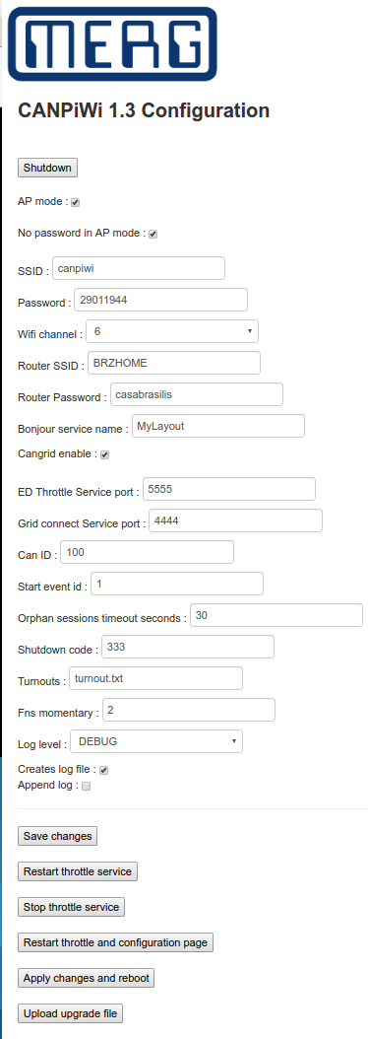

The parameters are described in the Configuration section.

Button Shutdown
This button shuts down the module. On shutdown it will emit an ACOF event.

Button Save changes
To save the properties you always have to press the button “Save changes”. This will validade the values and write them to the file “canpi.cfg”.

Button Restart throttle service

The button “Restart throttle service” restarts the ED throttle service. The module will disconnect all ED and GridConnect clients and restart the service. This won’t reboot the module, just restart the program internally. You may use this button to if you changed the CBUS parameters or/and the following ones:
- Turnouts
- Bounjour service name
- ED Throttle Service port
- Grid connect Service port
- Logfile
- Loglevel
- Create log file

The module will send an OFF short event with the value indicated on the parameter “Start event id” and another ON event when the service is active.

Button Stop throttle service
This button will stop the ED throttle and Grid connect service. The module will disconnect all ED and GridConnect clients and send an OFF short event with the value indicated on the parameter “Start event id”.
To start the service again press the “Restart throttle service” button.

Button Restart throttle and configuration page
Besides doing the same as the “Restart throttle service” button, it also restarts the Webpage server. You may need to reopen the page after pressing the button.

Button Apply changes and reboot
This button will reconfigure the wifi parameters according to the entries and reboot the module.
You need to use this button when you changes any Wifi parameter. Just changing and saving the changes won’t take effect until this button is pressed.

Button Upload upgrade file
See the section Upgrading process.

FCU configuration

Turnout control

The CANPiWi can inform the ED about available turnout control for the layout. The configuration is stored inside the CANPiWi in a file called “turnout.txt”. The file name can be changed, but the user has to provide the file inside the file system.
Currently there is no user interface to configure these entries, but you can use any sft tool to transfer or use the linux terminal to create the file.

The file location should be “/home/pi/canpi/” directory.

The turnout file is a simple text file and the entries have a simple format:
<Turnout name><space><number>
Example:
Cross1 51
Cross2 52

Each line represents one turnout.

You will need to download and install the FileZilla or any other SFTP client. If you are familiar with linux terminal and vi or nano editors you can skip this section and edit the file manually.

The turnout screen on ED in show below with some entries as example, including the shutdown event.

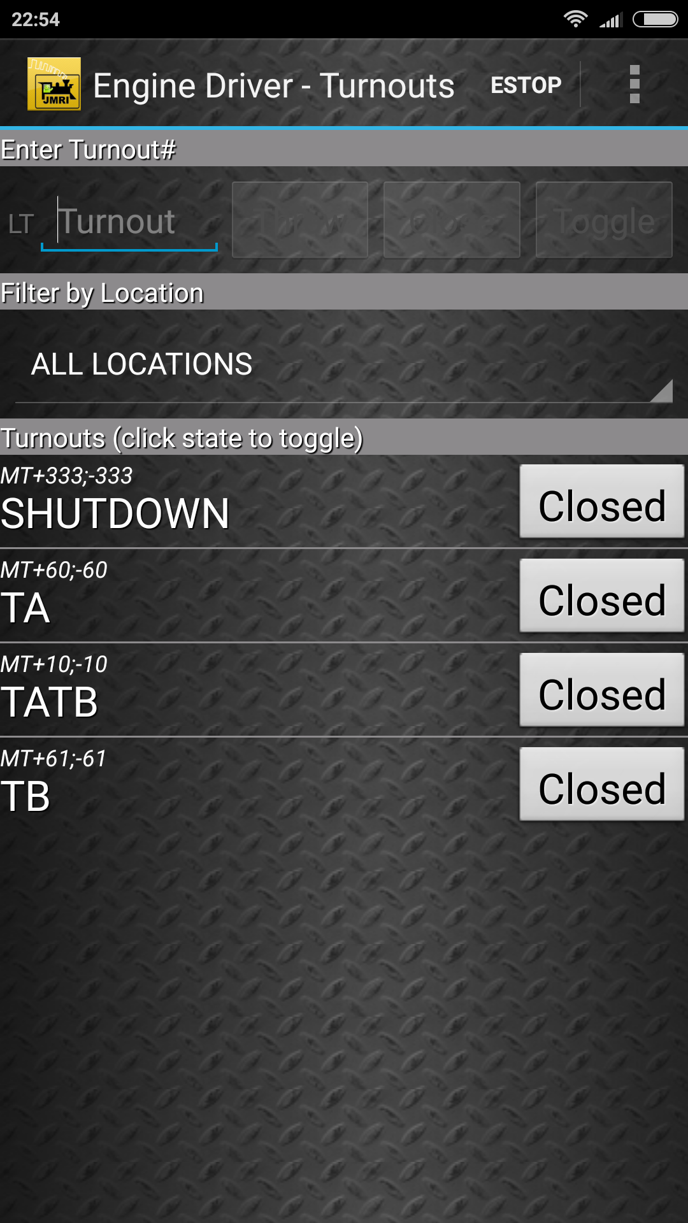

Fn configuration

The user is able to program the Fns behaviour for each locomotive. Once the user has selected a locomotive to drive, press the Fn28. Any other Fn pressed while the Fn28 is selected will toggle its functionality to momentary or switch mode. The configuration for that locomotive will be saved in the canpi.cfg file and be loaded every time the user selects that loco.
Example: suppose the user select the locomotive number 200 and want to change the Fn6 and Fn7 to be type of momentary. Press the Fn28, press the Fn6, press the Fn7 and press Fn28 again.

Grid connect service

The grid connect service is a TCP/IP service that allows multiple connections from different clients. It transforms the CBUS events to GridConnect messages in both directions. The user can connec the FCU, JMRI and RocRail to the layout using this service, or create your own application to control the layout based on the GridConnect protocol. The protocol details are described in the “CANPiWi Developer Guide”.

To connect the FCU to a layout using the CANPiWi proceed as folows:
- connect the PC/Laptop to the same network of the CANPiWi (see the Connecting section).
- open the FCU
- select on the menu [TODO: put screen]
- create a network entry [TODO: put screen]
- set the ip address and the port [TODO: put screen]
- save
- connect the to the network [TODO:put screen]

Upgrading process

Use the webpage to upgrade to new firmware. The firmware file has the format:
canpiwi-upgrade-yyyymmdd.zip.

On the webpage use the button “upgrade”. It will request to select a file and press the button apply or upload. It depends on the browser.

Troubleshooting

