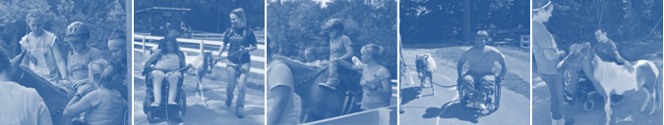

**Upcoming Training**

Date: January 3, 2010

Time: 6:00pm-8:00pm

Location: Horseshoes of Hope Riding Arena

Don’t forget your Volunteer Application—available at www.Horseshoesofhope.org

Volunteer Opportunities

Horseshoes of Hope Equine Academy provides unique opportunities for those who wish to be a part of our important mission of providing both children and adults with disabilities the opportunity to participate in Equine Assisted Activities and Therapies to become involved in a variety of ways. Whether you are youth group looking for service opportunities, a company looking to impact the community, or an individual interested kjkjkjkjkjkjin sharing your talents there are always ways for you to help!

Horseshoes of Hope volunteers participate in a variety programs and provide support for the everyday administrative needs of the organization. The following opportunities exist for individuals and groups interested in providing support for Horseshoes of Hope:

Horse Leaders ~ Sidewalkers ~ Stable Managers ~ Group Program Assistants ~ Landscape Design

Pasture Maintenance ~ Barn Upkeep ~ Public Relations ~ Fundraising ~ Event Planning

If you are interested in joining us please contact John Lambert to sign-up: jlambert@horseshoesofhope.org

August 2010

Horseshoes of Hope Equine Academy

At Bradford Woods

5040 State Road 67 North

Martinsville, IN 46151

www.horseshoesofhope.org