coursework

Ehansa Gajanayake

2024-07-16

library(tidyverse)

## ── Attaching core tidyverse packages ──────────────────────── tidyverse 2.0.0 ──  
## ✔ dplyr 1.1.4 ✔ readr 2.1.5  
## ✔ forcats 1.0.0 ✔ stringr 1.5.1  
## ✔ ggplot2 3.5.1 ✔ tibble 3.2.1  
## ✔ lubridate 1.9.3 ✔ tidyr 1.3.1  
## ✔ purrr 1.0.2   
## ── Conflicts ────────────────────────────────────────── tidyverse_conflicts() ──  
## ✖ dplyr::filter() masks stats::filter()  
## ✖ dplyr::lag() masks stats::lag()  
## ℹ Use the conflicted package (<http://conflicted.r-lib.org/>) to force all conflicts to become errors

library(MASS)

##   
## Attaching package: 'MASS'  
##   
## The following object is masked from 'package:dplyr':  
##   
## select

Q1

First_box <- c(1, 3, 5)  
Second_box <- c(2, 6, 8)  
  
#a  
Possible_Valuesof_X <- c(  
 First_box[1] + Second_box[1], First_box[1] + Second_box[2], First_box[1] + Second_box[3],  
 First_box[2] + Second_box[1], First_box[2] + Second_box[2], First_box[2] + Second_box[3],  
 First_box[3] + Second_box[1], First_box[3] + Second_box[2], First_box[3] + Second_box[3]  
)  
  
Possible_Valuesof_X

## [1] 3 7 9 5 9 11 7 11 13

#b  
Frequencies <- table(Possible_Valuesof_X)  
  
Frequencies

## Possible_Valuesof_X  
## 3 5 7 9 11 13   
## 1 1 2 2 2 1

#Calculating PMFs for each value  
Pmf_X_3 <- Frequencies["3"] / sum(Frequencies)  
Pmf_X_5 <- Frequencies["5"] / sum(Frequencies)  
Pmf_X_7 <- Frequencies["7"] / sum(Frequencies)  
Pmf_X_9 <- Frequencies["9"] / sum(Frequencies)  
Pmf_X_11 <- Frequencies["11"] / sum(Frequencies)  
Pmf_X_13 <- Frequencies["13"] / sum(Frequencies)  
  
Pmf_X_3

## 3   
## 0.1111111

Pmf_X_5

## 5   
## 0.1111111

Pmf_X_7

## 7   
## 0.2222222

Pmf_X_9

## 9   
## 0.2222222

Pmf_X_11

## 11   
## 0.2222222

Pmf_X_13

## 13   
## 0.1111111

#c  
Expected_Value_of_X <- (  
 (as.numeric(names(Frequencies)[1]) * Pmf_X_3) +   
 (as.numeric(names(Frequencies)[2]) * Pmf_X_5) +   
 (as.numeric(names(Frequencies)[3]) * Pmf_X_7) +  
 (as.numeric(names(Frequencies)[4]) * Pmf_X_9) +   
 (as.numeric(names(Frequencies)[5]) * Pmf_X_11) +   
 (as.numeric(names(Frequencies)[6]) * Pmf_X_13)  
)  
  
Expected_Value_of_X

## 3   
## 8.333333

#Var(X) = E(X^2) - [E(X)]^2  
  
Expected_Value_of_X2 <- (  
 (as.numeric(names(Frequencies)[1])^2 * Pmf_X_3) +   
 (as.numeric(names(Frequencies)[2])^2 * Pmf_X_5) +   
 (as.numeric(names(Frequencies)[3])^2 * Pmf_X_7) +  
 (as.numeric(names(Frequencies)[4])^2 * Pmf_X_9) +   
 (as.numeric(names(Frequencies)[5])^2 * Pmf_X_11) +   
 (as.numeric(names(Frequencies)[6])^2 * Pmf_X_13)  
)  
  
Expected_Value_of_X2

## 3   
## 78.33333

Variance_of_X <- (Expected_Value_of_X2 - ((Expected_Value_of_X)^2))  
  
Variance_of_X

## 3   
## 8.888889

#d  
#Y=3X-4  
  
Poss_Values_Y = (3*Possible_Valuesof_X)-4  
Poss_Values_Y

## [1] 5 17 23 11 23 29 17 29 35

Frequencies_2 = table(Poss_Values_Y)  
Frequencies_2

## Poss_Values_Y  
## 5 11 17 23 29 35   
## 1 1 2 2 2 1

Pmf_X_5 <- Frequencies_2["5"] / sum(Frequencies_2)  
Pmf_X_11 <- Frequencies_2["11"] / sum(Frequencies_2)  
Pmf_X_17 <- Frequencies_2["17"] / sum(Frequencies_2)  
Pmf_X_23 <- Frequencies_2["23"] / sum(Frequencies_2)  
Pmf_X_29 <- Frequencies_2["29"] / sum(Frequencies_2)  
Pmf_X_35 <- Frequencies_2["35"] / sum(Frequencies_2)  
  
Pmf_X_5

## 5   
## 0.1111111

Pmf_X_11

## 11   
## 0.1111111

Pmf_X_17

## 17   
## 0.2222222

Pmf_X_23

## 23   
## 0.2222222

Pmf_X_29

## 29   
## 0.2222222

Pmf_X_35

## 35   
## 0.1111111

#e  
cdf_of_Y1 = Pmf_X_5  
cdf_of_Y2 = cdf_of_Y1+Pmf_X_11  
cdf_of_Y3 = cdf_of_Y2+Pmf_X_17  
cdf_of_Y4 = cdf_of_Y3 + Pmf_X_23  
cdf_of_Y5 = cdf_of_Y4+Pmf_X_29  
cdf_of_Y = cdf_of_Y5+Pmf_X_35  
cdf_of_Y

## 5   
## 1

#f  
#P(Y=23)  
PY23 <- cdf_of_Y4 - cdf_of_Y3  
PY23

## 5   
## 0.2222222

Q2

number_of_values <- 500  
mean <- 25  
standard_deviation <- 8  
random_generation <- rnorm(number_of_values, mean, standard_deviation)

#a  
hist(random_generation, breaks=10, main="Histogram of Normal Distribution", freq=F)  
  
#b  
lines(density(random_generation), lwd=3, col="red")

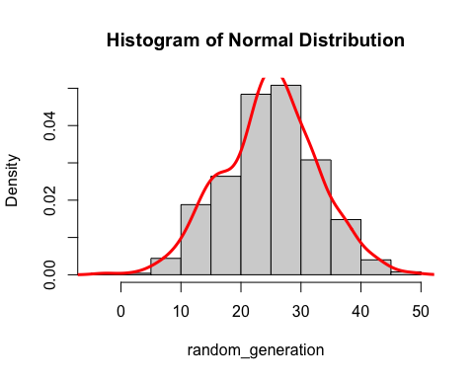

#c  
cat("We can see that the histogram and the density curve follow a normal distribution as the density curve is of a bell shape and the peak of the density curve is at the mean 25.")

## We can see that the histogram and the density curve follow a normal distribution as the density curve is of a bell shape and the peak of the density curve is at the mean 25.

Q3

#a  
X<- c(3.00, 3.40, 4.00, 4.60,5.00, 5.48, 6.00, 6.53, 7.00)  
Y <- c(8.0000, 6.5600, 5.0000, 4.1600, 4.0000, 4.2304, 5.0000, 6.3409, 8.0000)  
  
df <- data.frame(  
 X,Y  
)  
  
  
plot(df, main="Data Frame plot", xlab="X", ylab="Y")

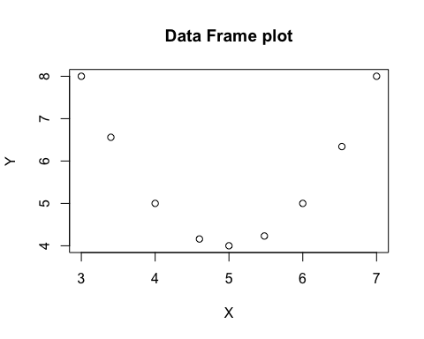

#b  
correlation_all_data <- cor(X,Y)  
correlation_all_data

## [1] -0.02763248

#c   
cat("It is a very weak negative correlation, as the value is close to zero. This suggests that there is almost no linear relationship between X and Y.")

## It is a very weak negative correlation, as the value is close to zero. This suggests that there is almost no linear relationship between X and Y.

#d  
last_six_X <- X[4:9]  
last_six_Y <- Y[4:9]  
  
correlation_last_six <- cor(last_six_X, last_six_Y)  
correlation_last_six

## [1] 0.9206644

cat("This is a very strong positive correlation. This is because the the relationship between the last six pairs are more linear than the first few data. The first few data points shows a lot more variations.")

## This is a very strong positive correlation. This is because the the relationship between the last six pairs are more linear than the first few data. The first few data points shows a lot more variations.

#e  
X1 <- (3-(2*X))  
X2 <- (2*(X^3))  
  
correlation_X1_Y <- cor(X1, Y)  
correlation_X2_Y <- cor(X2, Y)  
  
correlation_X1_Y

## [1] 0.02763248

correlation_X2_Y

## [1] 0.1896496

cat("X1=3-2X is a linear transformation. rxy = -0.02763248 and rx1y = 0.02763248. Linear transformations do not change the nature of the correlation, but since X is multiplied by negative 2, the sign of the correlation coefficient is changed. \n")

## X1=3-2X is a linear transformation. rxy = -0.02763248 and rx1y = 0.02763248. Linear transformations do not change the nature of the correlation, but since X is multiplied by negative 2, the sign of the correlation coefficient is changed.

cat("X2 = 2X^3 is a non linear transformation. rxy = -0.02763248 and rx2y = 0.1896496. The non linear transformation has changed the relationship between the variables. The new correlation shows a weak positive linear relationship between X2 and Y as opposed to the negative almost zero correlation between X and Y.")

## X2 = 2X^3 is a non linear transformation. rxy = -0.02763248 and rx2y = 0.1896496. The non linear transformation has changed the relationship between the variables. The new correlation shows a weak positive linear relationship between X2 and Y as opposed to the negative almost zero correlation between X and Y.

Q4

cars %>%  
 view()

#a  
cars %>%   
 head(10)

## speed dist  
## 1 4 2  
## 2 4 10  
## 3 7 4  
## 4 7 22  
## 5 8 16  
## 6 9 10  
## 7 10 18  
## 8 10 26  
## 9 10 34  
## 10 11 17

#b  
print(summary(cars))

## speed dist   
## Min. : 4.0 Min. : 2.00   
## 1st Qu.:12.0 1st Qu.: 26.00   
## Median :15.0 Median : 36.00   
## Mean :15.4 Mean : 42.98   
## 3rd Qu.:19.0 3rd Qu.: 56.00   
## Max. :25.0 Max. :120.00

#c  
plot(cars, xlab = "Speed (X)", ylab = "Stopping Distances of Cars (Y)",  
 main="Relationship between Speed and Stopping Distance of Cars",  
 col='red')

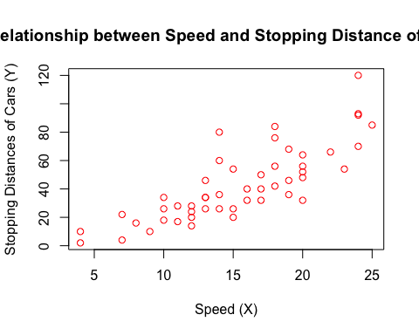

cat("It is a positive association where as the speed increases, the stopping distance of the cars also increase.")

## It is a positive association where as the speed increases, the stopping distance of the cars also increase.

#d  
LRmodel <- lm(formula = dist ~ speed, data = cars) #linear model  
LRmodel

##   
## Call:  
## lm(formula = dist ~ speed, data = cars)  
##   
## Coefficients:  
## (Intercept) speed   
## -17.579 3.932

summary(LRmodel)

##   
## Call:  
## lm(formula = dist ~ speed, data = cars)  
##   
## Residuals:  
## Min 1Q Median 3Q Max   
## -29.069 -9.525 -2.272 9.215 43.201   
##   
## Coefficients:  
## Estimate Std. Error t value Pr(>|t|)   
## (Intercept) -17.5791 6.7584 -2.601 0.0123 *   
## speed 3.9324 0.4155 9.464 1.49e-12 ***  
## ---  
## Signif. codes: 0 '***' 0.001 '**' 0.01 '*' 0.05 '.' 0.1 ' ' 1  
##   
## Residual standard error: 15.38 on 48 degrees of freedom  
## Multiple R-squared: 0.6511, Adjusted R-squared: 0.6438   
## F-statistic: 89.57 on 1 and 48 DF, p-value: 1.49e-12

plot(cars, xlab = "Speed (X)", ylab = "Stopping Distances of Cars (Y)",las = 1,  
 main="Relationship between Speed and Stopping Distances of Cars",  
 col='red')  
abline (LRmodel,col ="blue")

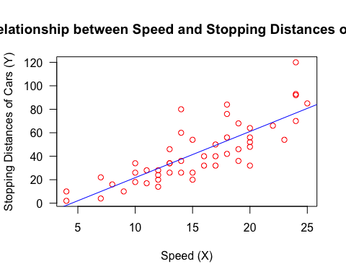

#e

$$\begin{matrix}\text{Stopping Distance}=−17.5791+3.9324*\text{Speed} \\ \end{matrix}$$

#f  
cat("3.9324")

## 3.9324

#g  
plot(fitted(LRmodel),resid(LRmodel),  
 xlab = "Fitted", ylab ="Residuals",las = 1,   
 main="Residuals versus Speed",  
 col='red')   
abline(0,0)

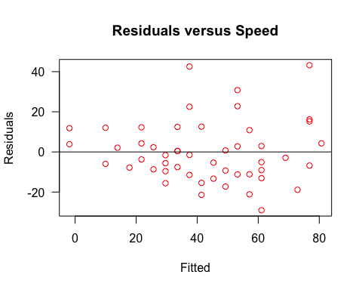

cat("In this residual(errors) plot, the points do not seem to be randomly scattered around the residual=0 line. So we can conclude that   
a linear model is not appropriate for modeling this data. There are a few points with larger residuals, both positive and negative indicating possible outliers.")

## In this residual(errors) plot, the points do not seem to be randomly scattered around the residual=0 line. So we can conclude that   
## a linear model is not appropriate for modeling this data. There are a few points with larger residuals, both positive and negative indicating possible outliers.

#h  
new_speed <- data.frame(speed = 21)  
predicted_dist <- predict(LRmodel, newdata = new_speed)  
predicted_dist

## 1   
## 65.00149

equation_predicted_dist <- -17.5791+ 3.9324 *21  
equation_predicted_dist

## [1] 65.0013

#Q5

#Part A

mean_5 <- 4.11  
standard_deviation_5 = 1.37

#a  
answer_0.85 <- qnorm(0.85, mean_5, standard_deviation_5)  
answer_0.85

## [1] 5.529914

#b  
answer_0.35 = qnorm(0.35, mean_5, standard_deviation_5)  
answer_0.35

## [1] 3.582111

#c  
median <- mean_5  
median

## [1] 4.11

#d  
morethan_5dollar_percentage <- pnorm(5, mean_5, standard_deviation_5, lower.tail = F)*100  
morethan_5dollar_percentage

## [1] 25.7964

Part B

#a  
cat("The most suitable distribution for X is binomial. This is because there is a fixed number of trials, 10 where a person can be either infected or not infected.The probability a person being infected in each trial is 0.1. \n")

## The most suitable distribution for X is binomial. This is because there is a fixed number of trials, 10 where a person can be either infected or not infected.The probability a person being infected in each trial is 0.1.

cat("n = 10 \n")

## n = 10

cat("p = 0.1 \n")

## p = 0.1

cat("X~Binomial(n,p) \n")

## X~Binomial(n,p)

cat("X~Binomial(10,0.1)")

## X~Binomial(10,0.1)

n_times <- 10  
probability <- 0.1

#b  
less_than_3 = pbinom(2,n_times,probability)  
less_than_3

## [1] 0.9298092

#c  
#E(X)=np  
#Var(X)=np(1-p)  
  
Mean_of_X = n_times*probability  
Variance_of_X2 = n_times*probability*(1-probability)  
  
Mean_of_X

## [1] 1

Variance_of_X2

## [1] 0.9

#d  
cat("n = 100 \n")

## n = 100

cat("p = 0.024 \n")

## p = 0.024

cat("Since the number of trials n is very large and the probability of being infected in a single trial is very small, Poisson distribution can be used to approximate the binomial distribution. Set the Poisson mean to equal the binomial mean where, \n")

## Since the number of trials n is very large and the probability of being infected in a single trial is very small, Poisson distribution can be used to approximate the binomial distribution. Set the Poisson mean to equal the binomial mean where,

cat("λ = np = 100*0.024 = 2.4 \n")

## λ = np = 100*0.024 = 2.4

cat("So X ~ Pois(2.4)")

## So X ~ Pois(2.4)

#Q6

N <- 50000 #number of bootstrap samples  
my_boootstrap <- numeric(N) #vector where to store sample mean  
data <- c(1, 2, 3, 3, 5, 8, 7, 6, 5, 9, 11, 15) #given data set  
  
mean(data) #checking the mean of the given data

## [1] 6.25

for (i in 1:N) {  
 s=sample(data,12,replace = T)  
 my_boootstrap[i]=mean(s)  
}

#a  
hist(my_boootstrap)

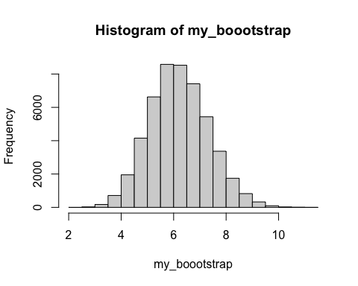

#b  
quantile (my_boootstrap, c(0.025, 0.975))

## 2.5% 97.5%   
## 4.166667 8.583333

#c  
qqnorm(my_boootstrap)  
qqline(my_boootstrap)

