**Aman Poddar** 8810592669 **apoddar223@gmail.com**

PORTFOLIO WEBSITES [report]



# [christammar.com](https://www.christammar.com/projects)

HEAD 🡪

TITLE: - Projects | christammar



TAG: - Google Site Tag (gtag.js)

FONT: - google fonts 🡪 Open Sans (400, 600, 700); Chivo (400); Lato(400); Droid Serif (400)

Numbers in ( ) represents font weight.

BODY 🡪

Background-color: (255,255,255,1);

Height: 1005;

Padding: 0;

Margin: 0;

TOP PART🡪



image source="https://s3-img.pixpa.com/com/large/20669/20669-1558485619-logo1.png"

padding-left: 3vw; padding-right: 3vw;

text-align: centre; margin: 0 auto;

{custom-image}🡪



Display: inline;

Vertical-align: top;

Max-width: 100%;

🡪

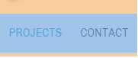

Display: inline-block;

Margin-top: 20px; margin-right: 0px; margin-bottom: 5px; margin-left: 0px;

Float: none;

Max-width: 75%;

Background: rgba(255,255,255,0);

Font-family: chivo, sans-serif;

Font-weight: 400;

Box-sizing: inherit;

🡪

Margin: 0 auto;

Float: none;

Display: inherit;

Text-align: center;

Width: 121px;

ALL IMAGES 🡪…

|||



Padding-top: 30px;

Position: relative;

Height: 2246px;

Width: 100%; calc (50% - 30px);

Margin-bottom: 30px;

Position: absolute;

Left: 0%;

Top: 30px;

Float: left; Overflow: hidden;

BOTTOM PART 🡪

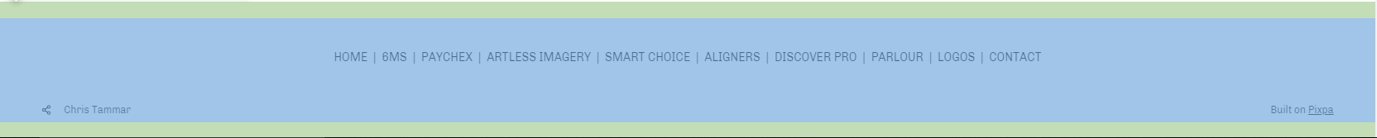

Padding-top: 2vh;

Padding-bottom: 2vh;

Padding-dleft: 0%;

Padding-right: 0%;

Background-color: rgba(255,255,255,1);

Font-family: chivo, sans-serif;

Color: #1d1d1e;

Font-size: 12px;

Font-weight: 400;

🡪C:\Users\Aman Poddar\AppData\Local\Microsoft\Windows\INetCache\Content.Word\Capture.png

Width: 100%;

Float: left;

Padding-left: 1rem; padding-right: 1rem;

🡪



Text-align: center;

Color: #1d1d1e;

Font-family: chivo, sans-serif;

Font-weight: 400;

Font-size: 14px;

Line-height: 1.8em;

Margin-bottom: 1rem; margin-top: 1rem;

🡪C:\Users\Aman Poddar\AppData\Local\Microsoft\Windows\INetCache\Content.Word\Capture.png

Padding-left: 0;

Line-height: 30px;

Height: 30px;

Cursor: pointer;

Display: inline-flex;

webkit-box-align: center;

Align-items: left;

Text-align: left; Float: left;

C:\Users\Aman Poddar\AppData\Local\Microsoft\Windows\INetCache\Content.Word\Capture.png

🡪

Line-height: 30px;

Height: 30px;

Max-width: 850px;

White-space: nowrap;

Text-overflow: ellipsis;

Padding-left: 15px;

Text-align: left;

Float: left;

🡪



Line-height: 30px;

Height: 30px;

Text-align: right;

Float: right;

Box-sizing: inherit;