Bug01

Bug One of the assessment is that the player is receiving the wrong amount when they have won.

1 match receives 5 instead of 10 (5 winnings + 5 bet returned).

2 matches receives 10 instead of 15 (10 winnings + 5 bet returned).

3 matches receives 15 instead of 20 (15 winnings + 5 bet returned).

Output of Buggy behaviour:

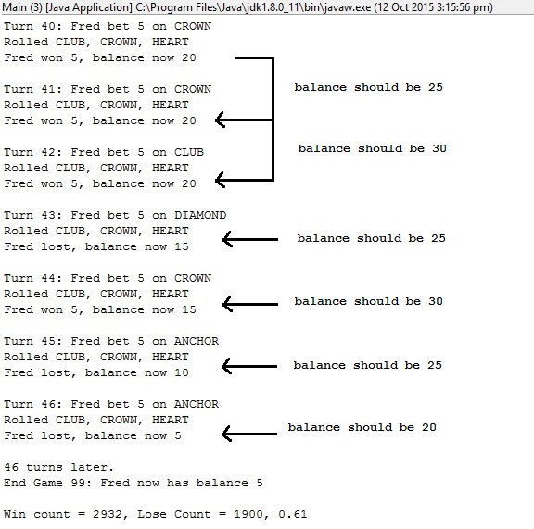

First Hypothesis:

My first hypothesis is that the bet is not being returned to the player if they have won. By running the game multiple times, this theory seems correct.

After writing a test for 1 match, 2 matches and 3 matches, I have proven my hypothesis correct. The test for Bug01 is in the test “testBug01.java”.

Bug01 Test with Buggy Output:

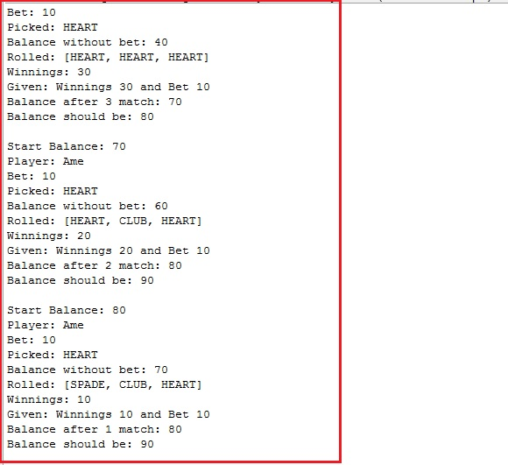

Bug01 Test Fixed: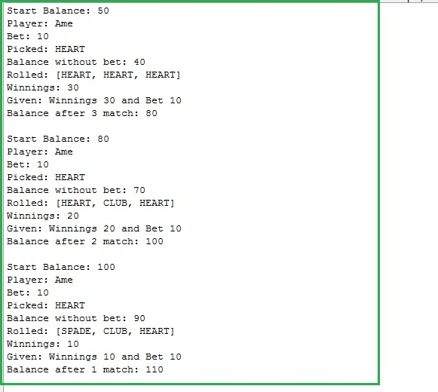

Origin Before:

In “Player.java”:

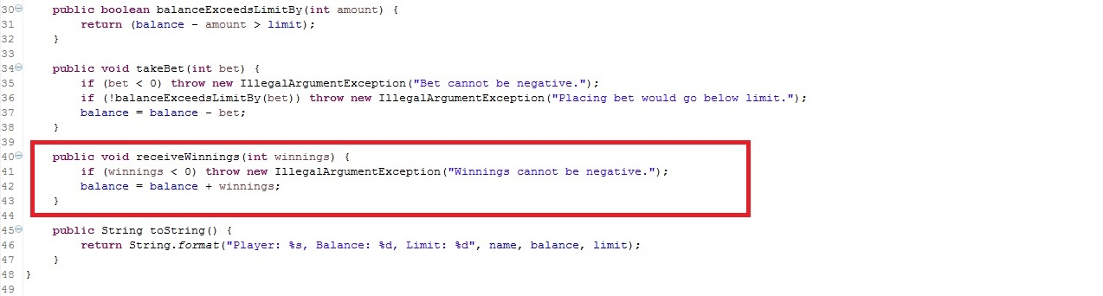

In “Game.java”:

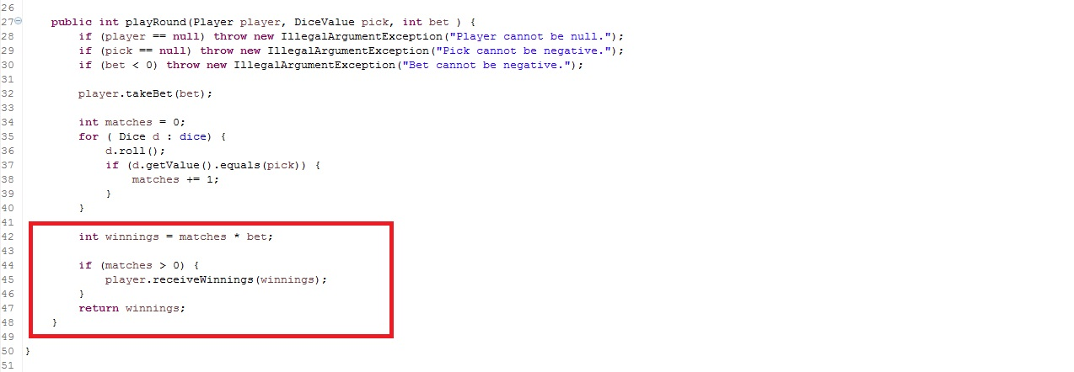

Origin After:

In “Player.java”:

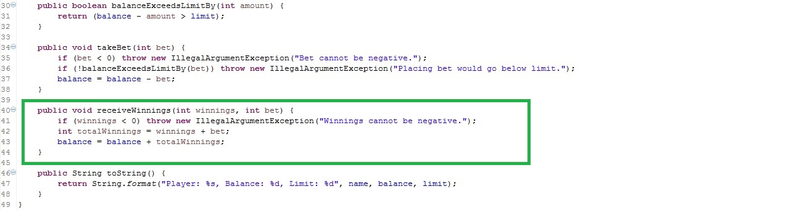

In “Game.java”:

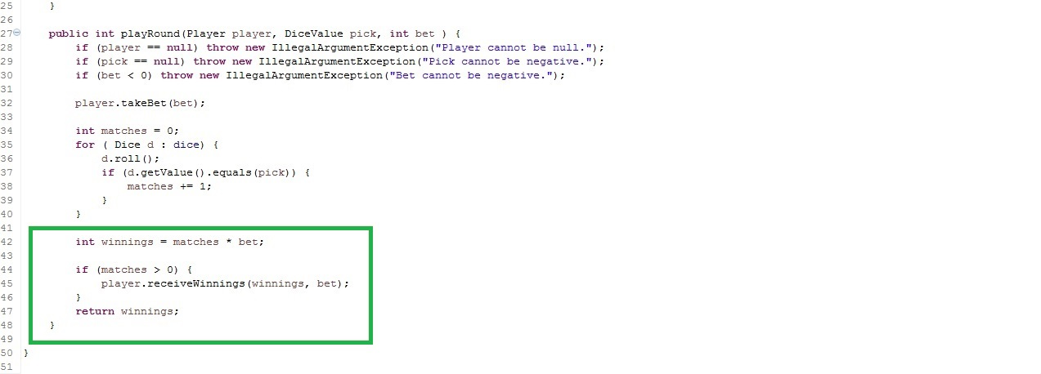

Output Bug Fixed:

