Bug02

Bug Two of the assessment is that the game ends when the player has 5 (dollars) remaining, instead of the game limit of 0.

First Hypothesis:

My first hypothesis is that the when there is an issues somewhere when the balance is compared to the limit. Because at the start of each game, it is shown therefore proven that the limit is correctly zero.

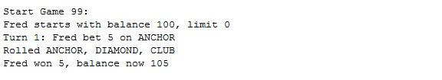

Conclusion:

After writing a test that where the balance is checked against the limit, using multiple balances. It was proven this is where the bug occurred, in the method “balanceExccedsLimitBy(int amount)”. The test for Bug02 is in the test “testBug02.java”.

Output of Buggy behaviour:

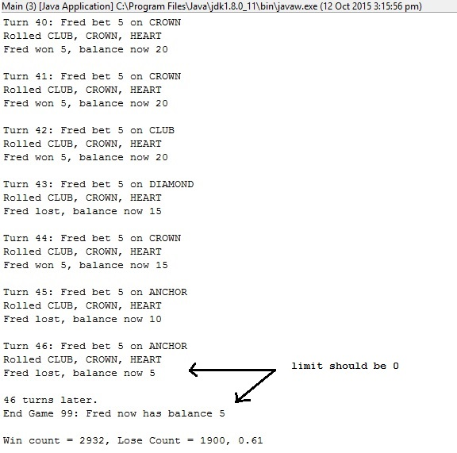

Bug02 Test with Buggy Output:

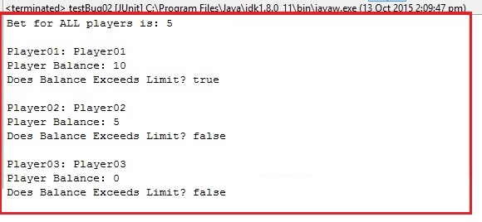

Bug02 Test Fixed:

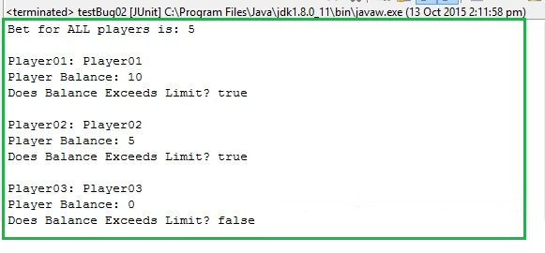

Origin Before:

In “Player.java”:

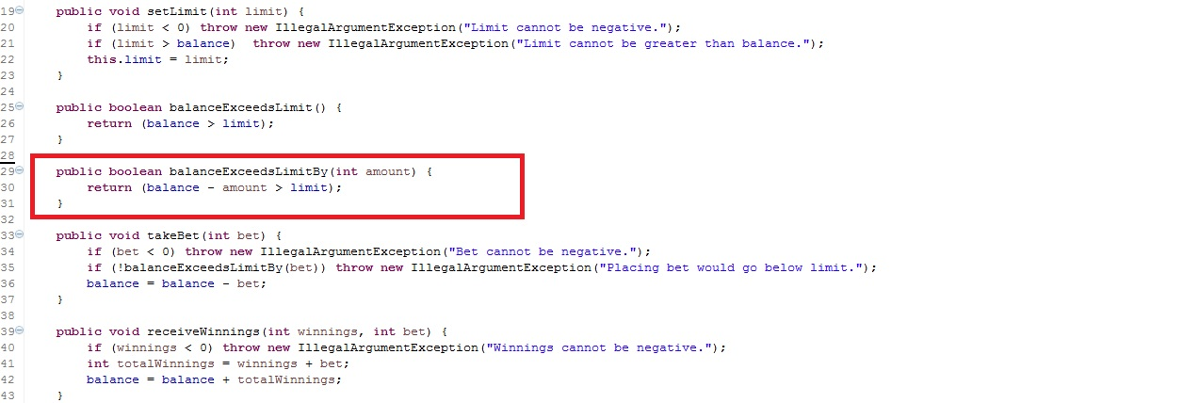

Origin After:

In “Player.java”:

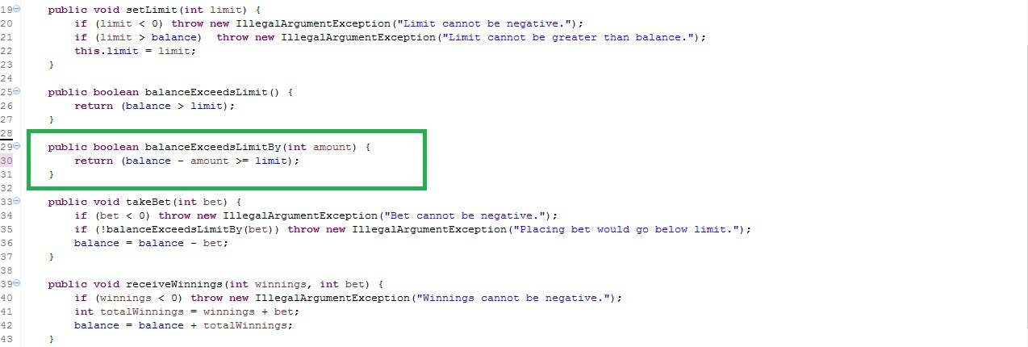

Output Bug Fixed:

