Bug03

Bug Three of the assessment is that the game is that Spade is NEVER rolled by the dice ever or picked by the player. This bug was found while running the game multiple times to check the occurrences and percentage of wins for Bug04 (which was previously Bug03) but this newly found bug needs to be fixed in-order for Bug04 to be properly fixed, so the two were separated.

First Hypothesis:

This is a bug I wasn’t expecting, so my hypothesis is that somewhere in the code where the dice is randomly selected (getRandom) there is an issue

Conclusion:

Running the game multiple times, and seeing that the player is never able to pick SPADE, and the game doesn’t ever roll a spade. I looked through the Dice.java and DiceValue.java classes, and found that that “getRandom()” method uses “int random = RANDOM.nextInt(DiceValue.SPADE.ordinal());”. Using this returns the ordinal Spade of the enum, Spade was the 6th symbol added: CROWN, ANCHOR, HEART, DIAMOND then SPADE, but by using ordinal() of SPADE which is 5 but is exclusive. In a map it starts at 0, which means goes from 0 to 5, but excludes 5. Therefore by replacing “DiceValue.SPADE.ordinal()” with the value of “6”, will read from 0 to 5 in-turn including SPADE, while excluding 6. The test for Bug03 is in the test “testBug03.java”.

Output of Buggy behaviour:

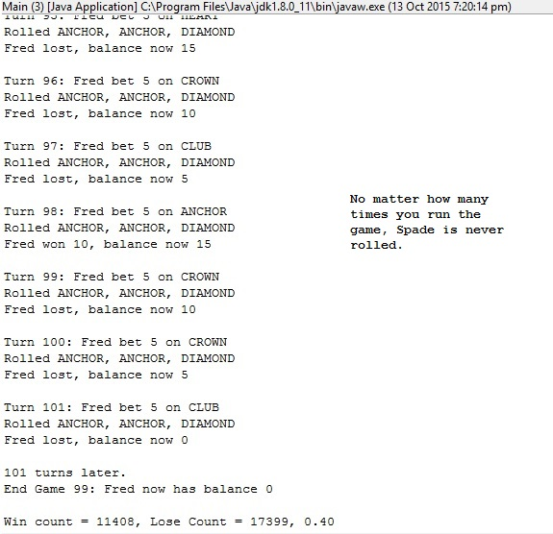

Bug03 Test with Buggy Output:

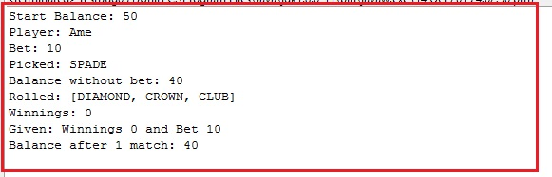

Bug03 Test Fixed:

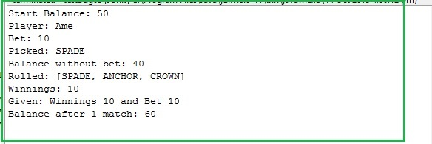

Origin Before:

In “DiceValue.java”:

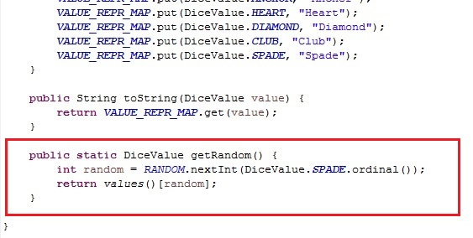

Origin After:

In “DiceValue.java”:

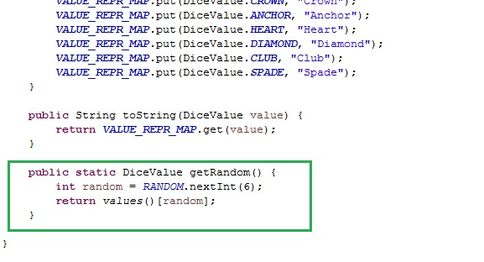

Output Bug Fixed:

