Bug04

Bug Three of the assessment is that the game has an 8% bias towards the house. When the ratio should be 0.42.

|  |  |
| --- | --- |
| Bug using Original Code | Bug using Code with Bug03 Fixed |
| 1 Match Percentages:  Club, Heart, Anchor = 59.7%  Diamond, Anchor, Diamond = 40.0% | 1 Match Percentages:  Spade, Crown, Diamond = 49.9%  Club, Heart, Spade = 50.0% |
| 2 Match Percentages:  Anchor, Anchor, Heart = 40.2%  Club, Crown, Diamond = 60.2% | 2 Match Percentages:  Diamond, Anchor, Diamond = 33.3%  Heart, Spade, Heart = 32.9% |
| 3 Match Percentages:  Diamond, Diamond, Diamond = 20.2%  Anchor, Anchor, Anchor = 20.2% | 3 Match Percentages:  Spade, Spade, Spade = 19.2%  Spade, Spade, Spade = 16.1% |

**Will use the code with Bug03 fixed.**

First Hypothesis:

There is an issue in the code where the randomly rolled dice is happening.

Conclusion:

In the method “roll()” method in Dice. The method returned the “DiceValue.getRandom()” but once rolled did nothing else, the results weren’t going anywhere.

Output of Buggy behaviour:

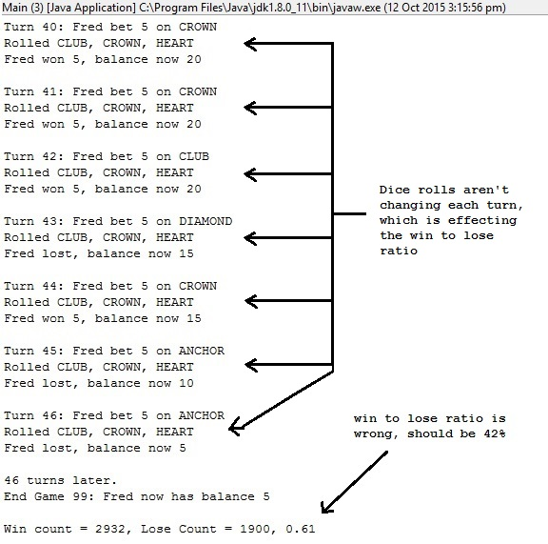

Origin Before:

In “Dice.java”:

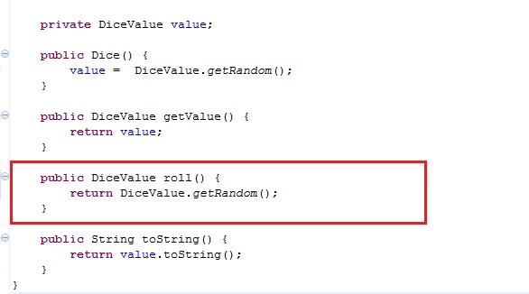

Origin After:

In “Dice.java”:

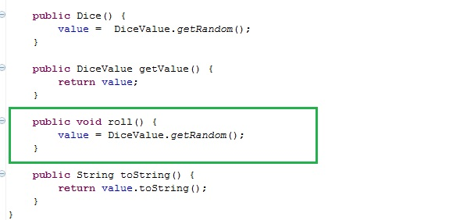

Output Bug Fixed:

