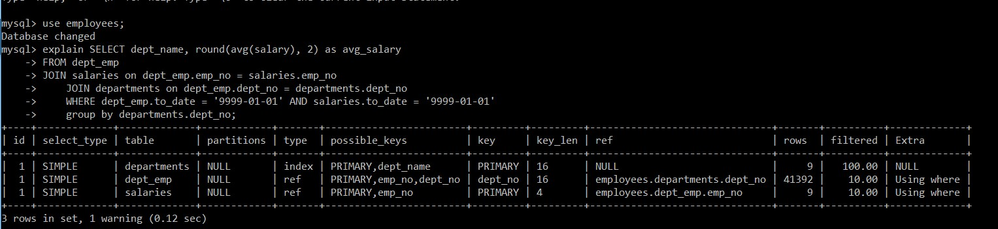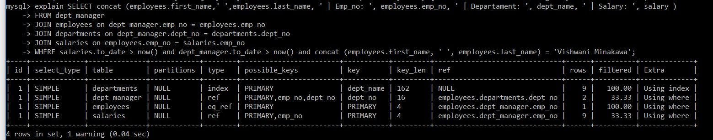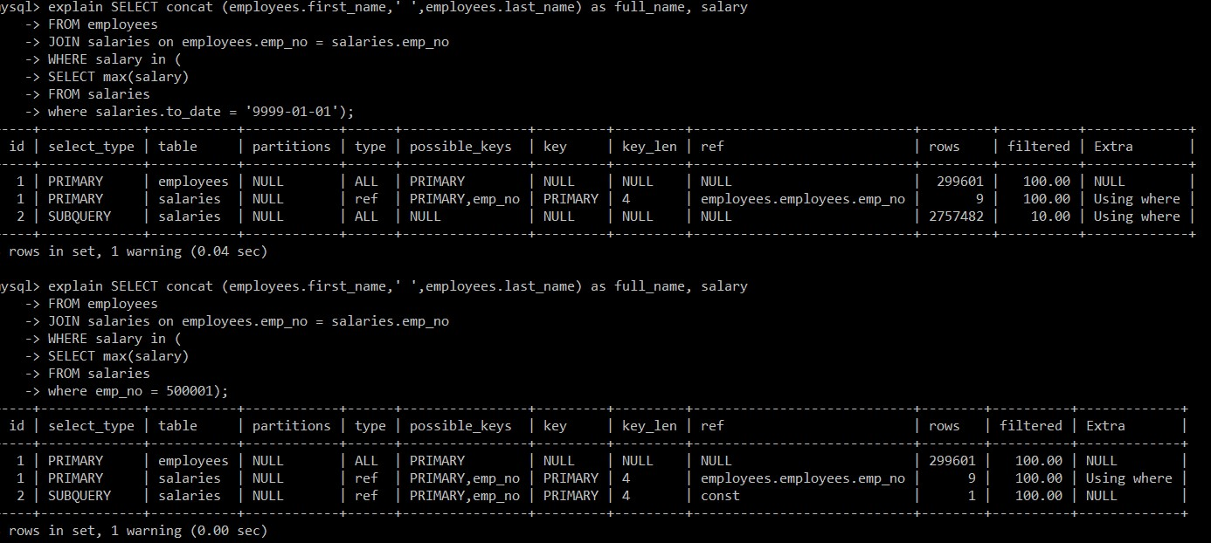

------------------------------------------------------------------------------------------------------------------------------------------------------------

start transaction;

begin

INSERT INTO employees VALUES (500002,'2000-01-01','Georgi','Simmel','M','2019-01-01');

INSERT INTO salaries VALUES (500002, 5000, '2019-01-01', '2019-01-01');

savepoint test;

UPDATE employees

SET emp_no=500002, birth_date='3000-01-01', first_name='Georgi',last_name='Simmel', gender='M',hire_date='2019-01-01'

where emp_no = 500002;

rollback test;

commit;

------------------------------------------------------------------------------------------------------------------------------------------------------------

start transaction;

begin

UPDATE dept_manager SET emp_no= '110114', from_date = '1989-12-17' where to_date > now() and dept_no = 'd001'; #emp_no = 110039

UPDATE dept_manager SET emp_no= '110039', from_date = '1991-10-01' where to_date > now() and dept_no = 'd002'; #emp_no = 110114

commit;

------------------------------------------------------------------------------------------------------------------------------------------------------------