Amazd Integration

This extension allows you to fully integrate your Magento shop with [AMAZD platform](https://www.amazd.co/).

[AMAZD](https://www.amazd.co/) is your new conversational storefront empowering you to bring genuine and hyper-personalised advice, and a good feeling to your customers for more sales and higher customer loyalty. With AMAZD your customers and experts can chat, have video calls, share/save products, and more.

[Contact us](https://www.amazd.co/get-started) to start the integration process and we'll setup AMAZD widget on your website. This extension for Magento is the next step in the process to allow customers interact with products via our widget.

1. Chat with customers and share products:

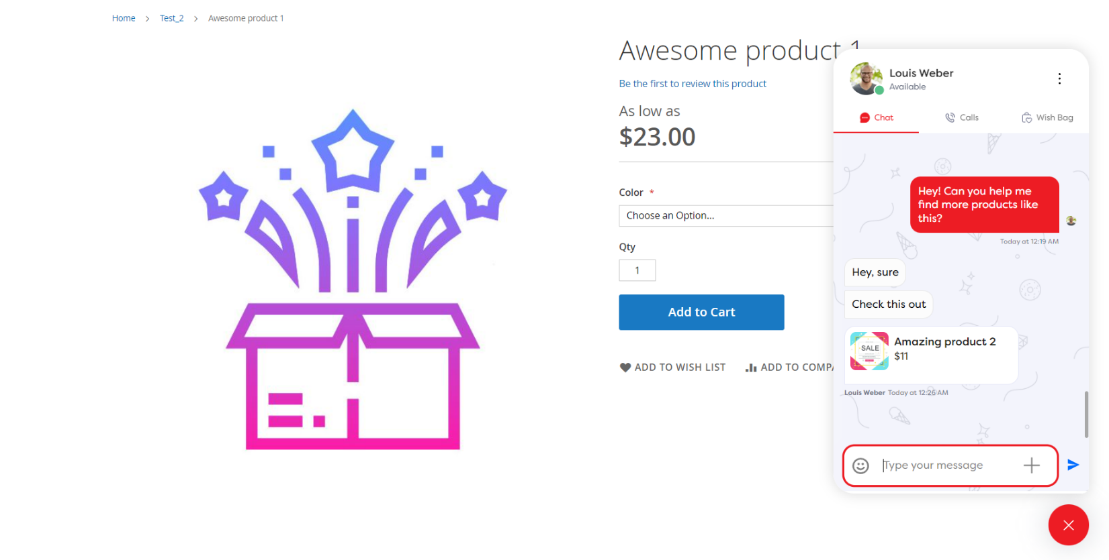

1. Add products to AMAZD Wish bag:

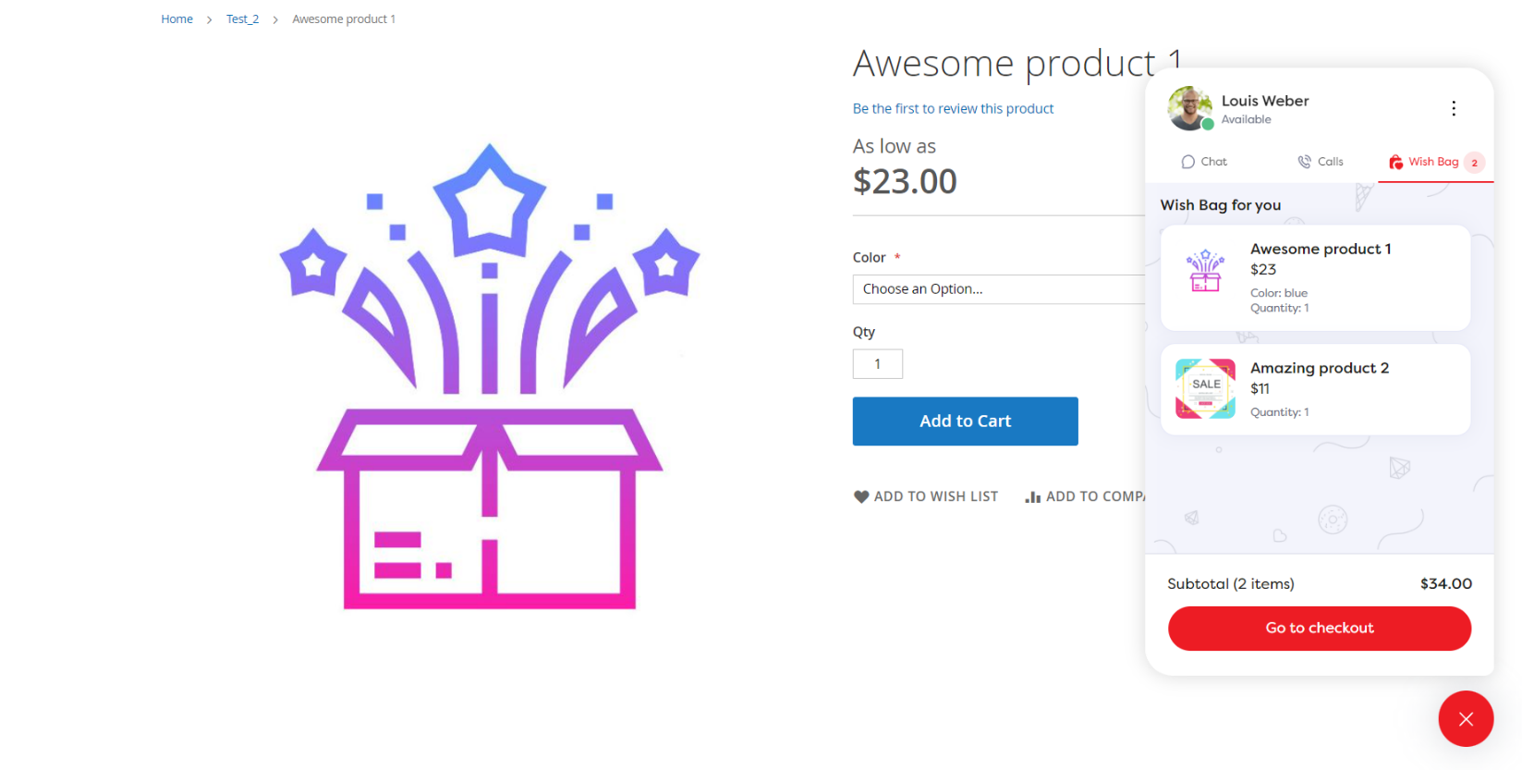

1. A customer can open checkout with added products:

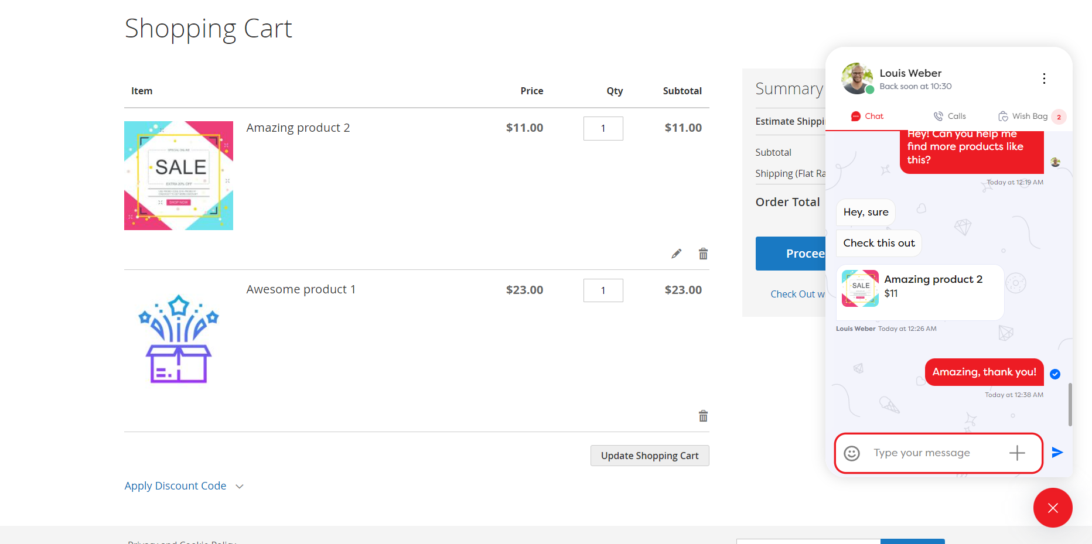

Installation

Install via composer:

composer require amazd/integration

php bin/magento module:enable Amazd_Integration

php bin/magento setup:upgrade

php bin/magento setup:di:compile

php bin/magento setup:static-content:deploy

Install from Github:

git clone https://github.com/amazd-code/magento-integration  
mv magento-integration {magento_root}/app/code/Amazd/Integration  
cd {magento_root}  
php bin/magento module:enable Amazd_Integration  
php bin/magento setup:upgrade  
php bin/magento setup:di:compile  
php bin/magento setup:static-content:deploy

Configuration

This extension doesn’t need to be configured in your Magento admin. Please contact AMAZD to setup your shop on our side and then integration will work

Source code

This extension is open-source, check the code at GitHub:

<https://github.com/amazd-code/magento-integration>