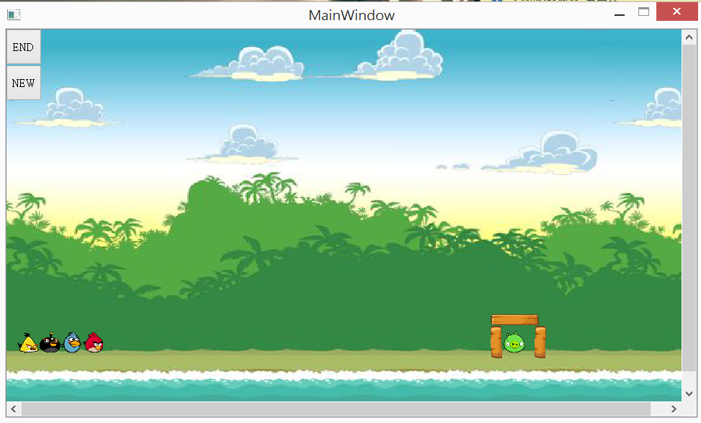

功能:一般的小鳥

功能:當射出去後按一下,會很快的向下進行攻擊

功能:當射出去之後,會很快地向前推進

功能:當射出去之後,他向下跟向上的速度會交換，進行奇襲

|  |
| --- |
| MainWindow |
| -scene: QgaphicsScene* - birdie3:Bird * - text:QTextEdit *  -timer1: QTimer - birdie4:Bird * - birdie:Bird * -birdie:Bird * - build:building * - birdie2:Bird * - nbutton:QPushButton * - build2:building * - superbird1:subird * mbutton :QPushButton * - build3:building* - timer1 :QTimer * -int presstime - ox :int - oy :int -rx:int - ry:int - yy:int - xx:int - vx:int - vy:int - |
| +<<ecplict>>MainWindow(parent:QWight*=0):void -<<slots>> tick():void  +~MainWindow() -<<slot>>QUITSLOT():void  +showEvent(QShowEvent*):void -<<slot>> QUIT():void  +eventFilter(QObject*,event:QEvent):bool -<<slot>> NEW():void  +closeEvent(QCloseEvent*):void -<<slot>> vanish():void |

UML Diagram

|  |
| --- |
| GameItem |
| #g_body:b2Body*  #g_pixmap: QgaphicsScene*  #g_size:QSizeF  #g_world:b2World*  #g_worldsize:static QSizeF  #g_windowsize:static QSizeF |
| +GameItem(world:b2World*)  +~GameItam()  +setGlobalSize(worldsize:QSizeF,windowsize:QSizeF):static void  +<<slots>>paint():void |

|  |
| --- |
| Bird |
| +Bird(x:float,y:float,radius:float,timer:QTimer*,  Pixmap:QPixmap,world:b2World*,  scene:QGraphicScene*,density:float)  +setLinearVelocity(velocity:b2Vec2):void |

|  |
| --- |
| Bird4 |
| +bird4(x:float,y:float,radius:float,timer:QTimer*,  Pixmap:QPixmap,world:b2World*,  scene:QGraphicScene*,density float)  + setLinearVelocity(b2Vec2 velocity): void  +skill():virtual void |

|  |
| --- |
| Bird3 |
| +bird3(x:float,y:float,radius:float,timer:QTimer*,  Pixmap:QPixmap,world:b2World*,  scene:QGraphicScene*,density float)  + setLinearVelocity(b2Vec2 velocity): void  +skill():virtual void |

|  |
| --- |
| building |
| +Obstacle(x:float,y:float,radius:float,  Pixmap:QPixmap,world:b2World*,  scene:QGraphicScene*,density:float) |

|  |
| --- |
| Land |
| +Land(x:float,y:float,w:float,h:float,  Pixmap:QPixmap,world:b2World*,  scene:QGraphicScene*) |

|  |
| --- |
| enemy |
| +pig(x:float,y:float,radius:float,timer:QTimer*,  Pixmap:QPixmap,world:b2World*,  scene:QGraphicScene*, density:float)  +setLinearVelocity(velocity:b2Vec2):void  +get(): bool |

|  |
| --- |
| Bird2 |
| +bird2(x:float,y:float,radius:float,timer:QTimer*,  Pixmap:QPixmap,world:b2World*,  scene:QGraphicScene*,density float)  + setLinearVelocity(b2Vec2 velocity): void  +skill():virtual void |