**Togonon, Rbryan S. BSIT – 2A**

**Assessment: Cartesian Product**

**CARTESIAN PRODUCT**

* is also an operator which works on two sets. It is sometimes called the **CROSS PRODUCT** or **CROSS JOIN**.
* It combines the tuples of one relation with all the tuples of the other relation.

**Examples:**

**1.**

**Output:**

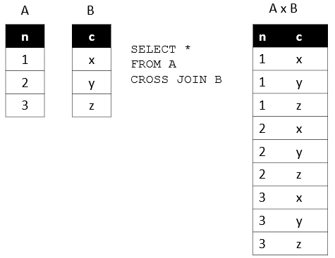

Source: <http://www.sqltutorial.org/sql-cross-join/>

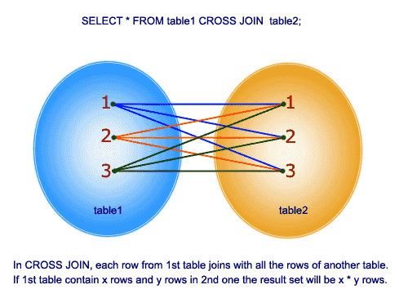

Source: <https://www.w3resource.com/sql/joins/cross-join.php>