Become a Brainrot — Performance & CCU Investigation
QA findings — client render profiling + analytics review

Summary
- The new brainrot models did NOT cause the CCU drop. The decline begins Jul 20 — two days before the models were published (Jul 22).
- The bulk of client render cost is one folder: Workspace.Garden holds ~1,781 particle emitters — 84% of all live emitters. Disabling it alone roughly halves render time.
- Brainrot models account for ~4% of live emitters. Their render contribution is minor.
- Session time did fall ~11%. Real, but a secondary effect and not proven tied to the models — it can't explain a 38% DAU drop on its own.

Part 1 — Did the model swap cause the CCU drop?
Short answer: no. The daily active users curve shows the decline starting before the update shipped.
Date | DAU (approx.) | Note
Jul 19 (Sun) | ~855K | local peak
Jul 20 (Mon) | ~610K | −29% — decline starts here
Jul 21 (Tue) | ~500K | −18%
Jul 22 (Wed) | ~370K | trough — new models published
Jul 23 (Thu) | ~565K | +53% — recovery
DAU by day. Values read from the dashboard chart (approximate).
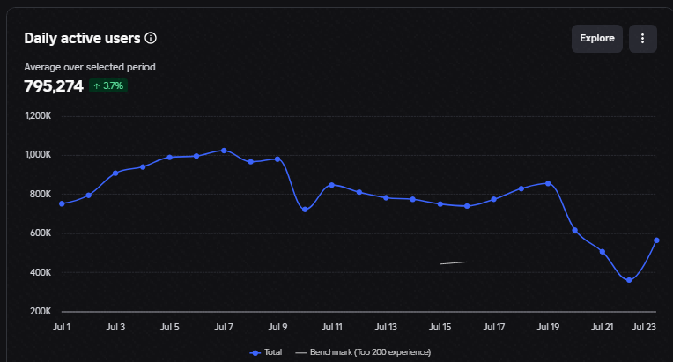
Daily active users, Jul 1–23. The break is Jul 19→20, before the Jul 22 publish.
Why this is conclusive: a drop that starts two days before the publish cannot have been caused by the publish. Jul 23 then recovers +53%, and growth has continued since. (Note: the Jul 23 spike is partly attributable to weekend admin activity, per Nina — but that affects the recovery, not the pre-publish decline, which is the load-bearing fact here.)
Still open: exact timestamp of the stolen-asset takedown. If it lands Jul 19–20, it fully explains the curve. Requested from Nina.

Part 2 — Where the render cost actually is
Method: MicroProfiler HTML dumps captured in Studio Play mode on the dev place, same camera position, 60 frames each. One variable changed between captures (particle emitters). Machine: AMD Ryzen 7 7800X3D, RX 9070 XT, 1080p, quality 12.

The ablation result
Metric | Baseline | Garden emitters off | All emitters off
Render (CPU) ms | 8.65 | 4.07 | 3.89
GPU ms | 1.40 | 1.79 | 1.31
Live particles | 9,730 | 1,323 | 10
Draw calls | 340 | 173 | 131
Materials | 1,368 | 174 | 114
Triangles | 610,738 | 471,615 | 577,199
Disabling Garden emitters alone recovers 4.58 ms of the 4.77 ms recovered by disabling everything.
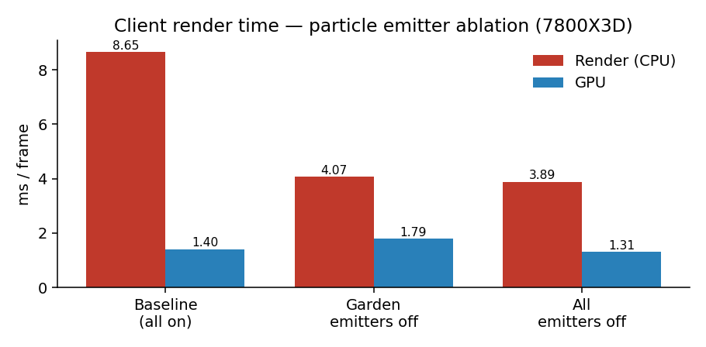
The GPU never moves — it sits at ~1.4 ms throughout while the render CPU thread is 8.65 ms. This is a CPU-bound render-submission problem, not a shading or overdraw problem. That matters for mobile: lowering graphics quality on a phone reduces GPU load, not CPU submission, so it will not help here.

Where the emitters live
Counted live in Workspace (single-player, one plot populated): 2,098 emitters total.
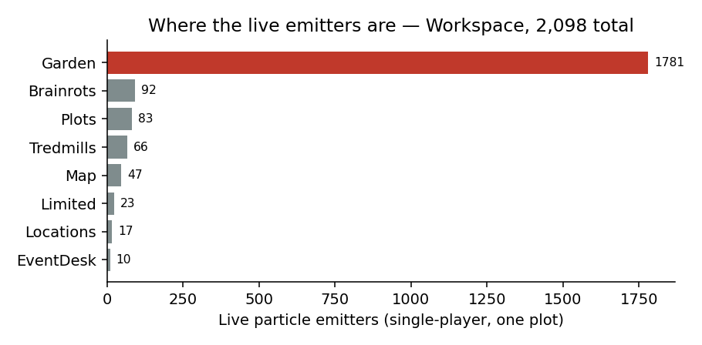
Source | Live emitters | Share
Workspace.Garden | 1,781 | 84%
Plots | 83 | 3.9%
Tredmills | 66 | 3.1%
Map | 47 | 2.2%
Brainrot models | 92 | 4.3%
Limited | 23 | 1.1%
Locations / EventDesk | 27 | 1.3%

What each particle costs
- ~0.50 µs of render CPU per live particle; ~2.1 µs per enabled emitter.
- Particles generated 92% of all materials (1,368 → 114) and 61% of all draw calls (340 → 131).
- On the test rig: ~114 FPS → ~254 FPS with emitters off. On mobile (4–6× slower single-thread), this is roughly the difference between ~20 FPS and ~45 FPS.

Caveats & confidence
- Single-player, one plot. On a full 6-plot server, brainrot emitters will be higher than 92 — but nowhere near Garden's 1,781, so the ranking holds. Re-measure on a populated server to firm up exact shares.
- The Garden-off capture had a slightly different scene state (1,931 vs 2,098 total emitters, and lower triangle count), so ~96% is approximate. A back-to-back same-session capture would nail it down.
- Weather events (Toxic / Candy) also carry emitters and were cycling during capture — worth isolating separately.

Recommended actions
Priority | Item | Action
HIGH | Workspace.Garden emitters | Audit ~1,781 emitters. Confirm whether Garden stays loaded outside the GrowGarden event — if so, every player pays ~4.5 ms permanently. Cull, pool, or LOD-gate by distance.
MED | Weather event emitters | Isolate Toxic/Candy emitter cost in a separate capture.
MED | Emitter budget per model | New models average 6.5 emitters each; newest world (Mystic) ~13. Set a per-model cap.
LOW | Pre-existing debt | 17 always-awake Guard Humanoids; 306 unthrottled animators; several 5.33 MB (1024²) textures. Not tied to the swap, but worth a pass.

Appendix — raw MicroProfiler context (baseline capture, brainrots visible during keyboard event)
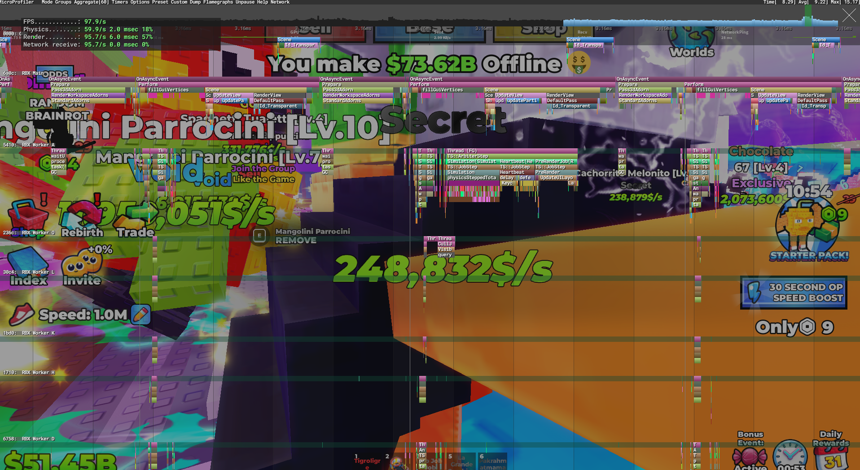
MicroProfiler flamegraph overlay, live game. Full HTML dumps available on request.

