Austin Byrd

CS 3300

Sprint 1

Part 2: Professional Documentation

To create a django app you need to first the code environment for the app. This is done by installing python, and django. Django requires python.

1. Install python
https://www.python.org/downloads/

2. Make a python virtual environment
py -m venv my_virtual_environment

3. Install Django
py -m pip install Django

4. Create your project
django-admin startproject my_project

5. Start Django Project
python manage.py runserver

6. Now that your Project is up make your App
django-admin startproject my_app

7. Your app will have Models, Views, Urls, Templates.

Structure below

Structure of App Folder:
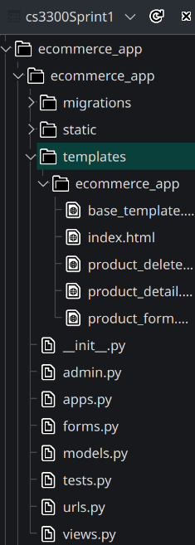The models used for the project is shown below. 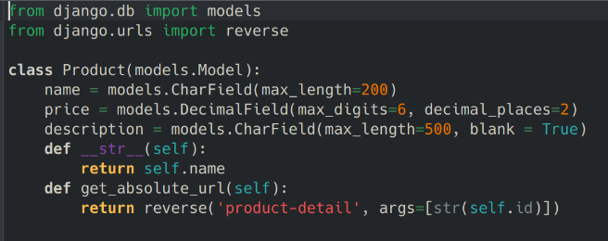

8. Make base template for website Home Page html
This has all the Bootstrap and HTML needed to structure the page and display it
It uses bootstrap classes for style and html divs for structure.
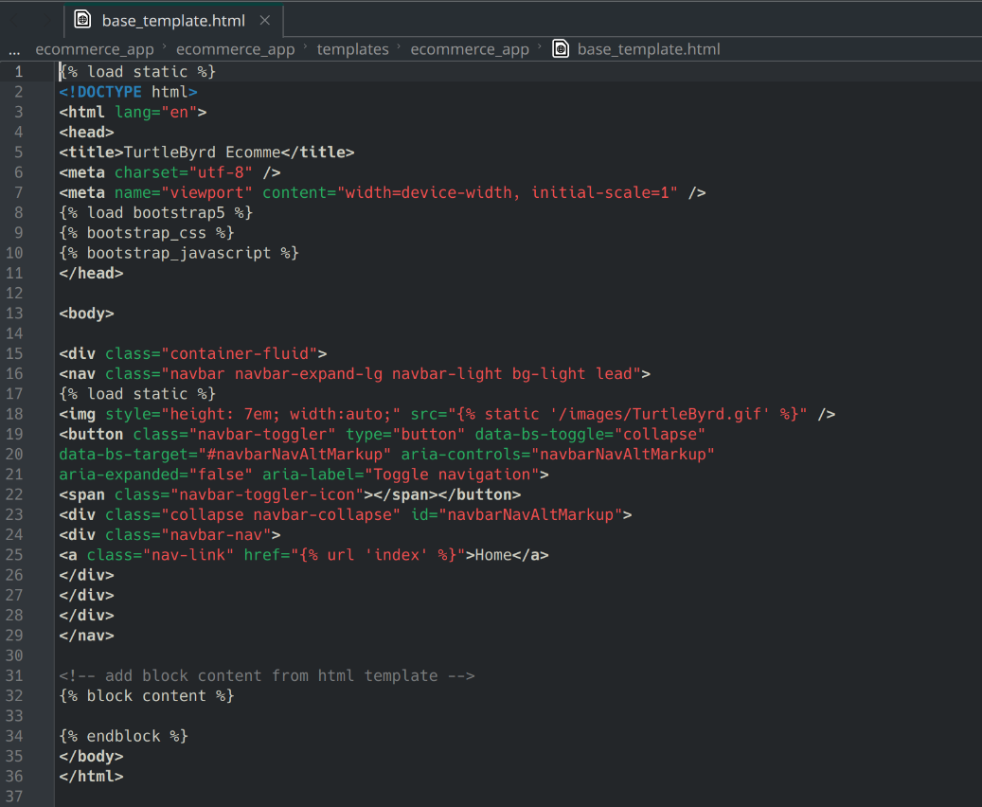

9. Index page for Home Page
# Notice this already includes functionality for the NEW, VIEW, UPDATE, and DELETE BUTTONS
# This will not be recovered but note that those buttons are there to go to different url’s made later.
This uses liquid html to dynamically bring in data from the database for all the products in the products model database spreadsheet.
This is done with the {% for i in products %} and {{i.element}} html inserts.
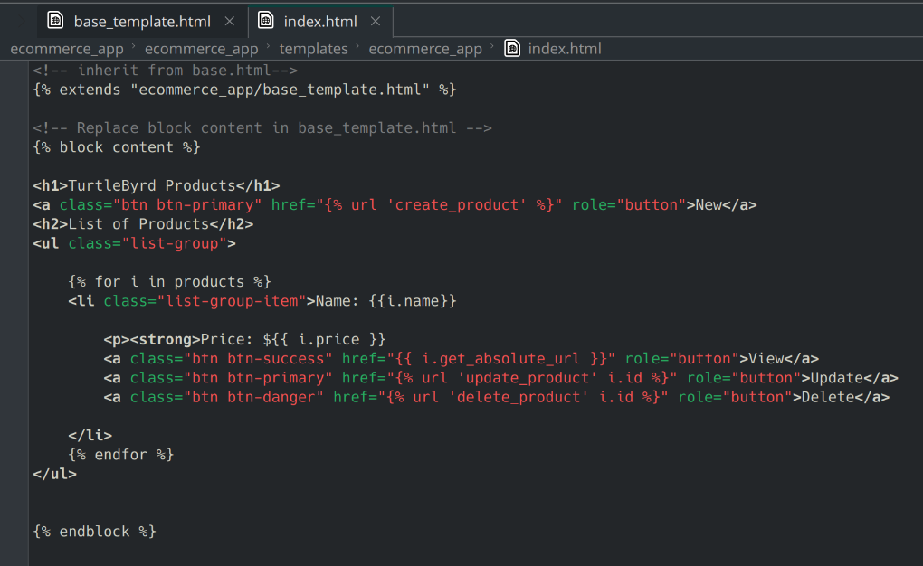

These HTML pages can be linked to via the Index View: In views.py
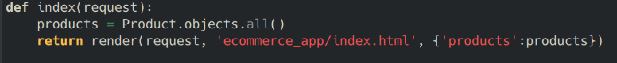

This view is called by the URL:
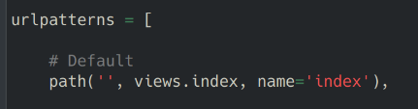

##################################################################################
This URL when searched for from the browser can then go to the view and process the request to send the user the html required for the browser to render the site.
##################################################################################

This allows the Home page to be displayed:
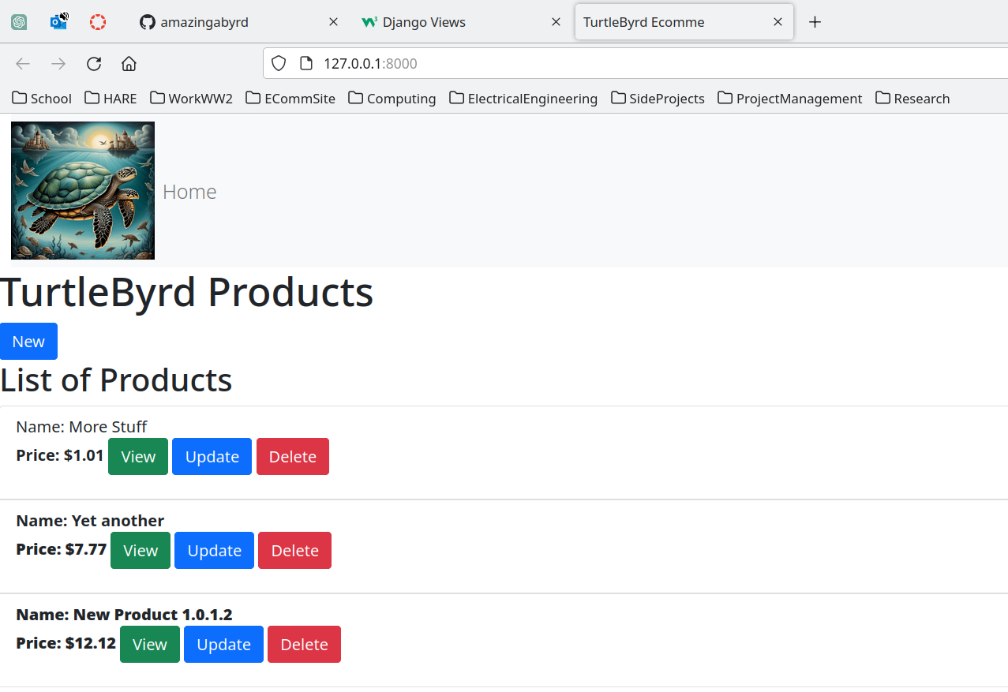
Disregard the buttons for New, View, Update, and Delete

10. Get New Product Page/Form Setup
With a new URL
View:
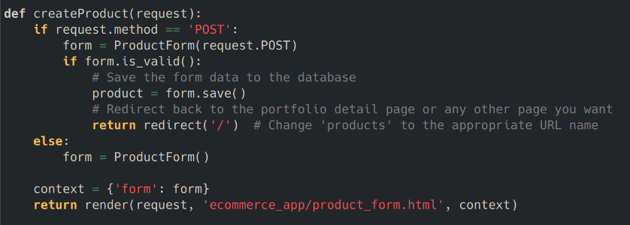
HTML Template:
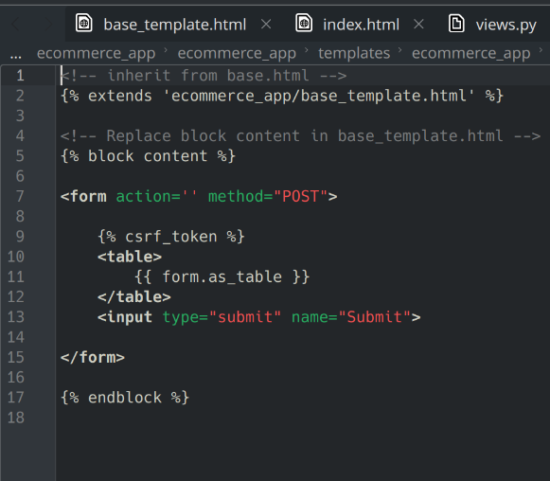

and Form:
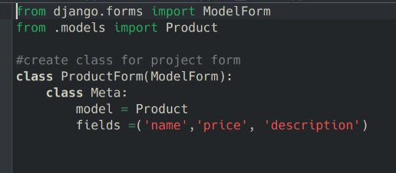
We have our create New Product Page
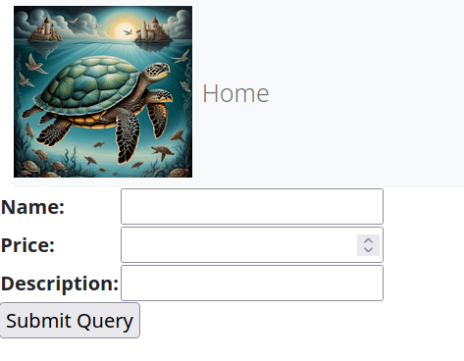

Thus making the Create Product functionality of the website.

11. Add Detail view for each product.

With a URL
View
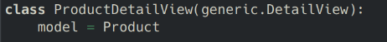
and HTML Template
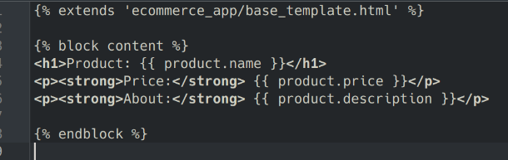
We add the functionality of the Detail View Page
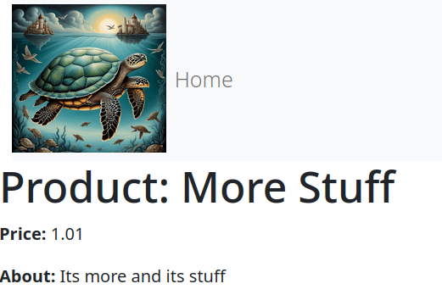

12. Add Update to each
With a URL
View
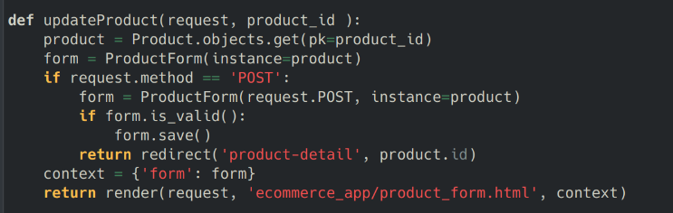
and Reusing the HTML Form Template
This allows the form to be displayed with the products information already filled in the form
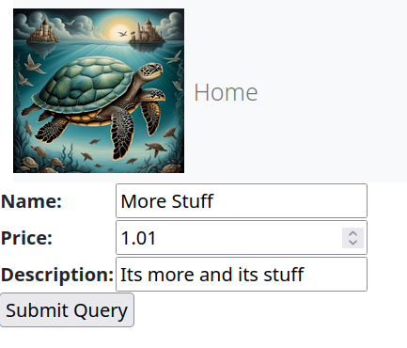

13. Add Delete Option for each Product.
With a new URL for confirmation of deletion
View
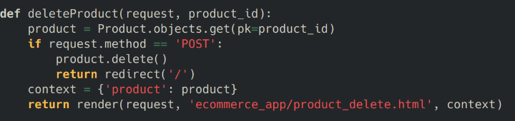
HTML
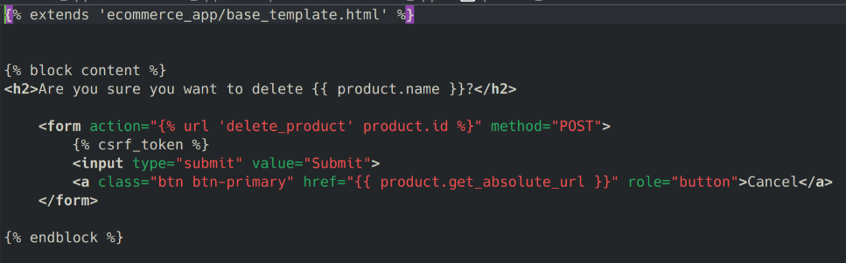
this allows you to delete products from the listings.

The picture on the homepage is kept in the static/images folder and it holds the .gif of the Picture used at the top left of the site. This is put into the html with a static command. Allowing the asset to be brought into the site.

