 | STAFF REPORT  City Council

DATE: | July 17, 2018
TO: | Honorable Mayor and City Councilmembers
FROM: | Christopher L. Foss, City Manager
SUBJECT: | Transit Center Site A-3 Planned Development Zoning with a related Stage 2 Development Plan, Site Development Review Permit, Tentative Map 8437, and Development Agreement for the Ashton at Dublin Station Project (PLPA 2017-00036)  Prepared by: Martha Battaglia, Associate Planner

Executive Summary:

The City Council will consider a request by the Applicant, Ashton at Dublin Station, LLC, to construct a residential project comprised of 220 apartment units, residential amenities including a fitness center, pool, roof top lounge, and 331 structured parking spaces on an approximately 2.36 acre site. The application includes Planned Development Zoning, Site Development Review, Condominium Map and a Development Agreement. The City Council denied the project in March, and the Applicant subsequently filed a lawsuit against the City. In accordance with the terms of the City’s Settlement Agreement with the Applicant, the City Council will reconsider the project and consider the proposed Development Agreement.

STAFF RECOMMENDATION:

Waive the reading and adopt an Ordinance Approving a Planned Development Zoning Stage 2 Development Plan for the Transit Center Site A-3; adopt the Resolution Approving a Site Development Review Permit and Tentative Map 8437 for the Transit Center Site A-3 project; and waive the reading and adopt an Ordinance Approving a Development Agreement between the City of Dublin and Ashton Station at Dublin, LLC.

FINANCIAL IMPACT:

No financial impact. All costs associated with processing the requested entitlements are borne by the Applicant.

DESCRIPTION:

The proposed Ashton at Dublin Station project is located at the northwest corner of DeMarcus Boulevard and Campbell Lane within the Transit Center (Figure 1). The site has a General Plan and Eastern Dublin Specific Plan land use designation of High Density Residential (25+ units per acre) and Planned Development Zoning with a Stage 1 Development Plan that permits a high density residential development. The 2.36-acre project site is the last remaining site with a residential land use designation in the Transit Center.

Figure 1. Vicinity Map
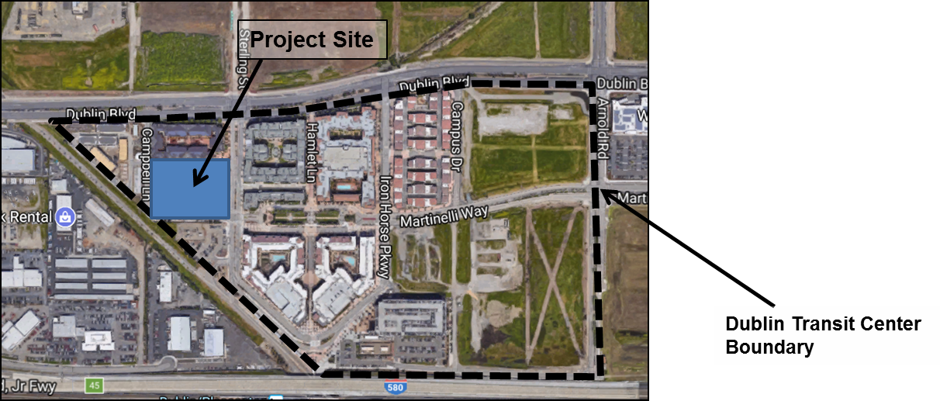

The Applicant proposed to construct a 220-unit apartment community and related amenities which include a fitness center, pool, roof top lounge, 331 structured parking spaces, and a mix of units as shown in Table 1 below. The proposed project includes three, four and five story building elements that are constructed over two levels of parking and vary in height from 61 feet to 83 feet at the peak of the tallest roof element. The project plans are included as Attachment 1. The requested entitlements include a Planned Development Stage 2 Development Plan, Site Development Review, a Condominium Map and a Development Agreement. Please refer to the Planning Commission Staff Report dated November 14, 2017 for a complete discussion of the project (Attachments 2).

Table 1. Unit Mix
Unit Type | Square Footage | # of Units | % of Project
Jr. 1 Bedroom | 640 SF | 22 | 10.0%
1 Bedroom | 800 SF | 94 | 42.7%
1+ Bedroom | 975 SF | 4 | 1.8%
2 Bedroom | 1,120 SF | 81 | 36.8%
2 Bedroom + den | 1,240 SF | 15 | 6.8%
3 Bedroom | 1,280 SF | 4 | 1.8%
Total |  | 220 | 100%

On November 14, 2017, the Planning Commission unanimously recommended approval of the proposed project (Attachments 3 and 4). The City Council held public meetings to consider the proposed project on December 5, 2017, February 6, 2018 and March 6, 2018. Ultimately, the City Council denied the project on March 6, 2018 (Attachment 5). The Applicant subsequently filed a lawsuit against the City. The City and the Applicant have entered into a Settlement Agreement. In accordance with the terms of the Settlement Agreement, the City Council will reconsider the project, and consider entering into a Development Agreement.

On July 11, 2018, the City Council introduced an Ordinance approving Planned Development Zoning with a Stage 2 Development Plan, and introduced an Ordinance approving a Development Agreement for the Ashton at Dublin Station residential project (Attachment 6). The City Council is currently requested to consider adopting Ordinances approving the Planned Development Zoning Stage 2 Development Plan and Development Agreement and adopting a resolution that approves the proposed Site Development Review Permit and Condominium Map for the Ashton at Dublin Station project.

The following is a brief overview of the requested entitlements.

- Planned Development Zoning: Establishing the detailed development plan for the site. This includes development standards, architectural standards, a preliminary site plan, and a preliminary landscape plan (Attachment 7).
- Site Development Review Permit: To construct a 220-unit apartment community and related amenities which include a fitness center, pool, roof top lounge, and 331 structured parking spaces (Attachment 8).
- Tentative Map 8437: For condominium purposes (Attachment 8).
- Development Agreement: Between the City of Dublin and Ashton at Dublin Station, LLC with the following terms: Developer to contribute a one-time payment of $600,000; Impact fees for the project shall be those that are in effect as of June 30, 2018; and a term of 5 years from the effective date (Attachments 9 & 10).

ENVIRONMENTAL REVIEW:

The City has determined that the project qualifies for a statutory exemption from CEQA under Government Code section 65457. The proposed project is consistent with the General Plan Land Use Designation for Site A-3 and does not exceed the units allowed by the Dublin Transit Center Stage 1 Planned Development Zoning. An EIR has been certified for the Dublin Transit Center Stage 1 Planned Development Zoning. The CEQA document in Support of a Specific Plan Exemption finds that no event as specified in Section 21166 of the Public Resources Code has occurred since the certification of the Dublin Transit Specific Plan EIR that requires preparation of a supplemental CEQA document. Public Resources Code Section 21166 and CEQA Guidelines Section 15162 identify the conditions requiring subsequent environmental review. After a review of these conditions, the City has determined that no subsequent EIR or Negative Declaration is required for this project. The approval of a Development Agreement does not require additional environmental review.

The CEQA Analysis in Support of a Specific Plan Exemption is included as Attachment 11. The 2002 Dublin Transit Center EIR, upon which the exemption relies, is available for review at the Planning Division in City Hall during normal business hours.

PUBLIC NOTICING:

In accordance with State law, a public notice was mailed to all property owners and occupants within 300 feet of the proposed project to advertise the project and the upcoming public hearing. A public notice also was published in the East Bay Times and posted at several locations throughout the City. A copy of this Staff Report has been provided to the Applicant.

ATTACHMENTS:
Item 6.1.a - 1. Project Plans Attachment
2. Planning Commission Staff Report dated November 14, 2017 without attachments
3. Planning Commission Meeting Minutes dated November 14, 2017
4. Planning Commission Resolutions 17-12, 17-13 & 17-14
5. City Council Meeting Minutes dated March 6, 2018
6. City Council Staff Report dated July 11, 2018 without Attachments
7. Ordinance Approving a Planned Development Zoning Stage 2 Development Plan
8. Resolution Approving a Site Development Review Permit and Tentative Map 8437
9. Ordinance Approving a Development Agreement between the City of Dublin and Ashton at Dublin Station
10. Exhibit A to Attachment 9 - Development Agreement between the City of Dublin and Ashton at Dublin Station
11. Ashton at Dublin Station CEQA Analysis update

