 | STAFF REPORT  City Council

DATE: | March 6, 2018
TO: | Honorable Mayor and City Councilmembers
FROM: | Christopher L. Foss, City Manager
SUBJECT: | Ashton at Dublin Station (Transit Center Site A-3) Planned Development Zoning Stage 2 Development Plan, Site Development Review Permit, and Tentative Map 8437 (PLPA 2017-00036)  Prepared by: Martha Battaglia, Associate Planner and John Bakker, City Attorney

Executive Summary:

The City Council will consider a request by the Applicant, Ashton at Dublin Station, to construct a residential project comprised of 220 apartment units, and related amenities including a fitness center, pool, roof top lounge, and 331 structured parking spaces on a 2.36-acre site located within the Dublin Transit Center. The proposed mix of residential units includes 22 studio units, 98 one-bedroom units, 96 two-bedroom units and 4 three-bedroom units. The site has a land use designation of High Density Residential (25.1 or greater units per acre). The application includes a Planned Development Zoning Stage 2 Development Plan, Site Development Review Permit, and Tentative Map for condominium purposes.

STAFF RECOMMENDATION:

Waive the reading and INTRODUCE an Ordinance Approving a Planned Development Zoning Stage 2 Development Plan for the Transit Center Site A-3, and adopt the Resolution Approving a Site Development Review Permit and Tentative Map 8437 for the Transit Center Site A-3 Project.

FINANCIAL IMPACT:

No financial impact to the City. All costs associated with this request are borne by the Applicant.

DESCRIPTION:

The proposed Ashton at Dublin Station project is located at the northwest corner of DeMarcus Boulevard and Campbell Lane within the Transit Center as shown in Figure 1 below. The site has a General Plan and Eastern Dublin Specific Plan land use designation of High Density Residential (25+ units per acre) and Planned Development Zoning with a Stage 1 Development Plan that permits a high density residential development. The subject site is surrounded by residential development on three sides, as shown in Table 1 below.

Figure 1. Vicinity Map
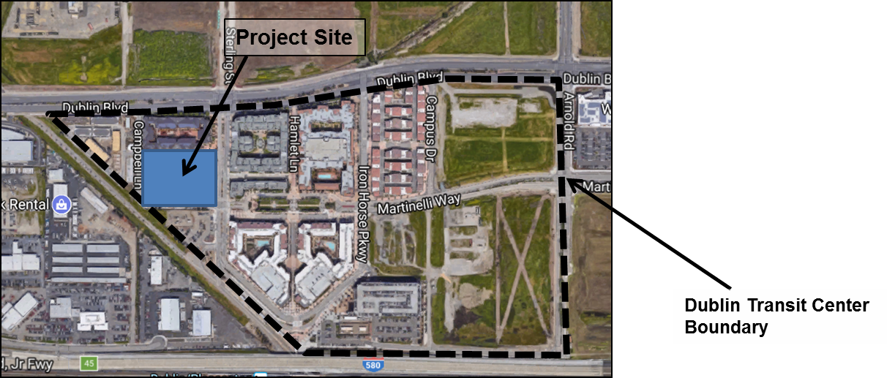

Table 1. Surrounding Land Uses
LOCATION | ZONING | GENERAL PLAN LAND USE | CURRENT USE | Building Height
North | PD | High-Density Residential | Camellia Place (112 units) | 55’3”; 4 stories (3 stories over 1 level parking)
South | PD | Public/Semi-Public | PG&E Substation | N/A
East | PD | High-Density Residential | Elan (257 multi-family townhomes & condominiums) | 85’ to peak of elevator tower, 79’ to main roofline; 7 stories above grade (5 stories + mezzanine over 2 levels of parking (1 level is subterranean))
West | PD | Medium-High Density Residential | Tribeca (52 townhomes) | 37’; 3 stories
*Note: Correction to building heights originally listed in Planning Commission Staff Report dated 11/14/17.

The Applicant is requesting approval of a Planned Development Zoning Stage 2 Development Plan, Site Development Review Permit and Condominium Map to construct a 220-unit apartment community and related amenities which include a fitness center, pool, roof top lounge, and 331 structured parking spaces. The proposed project includes 3, 4 and 5 story elements that are over 2 levels of parking, and vary in height from 61 feet to 83 feet at the peak of the tallest roof element. The project plans are included as Attachment 1 to this Staff Report. Please refer to the Planning Commission Staff Report dated November 14, 2017 for a complete discussion of the project (Attachment 2). The Planning Commission unanimously recommended approval of the project (Attachments 3 & 4).

On December 5, 2017, the City Council held a Public Hearing to consider the proposed project (Attachment 5). The City Council directed Staff to prepare a resolution of denial for consideration at a future meeting. Subsequently, the Applicant requested to postpone further consideration of the project until February 6, 2018, in order to give them time to prepare refined design documents and supplemental information to address the concerns expressed by the City Council. On January 9, 2018, the City Council directed Staff to schedule a Study Session to discuss the project.

On February 6, 2018, the City Council held a Study Session to further review and discuss the proposed project. The Applicant presented their refined project proposal. The refinements included enhanced drawings to better highlight the project details, enhanced color renderings, and a modified unit mix that reduced the number of 3 bedroom units. The currently proposed mix of units is shown in Table 2 below.

Table 2. Unit Mix
Unit Type | Square Footage | # of Units | % of Project
Jr. 1 Bedroom | 640 SF | 22 | 10.0%
1 Bedroom | 800 SF | 94 | 42.7%
1+ Bedroom | 975 SF | 4 | 1.8%
2 Bedroom | 1,120 SF | 81 | 36.8%
2 Bedroom + den | 1,240 SF | 15 | 6.8%
3 Bedroom | 1,280 SF | 4 | 1.8%
Total |  | 220 | 100%

Staff recommends that the City Council adopt the Ordinance approving the Planned Development Zoning Stage 2 Development Plan (Attachment 6) and the Resolution approving the Site Development Review Permit and Condominium Map (Attachment 7) for the Transit Center Site A-3 project.

ALTERNATIVE ACTION:

Staff, pursuant to the direction given at the December 5, 2017 City Council meeting, has prepared a resolution denying the application (Attachment 8) for the City Council’s consideration. The basis for the proposed denial would be several-fold. First, the proposed resolution denies the approval of the Stage 2 Development Plan. The focus of the proposed disapproval of the Stage 2 Development Plan is on the proposed density of the Project. The Stage 1 Development Plan adopted for the entire Transit Center established a net density of the Site A of approximately 64 units per acre, and the net density was later reduced to 52 units per acre. The proposed project would result in a site with a net density of 93 units per acre. Although the Stage 1 Development Plan established density based on Site A as a whole, the City Council could find that the density of the proposed project is inconsistent with the Stage 1 Development Plan, given the Project site would exceed the net density allowed over the entire site by nearly 45% (and by nearly 79% over the revised Stage 1 Development Plan). The disapproval of the Stage 2 Development Plan also focuses on the height, massing, and design of the Project and the Project’s incompatibility with existing and future development in the surrounding area. Second, the proposed denial would disapprove the proposed Site Development Review approval and Tentative Map on the grounds that (a) such permits cannot be approved in the absence of a Stage 2 Development Plan and (b) the proposed Project’s design, mass, height, and scale are incompatible with its surroundings.

The Applicant and a housing advocacy organization (the California Renters Legal Advocacy and Education Fund (CaRLA)) have asserted that a disapproval of the Project would be unlawful and lead to litigation. In particular, the Applicant asserts that the disapproval would be a breach of the Master Development Agreement Between the City of Dublin and the Surplus Property Authority of Alameda County for the Dublin Transit Center Project, dated May 6, 2003 as amended on October 4, 2005 (“the Development Agreement”), and the Applicant and CaRLA assert that the disapproval would violate the provisions of the Housing Accountability Act. The Development Agreement gives the Developer a “vested right to develop” the Site A-3 property “in accordance with” the existing entitlements. The vested existing entitlements include the General Plan, Eastern Dublin Specific Plan, and Stage 1 Development Plan, all of which provide for high-density, transit-oriented development on the site. The Housing Accountability Act (Government Code section 65589.5(j)) prohibits the City from disapproving a housing project that “complies with applicable, objective general plan, zoning, and subdivision standards and criteria, including design review standards” unless it finds that the project would have “specific, adverse impact upon the public health or safety” that cannot be mitigated. The Applicant has asserted that both the Development Agreement and the Housing Accountability Act compels approval of the project by the City.

In litigation challenging a disapproval, the City would, among other things, assert that the proposed denial violates neither the Development Agreement nor the Housing Accountability Act because of the disapproval of the Stage 2 Development Plan, a discretionary legislative zoning approval. The Stage 2 Development Plan, the Site Development Review, and the Tentative Map approvals sought by the Applicant are not vested. Therefore, the City’s decision to disapprove these proposed entitlements because of their inconsistency with one of the existing entitlements (the Stage 1 Development Plan) is not a breach of the Development Agreement. Similarly, the City would assert that the Housing Accountability Act is inapplicable unless and until the City has adopted the Stage 2 Development Plan; in the absence of such an approval, a project within the Transit Center cannot be determined to comply with the City’s “applicable, objective . . . zoning . . . standards and criteria.”

It is not certain that the City’s defenses would be successful. But, litigation challenging a disapproval appears much more certain, and it would be costly and time consuming for City staff. Although the Development Agreement does not allow monetary damages against the City for breach, the Applicant may be able to seek a court order compelling the City to approve the project. If a lawsuit is brought under the Housing Accountability Act and the petitioner prevails, the City could be liable for civil penalties. In addition, in both cases, the City could potentially be liable to pay the other side’s attorneys’ fees and costs.

The Applicant’s attorney submitted a letter on their behalf that outlines the legal limitations on the City Council’s discretion regarding the project, and the potential outcomes if the City Council voted to deny the proposed project (Attachment 9).

ENVIRONMENTAL REVIEW:

Staff recommends that the project be found statutorily exempt from the California Environment Quality Act (CEQA) under Government Code section 65457. The proposed project is consistent with the General Plan Land Use Designation of High-Density Residential and is consistent with the Eastern Dublin Specific Plan. An Environmental Impact Report (EIR) has been certified for the Dublin Transit Center Stage 1 Planned Development Zoning (SCH # 20001120395, City Council Resolution No. 215-02 adopted on November 19, 2002, incorporated herein by reference). The CEQA document in Support of a Specific Plan Exemption finds that no event as specified in Section 21166 of the Public Resources Code has occurred since the certification of the Dublin Transit Specific Plan EIR that requires preparation of a supplemental CEQA document. Public Resources Code Section 21166 and CEQA Guidelines Section 15162 identify the conditions requiring subsequent environmental review. After a review of these conditions, the City has determined that no subsequent EIR or Negative Declaration is required for this project.

The CEQA Analysis in Support of a Specific Plan Exemption is included as Attachment 10. The 2002 Dublin Transit Center EIR, upon which the exemption relies, is available for review at the Planning Division in City Hall during normal business hours.

PUBLIC NOTICING:

Although not required, a public meeting notice was mailed to all property owners and occupants within 300 feet of the proposed project and posted at several locations throughout the City for the February 20, 2018 meeting. The item was postponed until the March 6, 2018 City Council meeting. A copy of this Staff Report was provided to the Applicant and was made available on the City’s webpage.

ATTACHMENTS:
1. Project Plans
2. Planning Commission Staff Report dated November 14, 2017 without attachments
3. Planning Commission Meeting Minutes dated November 14, 2017
4. Planning Commission Resolutions No. 17-12, 17-13 & 17-14
5. City Council Meeting December 5, 2017 Minutes
6. Ordinance Approving a Planned Development Zoning Stage 2 Development Plan
7. Resolution Approving a Site Development Review Permit and Tentative Map 8437
8. Resolution Disapproving the Stage 2 Development Plan, Site Development Review and Tentative Map
9. Letter from Megan Jennings with Morrison Foerster, dated February 20, 2018
10. Ashton at Dublin Station CEQA Analysis

