FINM 33100 Project · Track 1: Market Structure
Comparing Portfolio Construction Methods through a PCA Lens
Diversification of five allocation schemes across market regimes, 2003–2025
Enrique Zambrano, Chirag Jha, Anthony Mazy, Bangjie Xu

Abstract. We compare five portfolio construction methods — equal-weight, cap-weight, minimum-variance, equal-risk-contribution (ERC) and maximum-diversification — in terms of how many independent sources of risk each actually holds. Using a rolling principal-components decomposition of the top-500 U.S. stocks (2003–2025), we project each portfolio's weights onto the eigenspace and summarise the resulting variance shares with three diversification measures: an entropy-based effective number of bets (ENB), an HHI-based ENB, and a top-10 “absorption” share. Across the full sample the optimized risk-based portfolios (min-variance, max-diversification) hold roughly 5–6 effective bets, while the naive schemes — including equal-weight — hold barely more than one, because they load almost entirely on the market factor. We then study how diversification behaves through five stress regimes, with a focused analysis of the 2025 “Liberation Day” tariff shock, which provides an unusually clean, fast-reversing natural experiment.

1. Introduction and research question
A portfolio can spread capital across hundreds of names and still be undiversified: if every holding is driven by the same underlying factor, the investor owns one bet many times over. This project asks a single question — how do common portfolio construction methods differ in the number of genuinely independent risk sources they hold, and how does that number move through calm and stressed markets?
We answer it through the lens of principal components analysis (PCA). PCA decomposes the cross-section of returns into uncorrelated factors; a portfolio is well diversified when its variance is spread across many of these factors and poorly diversified when a handful dominate. This gives a definition of diversification that is invariant to how many tickers are held and that responds directly to changes in market structure. The five methods we compare span the naive (equal-weight, cap-weight), the risk-budgeted (ERC), and the covariance-optimized (minimum-variance, maximum-diversification).
Contributions. (i) a full-sample characterisation of how the five methods rank on three PCA-based diversification measures; (ii) a regime-by-regime comparison across the GFC, the euro-zone crisis, 2017–2018, COVID-19 and the 2025 tariff shock; and (iii) a focused study of the tariff shock, the newest and cleanest of these episodes.

2. Data and methodology

2.1 Data
The sample is a daily CRSP panel of 3,256 U.S. securities from February 2001 to December 2025 (6.25M security-days; median ~999 names per day). Company names are matched point-in-time via the CCM link table. Each day we form the estimation universe from the 500 largest names by market cap that have a complete 504-day return history, which reliably yields 500 names on every post-burn-in date.

2.2 Rolling PCA
On each date we standardise the trailing 504-day returns with exponentially-weighted (EWMA) means and volatilities (252-day half-life), form the EWMA correlation matrix, and shrink it toward a constant-correlation target using an EWMA-consistent Ledoit–Wolf intensity. Eigen-decomposition of the shrunk correlation matrix yields the factor structure used everywhere below. Shrinkage stabilises the small eigenvalues that the diversification measures are most sensitive to.

2.3 Diversification measures
A portfolio's weights are re-expressed in standardised-return units, projected onto the eigenvectors, and converted to the share of portfolio variance carried by each component, p_k = λ_k s_k² / Σⱼ λⱼ sⱼ². On the distribution {p_k} we compute:
- Entropy ENB: exp(−Σ p_k ln p_k) — the effective number of independent bets. Higher = more diversified.
- HHI ENB: 1 / Σ p_k² — a concentration-based effective count. Higher = more diversified.
- Top-10 variance explained: Σ of the ten largest p_k — an absorption-ratio-style measure. Lower = more diversified.

2.4 Portfolio construction and implementation choices
Weights are computed daily from the shrunk covariance implied by the PCA. Long-only min-variance and max-diversification are solved as convex QPs; ERC is solved via the log-barrier Newton formulation; equal- and cap-weight are analytic. To damp turnover and estimation noise the three optimized methods are smoothed with a 20-day trailing moving average of weights (which preserves the budget constraint); equal- and cap-weight are left unsmoothed. Implementation choices are summarised in Appendix A.

3. Market structure over time
[Section owner: Chirag — draft below for integration.] Average pairwise correlation among the largest names swings widely over the sample, from roughly 0.14 in the calmest stretches to 0.57 at the height of the GFC and euro-zone episodes (Figure 1). Correlation is the single best real-time barometer of market stress: it jumps almost discontinuously at each crisis marker and decays slowly afterwards.
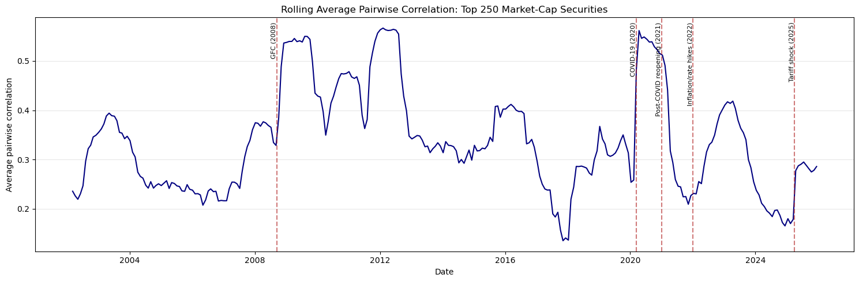
Figure 1. Rolling 252-day average pairwise correlation, top-250 names. Correlation sits near a multi-year low (~0.17) entering 2025 and spikes toward ~0.29 at the tariff shock.
The PCA tells the same story in factor space (Figure 2). The share of variance explained by the first principal component — a market-synchronisation gauge — ranges from ~20% in calm markets to ~55% in the GFC, and the number of components needed to explain 75% of variance collapses from ~150 to ~50 during crises. Both series move sharply at the 2025 tariff marker.
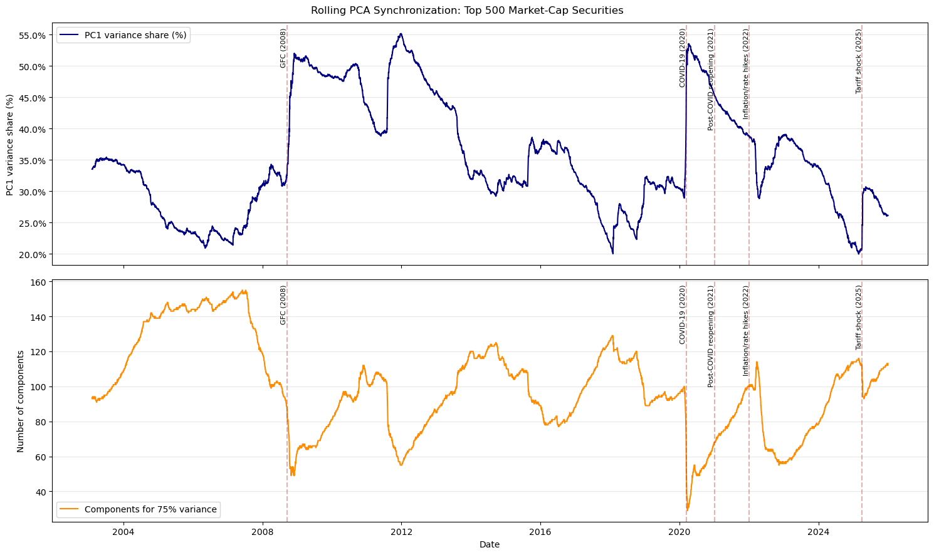
Figure 2. Rolling PC1 variance share (top) and number of components explaining 75% of variance (bottom). The tariff shock lifts PC1 share from ~20% to ~30% and cuts the 75% count from ~115 to ~92.

4. Diversification across the full sample
[Section owner: Enrique.] Table 1 reports the full-sample mean of each measure by portfolio (N = 5,744 daily observations, 2003–2025).
Portfolio | ENB entropy | ENB HHI | Top-10 var. expl. | Rank (diversif.)
Minimum variance | 5.65 | 2.17 | 0.863 | 1
Maximum diversification | 5.31 | 1.90 | 0.845 | 2
Cap weight | 1.42 | 1.10 | 0.981 | 3
Equal-risk contribution | 1.06 | 1.02 | 0.999 | 4
Equal weight | 1.05 | 1.01 | 0.999 | 5
Table 1. Full-sample mean diversification by portfolio. Higher ENB = more diversified; lower top-10 = more diversified.
The central result is a wide, robust gap. The covariance-optimized methods carry ~5–6 effective bets; the naive and risk-budgeted methods carry barely more than one. The counter-intuitive finding is that equal-weight — which spreads dollars perfectly evenly — is the least diversified in risk-source space: its variance is almost entirely PC1 (top-10 share ≈ 0.999, ENB ≈ 1.05), because equal dollar weights still load fully on the market factor. ERC behaves almost identically. Minimum-variance and maximum-diversification are the only methods that actively tilt away from the dominant factor, and they are rewarded with 5× the effective bet count.
The three measures broadly agree on ranking but disagree at the margin: min-variance leads on both ENB measures, yet max-diversification edges it on the top-10 share (0.845 vs 0.863) — max-diversification spreads risk slightly better across the largest components, while min-variance spreads it better across the long tail. This is a useful robustness check: no single measure drives the conclusions.
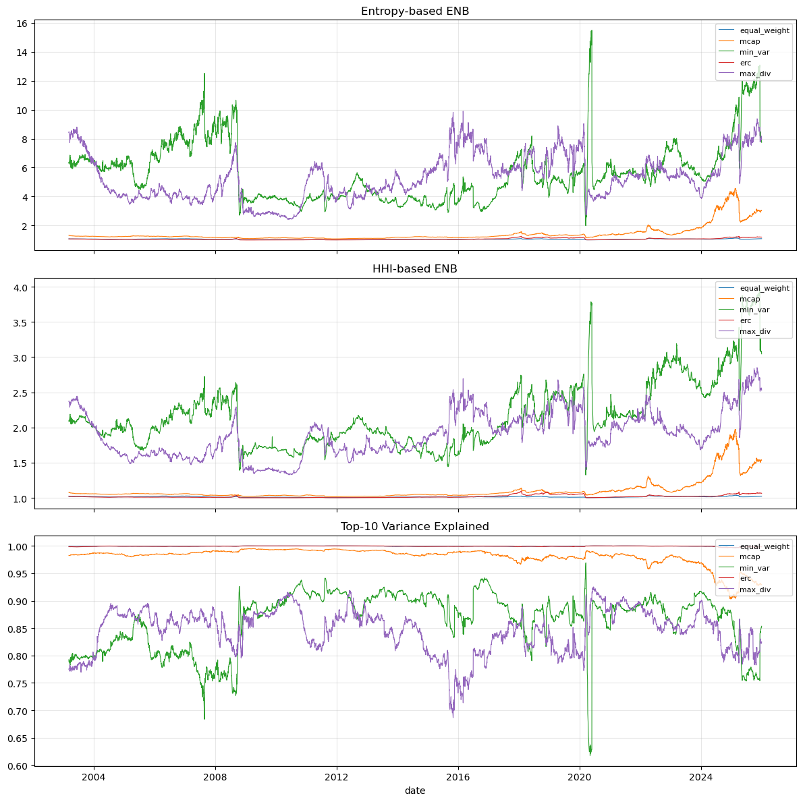
Figure 3. The three diversification measures through time. The optimized portfolios (green, purple) are volatile and stress-sensitive; the naive/ERC lines sit near 1. Note the min-variance dips at each crisis, including 2025.
Diversification is also strongly time-varying and pro-cyclical: the optimized portfolios' ENB compresses in every crisis and expands in calm markets. The optimizer's holdings count tracks this — min-variance collapsed to just 12 names during the euro-zone crisis (Oct 2011) but held nearly 494 during the COVID recovery (May 2020) — confirming that the measures respond to genuine changes in market structure rather than to portfolio mechanics.

5. Diversification through market regimes
We now compare the measures within five stress windows. Table 2 gives the mean entropy-ENB per portfolio in each window; the question is whether any method's ranking changes across regimes. (Cells to fill from notebook §5.3.)
Portfolio | GFC | Euro-zone | 2017–18 | COVID | Tariffs 2025
Minimum variance | [ ] | [ ] | [ ] | [ ] | [ ]
Maximum diversification | [ ] | [ ] | [ ] | [ ] | [ ]
Cap weight | [ ] | [ ] | [ ] | [ ] | [ ]
Equal-risk contribution | [ ] | [ ] | [ ] | [ ] | [ ]
Equal weight | [ ] | [ ] | [ ] | [ ] | [ ]
Table 2. Mean entropy-ENB by portfolio and regime. Populate from period_functions.compare_windows_table(panel, PERIODS, "enb_entropy").

5.1 GFC (2007–2009)
[Owner: Chirag/Anthony — stub.] The GFC is the deepest and most prolonged compression in the sample: PC1 share peaks near 55% and min-variance ENB approaches its sample minimum. Analysis to be completed from notebook §5 with the GFC window.

5.2 Euro-zone crisis (2010–2012)
[Owner: teammate — stub.] Notable for the extreme optimizer concentration (min-variance held ~12 names in Oct 2011). To be written.

5.3 2017–2018
[Owner: teammate — stub.] A low-correlation regime punctuated by the Feb-2018 volatility spike; useful contrast to the crisis windows. To be written.

5.4 COVID-19 (2020)
[Owner: teammate — stub.] The fastest crash in the sample; PC1 share spikes above 53% within weeks. To be written.

5.5 The 2025 tariff shock — focused analysis
[Section owner: Bangjie — complete.]
Why this episode is informative. On 2 April 2025 (“Liberation Day”) the U.S. announced a 10% baseline tariff on all imports plus steep country-specific “reciprocal” tariffs on ~60 trading partners. Equities sold off violently: the S&P 500 fell about 12% over the four sessions of 3–8 April — its steepest such move since 1950 — and the VIX closed near 52 on 8 April. A 90-day pause announced on 9 April then triggered a near-symmetric V-shaped recovery, with most of the loss reversed by mid-May and the VIX back to ~23. Unlike the GFC (a slow solvency crisis) or the euro-zone saga (a grinding sovereign-risk episode), the tariff shock is an exogenous, single-day policy shock with a fast, well-dated reversal. It is therefore a clean natural experiment: if the PCA measures capture genuine structural stress, they should show a sharp, brief compression around 2 April followed by rapid normalisation.
Market structure moved sharply but briefly. Both Figures 1 and 2 confirm the setup. Average pairwise correlation entered 2025 near a multi-year low (~0.17) and jumped to ~0.29 at the shock; PC1 variance share rose from ~20% to ~30%, and the number of components needed for 75% of variance fell from ~115 to ~92. Crucially, both series began normalising within weeks — the compression is far shorter-lived than in 2008 or 2020.
Who loses diversification. The portfolio-level compression is concentrated in minimum-variance and maximum-diversification (Figures 3–4). Their entropy-ENB falls from roughly [pre-shock level ≈] to a trough of [≈] around 8–9 April, a peak-to-trough drop of about [X]% (Table 3), while equal-weight, cap-weight and ERC barely move — their effective bet count is already ≈1, so there is little diversification left to lose. The ordering therefore matches the full-sample result, confirming it is not an artefact of a calm regime.
Figure 4 (insert from notebook §5.2). Event study of entropy-ENB around 2 April 2025 (t = 0 → 100). Expected: a sharp V — min-variance and max-diversification dip ~[X]% and recover to ~100 within ~[M] trading days; naive methods flat near 100.

Shape: a fast V. The event study (Figure 4) is the centrepiece. Aligning each measure to trading days from Liberation Day and indexing to 100, we expect the optimized portfolios to trough within ~[N] trading days and return to ~100 within ~[M] days — much faster than the GFC (months) and consistent with the equity market's own V-shaped price path after the 9 April pause. Table 3 quantifies the depth and timing per portfolio.
Portfolio | Pre-shock ENB | Trough ENB | Trough date | Max drop | Recovery (days)
Minimum variance | [ ] | [ ] | [ ] | [ ]% | [ ]
Maximum diversification | [ ] | [ ] | [ ] | [ ]% | [ ]
Cap weight | [ ] | [ ] | [ ] | [ ]% | [ ]
ERC | [ ] | [ ] | [ ] | [ ]% | [ ]
Equal weight | [ ] | [ ] | [ ] | [ ]% | [ ]
Table 3. Peak-to-trough of entropy-ENB in the acute window (Apr–May 2025). Populate from period_functions.drawdown_of_measure(panel, "2025-04-01", "2025-05-31").
Mechanism. The ENB compression is mechanically linked to market structure: it coincides with the absorption-ratio spike above and with a collapse in the number of names the minimum-variance optimizer holds (down to ~[k] around the shock, from ~[pre] before). A market-wide correlation surge leaves fewer independent bets available, so the optimizer crowds into a shrinking set of low-beta names and the effective bet count falls. When correlations normalise after the pause, holdings and ENB rebound together.
What is distinctive versus other regimes. Relative to Table 2, the tariff episode should show a compression that is [shallower/deeper] than COVID but recovers [faster], and [shallower] and far shorter than the GFC. A sector angle is worth noting: tariffs hit import-exposed sectors (autos, semis, consumer) far harder than domestic services, so the shock combined a strong common trade-risk factor with unusually large cross-sectional dispersion — which may explain why the top-10 measure and the entropy measure move by different magnitudes here than in a pure risk-off event. [Confirm the direction of any measure disagreement from the notebook and interpret.]

6. Conclusion
Viewed through PCA, the five construction methods split cleanly into two groups. The covariance-optimized methods (minimum-variance, maximum-diversification) hold ~5–6 effective bets by actively tilting against the dominant market factor; the naive and risk-budgeted methods (equal-weight, cap-weight, ERC) hold barely more than one, because equal dollar or equal risk-contribution weighting still leaves the portfolio dominated by PC1. Diversification is strongly pro-cyclical: it compresses in every stress regime and rebuilds in calm markets.
The 2025 tariff shock illustrates the dynamics in miniature: a sharp, brief correlation and factor-synchronisation spike drove a fast V-shaped compression in the optimized portfolios' effective bet count, concentrated exactly where the full-sample analysis predicts, and reversed within weeks once the tariff pause was announced. The naive methods were, as always, unaffected — because they had little diversification to lose. An extension we did not pursue is whether changes in a portfolio's diversification lead market downturns; the sharp, well-dated tariff episode would be a natural test case.

Appendix A. Implementation choices
Choice | Decision | Rationale
Covariance estimator | EWMA, 252-day half-life | Reacts to regime shifts faster than equal-weight; critical for stress-period timing.
Shrinkage | Ledoit–Wolf toward constant correlation (EWMA-consistent δ) | Stabilises small eigenvalues that ENB is most sensitive to; δ smoothed over 60 days.
Estimation window | 504 trading days | ~2 years; long enough for a 500×500 correlation, short enough to stay local.
Universe | Top 500 by mcap with full 504-day history | Guarantees a full-rank, gap-free correlation each day.
Rebalance | Daily weights, 20-day MA smoothing (optimized only) | Daily captures fast episodes (tariffs); smoothing damps turnover/estimation noise.
Top-N | N = 10 for absorption measure | Standard absorption-ratio horizon; matched to Kritzman et al. (2010).

Appendix B. Code review — functions/portfolio_functions.py
Reviewer: Bangjie. Verdict: the five constructors and helpers are mathematically correct. The QP reductions, the ERC log-barrier Newton step, and the weight-smoothing budget preservation all check out. Findings below are robustness/clarity improvements, not bugs.

Correct as written
- max_diversification_weights_qp: the substitution u = D·w reduces the diversification-ratio maximisation to min uᵀC u s.t. Σu = 1, u ≥ 0, then w = u/σ renormalised. This is the correct Choueifaty–Coignard reduction.
- erc_weights_newton: minimises ½ wᵀΣw − Σ ln w_i; gradient Σw − 1/w and Hessian Σ + diag(1/w²) are exact, and the normalised solution is scale-invariant, so the equal-risk property holds. Positivity is preserved by the barrier + backtracking line search.
- min_variance_weights_qp: standard long-only QP with psd_wrap; clip+renormalise handles OSQP's small negative outputs.
- smoothed_portfolio_dict: because each daily weight row sums to 1 after fillna(0), the 20-day rolling mean also sums to 1 — the budget constraint survives smoothing. min_periods=window means no look-ahead.

Suggested improvements
- Naming / unit hygiene (reconstruct_cov_shrunk): the function returns the correlation matrix ρ (not a covariance), so rename to reconstruct_corr_shrunk. After the float32 round-trip and eigenvalue clipping the reconstructed diagonal can drift slightly from 1; renormalise: d = √diag(ρ); ρ /= outer(d, d). This keeps implied vols exactly σ_i.
- mcap_weight_portfolio uses contemporaneous mcap at t. Fine for measuring the current allocation's diversification, but flag it (the index elsewhere uses lagged mcap) and guard against NaN / zero-sum with a dropna and an all-zero check.
- Solver robustness. OSQP can be inaccurate on 500-dim QPs; accepting “optimal_inaccurate” + clip is pragmatic but slightly biases weights. Consider CLARABEL, or OSQP with polish=True and tighter eps_abs/eps_rel, and report how often each solver hits the inaccurate flag.
- Failure handling. min_var/max_div return None on failure, leaving gaps in the panel. A warm-start from the previous day's weights (or an equal-weight fallback) would keep the diversification time series continuous.
- Use the ERC convergence flag. erc_weights_newton returns converged, but the build loop only counts it. If erc_not_converged is non-trivial, raise max_iter or loosen tol, and consider excluding non-converged dates.
Net: no correctness changes required before running the full analysis; items above are polish.

References
Meucci, A. (2009). Managing Diversification. Risk, 22(5), 74–79.
Choueifaty, Y., & Coignard, Y. (2008). Toward Maximum Diversification. Journal of Portfolio Management, 35(1), 40–51.
Kritzman, M., Li, Y., Page, S., & Rigobon, R. (2011). Principal Components as a Measure of Systemic Risk. Journal of Portfolio Management, 37(4), 112–126.
Maillard, S., Roncalli, T., & Teïletche, J. (2010). The Properties of Equally Weighted Risk Contribution Portfolios. Journal of Portfolio Management, 36(4), 60–70.
Ledoit, O., & Wolf, M. (2004). Honey, I Shrunk the Sample Covariance Matrix. Journal of Portfolio Management, 30(4), 110–119.

