THE RAG PIPELINE
A Detailed Flow Diagram with Section-by-Section Descriptions

How a Retrieval Augmented Generation system works
Companion to the CampusX RAG study notes
Three diagrams · Overview, Indexing, and Query-Time Flow

Contents

1. How to Read This Document
A RAG (Retrieval Augmented Generation) system has four stages: Indexing, Retrieval, Augmentation, and Generation. This document presents the pipeline as three connected diagrams, moving from the big picture down to the details, with a description of every section beneath each diagram.

Diagram | What it shows | Read it for
A. Pipeline overview | The four stages end to end, from user query to response. | The overall shape of the system.
B. Indexing in detail | The four sub-steps that build the knowledge base. | How data is prepared before any question is asked.
C. Query-time flow | What happens live when a user asks a question. | How retrieval, augmentation, and generation cooperate.

Two timelines in one pipeline
A key idea: the stages do not all run at the same time. Indexing happens once, ahead of time — it is offline preparation. Retrieval, Augmentation, and Generation happen live, every time a user asks a question. Keeping these two timelines separate is the easiest way to understand RAG.

2. Diagram A — The RAG Pipeline Overview
At the highest level, RAG is the marriage of two ideas: information retrieval (an old computer-science topic) and text generation (which became prominent with LLMs). The diagram below shows the four stages in order.
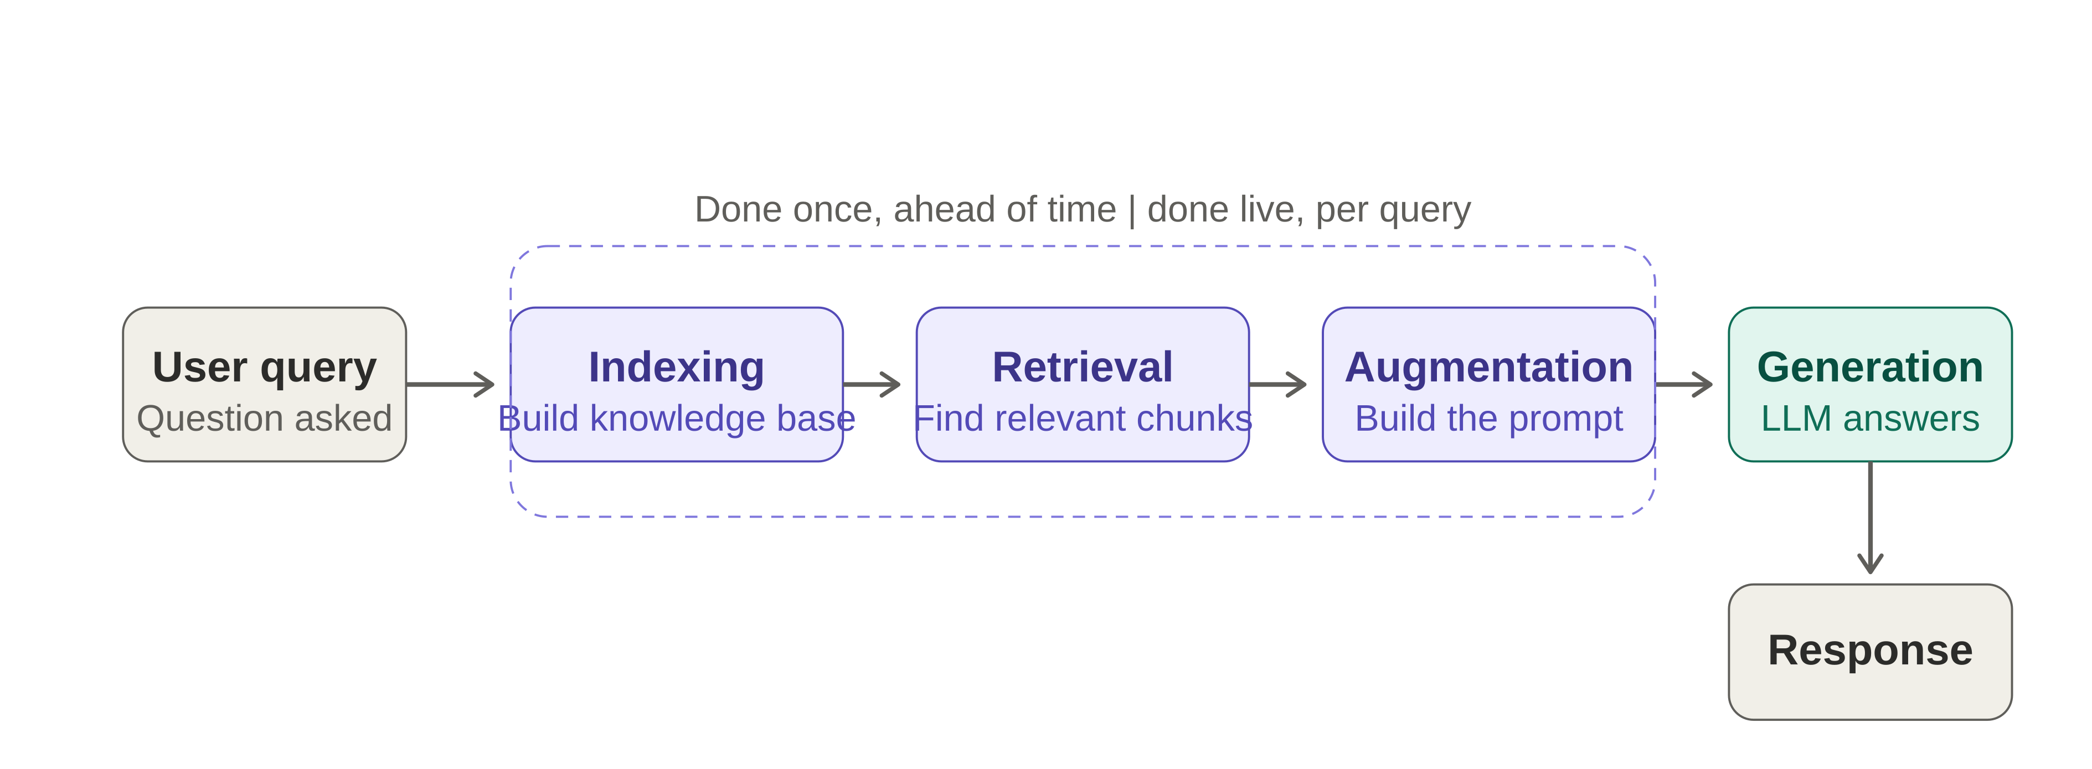
Diagram A — The four stages of a RAG pipeline, from user query to grounded response.

2.1 Description of Each Section

User query
The starting point. A user sends a question — technically a prompt — to the system. In a plain LLM setup the prompt would go straight to the model; in RAG it first triggers the retrieval machinery so that supporting information can be gathered.

Indexing
The offline preparation stage. Here the system builds an external knowledge base out of your own data. This is the only stage that does not run per query — it is done once, ahead of time, and refreshed whenever the underlying data changes. Diagram B breaks this stage into its four sub-steps.

Retrieval
The first live stage. Given the user query, retrieval searches the knowledge base and finds the small number of pieces — typically three to five chunks — that are most relevant to answering it. Instead of feeding the model everything, RAG feeds it only what matters. Diagram C shows this stage in detail.

Augmentation
The stage where the prompt is assembled. The user query and the retrieved chunks (the context) are combined into a single, enriched prompt. “Augmentation” refers to augmenting the model’s built-in knowledge with this extra, just-in-time context.

Generation
The final stage. The augmented prompt is sent to an LLM, which uses its text-generation ability — together with in-context learning — to read the context and produce the answer. Because the answer is built from supplied context, it is grounded rather than invented.

Response
The output returned to the user: an answer based on the organisation’s own data, drawn from the context that retrieval supplied.

3. Diagram B — Indexing in Detail
Indexing is the process of preparing your knowledge base so it can be searched efficiently at query time. It is itself a four-step pipeline, shown below.
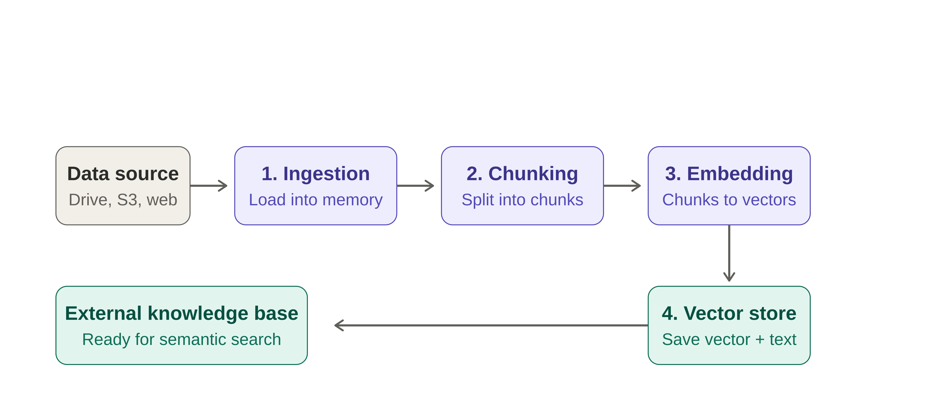
Diagram B — The four sub-steps of indexing. The result is an external knowledge base ready for semantic search.

3.1 Description of Each Section

Data source
Where the raw knowledge lives before indexing begins — a server, Google Drive, AWS S3, a website, PDFs, and so on. Indexing starts by reaching into these sources.

Step 1 — Document Ingestion
The source data is loaded into memory. Tools such as LangChain provide built-in document loaders — a PDF loader, a YouTube loader, a web-page loader, and others — for different source types. After ingestion, the document is held as a string, ready for further processing.

Step 2 — Text Chunking
The large document is broken into smaller, semantically meaningful chunks. This is done for two reasons:
- Context-length limits — an LLM can only process a limited number of tokens, so an entire large document cannot be sent at once.
- Search quality — semantic search performs poorly over one very large document; smaller, focused chunks search far better.
Ideally each chunk covers a single topic, with no abrupt cuts. Splitters such as the Recursive Character Text Splitter or a Semantic Chunker handle this.

Step 3 — Embedding Generation
Each chunk is converted into a dense vector called an embedding using an embedding model (for example, OpenAI or Sentence-Transformer embeddings). An embedding captures the semantic meaning of the text as numbers. This is necessary because the search performed later is semantic search, which always operates between embedding vectors.

Step 4 — Store in a Vector Store
Each vector — along with its original chunk text and metadata — is saved in a vector database. Options include local stores such as FAISS and Chroma, and cloud stores such as Pinecone, Weaviate, Milvus, and Qdrant.

External knowledge base
The end state of indexing: every chunk and its corresponding embedding stored together in one searchable place. This is the source from which all future context will be drawn.

4. Diagram C — The Query-Time Flow
Once the knowledge base exists, the system is ready for questions. The diagram below traces what happens live, the moment a user asks something — covering retrieval, augmentation, and generation in one view.
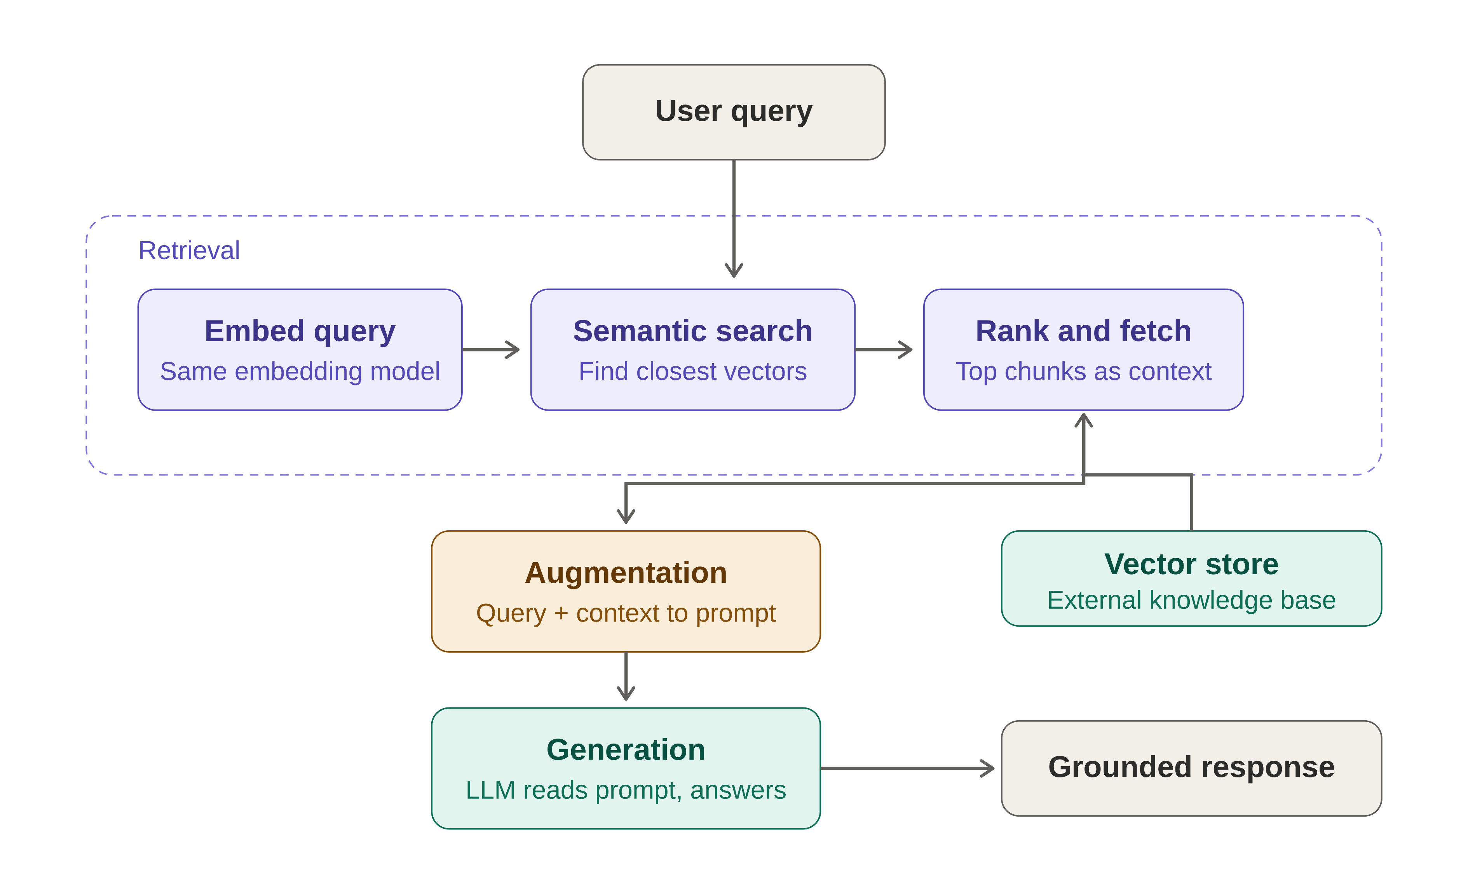
Diagram C — The live path from a user query to a grounded response.

4.1 Description of Each Section

User query
The live question that starts the flow — for example, “How do we perform the optimization step in gradient descent?” It enters the retrieval stage first.

Retrieval — Embed query
The retriever converts the query into an embedding vector, using the exact same embedding model that was used to embed the chunks during indexing. Using the same model is essential — the query vector and the chunk vectors must live in the same space to be comparable.

Retrieval — Semantic search
The query vector is compared against the vectors in the store to find the closest ones. This can be a simple similarity search or a more advanced method such as MMR or contextual compression. The idea is to locate the chunks whose meaning is nearest to the question.

Retrieval — Rank and fetch
The candidate chunks are ranked from most to least relevant — using a metric such as cosine similarity, or an advanced re-ranking algorithm — and the text of the top results is fetched. Together, these top chunks form the context.

Vector store
The external knowledge base built during indexing. At query time it is read-only: semantic search looks into it, and the relevant chunks are pulled out as context.

Augmentation
The user query and the retrieved context are combined into a single prompt. A typical prompt instructs the model to answer only from the provided context and to say “I don’t know” if the context is insufficient — an instruction that deliberately guards against hallucination.

Generation
The augmented prompt is sent to the LLM, which reads the context and uses its text-generation capability and in-context learning to produce an answer grounded in that context, supported by its own parametric knowledge.

Grounded response
The final answer returned to the user — “grounded” because it is tied to the supplied context rather than freely generated, which keeps it accurate and traceable to the source data.

4.2 The Whole Pipeline in One Line
End to end
Indexing → Retrieval → Augmentation → Generation
Indexing is done once to build the knowledge base. The other three run live for every question. This basic setup can be extended into far more advanced RAG systems.
— End of Document —

