**Task 7 Results:**

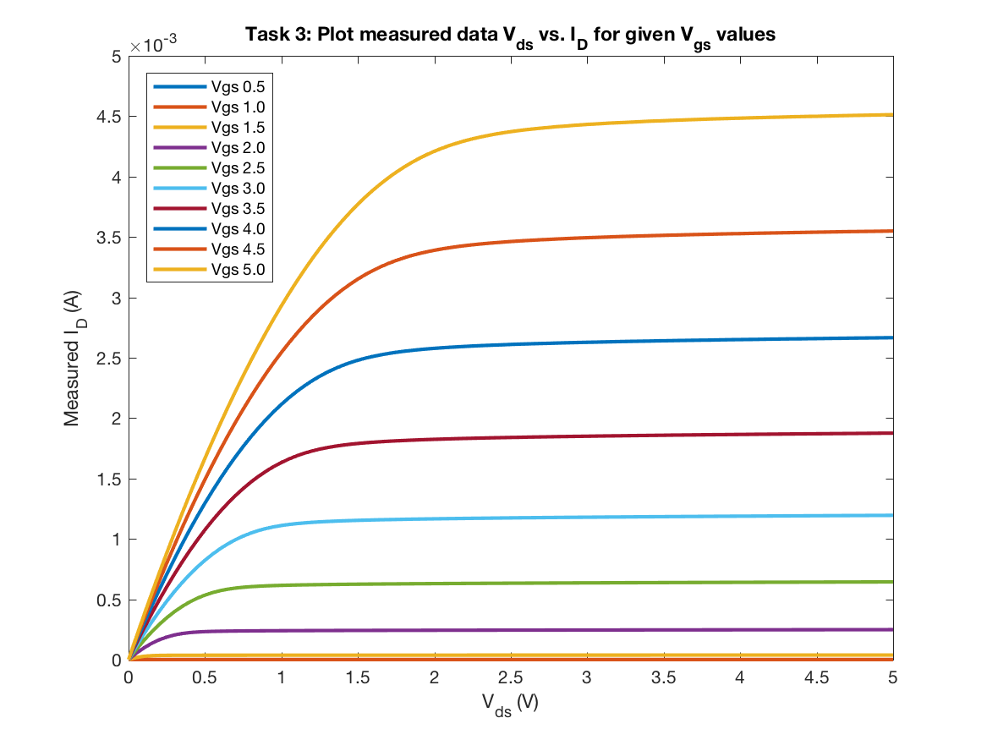

Figure 1: Ids Measured vs. Vds for given Vgs

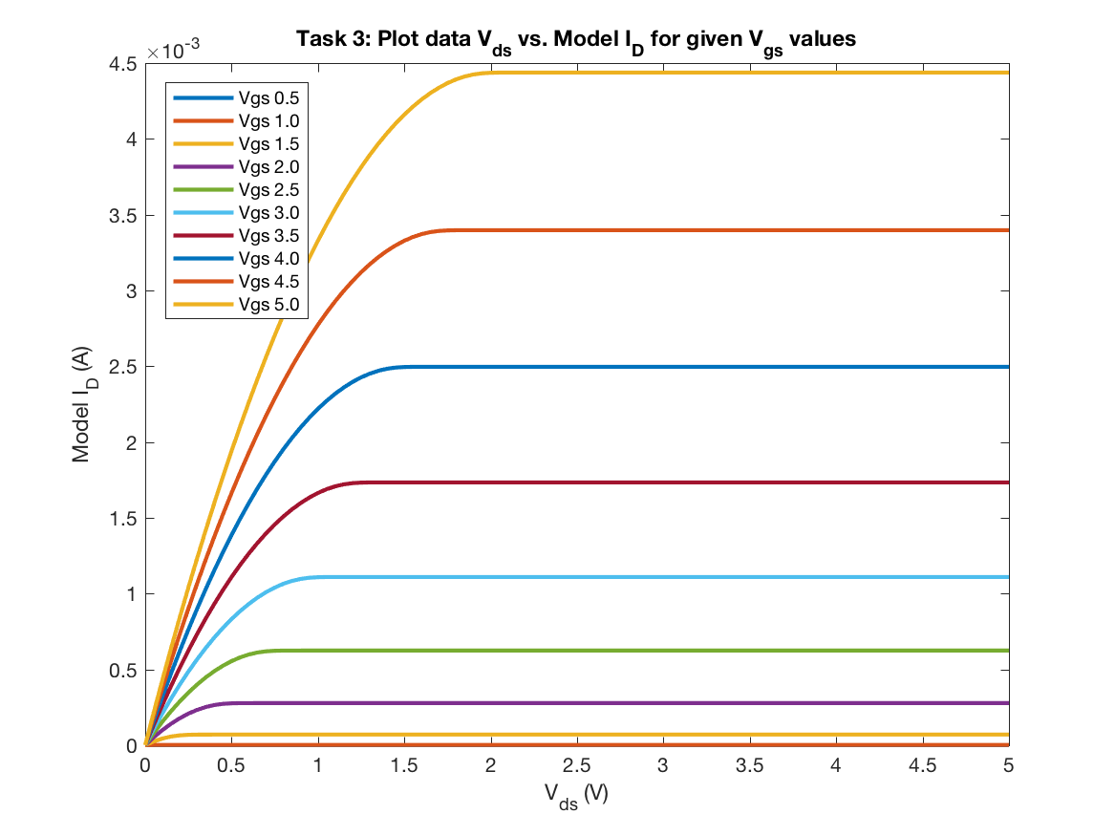

Figure 2: Ids Model vs. Vds for given Vgs

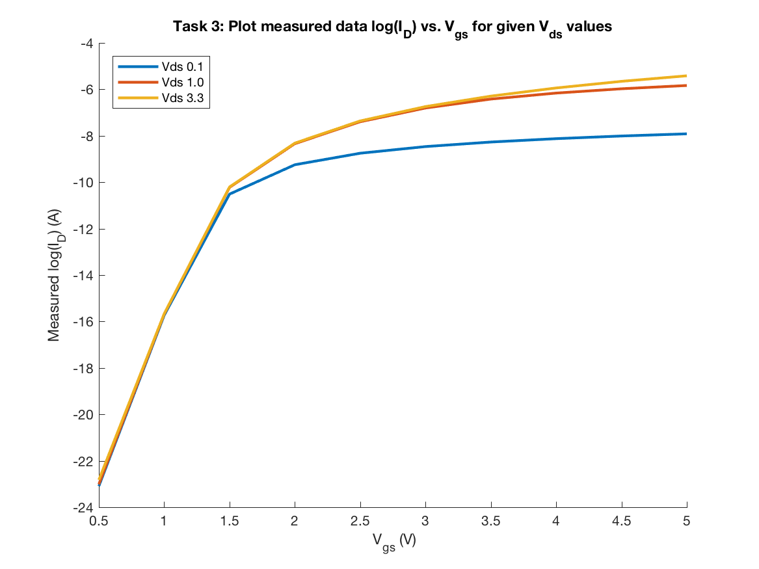

Figure 3: log(Ids) Measured vs. Vgs for given Vds

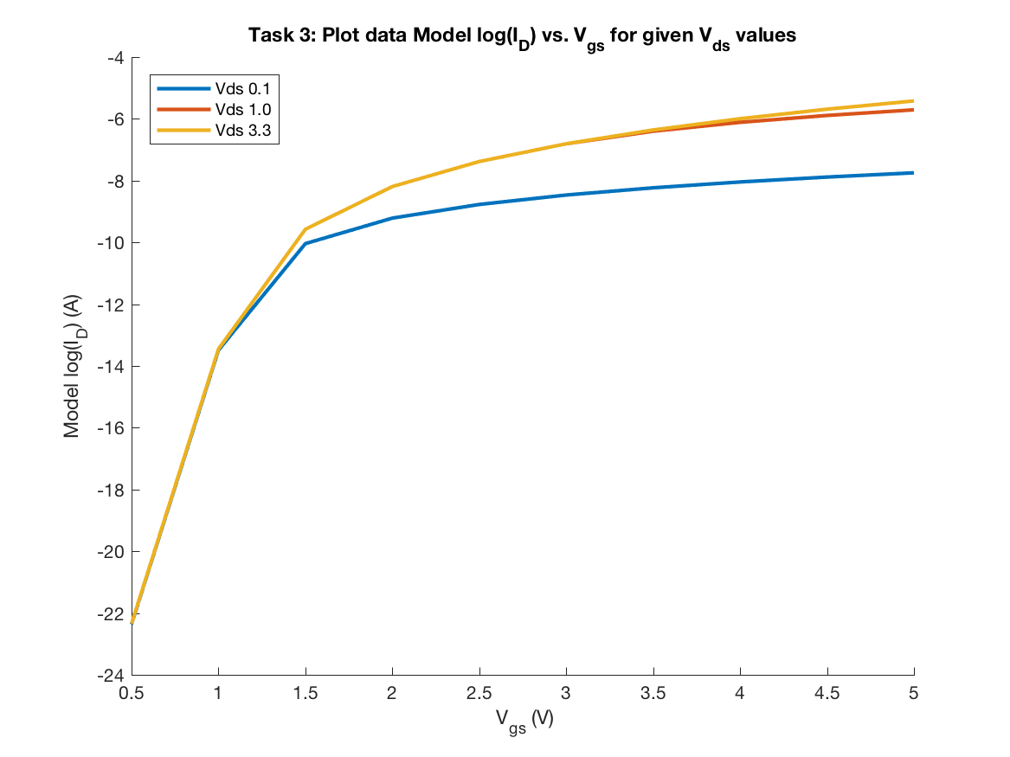

Figure 4: log(Ids) Model vs. Vgs for given Vds

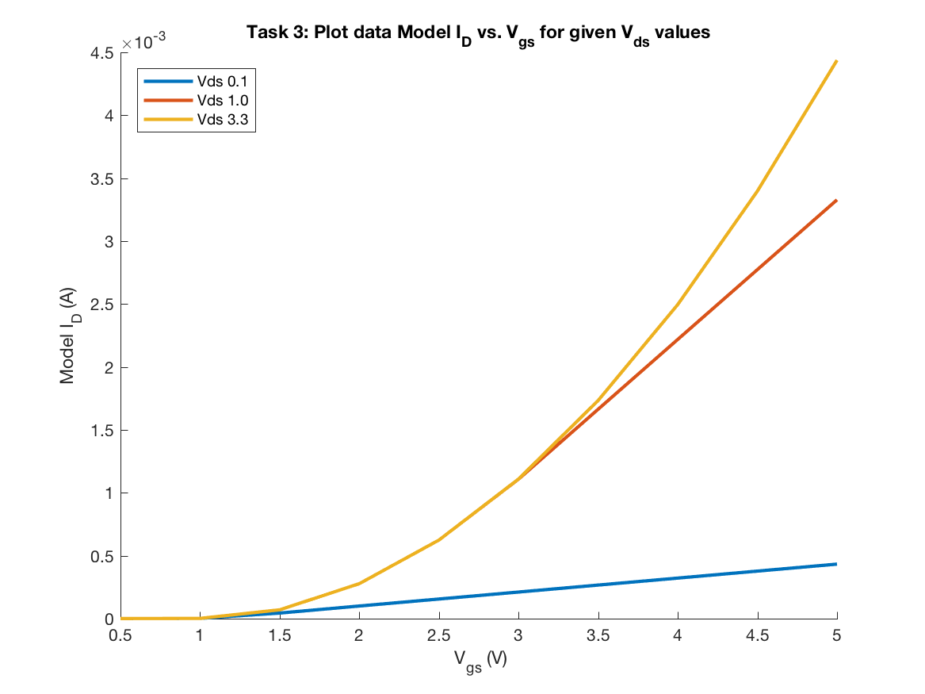

Figure 5: Ids Model vs. Vgs for given Vds

As requested in Task 7, figures 1 and 3 display the measured Ids values with respect to VDS and VGS values (respectively). The graphs appear to be very similar to figures 2 and 4, which take the Ids values generated from the Ids model function using the optimal parameters found from task 6 using the various methods of parameter extraction.

Figure 5, takes the same data used in figure 4 and plots the IDS model data without taking the log of it. This allows us to see the quadratic behavior between IDS and VGS better.

Given that kappa = 0.5 and Vth = 1.0 (generalized values form the optimal parameters) and We can calculate VDsat for all VGS values:

|  |  |
| --- | --- |
| **VGS** | **Vdsat** |
| 0.5 | -0.25 |
| 1.0 | 0 |
| 1.5 | 0.25 |
| 2.0 | 0.5 |
| 2.5 | 0.75 |
| 3.0 | 1.0 |
| 3.5 | 1.25 |
| 4.0 | 1.5 |
| 4.5 | 1.75 |
| 5.0 | 2.0 |

* For *VGS* < *Vth*, *IDmodel* should be an exponential function of *VGS* with *κ* < 1 and nearly insensitive to *VDS*.

In figure 4, it shows the model log( IDS ) values with respect to VGS. Since the assumed optimal kappa value is less than 1.0, then for all VGS < Vth (assumed to be 1.0), then IDS is assumed to be exponential with respect to VGS, which is confirmed from this graph. Since all VDS values are undistinguishable when VGS < 1.0, and log(IDS ) appears to be linear while VGS < 1.0, then it is the same as saying IDS is exponential for VGS < 1.0.

* For *VGS* > *Vth* and *VDS* >  , *IDmodel* should be quadratic to *VGS* and insensitive to *VDS*, or . This is the shape of the family curve in *ID(VDS)* with *VGS* as parameters.

Based on these values we can see that:

*VGS* > *Vth* and *VDS* > VDsat , *IDmodel* should be quadratic to *VGS* and insensitive to *VDS*.

For figure 5, consider the instance when *VGS* > 1.0, when VDS  is 3.3 V (the yellow line) it is always having a quadratic behavior because it is always greater than VDsat for all *VGS* > 1.0.

Now still considering figure 5, consider the instance when *VGS* > 1.0, when VDS  is 1.0 V (the red line) then the *VDS* > VDsat true until *VGS* > 3.0. The blue line is quadratic until VGS is 3.0 and then seems to become linear as *VGS* continues to grow. Between 1.0 < *VGS* < 3.0, the IDS value appears to be insensitive to VDS meaning that they achieve the same ID for the same values of VGS at different VDS values.

* For *VGS* > *Vth* and *VDS* < *VDsat*, *IDmodel* should be quadratic to *VDS*.

Consider figure 3, it can be seen that there is quadratic behavior between IDS and VDS that occurs when VGS > Vth = 1.0 V and VDS < VDsat. When VGS = 1.0 (see the red-orange line), we can see that the behavior never becomes quadratic and appears to be linear. When VGS = 3.0 (see the light blue line), VDsat = 1.0, thus, When VDS < 1.0, it can be seen that IDS has quadratic behavior to VDS for all VDS less than 1.0, when VDS is greater than 1, the IDS model values appear to become linear with respect to VDS.