Andon Control System

User Manual & Technical Overview

1. Introduction
Welcome to the Andon Control System, a state-of-the-art solution for wireless process management and status indication. This system was engineered from the ground up to provide unparalleled reliability, safety, and ease of use.
By combining a professionally designed hardware controller with an intuitive desktop application, you can effortlessly monitor and control up to 20 distinct outputs (relays) in real-time over your existing Wi-Fi network. This manual will guide you through the system's features, installation, and operation.

2. System Features
This system is built with industrial-grade components and robust software to ensure long-term, maintenance-free operation.

Hardware Features
- Advanced Core Controller: At its heart is the Raspberry Pi Pico W, a powerful and reliable microcontroller from a world-renowned manufacturer, providing robust processing and seamless Wi-Fi connectivity.
- Complete Electrical Isolation: Your safety and the longevity of your equipment are paramount. The controller is fully isolated from the high-voltage relays using high-quality PC817 optocouplers. This design prevents any electrical noise or power surges from affecting the sensitive control circuitry.
- Dual Power Supply Architecture: The controller and the relays are powered by separate, dedicated power supplies, further enhancing system stability and isolation.
- Studio-Grade Power Regulation: We use top-of-the-line Hi-Link power supply units. These compact, board-mounted PSUs deliver clean, stable power, minimizing electrical noise and ensuring consistent performance.
- High-Quality Solid State Relays (SSRs): The system utilizes original, brand-name SSRs for silent, fast, and reliable switching with a significantly longer lifespan than traditional mechanical relays.
- Professional PCB & Ease of Installation: All components are mounted on a custom-designed Printed Circuit Board (PCB) with clear labeling. The use of detachable screw terminals makes wiring simple, secure, and easy to modify.

Software Features
- Intuitive Desktop Application: The included Windows application provides an elegant and user-friendly interface to manage the entire system. Clear visual feedback shows the current status of every channel at a glance.
- Seamless Wi-Fi Connectivity: Connection is effortless. The controller automatically connects to your pre-configured Wi-Fi network on power-up. Simply enter the controller's IP address in the software and connect.
- Real-Time, Instantaneous Control: User actions in the application are transmitted instantly to the controller, providing immediate and responsive control over your processes.
- Customizable Interface: Tailor the application to your specific needs by editing the title of each control column. Your custom titles are automatically saved and will be reloaded the next time you launch the program.
- Onboard Diagnostic LED: The controller features a status LED that provides immediate feedback:
  - Solid Green: The controller is powered on and attempting to connect to Wi-Fi.
  - Blinking Green: The connection was successful, and the system is ready for operation.

3. Installation & Wiring
⚠️ SAFETY WARNING: Installation involves working with mains AC voltage. This should only be performed by qualified personnel. Ensure all power is disconnected before wiring the device.

PCB Wiring Diagram
The diagram below illustrates the main connection points on the controller board.
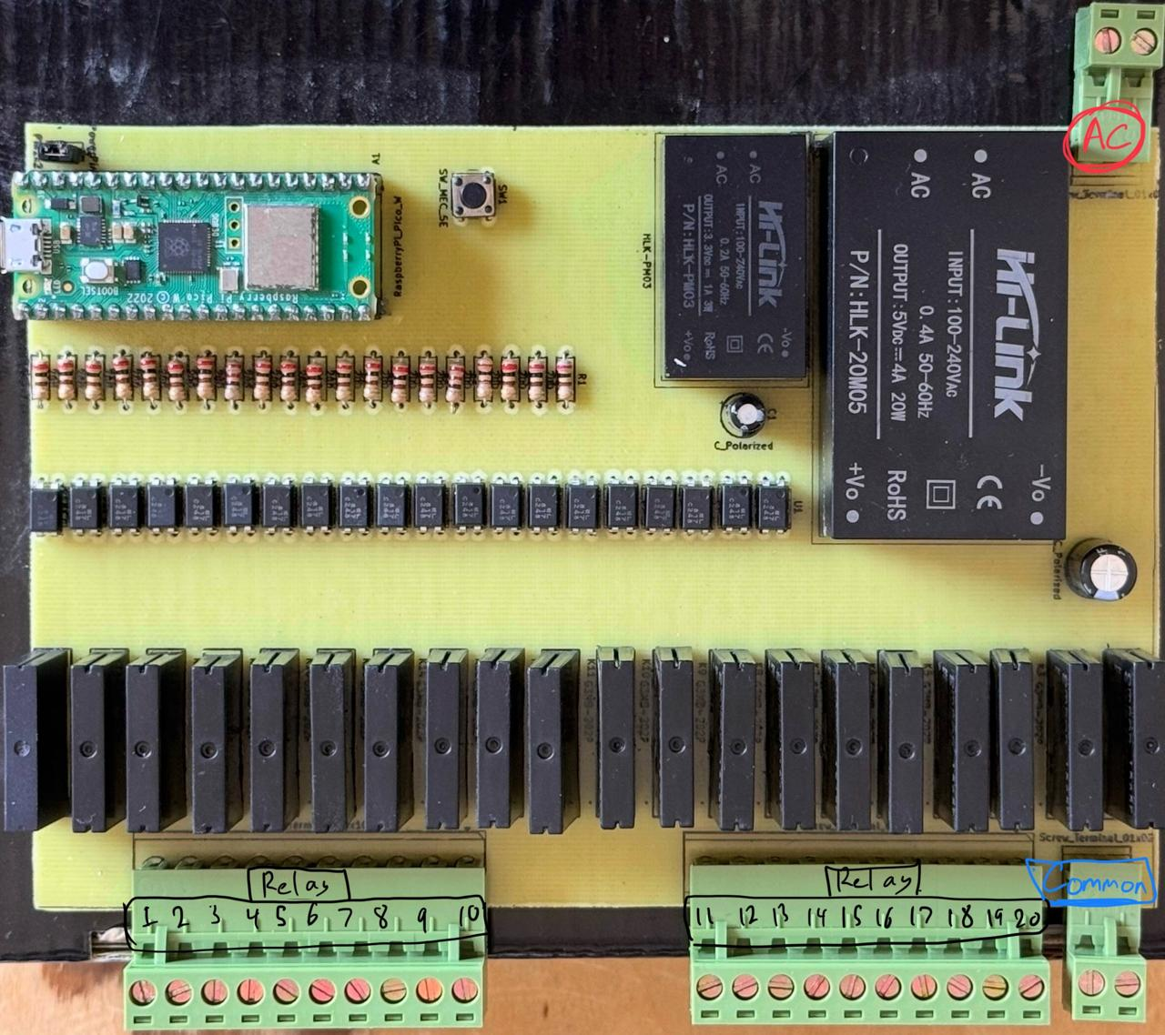

Wiring Instructions
- Mount the Device: Securely mount the Andon Control System PCB in a dry, protected enclosure.
- Connect AC Power: Connect your mains AC power (e.g., 110V/220V) to the AC POWER INPUT terminals:
  - L: Live / Hot
  - N: Neutral
  - GND: Ground (Earth)
- Wire the Loads (e.g., Lights, Buzzers):
  - Connect the main power wire for your loads to the COMMON terminal.
  - Connect the return wire from your first load (e.g., a red light) to the desired relay output, for example, R0 (Relay 0).
  - Connect the return wire from your second load (e.g., a yellow light) to R1, and so on.

4. Software & Operation Instructions
- Power On the Controller: Apply power to the Andon Control board. The green STATUS LED on the board will turn on (solid). Wait a few moments. When it starts blinking, the controller is connected to the Wi-Fi and ready.
- Launch the Application: On your Windows PC (which must be on the same Wi-Fi network), run the Andon Control Panel.exe application.
- Connect to Controller:
  - In the bottom panel of the application, enter the IP address provided for the controller into the IP field.
  - Ensure the Port is set to 8888.
  - Click the Connect button.
  - The button will turn red and change its text to "Disconnect". The status bar at the very bottom will display a "Successfully connected" message.
- Control the System:
  - Direct Control: Click any of the Red, Yellow, or Green buttons in a column to activate that specific relay and deactivate the other two in that same column.
  - Cycle Control: Use the Up and Down arrow buttons to cycle through the states.
  - Customize Titles: Simply click on a title (e.g., "VISUAL") and type a new name for that column. The change is saved automatically when you close the application.

5. Troubleshooting
Issue | Possible Cause & Solution
App Cannot Connect | 1. Ensure your PC is on the same Wi-Fi network as the controller. SSID<Fabric3> Password: <3033330333fa3>  2. Double-check that the IP address entered in the app is correct.  3. Verify the controller's LED is blinking.
Controller LED is Solid (Not Blinking) | The controller could not connect to the Wi-Fi network. Please check that your Wi-Fi router is on and functioning correctly. The controller will automatically keep trying to connect.
Relays Do Not Activate | 1. Check that the app's status bar shows a "Successfully connected" message.  2. Verify that your wiring to the COMMON and R# terminals is correct and secure.

6. Support & Authenticity

This complete hardware and software solution was proudly designed, developed, and tested by:
Eng. AbdulRahman Mohsen Badran
Contact:
- Email: ambadran717@hotmail.com
- Phone: +201010670859
Thank you for choosing this system. We are confident it will provide exceptional value and performance for your operational needs.
Document Version 1.0 - July 2025

