

***Modern University for Technology & Information***

**Faculty Of Engineering**

**Control Engineering Department**

***SIMACAS***

**A premium project submitted to Control Engineering Department in partial fulfilment of the requirements for the degree of Bachelor of Science in Control Engineering**

**SUPERVISED BY:**

DR. MOHAMED FAWZY ABD EL HAMED

**PROVIDED BY:**

**AHMED MOHAMED SOBHY**

**ABD ELRAHMAN ALHAMMADY**

**MOSTAFA AHMED ELSHEIKH**

Table of Contents

Executive Summary 5

Chapter 1: Introduction 6

Project Aim 6

Summarized Methodology 8

Quick Walkthrough 10

Chapter 2: Literature Review 11

Chapter 3: Methodology 20

System Overview 20

Mechanical Design 21

Intro 21

Aluminum Frame 21

Profile Traversal Mechanism 21

Water Distribution System 23

Electronics 24

Intro 24

Axis Control 24

Water Distribution Circuit 24

Sensor Monitoring 24

Programming 25

Intro 25

Axis Control 25

Sensor Monitoring 25

Main Board 25

Chapter 4: Conclusion 26

References 27

Figure 1: Aluminum Profile Frame 3D model 18

# Executive Summary

# Chapter 1: Introduction

## Project Aim

Irrigation stands as a cornerstone of human civilization, pivotal to its survival and growth throughout history. From ancient times to modern days, the evolution of irrigation has mirrored the progress of civilization itself. Particularly since the Industrial Revolution, and more recently the Data Revolution, advancements in technology have transformed traditional practices. Modern machinery and automation have streamlined many processes that were once labor-intensive, achieving levels of efficiency and precision that were previously unattainable. Despite these advancements, the field of irrigation continues to offer opportunities for innovation, especially in specialized applications.

This project targets one such niche: the development of a small-scale, temporary, automated irrigation system designed for highly controlled environments. These systems are particularly beneficial for specialized agricultural research or the cultivation of rare and exotic plants under precise conditions. The primary goal of this project is to engineer a sophisticated system capable of meticulously monitoring and controlling every aspect of a plant’s environment.

Key features of this innovative system include:

* Comprehensive Monitoring: Utilizing an array of sensors, the system will continuously monitor critical parameters such as temperature, humidity, water levels, and CO2 concentrations. This data-rich approach ensures that all environmental factors affecting plant growth are observed and analyzed.
* Precise Irrigation and Fertilization: The core of the system’s functionality lies in its ability to dispense water and nutrients with pinpoint accuracy. Through the integration of advanced robotics, both the quantity and timing of water and fertilizer application can be precisely controlled, tailored to the plant's specific needs at any growth stage.
* Intelligent Control System: At the heart of the operation is a main Microcontroller Unit (MCU). This MCU is tasked with interpreting sensor data and managing output actions. It is programmed with a sophisticated 'model predictive control' algorithm, which optimizes conditions for maximum plant growth and yield.
* Adaptive Algorithms: The system’s adaptive capabilities allow for real-time adjustments based on immediate environmental feedback, enhancing the efficacy and responsiveness of the irrigation strategy.

By focusing on these advanced technological solutions, this project aims to push the boundaries of what is possible in controlled agricultural systems. It promises not only to enhance the precision of plant cultivation but also to contribute valuable insights into the optimal conditions for plant growth, offering potential applications in both research settings and rare plant cultivation.

Central to achieving this precision is the integration of a model predictive control (MPC) algorithm within the system's main Microcontroller Unit (MCU). The MPC algorithm is crucial for several reasons:

* Anticipatory Adjustments: Unlike conventional control systems that react to changes, MPC predicts future conditions and makes proactive adjustments. This predictive capability allows for the optimization of irrigation and fertilization schedules based on forecasted environmental and plant needs.
* Optimal Resource Utilization: By accurately forecasting future states, the MPC algorithm ensures optimal use of water and nutrients, which is essential for conserving resources while maximizing plant health and productivity.
* Enhanced Growth and Yield: The algorithm continuously refines its predictions and control outputs, adapting to the plant’s growth stages and environmental fluctuations. This adaptability is key to enhancing plant growth rates and maximizing yield.
* Precision and Control: The system's ability to precisely control the delivery of water and nutrients directly addresses the specific needs of each plant, tailored to its particular growth conditions. This level of control is particularly advantageous in research settings or for cultivating plants that require specific care.

The proposed irrigation system not only focuses on the practical aspects of plant cultivation but also embodies a cutting-edge approach to agricultural technology. Through the application of the MPC algorithm, this project aims to set new standards in the precision farming industry, providing insights that could influence broader agricultural practices.

By leveraging such advanced control strategies, this project not only aims to enhance the efficiency and effectiveness of irrigation practices but also to contribute to the broader field of agricultural science, offering scalable solutions that could be adapted for various controlled-environment agriculture applications.

## Summarized Methodology

To achieve an efficient and controlled environment for plant development, a novel irrigation system was designed and developed. The system integrates advanced automation and precision control technologies, aimed at optimizing plant growth conditions.

Structural Framework:

* Expandable Aluminum Frame: A robust and expandable aluminum frame is suspended above the plants. This frame provides a durable and stable platform for the robotic components.
* V-Wheel Ball Bearings and Stepper Motors**:** Small robots traverse the aluminum frame using V-wheel ball bearings driven by stepper motors, ensuring smooth and precise movement.

Robotic Components:

* 3D Printed Robot Frame**:** The robot frame is 3D printed using PLA+ material, which is known for its high reliability and durability in outdoor environments. This material choice also lowers manufacturing costs and allows for complex geometries that would be difficult to achieve with traditional manufacturing methods.
* Dual Sprinkler System**:** Each robot is equipped with two 3D printed sprinklers, connected to separate tubes—one for water and the other for low viscosity fertilizer and essential chemicals. The sprinklers are designed for easy exchange and redesign, enhancing the system's adaptability. Various sprinkler designs cater to different irrigation needs, such as far radial dispersal or direct downward dispersal, increasing the versatility of the system.

Control Circuitry:

* Custom PCB and Microcontroller**:** A specialized circuit was designed, and a PCB was fabricated to ensure maximal reliability and efficiency. The circuit includes a powerful microcontroller, a radio transceiver, an ultrasonic sensor, stepper motor drivers, and other complementary components.
* Wireless Communication and Closed-Loop Control**:** The microcontroller receives commands wirelessly from the main microcontroller running the Model Predictive Control (MPC) algorithm. It then executes these commands by signaling the stepper motor drivers. The ultrasonic sensor on the robot frame measures the distance from the origin point, enabling closed-loop control. This allows for precise movement adjustments based on real-time measurements.

Fluid Control Network:

* Solenoid Valves**:** A network of solenoid valves precisely controls the flow of liquids from the water and fertilizer tanks to the desired robot and sprinkler. These valves are monitored and controlled by the main microcontroller.

Main Control System:

* Main Microcontroller Board**:** The main microcontroller wirelessly manages the traversing robots and solenoid valves. It is also connected to a myriad of sensors monitoring various plant conditions.
* MPC Algorithm Implementation**:** The MPC algorithm on the main microcontroller analyzes sensor data, performs intricate calculations, and determines the optimal control actions. This ensures precise irrigation and nutrient delivery tailored to the plants' needs, maximizing growth and yield.

This integrated system leverages modern manufacturing techniques, advanced control algorithms, and real-time monitoring to create an optimized environment for plant growth.

## Quick Walkthrough

Steps to use the project and quick results

# Chapter 2: Literature Review

[1] The practise of farming has endured significant transformation as technology advances every day. The constraints of area and nonlinear nature of climatic conditions, polyhouse kind of concepts are increasing, which is helpful in production of flowers, vegetables and fruits. The proposed work discusses such an automated irrigation system that highlights the optimum solution for the efficient use of water and electricity for agricultural purposes. Field survey and literature shows that the existing systems are available with two solutions, one is timer-based and another one is moisture-based automization. Moreover, the timer-based system has demerits like being semi-automated i.e., timer needs to be changed manually according to climate. Similarly, in moisture-based systems, reliability is the issue. Therefore, the main objectives of the proposed work are to overcome the demerits of the present systems by integrating both the systems, to develop a fully automated irrigation system, to manage the use of water, electricity, and to add a remote controlling system. The report includes algorithm for the integration of moisture and timer-based system which provides the optimum efficiency on the water use and the use of solenoidal valve.

[2] The article "Improving water-efficient irrigation: Prospects and difficulties of innovative practices" by Levidow et al. (2014) discusses the challenges and potential of innovative irrigation practices aimed at enhancing water efficiency. The authors emphasize that while technological advancements in irrigation can offer significant benefits, such as economic advantages and reduced environmental impacts, there are several barriers to their effective implementation.

Key challenges include the lack of adequate knowledge among farmers regarding water usage, irrigation applications, and crop yield responses to different water management practices. The article highlights the importance of a knowledge-exchange system that involves all stakeholders, including farmers, extension services, and water management organizations, to promote better water management practices.

The study presents two case studies from Europe that illustrate these challenges and opportunities. In both cases, despite the availability of advanced irrigation technologies, farmers faced difficulties in achieving optimal water efficiency due to inadequate knowledge and support systems. The authors suggest that a continuous knowledge-exchange system is necessary to ensure that stakeholders can share responsibilities and achieve greater water efficiency across the entire water-supply chain.

[3] The paper "Model Predictive Control for Closed-Loop Irrigation" by Lozoya et al. (2014) explores the use of model predictive control (MPC) in irrigation systems to enhance water efficiency. The primary objective is to optimize the amount of water used by accurately controlling soil moisture levels based on real-time climatic factors and soil conditions. The authors present a detailed model that incorporates soil moisture control and climatic variables, demonstrating that MPC can significantly improve water use efficiency compared to traditional time-based and basic soil moisture control irrigation systems.

Key highlights of the paper include:

Hydrological Balance Model: The paper outlines a model based on the hydrological balance that describes water storage changes in relation to irrigation, rainfall, evapotranspiration, and other factors.

Evapotranspiration and Soil Moisture: It discusses the critical role of evapotranspiration and soil moisture in irrigation control, explaining how these factors influence water demand and availability.

MPC Implementation: The authors propose an MPC strategy that predicts future irrigation needs and adjusts water application accordingly, minimizing water consumption while maintaining optimal soil moisture for crop health.

Simulation and Validation: Through simulations, the MPC-based system is compared with traditional irrigation methods, showing superior performance in reducing water usage and maintaining soil moisture levels.

Practical Considerations: The paper addresses the computational demands of MPC and suggests that advancements in embedded systems make the implementation feasible for large-scale agricultural applications.

The study concludes that MPC offers a promising approach to improving irrigation efficiency, which is crucial for sustainable water management in agriculture.

[4] The paper "Model Predictive Control for Real-Time Irrigation Scheduling" by Khusro Saleem et al. (2013) discusses the application of Model Predictive Control (MPC) to optimize irrigation scheduling, thereby improving agricultural productivity by better matching water supply to crop demand. The authors highlight that traditional irrigation scheduling often relies on heuristic rules, which can lead to over-watering, wasting water, and reducing crop yields.

Key points from the paper include:

MPC Framework: The authors propose an MPC framework that incorporates real-time data, such as soil moisture and climatic conditions, to make more accurate irrigation decisions. The MPC algorithm optimizes watering schedules within operational constraints like water availability and maximum or minimum water application limits.

Water Balance Model: The foundation of the proposed system is a water balance model that accounts for various water flows into and out of the soil column, including irrigation, precipitation, evapotranspiration, runoff, and deep percolation. This model helps in predicting the soil moisture deficit and planning irrigation events accordingly.

Optimization and Control: The paper details how the MPC controller uses predictive models to minimize deviations from desired soil moisture levels, ensuring efficient water use. The approach accounts for uncertainties in climate inputs and operational constraints, providing a systematic method for real-time irrigation scheduling.

Simulation and Results: Using measured evapotranspiration and precipitation data, the authors demonstrate that the MPC approach leads to improved set-point tracking and adherence to constraints compared to traditional heuristic methods. The results show that MPC can significantly reduce over-watering and under-watering issues.

[5] The paper "An Overview of Smart Irrigation Management for Improving Water Productivity under Climate Change in Drylands" by Ahmed et al. (2023) reviews various smart irrigation techniques aimed at enhancing water use efficiency (WUE) in dryland regions, which face significant challenges due to water scarcity and climate change. The authors discuss the limitations of traditional irrigation scheduling methods, which often lead to over- or under-irrigation, and highlight the potential of smart irrigation systems to address these issues.

Key points from the paper include:

Smart Irrigation Systems: These systems use a combination of soil, climate, and plant data to optimize irrigation schedules. Technologies such as artificial intelligence (AI), deep learning, variable rate irrigation (VRI), and unmanned aerial vehicles (UAVs) are integral to these systems, enabling precise water application based on real-time data.

Benefits of Smart Irrigation: Smart irrigation systems can significantly improve WUE by ensuring that water is applied in the right amounts, at the right times, and in the right places. This leads to increased crop yields, reduced water usage, and better resource management.

Model Predictive Control (MPC): MPC is highlighted as a key technology in smart irrigation, capable of managing irrigation schedules based on predictive models that consider future climatic and soil conditions. This approach helps in maintaining optimal soil moisture levels, thereby enhancing crop growth and productivity.

Challenges and Recommendations: Despite the advantages, the implementation of smart irrigation systems faces challenges such as high costs, complexity, and the need for extensive training for farmers. The authors recommend further research and development to make these technologies more affordable and user-friendly, as well as greater support from governments and institutions to promote widespread adoption.

Case Studies and Applications: The paper provides examples of successful smart irrigation implementations in various regions, demonstrating the effectiveness of these technologies in improving agricultural productivity and sustainability in drylands.

[6] The paper "Computation of Control Law for State Transfer Problem in Efficient Way for a Single Input" by Rajani Metri and Bhooshan Rajpathak (2022) presents a novel method for solving the state transfer problem (STP) in linear time-invariant (LTI) systems with a single input. The proposed method focuses on reducing the computational complexity typically associated with solving the STP by eliminating the need to compute the controllability Gramian matrix and the state transition matrix, which are traditionally required in conventional methods.

Key points from the paper include:

Control Law Computation: The authors introduce an efficient technique for computing the control law for STP without calculating the controllability Gramian and state transition matrix. This method relies on direct computations involving mode vectors and simplifies the process significantly.

Mathematical Efficiency: The proposed method minimizes the use of complex mathematical operations such as matrix inverses and determinant calculations, which are often computationally intensive and prone to rounding errors.

Special Cases Handling: The method is particularly advantageous for systems with real and distinct roots, repeated roots, and complex eigenvalues, demonstrating flexibility across various types of LTI systems.

Theoretical and Experimental Validation: The paper includes theoretical proofs and experimental results to validate the proposed method. The experimental setup involves a Hardware-In-Loop (HIL) system to demonstrate the practical applicability of the control law in an industrial context.

Advantages: The method provides a computationally efficient way to achieve state transfer in finite time with minimum control energy, making it suitable for real-time applications in industrial automation, electric drives, and other control systems.

[7] The paper "Design and Evaluation of Mobile Drip Irrigation System" by Khairy et al. (2016) explores the development and performance assessment of a Mobile Drip Irrigation System (MDIS). This system combines the efficiency of surface drip irrigation with the flexibility and economic benefits of center pivot and lateral move irrigation systems. The research emphasizes the system's ability to improve application efficiency through precise water and nutrient delivery, reducing water losses due to wind drift and evaporation.

Key points from the paper include:

MDIS Design: The MDIS utilizes classic drip irrigation materials, integrating on-line drip hoses with center pivot or lateral move systems. The design aims to optimize wetting patterns and ensure efficient water distribution.

Efficiency and Performance: The study found that the MDIS achieved application efficiencies higher than 82%. The system's efficiency is attributed to the slow, methodical release of water directly to the soil, promoting optimal plant growth.

System Components and Setup: The MDIS comprises several components, including driven wheels, a water supply pipe, drip tubes, and pressure compensating drippers. The system's speed and the distance between drip tubes were varied to assess performance under different conditions.

Wetting Front Advance: The research measured the wetting front advance in horizontal, vertical, and diagonal directions in loamy sand soil. Results showed that the wetting front advance increased with higher discharge rates and system speeds, indicating effective water infiltration and distribution.

Calibration and Evaluation: The MDIS was calibrated at different operating pressures and evaluated for parameters such as the coefficient of variation, emission uniformity, and flow variation. The study confirmed that the drip tubes used were fully pressure compensating and performed well under various pressures.

Application in Drylands: The paper suggests that the MDIS technology can significantly improve irrigation efficiency in dryland regions, where water conservation is crucial. The system's ability to maintain dry wheel tracks and reduce soil compaction is particularly beneficial for these areas.

[8] The paper "Irrigation Control Based on Model Predictive Control (MPC): Formulation of Theory and Validation Using Weather Forecast Data and AQUACROP Model" by Delgoda et al. (2016) presents a robust model predictive control (MPC) framework for optimizing irrigation schedules. The main goal is to minimize both root zone soil moisture deficit (RZSMD) and irrigation amount, especially under limited water supply conditions. The authors investigate the integration of direct measurements into the MPC system and introduce two robust MPC techniques—Certainty Equivalence control (CE) and Disturbance Affine Feedback control (DA)—to handle uncertainties in weather forecasts.

Key points from the paper include:

MPC Framework: The proposed framework aims to maintain optimal soil moisture levels by adjusting irrigation amounts based on predictive models that account for future weather conditions and soil moisture data. This approach is proactive, unlike traditional methods that react to soil moisture deficits after they occur.

Robust MPC Techniques:

Certainty Equivalence Control (CE): Assumes perfect knowledge of future disturbances and uses deterministic forecasts to optimize irrigation.

Disturbance Affine Feedback Control (DA): Accounts for uncertainty in weather forecasts by using a set of possible disturbances, leading to more conservative but reliable irrigation schedules.

System Model: The study uses a simplified water balance model to represent the actual physical system, focusing on the main dynamics affecting soil moisture. The model is validated using AQUACROP simulations and weather data from Shepparton, Victoria, Australia.

Feasibility and Stability: The paper discusses the importance of ensuring feasibility and stability (Input to State Stability, ISS) in MPC-based irrigation systems. The authors propose removing state constraints to enhance feasibility under water-limited conditions and demonstrate the system's ability to recover from extreme rainfall events.

[9] The paper "Smart Irrigation Systems: Overview" by Gamal et al. (2023) provides a comprehensive review of smart irrigation systems aimed at enhancing water efficiency in agriculture. The authors discuss the integration of advanced technologies such as wireless communication systems, Internet of Things (IoT), smart sensing, and energy harvesting to improve irrigation scheduling and overall water management.

Key points from the paper include:

Smart Irrigation Technologies: The paper highlights the critical role of smart technologies in irrigation, including IoT devices for real-time monitoring, AI for predictive analytics, and wireless sensor networks (WSNs) for data collection and communication. These technologies facilitate precise control over water usage, optimizing irrigation schedules based on real-time data.

Components of Smart Irrigation:

Real-time Irrigation Scheduling: Using real-time data from soil and climate sensors to adjust irrigation schedules dynamically.

IoT and Wireless Communication: Leveraging IoT devices and WSNs to collect and transmit data efficiently, enabling remote monitoring and control of irrigation systems.

Smart Sensing: Implementing advanced sensors to monitor soil moisture, weather conditions, and plant health, ensuring accurate data collection for better decision-making.

Energy Harvesting: Utilizing renewable energy sources, such as solar panels, to power irrigation systems, making them more sustainable and reducing operational costs.

Challenges and Opportunities: The paper discusses various challenges in implementing smart irrigation systems, including high costs, complexity, and the need for extensive training for farmers. It also explores opportunities for improving water use efficiency and agricultural productivity through smart irrigation.

[10] The paper "Automatic Irrigation Systems for Efficient Usage of Water using Embedded Control Systems" by Vijendra Babu et al. (2020) explores the development and implementation of an automatic irrigation system aimed at optimizing water usage in agriculture through embedded control systems. The paper addresses the need for efficient water management in the context of increasing water scarcity and the rising demand for food production.

Key points from the paper include:

Automation and Embedded Control Systems: The authors propose the use of embedded control systems to automate irrigation, replacing the traditional manual methods. The system utilizes various sensors to monitor environmental parameters such as soil moisture, humidity, and temperature, which inform the irrigation process.

System Design: The proposed system includes an Arduino Uno development board that interfaces with multiple sensors (ultrasonic, light ambient, humidity, temperature, and soil moisture sensors). These sensors provide real-time data to control irrigation equipment such as solenoid valves and water sprinklers, ensuring precise water application.

Operational Efficiency: The automatic irrigation system is designed to operate based on real-time soil moisture levels, turning on the water supply only when necessary. This approach prevents over-watering, reduces water waste, and enhances crop yield and quality.

Prototype Implementation: A prototype of the system was developed and tested. The results demonstrated effective utilization of water resources and significant labor savings. The system also helped in preventing soil erosion and nutrient runoff by avoiding excessive water flow.

Scalability: The paper discusses the scalability of the proposed system for larger fields by increasing the number of sensors and control units. This adaptability makes it suitable for various agricultural settings.

# Chapter 3: Methodology

## System Overview

High level system overview with charts of everything

## Mechanical Design

### Intro

What challenges to solve

Brief overview of the innovative solutions

### Aluminum Frame

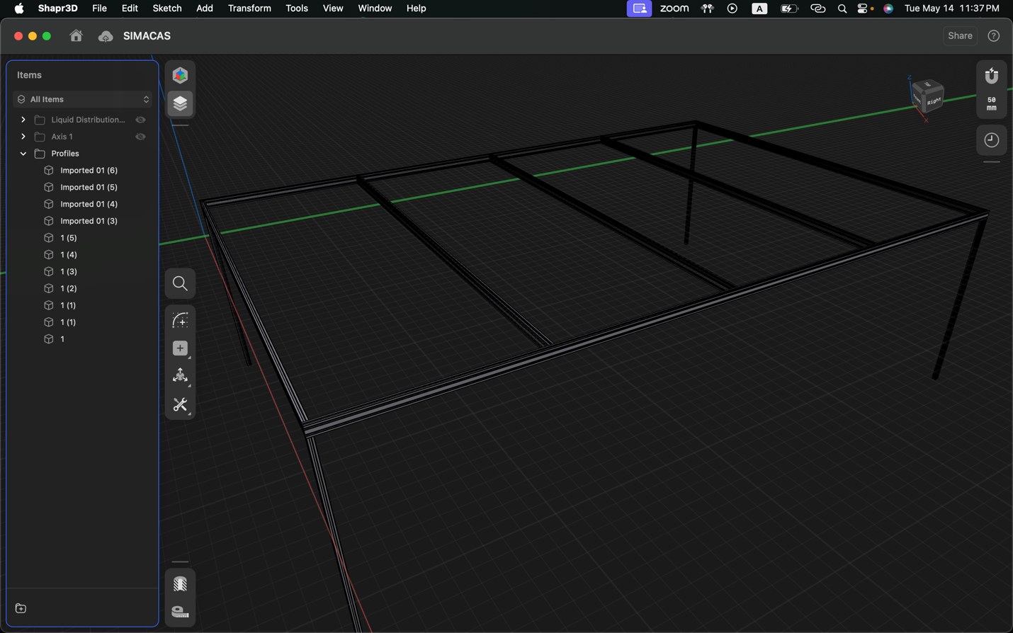

Figure 1: Aluminum Profile Frame 3D model

### Profile Traversal Mechanism

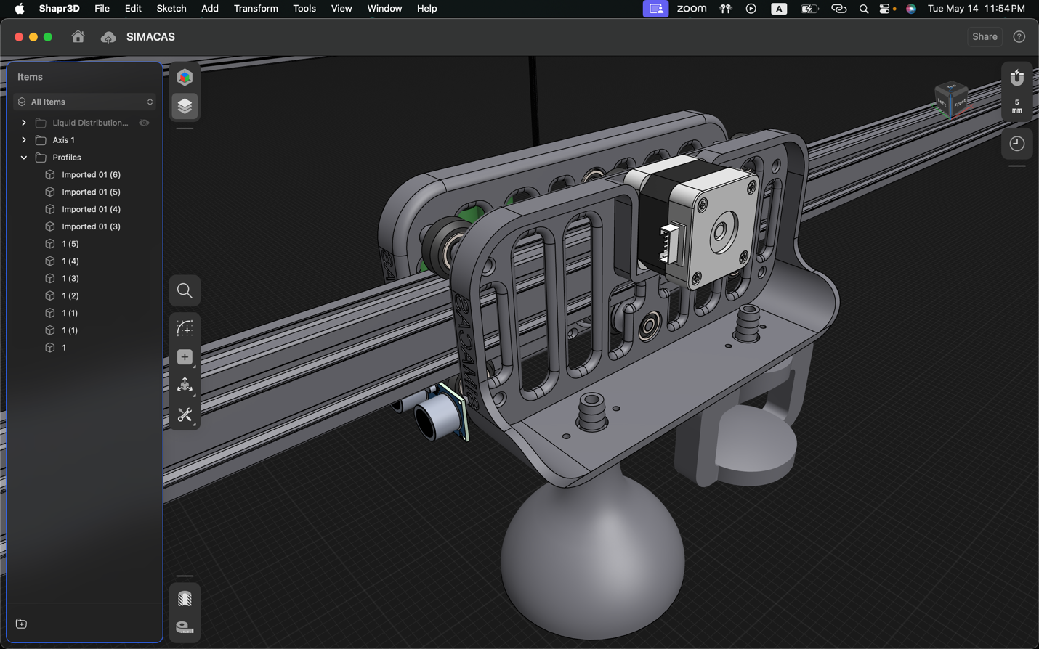

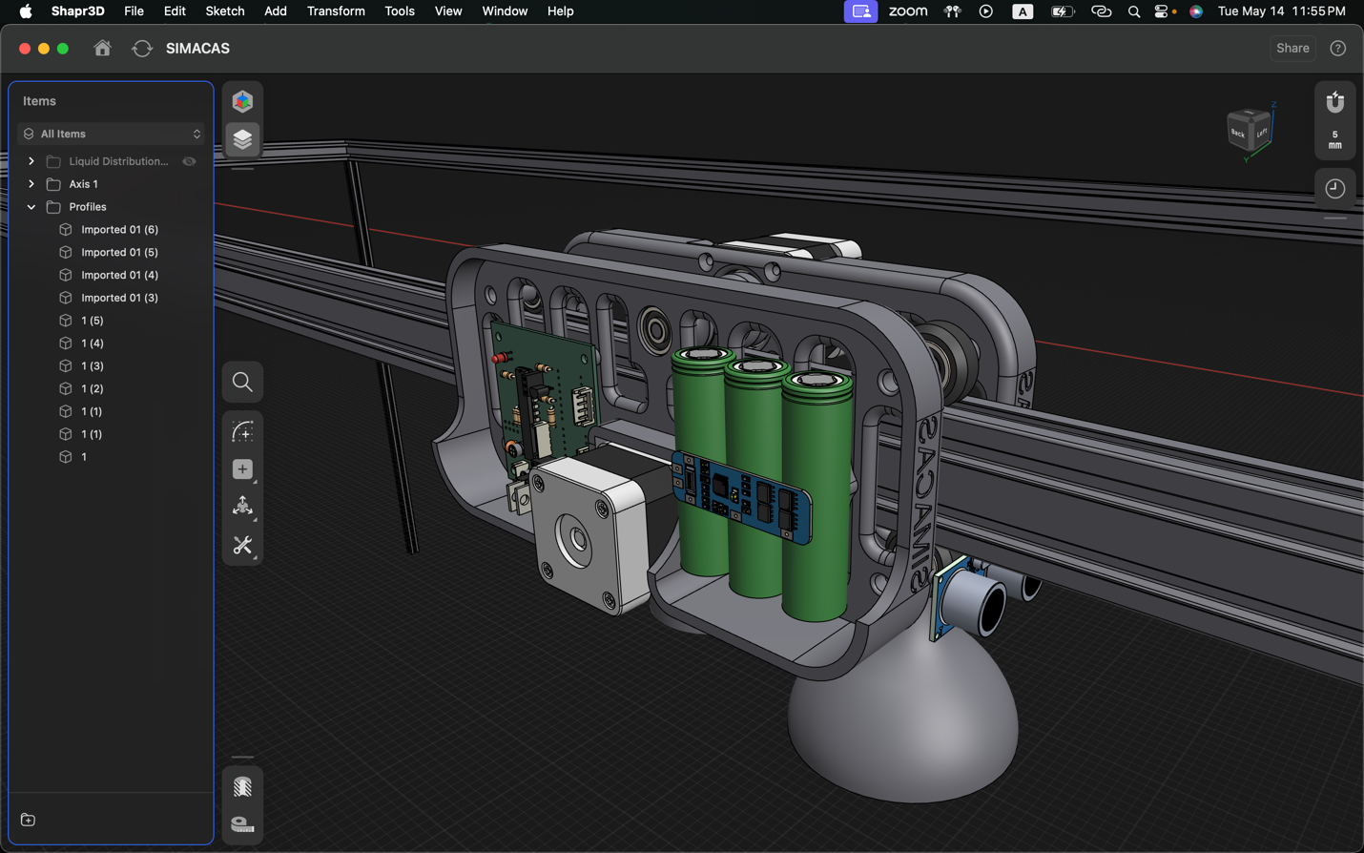

### Water Distribution System

## Electronics

### Intro

### Axis Control

#### Circuit

#### PCB

### Water Distribution Circuit

### Sensor Monitoring

#### Circuit

#### PCB

## Programming

### Intro

### Axis Control

### Sensor Monitoring

### Main Board

#### Interfacing Other Boards

#### Control Algorithms – Model Predictive Control (MPC)

##### Intro to MPC.

##### System Model

##### Implementing the Model

#### Website Control – IOT Application

# Chapter 4: Conclusion

# References

[1] A. A. Desai, R. A. Metri, S. R. Patil, A. A. Nagargoje and D. S. Desai, "Automated Irrigation System for Efficient and Portable Farming," 2023 International Conference on Power, Instrumentation, Control and Computing (PICC), Thrissur, India, 2023, pp. 1-6, doi: 10.1109/PICC57976.2023.10142376.

[2] Levidow, L., Zaccaria, D., Maia, R., Vivas, E., Todorovic, M., & Scardigno, A. (2014). Improving water-efficient irrigation: Prospects and difficulties of innovative practices. Agricultural Water Management, 146, 84-94. doi:10.1016/j.agwat.2014.07.012

[3] Lozoya, C., Mendoza, C., Mejía, L., Quintana, J., Mendoza, G., Bustillos, M., Arras, O., & Solís, L. (2014). Model predictive control for closed-loop irrigation. Proceedings of the 19th World Congress The International Federation of Automatic Control, Cape Town, South Africa, August 24-29, 2014. doi:10.3182/20140824-6-ZA-1003.01920

[4] Saleem, K., Delgoda, D., Ooi, S. K., Dassanayake, K. B., Liu, L., Halgamuge, M. N., & Malano, H. (2013). Model predictive control for real-time irrigation scheduling. Retrieved from [ResearchGate](https://www.researchgate.net/publication/260418442).

[5] Ahmed, Z., Gui, D., Murtaza, G., Yunfei, L., & Ali, S. (2023). An Overview of Smart Irrigation Management for Improving Water Productivity under Climate Change in Drylands. Agronomy, 13(8), 2113. https://doi.org/10.3390/agronomy13082113

[6] Metri, R. A., & Rajpathak, B. A. (2022). Computation of Control Law for State Transfer Problem in Efficient Way for a Single Input. IEEE Transactions on Industry Applications. doi:10.1109/TIA.2022.3159502

[7] Khairy, M. F. A., Elmesery, A. A. M., Zabady, F. E., & Fayed, M. H. (2016). Design and Evaluation of Mobile Drip Irrigation System. Misr Journal of Agricultural Engineering, 33(4), 1329-1350.

[8] Delgoda, D., Malano, H., Saleem, S. K., & Halgamuge, M. N. (2016). Irrigation Control Based on Model Predictive Control (MPC): Formulation of Theory and Validation Using Weather Forecast Data and AQUACROP Model. Environmental Modelling & Software, 78, 40-53. doi:10.1016/j.envsoft.2015.12.012

[9] Gamal, Y., Soltan, A., Said, L. A., Madian, A. H., & Radwan, A. G. (2023). Smart Irrigation Systems: Overview. IEEE Access. doi:10.1109/ACCESS.2023.3251655

[10] Babu, D. V., Shijin, K. V., Sreejith, N. S., Anjana, V. S., & Karthikeyan, C. (2020). Automatic Irrigation Systems for Efficient Usage of Water using Embedded Control Systems. IOP Conference Series: Materials Science and Engineering, 993, 012077. doi:10.1088/1757-899X/993/1/012077