Case Study Part 1

**Four Modules:**

* Lead Module
* Job Module
* Bill_Shipment Module
* Performance Module

**1. Dimensions**

|  |  |  |  |
| --- | --- | --- | --- |
| **Dimension** | **Attributes** | **Hierarchies** | **Data Sources** |
| Agent_Dim | Sales_Agent_Id |  | SalesAgent |
| Agent_Dim | Sales_Agent_Name |  | SalesAgent |
| Job_SubJob_Dim | Job_SubJob_Id |  | Job, Subjob |
| Job_SubJob_Dim | Cust_Name |  | Customer |
| Job_SubJob_Dim | Manufacturer |  | MachineType |
| Location_Dim | Location_Id |  | Location |
| Location_Dim | Location_Name |  | Location |
| Product_Dim | Sales_Class_Id |  | SalesClass |
| Product_Dim | Sales_Class_Desc |  | SalesClass |
| Shipment_Dim | Shipment_Id |  | Shipment |
| Shipment_Dim | Zip | Country →State →County→ City→Area | CustLocation |
| Calendar_Dim | Time_Id |  | Time Dimension Table |
| Calendar_Dim | Year |  | Time Dimension Table |
| Calendar_Dim | Quarter |  | Time Dimension Table |
| Calendar_Dim | Month |  | Time Dimension Table |
| Calendar_Dim | Day |  | Time Dimension Table |
| Calendar_Dim | Week |  | Time Dimension Table |

**2. Measures**

|  |  |  |
| --- | --- | --- |
| **Data Source** | **Measures** | **Aggregation Properties** |
| Lead file | Quote_Qty | Additive |
| Lead file | Quote_Price | Snapshot |
| Lead file | Quote_Value | Additive |
| Job | Unit_Price | Snapshot |
| Job | Quantity_Ordered | Additive |
| Invoice | Invoice_Amount | Additive |
| Sales Summary | Actual_Amount | Additive |
| Sales Summary | Forecast_Amount | Additive |
| Cost Summary | Actual_Labor_Cost | Additive |
| Cost Summary | Actual_Material_Cost | Additive |
| Cost Summary | Actual_Overhead_Cost | Additive |
| Cost Summary | Actual_Machine_Cost | Additive |
| Cost Summary | Budget_Labor_Cost | Additive |
| Cost Summary | Budget_Material_Cost | Additive |
| Cost Summary | Budget_Overhead_Cost | Additive |
| Cost Summary | Budget_Machine_Cost | Additive |

|  |  |  |
| --- | --- | --- |
| **Cube** | **Dimensions** | **Measures** |
| Lead Cube | Agent_Dim | Quote_Qty |
|  | Job_SubJob_Dim | Quote_Price |
|  | Calendar | Quote_Value |
| Job Cube | Location_Dim | Unit_Price |
|  | Product_Dim | Quantity_Ordered |
|  | Job_SubJob_Dim | Job_Revenue |
|  | Calendar | Invoice_Amount |
| Bill_Shipment Cube | Shipment_Dim | Contract_Time_Ship |
|  | Job_SubJob_Dim | Requested_Time_Ship |
|  | Product_Dim | Invoice_Time |
|  | Location_Dim | Invoice_Trend |
|  | Calendar |  |
| Performance Cube | Location_Dim | Actual_Amount |
|  | Product_Dim | Forecast_Amount |
|  | Calendar | Actual_Labor_Cost |
|  |  | Actual_Material_Cost |
|  |  | Actual_Overhead_Cost |
|  |  | Actual_Machine_Cost |
|  |  | Budget_Labor_Cost |
|  |  | Budget_Material_Cost |
|  |  | Budget_Overhead_Cost |
|  |  | Budget_Machine_Cost |
|  |  | Actual_Cost |
|  |  | Budget_Cost |
|  |  | Gross_Margin |
|  |  | Gross_Margin_Forecast |
|  |  | Gross_Margin_Budget |

**3. Grain Size Calculation:**

Lead Cube:

The most detail grain is the combination of individual Agent_Dim, Lead_FT, Job_SubJob_Dim and date.

* 50 Sales Agent
* 50,000 X 5 Job_SubJob rows
* 365 days
* 125000 leads per year
* Sparcity:
  + 1 - ( fact table size / product of dimensions )
  + 1 -(125000/(50 X 50000 X 5 X 365))
  + 0.9999726
* Grain= 0.000027
* Unadjusted Size=50 X 50000 X 5 X 365

Order Cube:

The most detail grain is the combination of individual Location, Product, Customer, Manufacturer, and date and Order_FT.

* 10 Location
* 6 Product
* 365 days
* 3000 customers
* 10 manufacturer (MachineTypes)
* 50000 order per year
* Sparcity:
  + 1 - ( fact table size / product of dimensions )
  + 1 -(50000/(10 X 6 X 3000 X 10 X 365))
  + 0.99992
* Grain= 0.0000761
* Unadjusted Size=10 X 6 X 3000 X 10 X 365=657000000

Bill_Shipment Cube:

The most detail grain is the combination of individual Location, Product, JobSubJob, shipment and date and Invoice_FT.

* 10 Location
* 6 Product
* 365 days
* 50000 X 5 JobsSubJobs rows
* 50000 X 5 X 5 shipments
* (50000 X 5 X 5 )/2.5 Invoice rows
* Sparcity:
  + 1 - ( fact table size / product of dimensions )
  + 1 -(50000 X 5 X 5/(2.5 X 50000 X 5 X 5 X 50000 X 5 X 365 X 6 X 10))
  + 0.999999
* Grain= 0.000001
* Unadjusted Size=50000 X 5 X 5 X 50000 X 5 X 365 X 6 X 10=6.84e15

Performance Cube:

The most detail grain is the combination of individual Location, Product, dates and Summary Fact table.

* 10 Location
* 6 Product
* 365 days
* Sales = .70 X 1800/5 =252 rows
* Cost=.85 X 5400 /5 = 918 rows
* Sparcity:
  + 1 - ( fact table size / product of dimensions )
  + 1 -((252+918)/(10 X 6 X 365))
  + 0.05342
* Grain= 0.9465
* Unadjusted Size=21900

|  |  |  |  |
| --- | --- | --- | --- |
| **Cube** | **Grain** | **Unadjusted Size** | **Sparsity** |
| Lead Cube | 0.00002739 | 4562500000 | 0.9999726 |
| Order Cube | 0.0000761 | 657000000 | 0.99992 |
| Bill_Ship_Cube | 0.000001 | 6.84e15 | 0.999999 |
| Performance Cube | 0.9465 | 21900 | 0.05342 |

**4. Schema Details**

**Lead Module:**

Agent_Dim = {Sales_Agent_Id, Sales_Agent_Name}

Lead_FT = {Lead_Id, Sales_Agent_Id (F.K.), Time_Id (F.K.), Job_SubJob_Id (F.K.), Quote_Qty, Quote_Price, Quote_Value}

Calandar_Dim = {Time_Id, Year, Quarter, Month, Week}

Job_SubJob_Dim = {Job_SubJob_Id, Cust_Name, Manufacturer}

Forign Keys (Sales_Agent_Id, Time_Id, Job_SubJob_Id)

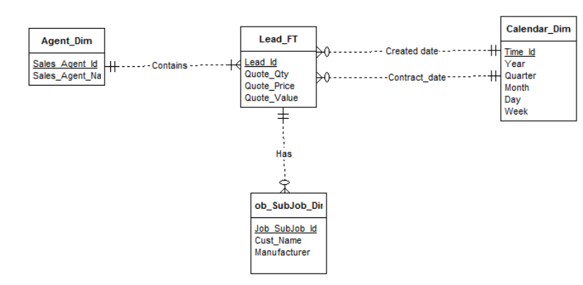

**Job Module:**

Location_Dim = {Location_Id, Location_Name}

Order_FT = {Order_Id, Location_Id (F.K.), Time_Id (F.K.), Sales_Class_Id (F.K.), Job_Sub_Id (F.K.), Unit_Price, Quantity_Ordered, Job_Revenue}

Calandar_Dim = {Time_Id, Year, Quarter, Month, Week}

Product_Dim = {Sales_Class_Id, Sales_Class_Desc}

Job_SubJob_Dim = {Job_Sub_Id, Cust_Name, Manufacturer}

Forign Keys (Location_Id, Time_Id, Sales_Class_Id, Job_Sub_Id)

**Calculation:**

Job_Revenue (Unit_Price * Quantity)

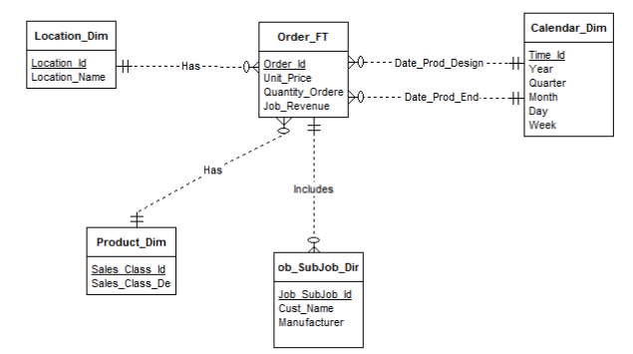

**Bill_Shipment Module:**

Shipment_Dim = {Shipment_Id, Zip}

Invoice_FT = {Invoice_Id, Shipment_Id(F.K.), Time_Id (F.K.), Job_Sub_Id (F.K.), Sales_Class_Id (F.K.), Location_Id(F.K.), Invoice_Amt, Contract_Time_Ship, Requested_Time, Invoice_Time, Invoice_Trend}

Calandar_Dim = {Time_Id, Year, Quarter, Month, Week}

Job_SubJob_Dim = {Job_Sub_Id, Cust_Name, Manufacturer}

Product_Dim = {Sales_Class_Id, Sales_Class_Desc}

Location_Dim = {Location_Id, Location_Name}

Forign Key (Shipment_Id, Time_Id, Job_Sub_Id, Sales_Class_Id, Location_Id)

**Calculation:**

Contract_Time_Ship (Actual_Shi_Date – Contract_Date)

Requested_Time_Ship (Actual_Ship_Date – Requested_Ship_Date)

Invoice_Time (Posting_Date – Date_Invoiced)

Invoice_Trend (Invoice_Shipped – Invoice_Quantity)

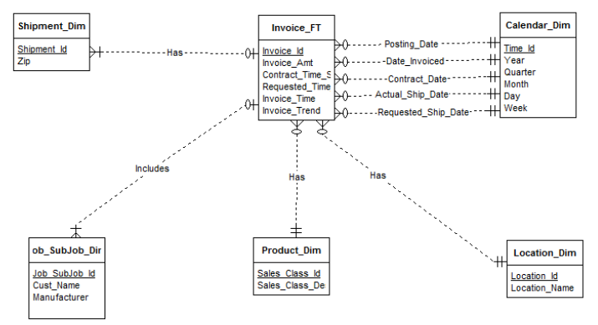

**Performance Module:**

Location_Dim = {Location_Id, Location_Name}

Summary_FT = {Summary_Id, Location_Id (F.K.), Time_Id(F.K.), Sales_Class_Id(F.K.) Actual_Amount, Forecast_Amount, Actual_Labor_Cost, Actual_Material_Cost, Actual_Overhead_Cost, Actual_Machine_Cost, Budget_Labor_Cost, Budget_Material_Cost, Budget_Overhead_Cost, Budget_Machine_Cost, Actual_Cost, Budget_Cost, Gross_Margin, Gross_Margin_Forecast, Gross_Margin_Budget}

Calandar_Dim = {Time_Id, Year, Quarter, Month, Week}

Product_Dim = {Sales_Class_Id, Sales_Class_Desc}

Forign Key (Location_Id, Time_Id, Sales_Class_Id)

**Calculation:**

Actual_Cost (Actual_Labor_Cost + Actual_Material_Cost + Actual_Overhead_Cost + Actual_Machine_Cost)

Budget_Cost (Budget_Labour_Cost + Budget_Material_Cost + Budget_Overhead_Cost + Budget_Machine_Cost)

Gross_Margin (Actual_Amount – Actual_Cost)

Gross_Margin_Forecast (Gross_Margin – Forecast_Amount)

Gross_Margin_Budget (Gross_Margin – Budget_Cost)

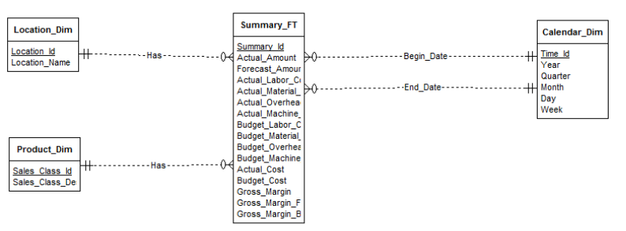

|  |  |  |  |
| --- | --- | --- | --- |
| **Schema type** | **Dimension tables** | **Fact table** | **Comments** |
| Star | Agent_Dim, Job_SubJob_Dim, Calendar_Dim | Lead_FT | Sales Agent Productivity |
| Star | Location_Dim, Product_Dim, Job_SubJob_Dim, Calendar_Dim | Order_FT | Job Revenue and production trends |
| Star | Shipment_Dim,Location_Dim,Product_Dim,Job_SubJob_Dim, Calendar_Dim | Invoice_FT | Shipping and Invoice trends |
| Star | Location_Dim,Product_Dim, Calemdar_Dim | Summary_FT | Financial Summary trends |

**5. Summarizability Problems:**

1. Week – Month has Non strict non- summarizability issue because, Week has overlapping months in Calendar_Dim.
2. Manufacturer has null values in the Job_SubJob_Dim. This may lead to rollup incompleteness, which can be avoided by adding a default type.
3. Contract_Date has null values in Lead_FT. This may lead to rollup incompleteness.
4. Quote_Price will support null values.