## Case Study Part 3

## Query Formulation

**Base Queries**

**1. BQ1: Location/Sales class summary for job quantity and amount**

Create view BQ1 AS

SELECT l.location_id, l.location_name, s.sales_class_id,s.sales_class_desc,

t.time_year,t.time_month, s.base_price,

SUM(j.quantity_ordered) AS sum_quantity_ordered,

SUM(j.Quantity_Ordered * j.Unit_Price) AS Sum_Job_amount

FROM W_Location_D l,W_Sales_Class_D s,W_Time_D t,W_Job_F j

WHERE l.Location_Id = j.Location_Id

AND s.Sales_Class_Id = j.Sales_Class_Id

AND t.Time_Id = j.Contract_Date

GROUP BY l.location_id, l.location_name, s.sales_class_id,s.sales_class_desc,

t.time_year,t.time_month, s.base_price;

Output

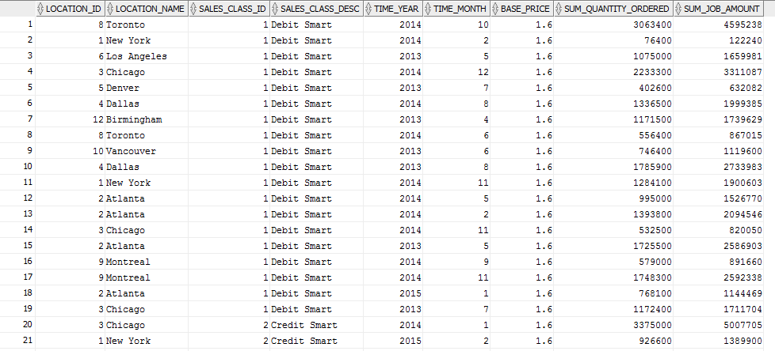

**2. BQ2: Location invoice revenue summary**

Create view BQ2 AS

SELECT j.Job_id, l.Location_id, l.Location_name,j.Unit_price,j.Quantity_Ordered,

t.Time_year,t.Time_month,

SUM(i.Invoice_amount) AS sum_Invoice_amount,

SUM(i.Invoice_Quantity ) AS sum_Invoice_Quantity

FROM W_JOB_F j,W_Location_D l,W_TIME_D t,W_INVOICELINE_F i

WHERE l.Location_Id = j.Location_Id

AND t.Time_Id = j.Contract_Date

AND i.Sales_class_id = j.Sales_class_id

GROUP BY j.Job_id, l.Location_id, l.Location_name,j.Unit_price,j.Quantity_Ordered,

t.Time_year,t.Time_month;

Output:

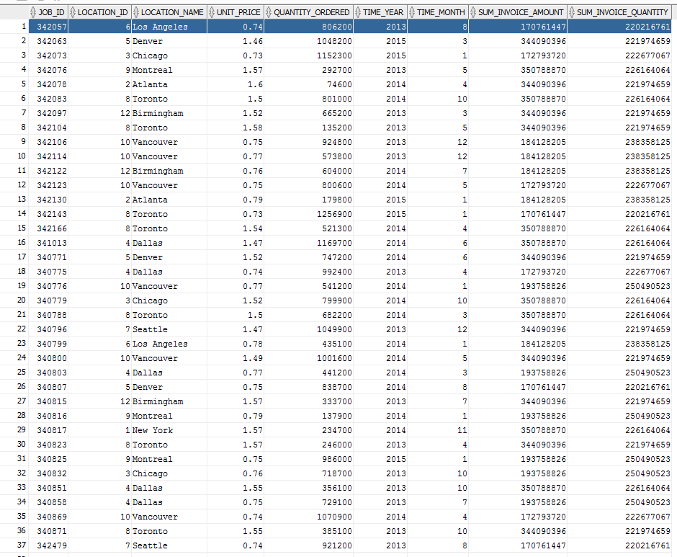

**3. BQ3: Location subjob cost summary**

Create View BQ3 AS

Select j.job_id, l.location_id, l.location_name, t.time_year,t.time_month, sum(sj.cost_labor) AS labour_cost,

sum(sj.cost_material) AS material_cost, sum(sj.machine_hours*m.rate_per_hour) machine_cost, sum(sj.cost_overhead) AS overhead_cost,

sum(sj.quantity_produced) AS quantity_produced,

sum(sj.cost_labor) + sum(sj.cost_material)+ sum(sj.machine_hours*m.rate_per_hour) + sum(sj.cost_overhead) AS Total_Cost,

(sum(sj.cost_labor) + sum(sj.cost_material)+ sum(sj.machine_hours*m.rate_per_hour) + sum(sj.cost_overhead))/sum(sj.quantity_produced) AS Unit_Cost

FROM W_Location_D l,W_Time_D t,W_Job_F j, W_Sub_Job_F sj, W_Machine_Type_D m

WHERE l.location_Id = j.location_Id

AND j.job_id = sj.job_id

AND t.Time_Id = j.Contract_Date

AND m.machine_type_id= sj.machine_type_id

GROUP BY j.job_id, l.location_id, l.location_name, t.time_year,t.time_month;

Output:

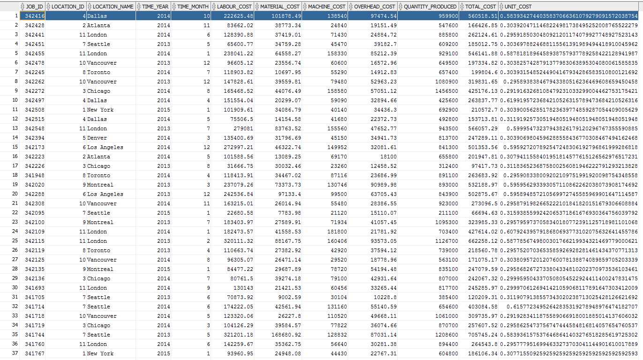

**4. BQ4: Returns by location and sales class**

CREATE VIEW BQ4 AS

SELECT l.Location_Id, l.Location_Name,sc.Sales_Class_Id,

sc.Sales_Class_Desc,t.Time_Year,t.Time_Month,

SUM(i.Quantity_Shipped - i.Invoice_Quantity) AS Sum_Quantity_Returned,

SUM ((Invoice_Amount/Invoice_Quantity)* (i.Quantity_Shipped - i.Invoice_Quantity)) AS Sum_Amount_Returns

FROM W_Location_D l,W_SALES_CLASS_D sc,W_TIME_D t,W_INVOICELINE_F i

WHERE l.Location_Id = i.Location_Id

AND sc.Sales_Class_Id = i.Sales_Class_Id

AND t.Time_Id = i.Invoice_Sent_Date

AND (i.Quantity_Shipped - i.Invoice_Quantity) > 0

GROUP BY l.Location_Id, l.Location_Name,sc.Sales_Class_Id,

sc.Sales_Class_Desc,t.Time_Year,t.Time_Month;

Output:

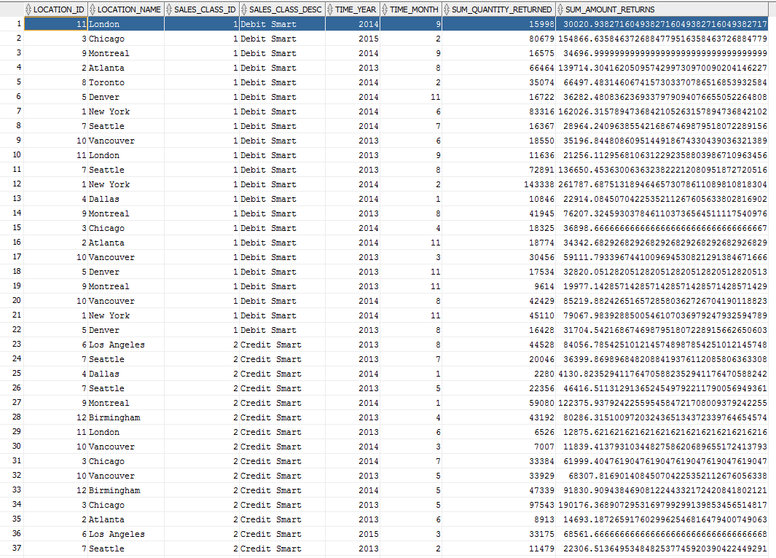

**5. BQ5: Last shipment delays involving date promised**

CREATE VIEW BQ5 AS

SELECT X1.Job_Id, l.Location_Id, l.Location_Name,sc.Sales_Class_Id,

sc.Sales_Class_Desc,j.Date_Promised,X1.Last_Shipment_Date, j.Quantity_Ordered,X1.SumDelayShipQty,

GETBUSDAYSDIFF(X1.Last_Shipment_Date,j.Date_Promised) AS BUS_DAY_DIFF

FROM W_Job_F j ,W_Location_D l,W_SALES_CLASS_D sc,

( SELECT W_SUB_JOB_F.JOB_ID,

MAX(actual_ship_Date) AS Last_Shipment_Date,

SUM ( actual_Quantity ) AS SumDelayShipQty

FROM W_JOB_SHIPMENT_F, W_SUB_JOB_F, W_Job_F

WHERE W_SUB_JOB_F.SUB_JOB_ID = W_JOB_SHIPMENT_F.SUB_JOB_ID

AND W_Job_F.Job_Id = W_SUB_JOB_F.JOB_ID

AND Actual_Ship_Date > Date_Promised

GROUP BY W_SUB_JOB_F.JOB_ID

) X1

WHERE l.Location_Id = j.Location_Id

AND sc.Sales_Class_Id = j.Sales_Class_Id

AND X1.Job_Id = j.Job_Id;

Output:

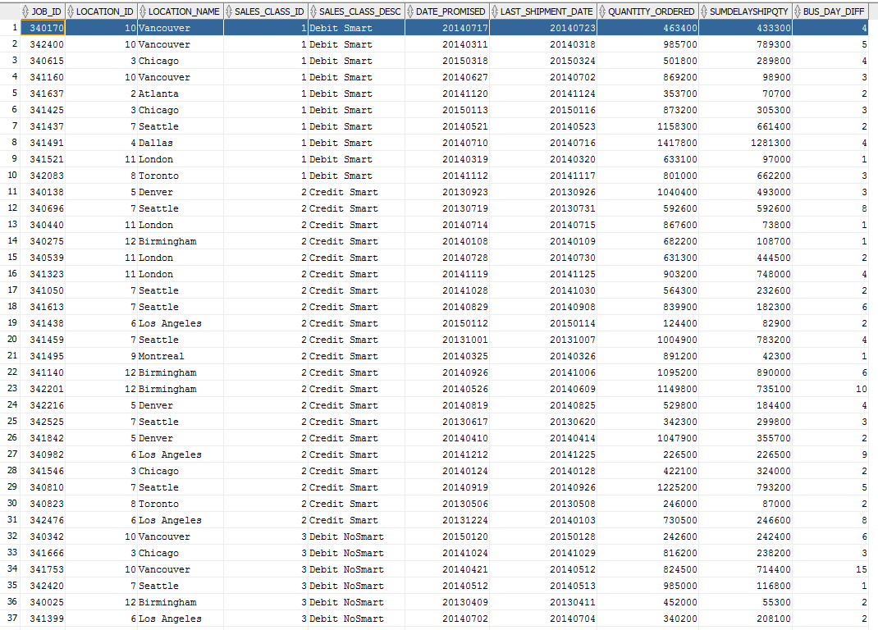

**6. BQ6: First shipment delays involving shipped by date**

CREATE VIEW BQ6 AS

SELECT X1.Job_Id, l.Location_Id, l.Location_Name,sc.Sales_Class_Id,

sc.Sales_Class_Desc,j.Date_Ship_By,X1.FirstShipDate,

GETBUSDAYSDIFF(X1.FirstShipDate,j.Date_Ship_By) AS BUS_DAY_DIFF2

FROM W_Job_F j ,W_Location_D l,W_SALES_CLASS_D sc,

( SELECT W_SUB_JOB_F.JOB_ID, MIN(Actual_Ship_Date) as FirstShipDate

FROM W_JOB_SHIPMENT_F, W_SUB_JOB_F

WHERE W_SUB_JOB_F.SUB_JOB_ID = W_JOB_SHIPMENT_F.SUB_JOB_ID

GROUP BY W_SUB_JOB_F.JOB_ID

) X1

WHERE l.Location_Id = j.Location_Id

AND sc.Sales_Class_Id = j.Sales_Class_Id

AND X1.Job_Id = j.Job_Id;

Output:

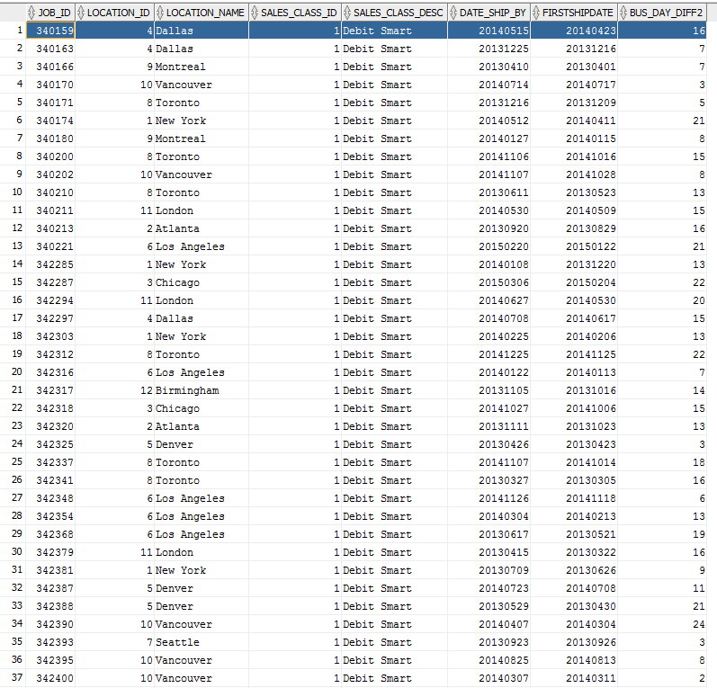

**Analytical Queries**

**1. AQ1: Cumulative amount for locations**

SELECT l.location_name, t.time_year,t.time_month,

SUM(j.Quantity_Ordered * j.Unit_Price) AS Sum_Job_amount,

SUM(SUM(j.Quantity_Ordered * j.Unit_Price)) OVER

(PARTITION BY l.location_name, t.time_year ORDER BY t.time_month

ROWS UNBOUNDED PRECEDING ) AS Cum_Sum_Job_amount

FROM W_Location_D l,W_Time_D t,W_Job_F j

WHERE l.Location_Id = j.Location_Id

AND t.Time_Id = j.Contract_Date

GROUP BY l.location_name, t.time_year,t.time_month;

Output:

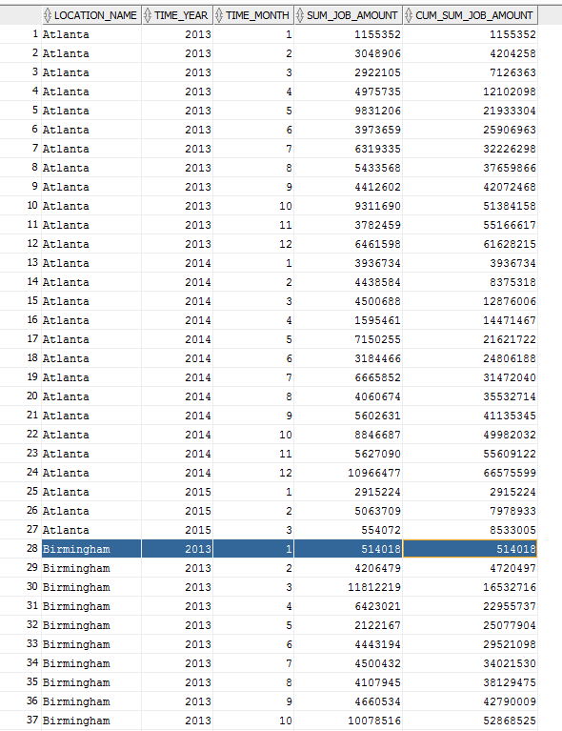

**2. AQ2: Moving average of average amount ordered for locations**

SELECT l.location_name, t.time_year,t.time_month,

SUM(j.Quantity_Ordered * j.Unit_Price)/count(*) AS AVG_Job_amount,

AVG(SUM(j.Quantity_Ordered * j.Unit_Price)/count(*)) OVER

(PARTITION BY l.location_name ORDER BY t.time_year, t.time_month

ROWS BETWEEN 11 PRECEDING AND 0 FOLLOWING) AS Mvg_AVG_Job_amount

FROM W_Location_D l,W_Time_D t,W_Job_F j

WHERE l.Location_Id = j.Location_Id

AND t.Time_Id = j.Contract_Date

GROUP BY l.location_name, t.time_year,t.time_month;

Output

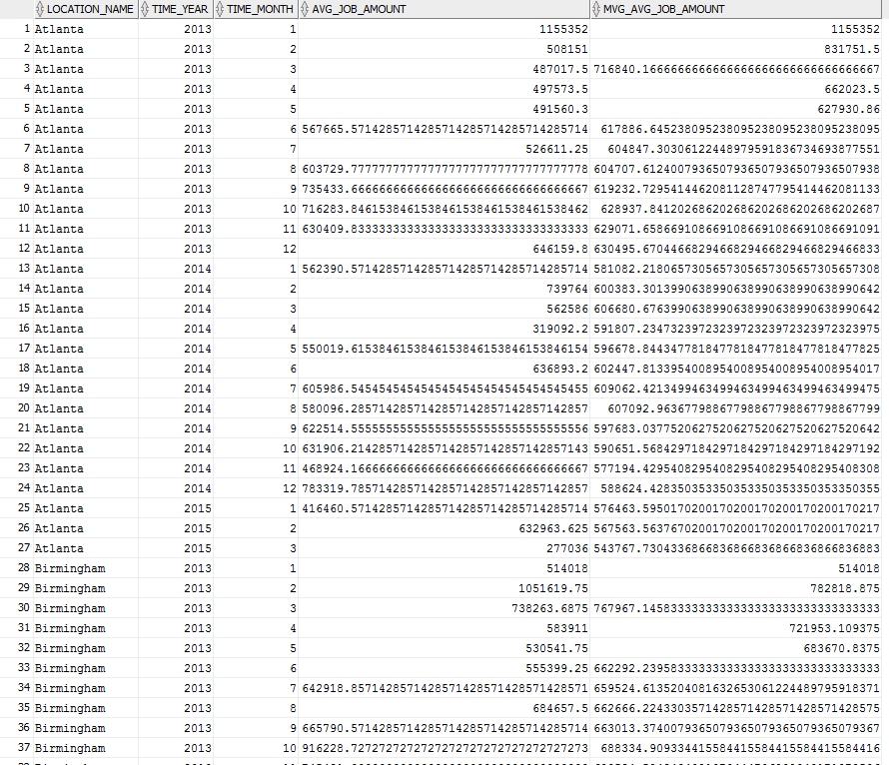

**3. AQ3: Rank locations by descending sum of annual profit**

SELECT BQ2.location_name, BQ2.time_year,

SUM(BQ2.Sum_Invoice_Amount - BQ3.Total_Cost) AS Sum_Of_Profit,

RANK() OVER (

PARTITION BY BQ2.time_year

ORDER BY SUM(BQ2.Sum_Invoice_Amount - BQ3.Total_Cost)DESC ) AS Rank_AP

FROM BQ2 , BQ3

WHERE BQ2.Job_Id = BQ3.Job_Id

GROUP BY BQ2.location_name, BQ2.time_year;

Output

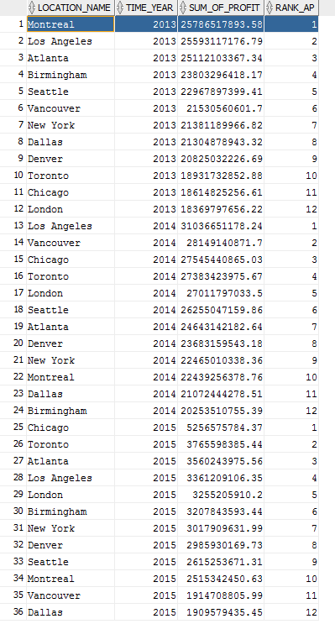

**4. AQ4: Rank locations by descending annual profit margin**

SELECT BQ2.location_name, BQ2.time_year,

SUM(BQ2.Sum_Invoice_Amount - BQ3.Total_Cost) / SUM(BQ2.Sum_Invoice_Amount) AS Profit_Margin,

RANK() OVER (

PARTITION BY BQ2.time_year

ORDER BY SUM(BQ2.Sum_Invoice_Amount - BQ3.Total_Cost) / SUM(BQ2.Sum_Invoice_Amount)DESC ) AS Rank_PM

FROM BQ2 , BQ3

WHERE BQ2.Job_Id = BQ3.Job_Id

GROUP BY BQ2.location_name, BQ2.time_year;

**Output**

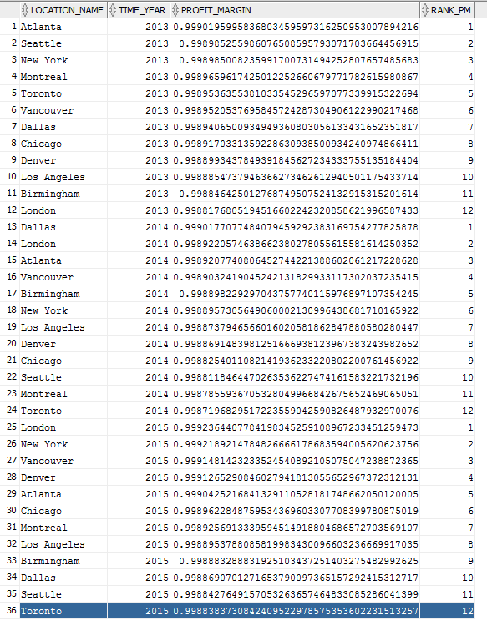

**5. AQ5: Percent rank of job profit margins for locations**

CREATE VIEW AQ5 AS

SELECT BQ2.Job_Id, BQ2.location_name, BQ2.time_year, BQ2.time_month,

SUM(BQ2.Sum_Invoice_Amount - BQ3.Total_Cost) / SUM(BQ2.Sum_Invoice_Amount) AS Profit_Margin,

PERCENT_RANK() OVER (

ORDER BY SUM(BQ2.Sum_Invoice_Amount - BQ3.Total_Cost) / SUM(BQ2.Sum_Invoice_Amount)DESC ) AS Percent_Rank_PM

FROM BQ2 , BQ3

WHERE BQ2.Job_Id = BQ3.Job_Id

GROUP BY BQ2.Job_Id, BQ2.location_name, BQ2.time_year, BQ2.time_month;

**Output**

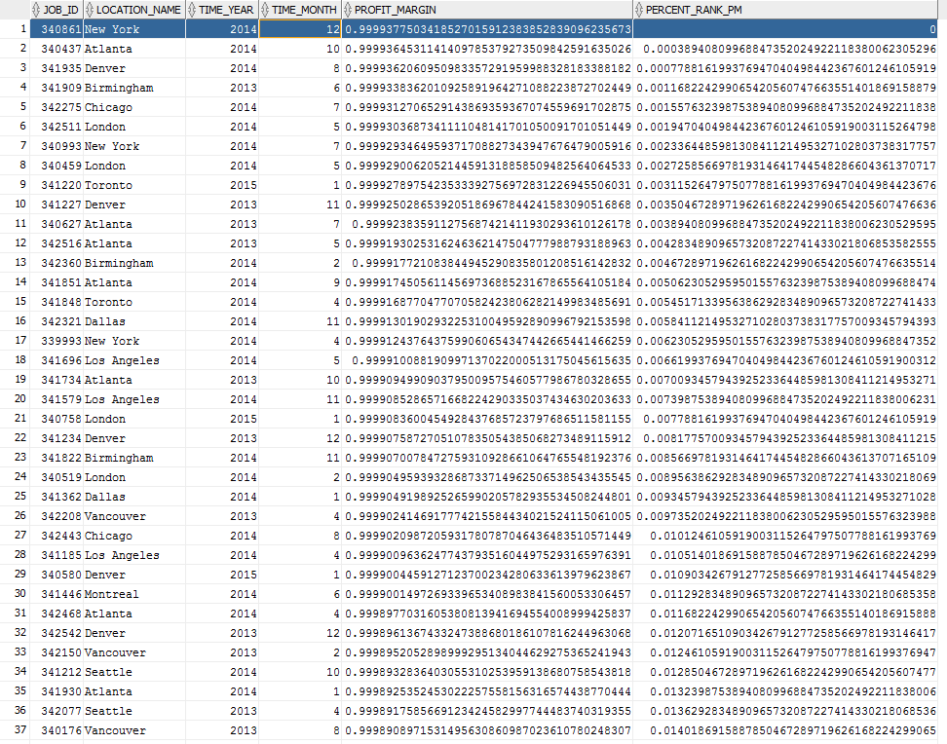

**6. AQ6: Top performers of percent rank of job profit margins for locations**

SELECT Job_Id, location_name, time_year,time_month,Profit_Margin,Cum_Rank_PM

FROM (

SELECT Job_Id, location_name, time_year,time_month, Profit_Margin,

CUME_DIST() OVER (

ORDER BY Profit_Margin DESC ) AS Cum_Rank_PM

FROM AQ5

)

WHERE Cum_Rank_PM <= .05;

Output

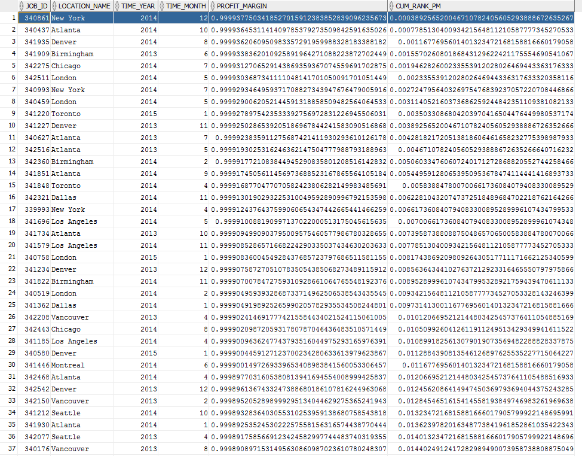

**7. AQ7: Rank sales class by return quantities for each year**

SELECT sc.Sales_Class_Desc,t.Time_Year,

SUM(i.Quantity_Shipped - i.Invoice_Quantity) AS Sum_Quantity_Returned,

RANK() OVER (

PARTITION BY t.Time_Year

ORDER BY SUM(i.Quantity_Shipped - i.Invoice_Quantity) DESC ) AS Rank_QR

FROM W_SALES_CLASS_D sc,W_TIME_D t,W_INVOICELINE_F i

WHERE sc.Sales_Class_Id = i.Sales_Class_Id

AND t.Time_Id = i.Invoice_Sent_Date

AND (i.Quantity_Shipped - i.Invoice_Quantity) > 0

GROUP BY sc.Sales_Class_Desc,t.Time_Year;

**Output**

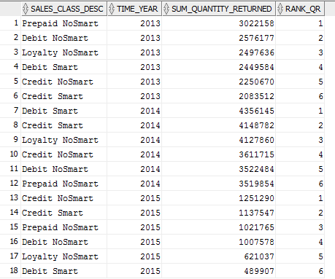

**8. AQ8: Ratio to report of return quantities for sales classes by year**

SELECT sc.Sales_Class_Desc,t.Time_Year,

SUM(i.Quantity_Shipped - i.Invoice_Quantity) AS Sum_Quantity_Returned,

RATIO_TO_REPORT (SUM(i.Quantity_Shipped - i.Invoice_Quantity))

OVER (PARTITION BY t.Time_Year) AS Ratio_Quantity_Returned

FROM W_SALES_CLASS_D sc,W_TIME_D t,W_INVOICELINE_F i

WHERE sc.Sales_Class_Id = i.Sales_Class_Id

AND t.Time_Id = i.Invoice_Sent_Date

AND (i.Quantity_Shipped - i.Invoice_Quantity) > 0

GROUP BY sc.Sales_Class_Desc,t.Time_Year

ORDER BY t.Time_Year,Sum_Quantity_Returned;

Output

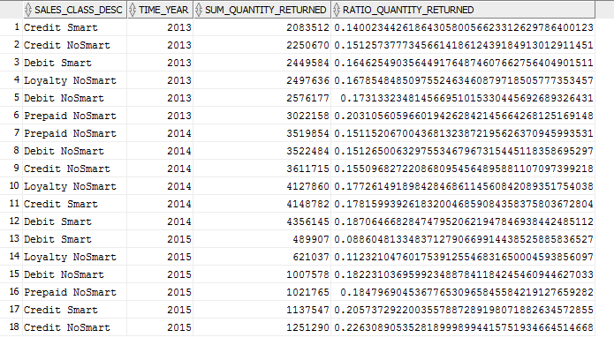

**9. AQ9: Rank locations by sum of business days delayed for the job shipped by date**

SELECT BQ6.Location_Name,t.Time_Year,

SUM(Bus_Day_Diff2) AS Sum_Bus_Day_Diff2,

RANK() OVER (

PARTITION BY t.Time_Year

ORDER BY SUM(Bus_Day_Diff2)DESC ) AS Rank_AP,

DENSE_RANK() OVER (

PARTITION BY t.Time_Year

ORDER BY SUM(Bus_Day_Diff2)DESC ) AS D_Rank_AP

FROM BQ6,W_Time_D t

WHERE t.Time_Id = BQ6.Date_Ship_By

GROUP BY BQ6.Location_Name,t.Time_Year;

Output

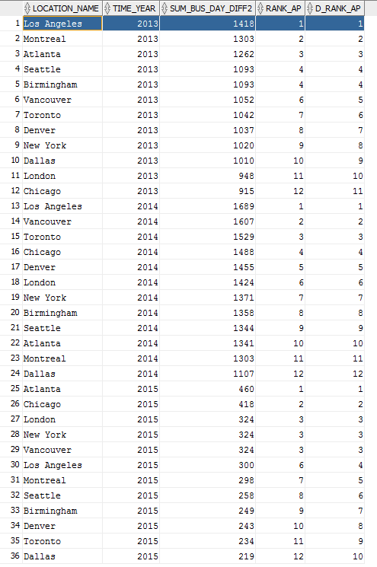

**10. AQ10: Rank locations by delay rate for jobs delayed on the last shipment date**

SELECT BQ5.Location_Name,t.Time_Year,count(*) AS Count_Delay_Job,

SUM(Bus_Day_Diff) AS Sum_Bus_Day_Diff,

RANK() OVER (

PARTITION BY t.Time_Year

ORDER BY SUM(BQ5.Quantity_Ordered - SumDelayShipQty) / SUM(Quantity_Ordered) DESC ) AS Delay_Rate

FROM BQ5,W_Time_D t

WHERE t.Time_Id = BQ5.Date_Promised

GROUP BY BQ5.Location_Name,t.Time_Year;

Output

