Assignment 1: WebPivotTable Tutorial Assignment

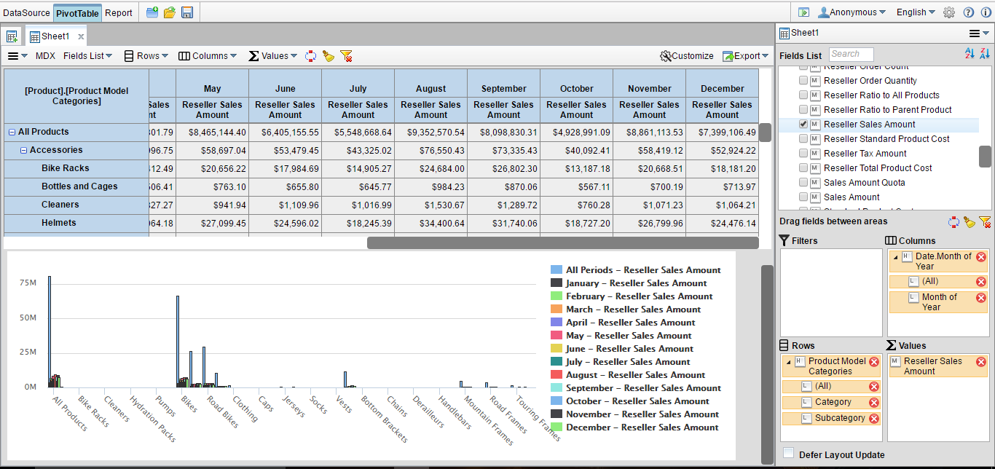

Part 1: Datasheet with PivotTable Fields

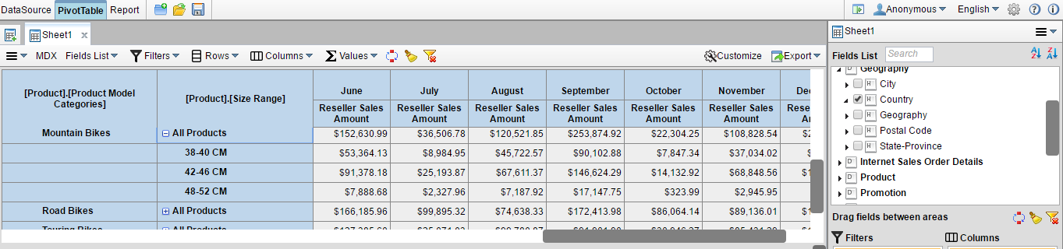

Part 2: Pivot Table after Filtering on United Kingdom