# Assignment 4

# Part 1: Using Subtotal Operators

**Query 1:**

**SELECT AK_DATE_DIM.CALMONTH, AK_CUST_VENDOR_DIM.ADDRCATCODE1, SUM (AK_INVENTORY_FACT.QUANTITY) Total_Quantity, SUM (AK_INVENTORY_FACT.EXTCOST) Total_Cost**

**FROM AK_CUST_VENDOR_DIM, AK_DATE_DIM, AK_INVENTORY_FACT**

**WHERE AK_INVENTORY_FACT.TRANSTYPEKEY = 5 and AK_DATE_DIM.CALYEAR= 2011 and**

**AK_CUST_VENDOR_DIM.CUSTVENDORKEY = AK_INVENTORY_FACT.CUSTVENDORKEY and AK_INVENTORY_FACT.DATEKEY = AK_DATE_DIM.DATEKEY**

**GROUP BY CUBE (AK_CUST_VENDOR_DIM.ADDRCATCODE1, AK_DATE_DIM.CALMONTH);**

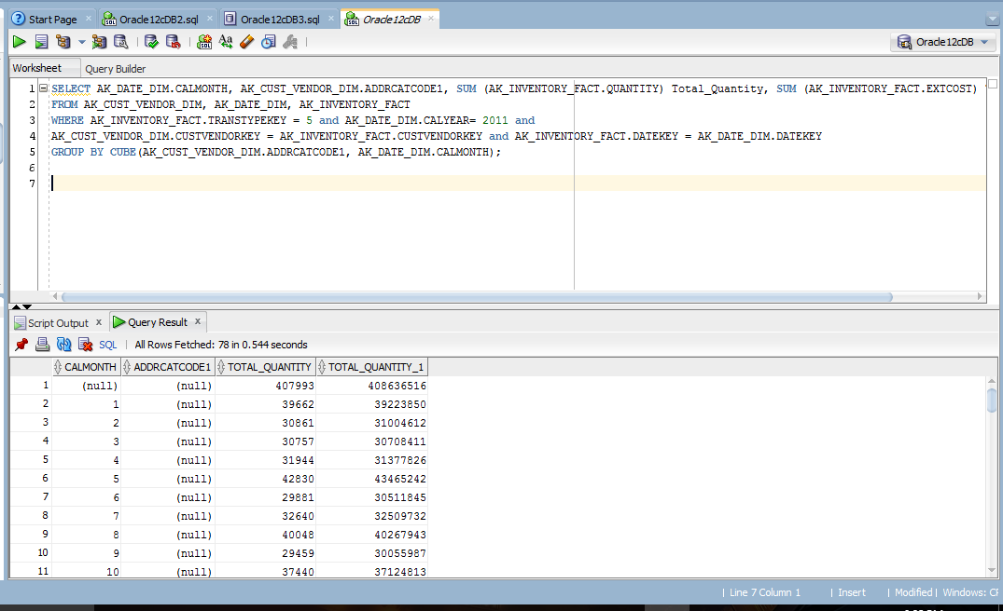

**Query 2:**

**SELECT CV.NAME , CV.ZIP, DD.CALQUARTER, SUM (IF.EXTCOST) Total_Cost, Count(*)**

**FROM AK_INVENTORY_FACT IF, AK_DATE_DIM DD, AK_CUST_VENDOR_DIM CV**

**WHERE IF.TRANSTYPEKEY = 5 and DD.CALYEAR BETWEEN 2010 AND 2011 AND**

**DD.DATEKEY = IF.DATEKEY AND IF.CUSTVENDORKEY = CV.CUSTVENDORKEY AND IF.DATEKEY = DD.DATEKEY**

**GROUP BY GROUPING SETS ((CV.NAME, CV.ZIP, DD.CALQUARTER), (CV.NAME,CV.ZIP),**

**(CV.NAME, DD.CALQUARTER),(CV.ZIP, DD.CALQUARTER),CV.NAME, CV.ZIP, DD.CALQUARTER,());**

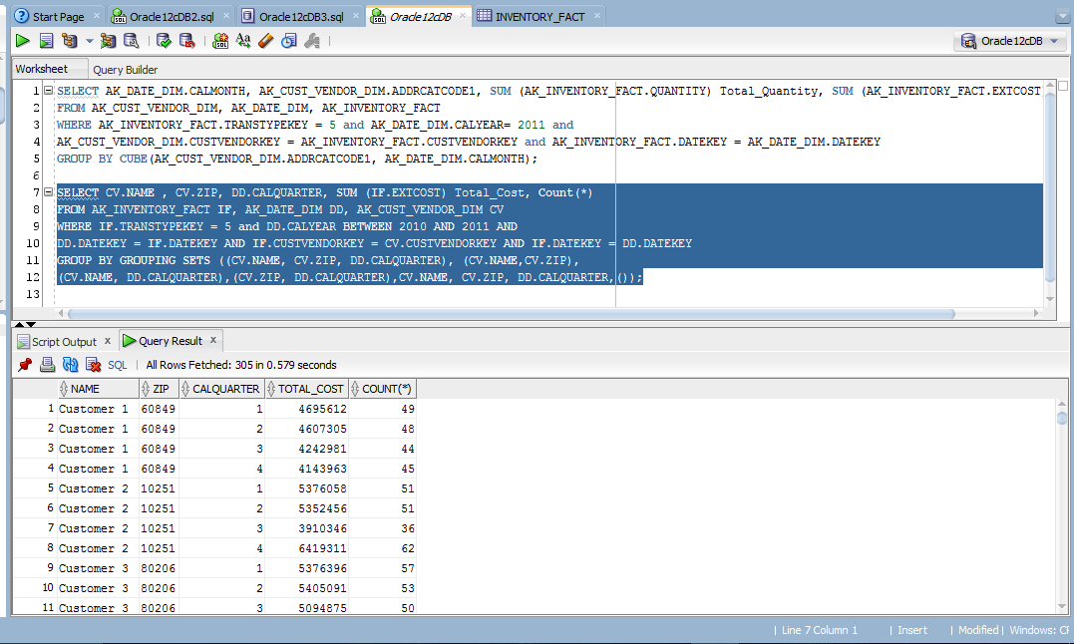

**Query 3:**

**SELECT COMPANYNAME, BP.BPNAME, SUM(ExtCost) Sum_of_Cost, SUM(Quantity) Sum_of_Quantity**

**FROM AK_COMPANY_DIM CD, AK_INVENTORY_FACT IF, AK_BRANCH_PLANT_DIM BP**

**WHERE IF.TRANSTYPEKEY = '2' AND BP.BRANCHPLANTKEY = IF.BRANCHPLANTKEY AND**

**CD.COMPANYKEY = BP.COMPANYKEY**

**GROUP BY ROLLUP(COMPANYNAME, BPNAME);**

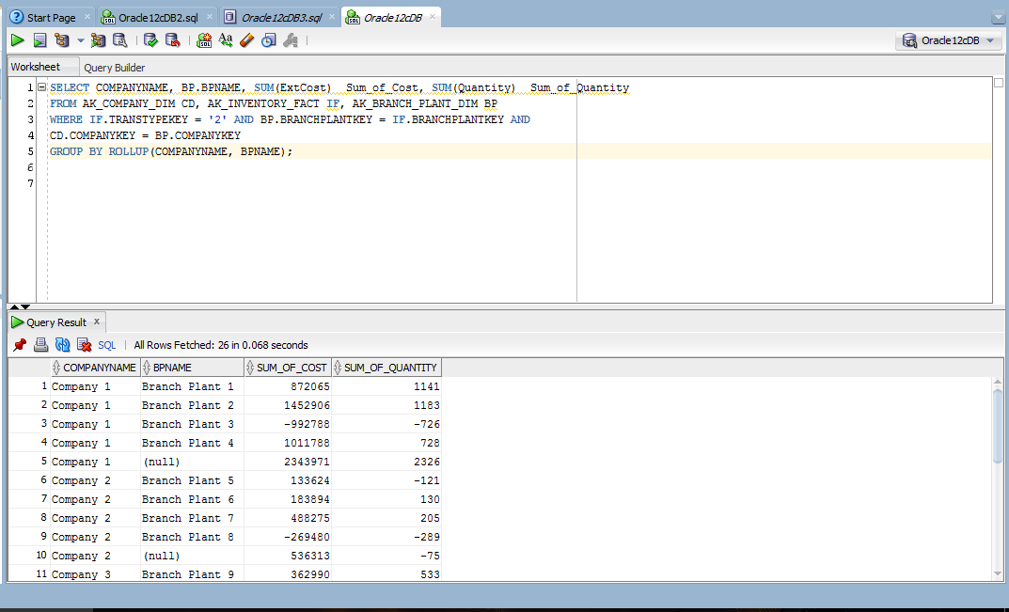

**Query: 4**

**select TT.transdescription, BP.bpname, CD.companyname , sum(extcost), count(*)**

**from AK_inventory_fact IF, AK_trans_type_dim TT, AK_company_dim CD, AK_branch_plant_dim BP**

**where IF.transtypekey = TT.transtypekey and**

**IF.branchplantkey = BP.branchplantkey and**

**BP.companykey = CD.companykey**

**group by grouping sets((TT.transdescription, BP.bpname, CD.companyname),(TT.transdescription,CD.companyname), TT.transdescription, ());**

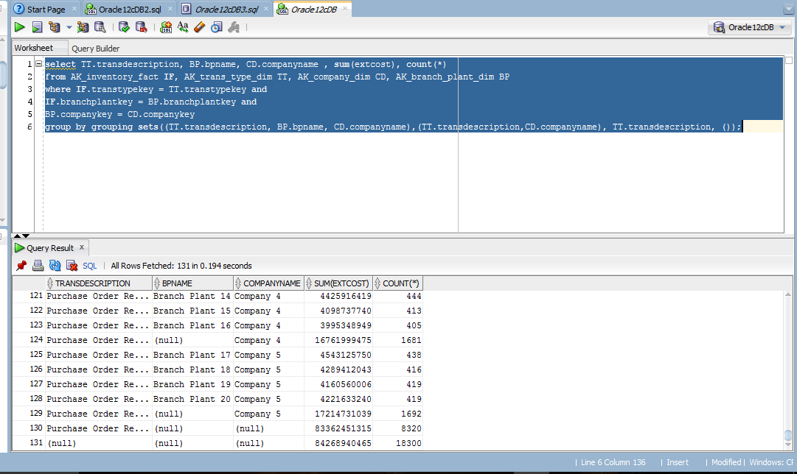

**Query 5:**

**SELECT DD.CALYEAR, DD.CALQUARTER, CV.NAME, SUM(IF.EXTCOST), COUNT(*)**

**FROM AK_INVENTORY_FACT IF, AK_CUST_VENDOR_DIM CV, AK_DATE_DIM DD**

**WHERE IF.CUSTVENDORKEY = CV.CUSTVENDORKEY**

**AND IF.DATEKEY = DD.DATEKEY**

**AND IF.TRANSTYPEKEY = 5**

**AND DD.CALYEAR IN (2011,2012)**

**GROUP BY CV.NAME, ROLLUP(DD.CALYEAR,DD.CALQUARTER)**

**ORDER BY DD.CALYEAR, DD.CALQUARTER, CV.NAME;**

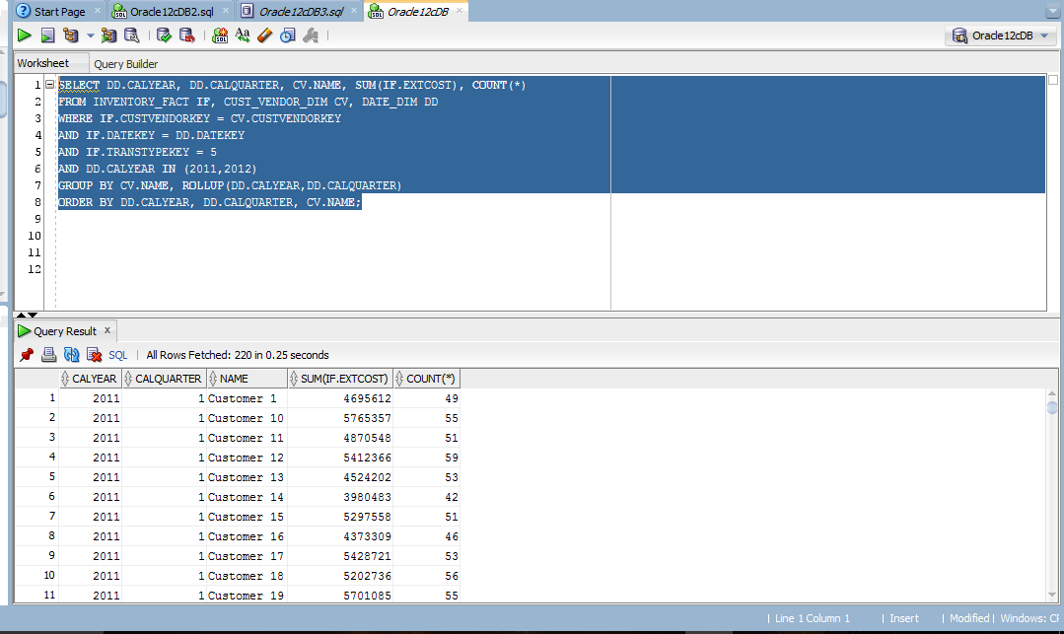

**Query 6:**

**SELECT DD.CALMONTH, CV.ADDRCATCODE1, SUM(IF.EXTCOST), SUM(IF.QUANTITY)**

**FROM AK_Inventory_fact IF, AK_Cust_Vendor_Dim CV, AK_Date_Dim DD**

**Where IF.CUSTVENDORKEY = CV.CUSTVENDORKEY**

**AND IF.Datekey = DD.DATEKEY**

**AND IF.Transtypekey = 5 AND DD.CALYEAR = 2011**

**Group by DD.CALMONTH, CV.ADDRCATCODE1**

**UNION**

**SELECT DD.CALMONTH, NULL, SUM(IF.EXTCOST), SUM(IF.QUANTITY)**

**FROM AK_Inventory_fact IF, AK_Cust_Vendor_Dim CV, AK_Date_Dim DD**

**Where IF.CUSTVENDORKEY = CV.CUSTVENDORKEY**

**AND IF.Datekey = DD.DATEKEY**

**AND IF.Transtypekey = 5 AND DD.CALYEAR = 2011**

**Group by DD.CALMONTH**

**UNION**

**SELECT NULL, CV.ADDRCATCODE1, SUM(IF.EXTCOST), SUM(IF.QUANTITY)**

**FROM AK_Inventory_fact IF, AK_Cust_Vendor_Dim CV, AK_Date_Dim DD**

**Where IF.CUSTVENDORKEY = CV.CUSTVENDORKEY**

**AND IF.Datekey = DD.DATEKEY**

**AND IF.Transtypekey = 5 AND DD.CALYEAR = 2011**

**Group by CV.ADDRCATCODE1, NULL**

**UNION**

**SELECT NULL, NULL, SUM(IF.EXTCOST), SUM(IF.QUANTITY)**

**FROM AK_Inventory_fact IF, AK_Cust_Vendor_Dim CV, AK_Date_Dim DD**

**Where IF.CUSTVENDORKEY = CV.CUSTVENDORKEY**

**AND IF.Datekey = DD.DATEKEY**

**AND IF.Transtypekey = 5 AND DD.CALYEAR = 2011**

**Order By 1,2;**

**Query 7:**

**select companyname, BPName, sum(ExtCost) as "Extended Cost",**

**sum(Quantity) as "Total Quantity"**

**from AK_Company_Dim comp, AK_inventory_fact inv, AK_branch_plant_dim branch**

**where TransTypeKey = '2' and**

**branch.branchplantkey = inv.branchplantkey and**

**comp.companykey = branch.companykey**

**Group by companyname,branch.bpname**

**Union**

**select companyname, NULL, sum(ExtCost) as "Extended Cost",**

**sum(Quantity) as "Total Quantity"**

**from AK_Company_Dim comp, AK_inventory_fact inv, AK_branch_plant_dim branch**

**where TransTypeKey = '2' and**

**branch.branchplantkey = inv.branchplantkey and**

**comp.companykey = branch.companykey**

**Group by companyname**

**Union**

**select null, null, sum(ExtCost) as "Extended Cost",**

**sum(Quantity) as "Total Quantity"**

**from AK_Company_Dim comp, AK_inventory_fact inv, AK_branch_plant_dim branch**

**order by 1, 2;**

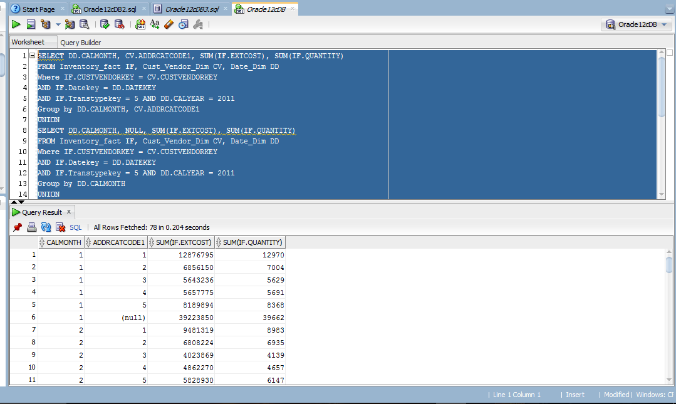

**Query: 8**

**select sum(extcost), count(*), cus.name,dat.calyear, dat.calquarter**

**from AK_inventory_fact inv ,AK_cust_vendor_dim cus ,AK_date_dim dat**

**where transtypekey='5' and (calyear='2011' or calyear='2012') and**

**inv.custvendorkey = cus.custvendorkey and**

**inv.datekey = dat.datekey**

**group by cube(cus.name,(dat.calyear,dat.calquarter))**

**order by cus.name, dat.calyear, dat.calquarter;**

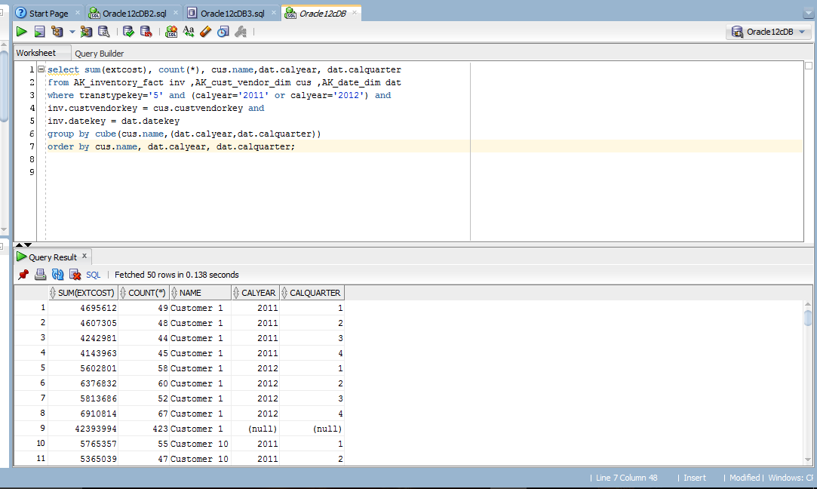

**Query 9:**

**select sum(extcost) as "Extended Cost", sum(quantity) as "Quantity",calmonth as "Month",addrcatcode1 as "Category Code",**

**Grouping_ID(calmonth, addrcatcode1) as Group_Level**

**from AK_inventory_fact inv ,AK_date_dim dat , AK_cust_vendor_dim cus**

**where TransTypeKey = '5' and**

**calyear='2011' and**

**inv.datekey = dat.datekey and**

**inv.custvendorkey = cus.custvendorkey**

**group by cube(calmonth, addrcatcode1)**

**order by Group_Level;**

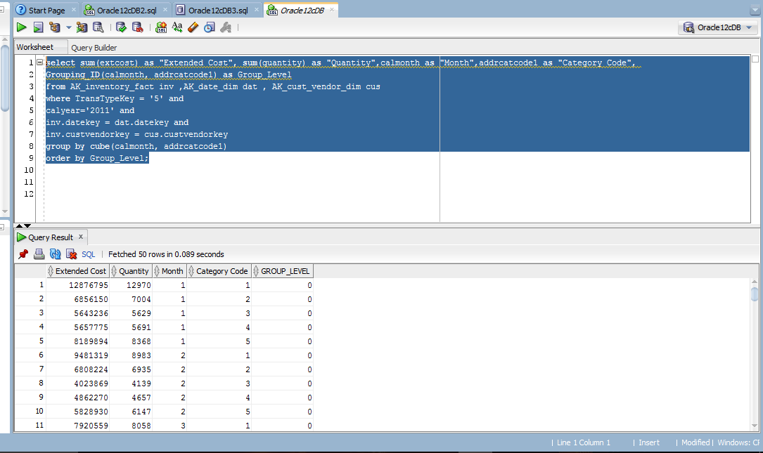

**Query: 10**

**select sum(extcost), count(*), CV.name,DD.calyear, DD.calquarter**

**from AK_inventory_fact IF ,AK_cust_vendor_dim CV ,AK_date_dim DD**

**where transtypekey='5' and (calyear='2011' or calyear='2012') and**

**IF.custvendorkey = CV.custvendorkey and**

**IF.datekey = DD.datekey**

**group by grouping sets(CV.name,Rollup(DD.calyear,DD.calquarter))**

**order by CV.name, DD.calyear, DD.calquarter;**

