Assignment 5

Creating and Manipulating Materialized Views
Assignment 5 provides experience creating and manipulating materialized views in Oracle. You will create several materialized views and apply the matching process to rewrite several queries using the materialized views. You will use the Inventory Data Warehouse in Assignment 5. Another document describes the Inventory Data Warehouse. You can use my Inventory Data Warehouse tables or your own tables for Assignment 5. If using your tables, you should ensure that the tables have the original rows, not additional rows from assignment 3.

1. Create Materialized Views
Write CREATE MATERIALIZED VIEW statements according to the following specifications. To assist in my grading, please include DROP MATERIALIZED VIEW statements before your CREATE MATERIALIZED VIEW statements.
- Both materialized views should contain the sum of the extended cost, the sum of the quantity, and the number of inventory transactions.
- In both materialized views, these calculated amounts should be summarized by the customer vendor key and the date key.
- The first materialized view sho0uld include only sales shipment transactions (transaction type 5) for the year 2011.
- The second materialized view should include only sales shipment transactions (transaction type 5) for the year 2012.
- Neither materialized view should include subtotals that are created by the CUBE and the ROLLUP keywords.
Query1-part1
DROP MATERIALIZED VIEW MV1;

CREATE MATERIALIZED VIEW MV1
BUILD IMMEDIATE
REFRESH COMPLETE ON DEMAND
ENABLE QUERY REWRITE AS
SELECT sum(amb_INVENTORY_FACT.extcost) as INV_EXTCOST , sum(amb_INVENTORY_FACT.quantity) as INV_QUANTITY, Count(*) as INV_TRANS,
amb_INVENTORY_FACT.custvendorkey, amb_INVENTORY_FACT.datekey
FROM amb_CUST_VENDOR_DIM, amb_DATE_DIM, amb_INVENTORY_FACT
WHERE amb_INVENTORY_FACT.TRANSTYPEKEY = 5 and amb_DATE_DIM.CALYEAR= 2011 and
amb_CUST_VENDOR_DIM.CUSTVENDORKEY = amb_INVENTORY_FACT.CUSTVENDORKEY and amb_INVENTORY_FACT.DATEKEY = amb_DATE_DIM.DATEKEY
GROUP BY amb_INVENTORY_FACT.custvendorkey, amb_INVENTORY_FACT.datekey;
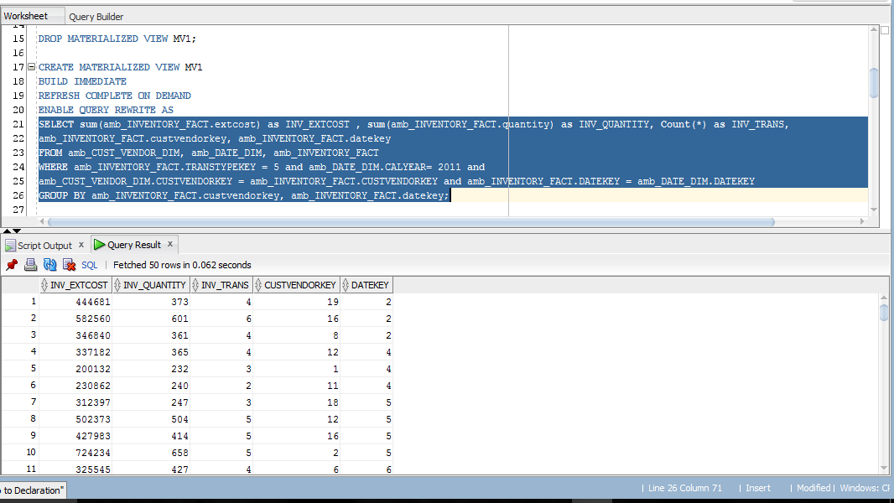

Query1-part2
DROP MATERIALIZED VIEW MV2;

CREATE MATERIALIZED VIEW MV2
BUILD IMMEDIATE
REFRESH COMPLETE ON DEMAND
ENABLE QUERY REWRITE AS
SELECT sum(amb_INVENTORY_FACT.extcost) as INV_EXTCOST , sum(amb_INVENTORY_FACT.quantity) as INV_QUANTITY, Count(*) as INV_TRANS,
amb_INVENTORY_FACT.custvendorkey, amb_INVENTORY_FACT.datekey
FROM amb_CUST_VENDOR_DIM, amb_DATE_DIM, amb_INVENTORY_FACT
WHERE amb_INVENTORY_FACT.TRANSTYPEKEY = 5 and amb_DATE_DIM.CALYEAR= 2012 and
amb_CUST_VENDOR_DIM.CUSTVENDORKEY = amb_INVENTORY_FACT.CUSTVENDORKEY and amb_INVENTORY_FACT.DATEKEY = amb_DATE_DIM.DATEKEY
GROUP BY amb_INVENTORY_FACT.custvendorkey, amb_INVENTORY_FACT.datekey;
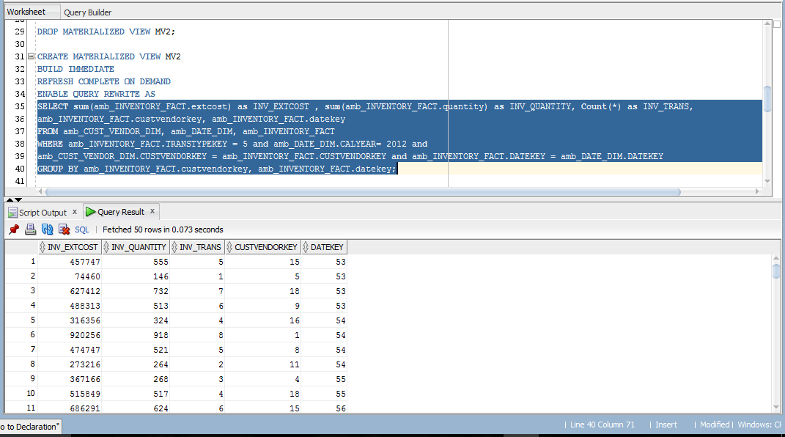

2. Use Materialized View to Rewrite Queries
Using the materialized views that you created in part 1, you should rewrite queries 1 and 2 from Assignment 4 (Part 1) using the materialized views that you created in part 1. You should have solutions to queries 1 and 2 from grading of assignment 4 (part 1). Rewrite queries 1 and 2 using the materialized views to replace the fact tables. For both rewritten queries, you should not use a CREATE VIEW statement in your solution. If you are using my Inventory Data Warehouse tables, you need to prefix the table names with my schema name (mmannino) or create synonyms for my tables. Here is an example of a CREATE SYNONYM statement for a table in my schema.
CREATE SYNONYM cust_vendor_dim FOR mmannino.cust_vendor_dim;
Query2-part1
SELECT amb_DATE_DIM.CALMONTH, amb_CUST_VENDOR_DIM.ADDRCATCODE1, SUM (MV1.INV_QUANTITY) Total_Quantity, SUM (MV1.INV_EXTCOST) Total_Cost
FROM amb_CUST_VENDOR_DIM, amb_DATE_DIM, MV1
WHERE amb_CUST_VENDOR_DIM.CUSTVENDORKEY = MV1.CUSTVENDORKEY and MV1.DATEKEY =amb_DATE_DIM.DATEKEY
GROUP BY CUBE (amb_CUST_VENDOR_DIM.ADDRCATCODE1, amb_DATE_DIM.CALMONTH);
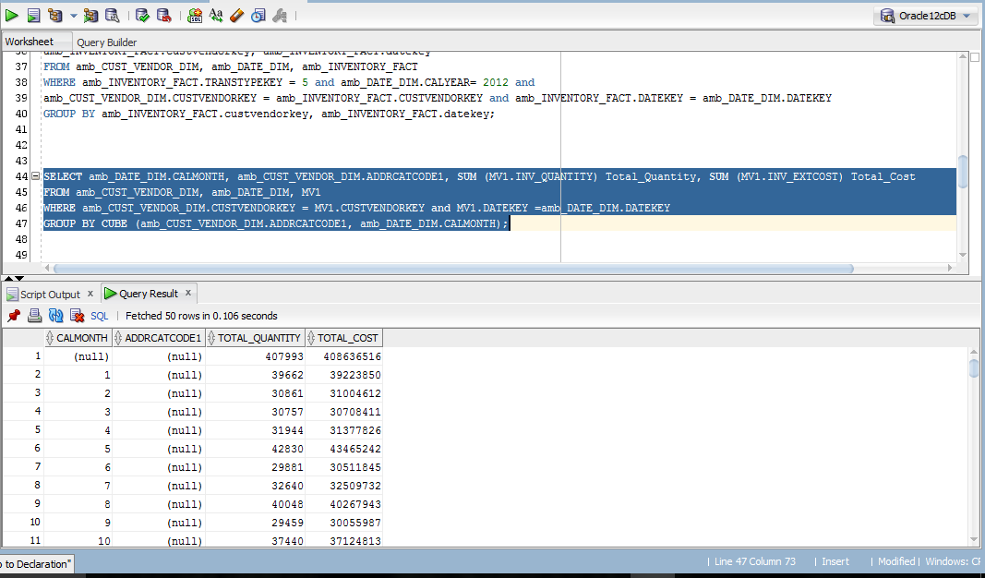
Query2-part2
SELECT NAME , ZIP, CALQUARTER, SUM(Total_Cost) as grand_Cost, COunt(INV_TRANS) Grand_COunt
FROM
(
SELECT CV.NAME , CV.ZIP, DD.CALQUARTER, INV_EXTCOST as Total_Cost, INV_TRANS
FROM MV1, amb_DATE_DIM DD, amb_CUST_VENDOR_DIM CV
WHERE DD.DATEKEY = MV1.DATEKEY AND MV1.CUSTVENDORKEY = CV.CUSTVENDORKEY
UNION
SELECT CV.NAME , CV.ZIP, DD.CALQUARTER, INV_EXTCOST as Total_Cost, INV_TRANS
FROM MV2, amb_DATE_DIM DD, amb_CUST_VENDOR_DIM CV
WHERE DD.DATEKEY = MV2.DATEKEY AND MV2.CUSTVENDORKEY = CV.CUSTVENDORKEY
)
GROUP BY GROUPING SETS ((NAME, ZIP, CALQUARTER), (NAME,ZIP),
(NAME, CALQUARTER),(ZIP, CALQUARTER),NAME, ZIP, CALQUARTER,())
order by NAME , ZIP, CALQUARTER ;
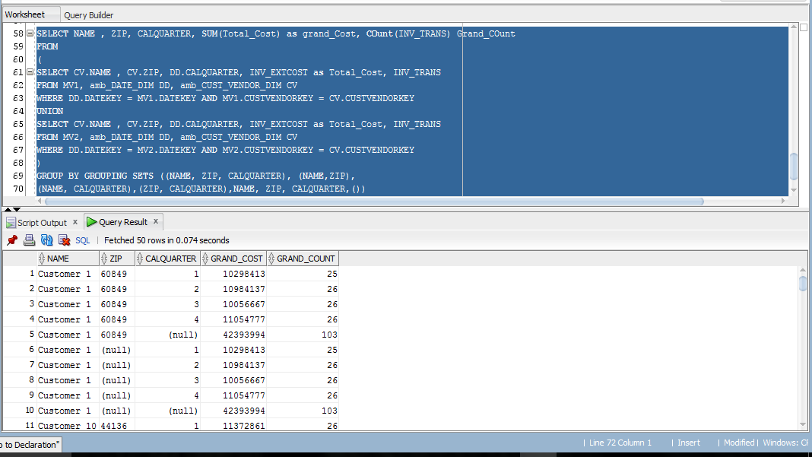

Grading
Your performance will be assessed by a quiz designed to test your understanding of each problem and by evidence of query executions. Since some quiz questions will involve results of execution of your statements, you should execute your statements against my inventory data warehouse tables. Beyond the quiz, I will check the documentation that you submit to the gradebook to confirm that you created and executed the statements.
- You will receive 50% if your documentation contains SQL statements and partial results for each problem.
- The quiz score will provide the other 50% of your grade.

Completion
You should upload a file containing your Oracle SQL statements and execution results to the gradebook item for assignment 5. For the execution results, you should take a snapshot of the script output window in SQL Developer showing the execution results. For the SELECT statements, you only need to show the first 10 rows or so of the result. You do not need to take a snapshot showing execution of the CREATE MATERIALIZED VIEW statements. You should use the following naming scheme for your assignment file: LastNameFirstNameA5. As part of good coding practice, you should format your statements neatly.

