Assignment 4

Part 2: Using Analytic Functions
Part 2 of Assignment 4 provides experience writing SELECT statements using the SQL analytic functions. For the analytic function problems, you should adapt the examples given in the notes. Each problem is based on a similar problem in the notes.
Your SELECT statements will reference the tables of the Inventory Data Warehouse, described in another document. You can use my Inventory Data Warehouse tables by prefixing the table name with my schema name (mmannino). Alternatively, you can create synonyms for my tables so that you can just use the table names. Here is an example of a CREATE SYNONYM statement for a table in my schema.
CREATE SYNONYM cust_vendor_dim FOR mmannino.cust_vendor_dim;

Analytic Functions
Write Oracle SELECT statements for the following problem statements. You should use the analytic functions with appropriate options such as partitioning as indicated.

Query 1: Ranking within the entire result

Use the RANK function to rank customers in descending order by the sum of extended cost for shipments (transaction type 5). You should use the entire result as a single partition. The result should include the customer name, sum of the extended cost, and rank.

SELECT NAME, SUM(EXTCOST) AS SumSales,
RANK() OVER (ORDER BY SUM(EXTCOST) DESC) ExtendedCost
FROM IF_INVENTORY_FACT, CV_CUST_VENDOR_DIM
where transtypekey = 5 and
CV_CUST_VENDOR_DIM.CUSTVENDORKEY = IF_INVENTORY_FACT.CUSTVENDORKEY
GROUP BY NAME;

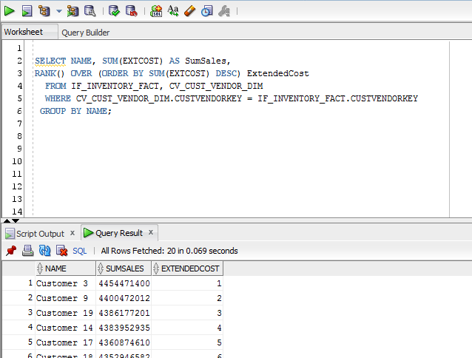

Query 2: Ranking within a partition

Use the RANK function to rank customers in descending order by the sum of extended cost for shipments (transaction type 5). You should partition the rank values by customer state. The result should include the customer state, customer name, sum of the extended cost, and rank. You should order the result by customer state.

SELECT STATE, NAME, SUM(EXTCOST) AS SumSales,
RANK() OVER (PARTITION BY STATE ORDER BY SUM(EXTCOST) DESC) SalesRank
FROM CV_CUST_VENDOR_DIM, IF_INVENTORY_FACT
where transtypekey = 5 and
CV_CUST_VENDOR_DIM.CUSTVENDORKEY = IF_INVENTORY_FACT.CUSTVENDORKEY
GROUP BY STATE, NAME
ORDER BY STATE;

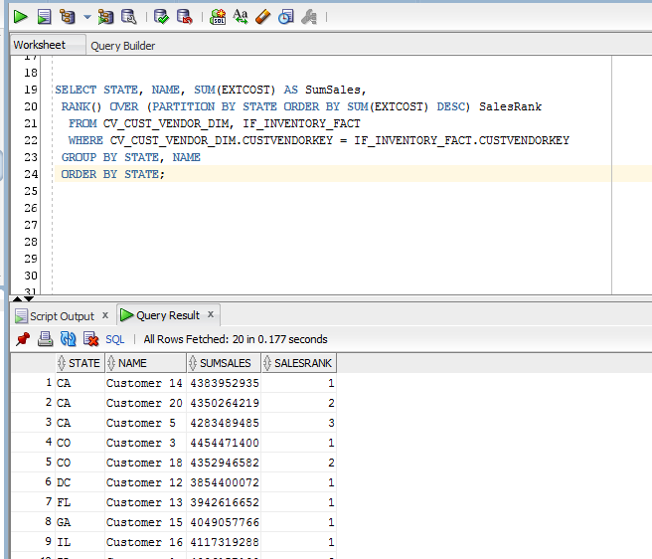

Query 3: Ranking and dense ranking within the entire result

Use both RANK and DENSE_RANK functions to rank customers in descending order by the count of inventory transactions for shipments (transaction type 5). You should use the entire result as a single partition. The result should include the customer name, count of transactions, rank, and dense rank.

select name, count(*),
rank() over (order by count(*) desc)"Rank",
dense_rank() over (order by count(*) desc)"DenseRank"
from CV_CUST_VENDOR_DIM, IF_INVENTORY_FACT
where transtypekey = 5 and
CV_CUST_VENDOR_DIM.CUSTVENDORKEY = IF_INVENTORY_FACT.CUSTVENDORKEY
group by name;

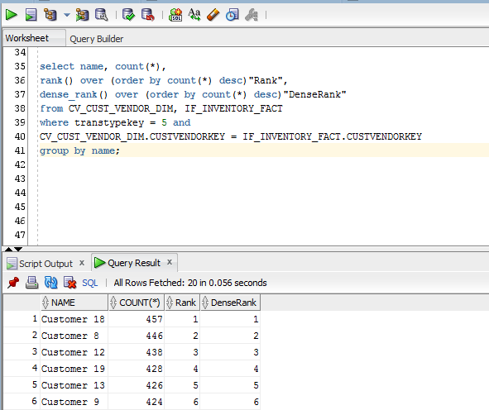

Query 4: Cumulative extended costs for the entire result

Calculate the cumulative sum of extended cost ordered by customer zip code, calendar year, and calendar month for shipments (transaction type 5). The result should include the customer zip code, calendar year, calendar month, sum of the extended cost, and cumulative sum of the extended cost. Note that the cumulative extended cost is the sum of the extended cost in the current row plus the cumulative sum of extended costs in all previous rows.

select zip, calyear, calmonth, sum(extcost) as MyCost,
sum(sum(extcost)) over(order by zip, calyear, calmonth
ROWS UNBOUNDED PRECEDING) as UnbountCost
from if_inventory_fact, dd_Date_Dim, cv_cust_vendor_dim
where transtypekey = 5 and
if_inventory_fact.custvendorkey = cv_cust_vendor_dim .custvendorkey and if_inventory_fact.datekey = dd_Date_Dim.datekey
group by zip, calyear, calmonth;

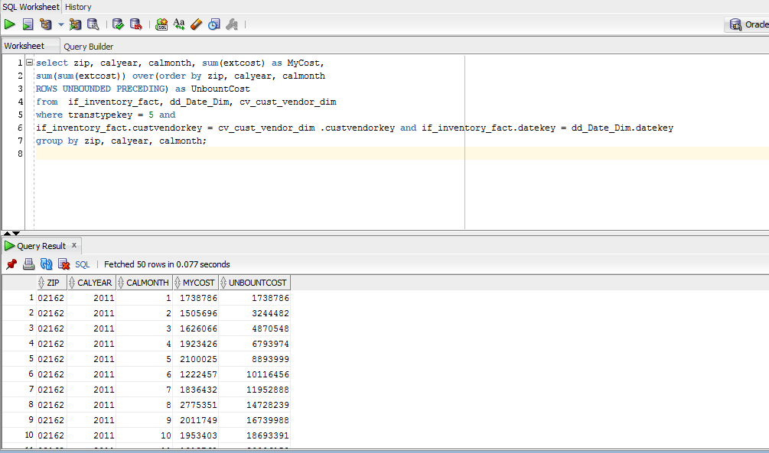

Query 5: Cumulative extended costs for a partition

Calculate the cumulative sum of extended cost ordered by customer zip code, calendar year, and calendar month for shipments (transaction type 5). Restart the cumulative extended cost after each combination of zip code and calendar year. The result should include the customer zip code, calendar year, calendar month, sum of the extended cost, and cumulative sum of the extended cost. Note that the cumulative extended cost is the sum of the extended cost in the current row plus the cumulative sum of extended costs in all previous rows of the store zip code and years. The value of cumulative extended cost resets in each partition (new value for zip code and year).

select zip, calyear, calmonth, sum(extcost) as MyCost,
sum(sum(extcost)) over(partition by zip, calyear order by zip, calyear, calmonth
ROWS UNBOUNDED PRECEDING) as UnboundCost
from if_inventory_fact, dd_Date_Dim, cv_cust_vendor_dim
where transtypekey = 5 and
if_inventory_fact.custvendorkey = cv_cust_vendor_dim.custvendorkey and if_inventory_fact.datekey = dd_Date_Dim.datekey
group by zip, calyear, calmonth;

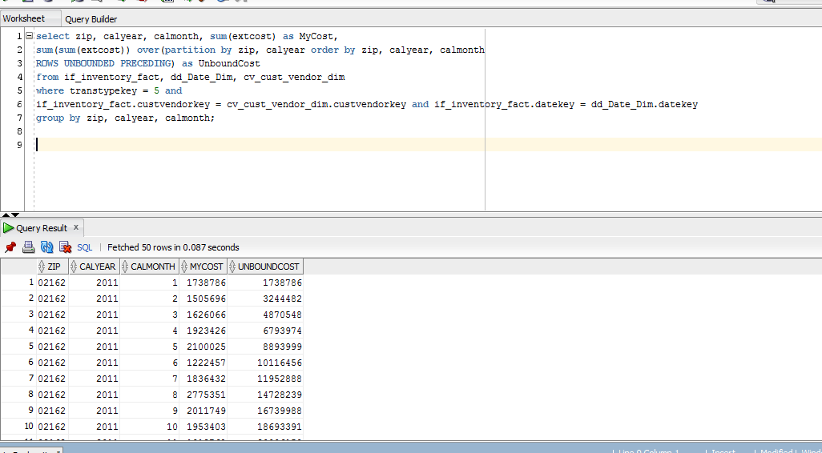

Query 6: Ratio to report applied to the entire result

Calculate the ratio to report of the sum of extended cost for adjustments (transaction type 1). You should sort on descending order by sum of extended cost. The result should contain the second item id, sum of extended cost, and ratio to report.

select seconditemid, sum(extcost) as MyCost, ratio_to_report(sum(extcost)) over() as MyReport
from if_inventory_fact, im_item_master_dim
where transtypekey = 1 and
if_inventory_fact.itemmasterkey = im_item_master_dim . itemmasterkey
group by seconditemid
order by sum(extcost) desc;

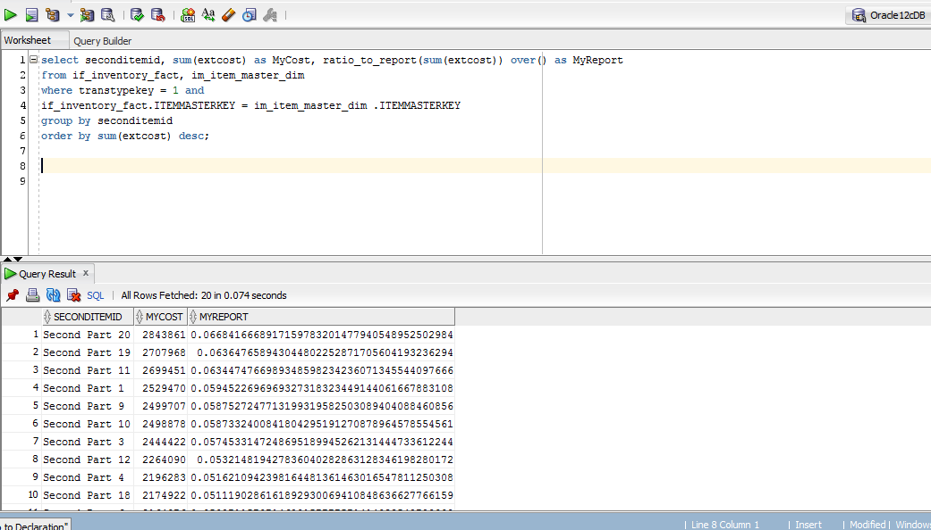

Query 7: Ratio to report applied to a partition

Calculate the ratio to report of the sum of extended cost for adjustments (transaction type 1) with partitioning on calendar year. You should sort on ascending order by calendar year and descending order by sum of extended cost. The result should contain the calendar year, second item id, sum of extended cost, and ratio to report.

select calyear, seconditemid, sum(Extcost) , ratio_to_report(sum(extcost)) over(partition by calyear)
from if_inventory_fact, dd_date_dim , im_item_master_dim
where transtypekey = 1 and
if_inventory_fact. itemmasterkey = im_item_master_dim. itemmasterkey and
if_inventory_fact.datekey = dd_date_dim.datekey
group by calyear, seconditemid
order by calyear asc, sum(extcost) desc;

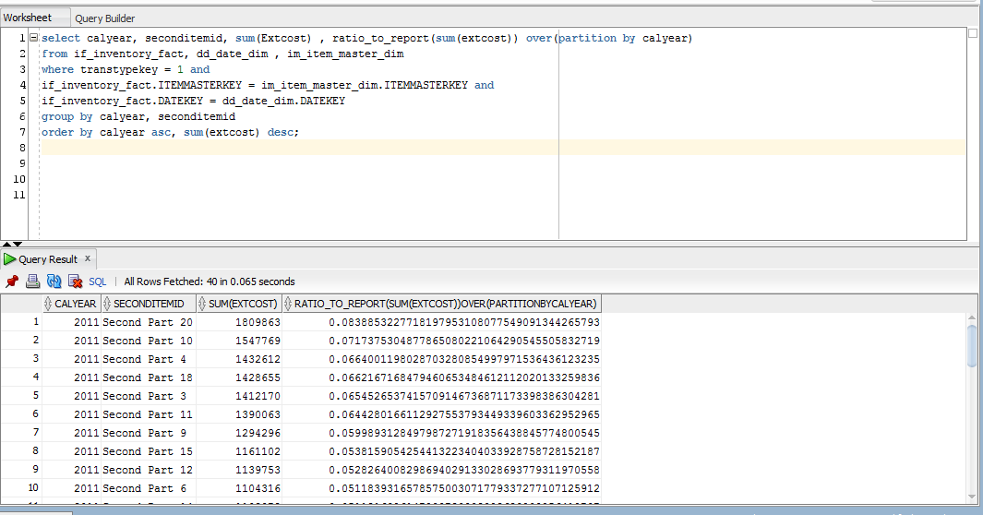

Query 8: Cumulative distribution functions for carrying cost of all branch plants

Calculate the rank, percent_rank, and cume_dist functions of the carrying cost in the branch_plant_dim table. The result should contain the bpname, companykey, carryingcost, rank, percent_rank, and cume_dist. Cume_dist should be calculated in ascending order.

select bpname, carryingcost, cd_company_dim.companykey,
rank() over(order by carryingcost),
percent_rank() over(order by carryingcost) ,
cume_dist() over (order by carryingcost asc)
from cd_company_dim, bp_branch_plant_dim
where bp_branch_plant_dim.companykey = cd_company_dim.companykey;

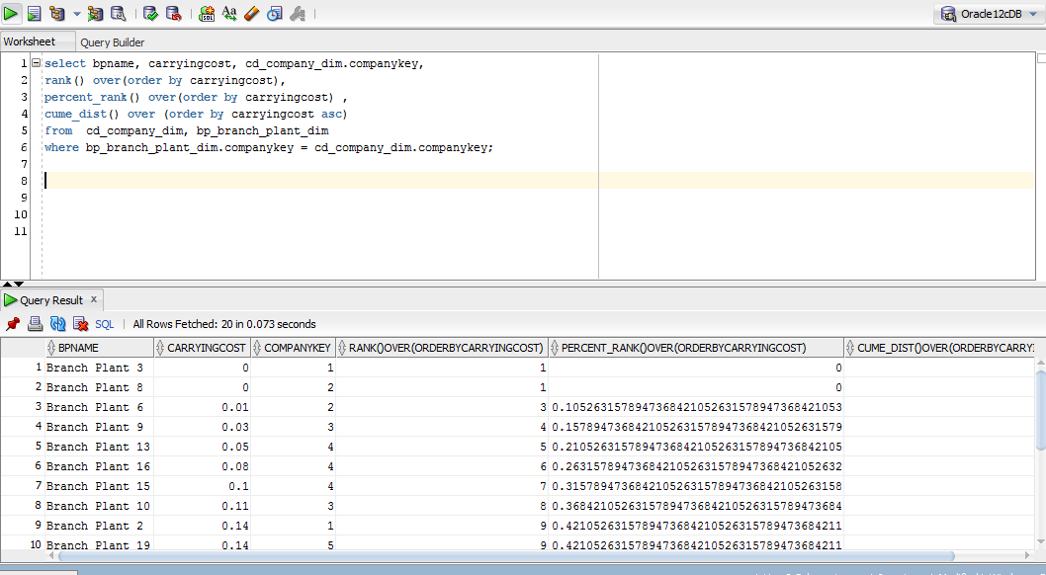

Query 9: Determine worst performing plants

Determine the branch plants with the largest carrying costs (top 15%). The result should contain BPName, CompanyKey, CarryingCost, and cume_dist. Cume_dist should be calculated in ascending order.

select Companykey, carryingcost, CarryingRate, bpname
from
(select cd_company_dim.Companykey, bp_branch_plant_dim.carryingcost, bp_branch_plant_dim.bpname,
cume_dist() over(order by bp_branch_plant_dim.carryingcost) as CarryingRate
from bp_branch_plant_dim , cd_company_dim
where bp_branch_plant_dim.companykey=cd_company_dim.companykey)
where CarryingRate>=0.85;

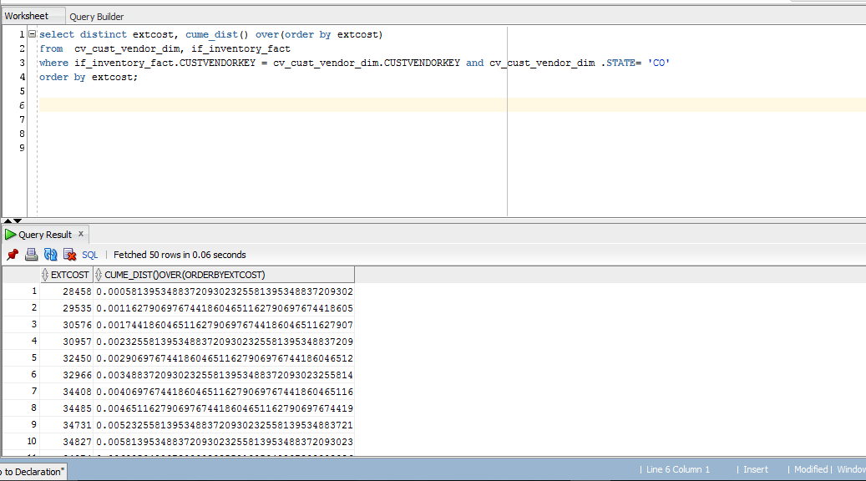

Query 10: Cumulative distribution of extended cost for Colorado inventory

Calculate the cumulative distribution of extended cost for Colorado inventory (condition on customer state). The result should contain the extended cost and cume_dist, ordered by extended cost. You should eliminate duplicate rows in the result.

select distinct extcost, cume_dist() over(order by extcost)
from cv_cust_vendor_dim, if_inventory_fact
where if_inventory_fact.custvendorkey = cv_cust_vendor_dim.custvendorkey and cv_cust_vendor_dim .state= 'CO'
order by extcost;

Grading
Your performance will be assessed by a quiz designed to test your understanding of each problem and by evidence of query executions. Since some quiz questions will involve results of execution of your statements, you should execute your statements against my inventory data warehouse tables. Beyond the quiz, I will check the documentation that you submit to the gradebook to confirm that you created and executed the statements.
- Note that each problem has important elements such as the usage of the correct tables, function, partitioning, and sorting. Missing key elements are medium errors in most problems.
- You will receive 50% if your documentation contains a SELECT statement and partial results for each problem. Execution of your SQL statements demonstrates correct syntax.
- The quiz score will provide the other 50% of your grade.

Completion
You should upload a file containing your Oracle SQL statements and execution results to the grade book item for part 2 of assignment 4. For the execution results, you should take a snapshot of the script output window in SQL Developer showing the execution results. You only need to show the first 10 rows or so of the result. You should paste the execution results after the associated SELECT statement. Use the following naming scheme for your assignment file: LastNameFirstNameA4P2. As part of good coding practice, you should format your statements neatly. If you are using Microsoft Word, you need to use straight quotes in your statements, not smart quotes. Microsoft Word defaults to smart quotes.

