Lab6: MongoDB

Objectives: Study NoSQL Document Model using MongoDB
Estimated Time : 3 hours

Lab Instruction

Outline
- Mongo DB Overview
- Setup Database on cloud
  - Create database
  - Create database user
  - Connect to database
- CRUD Operations
  - Insert Document
  - Update Document
  - Delete Document
  - Query Data
  - Basic Query
  - Query Nested Field
  - Aggregate Function
  - Join

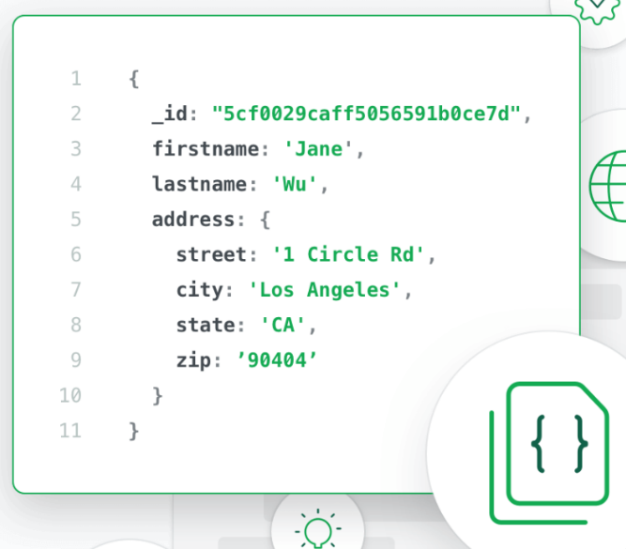
MongoDB Overview
  - About MongoDB
- Stores data in flexible, JSON-like documents
- Fields can vary from document to document and data structure can be changed over time
- Distributed database, high availability, horizontal scaling, and geographic distribution
- Free to use
- Scalability
  - Performance Scale: Sustaining 100,000+ database read and writes per second while maintaining strict latency SLAs
  - Data Scale: Storing 1 billion+ documents in the database
  - Cluster Scale: Distributing the database across 100+ nodes, often in multiple data centers
Ref. Examples of MongoDB users: https://www.mongodb.com/mongodb-scale

  - MongoDB Architecture
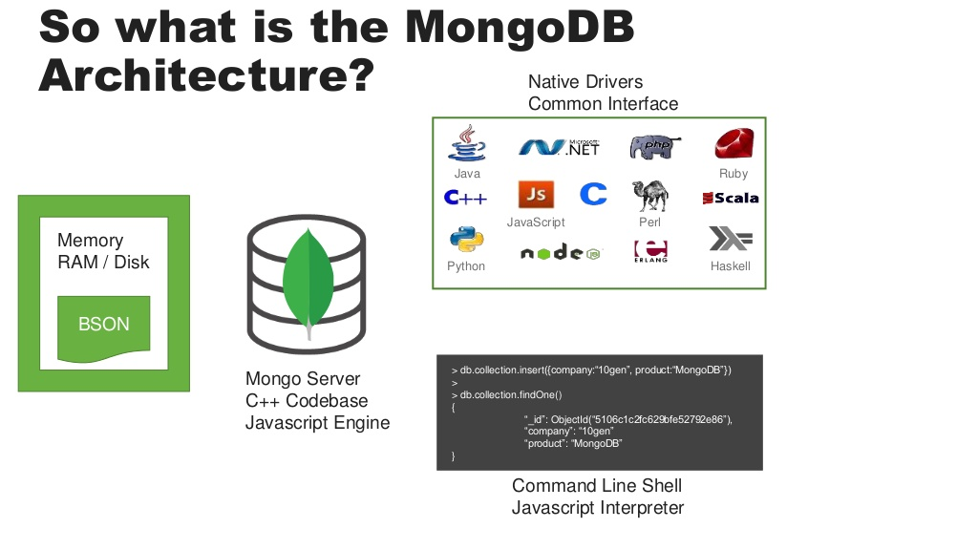
MongoDB Atlas
MongoDB Shell / MongoDB Compass

  - MongoDB Terminology
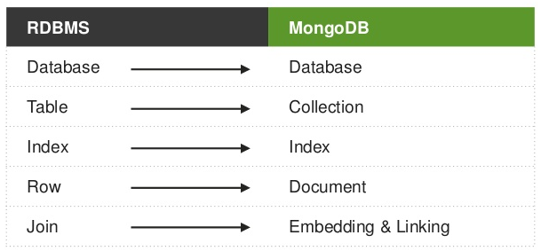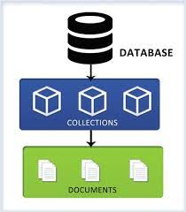

Set up our cluster (= Database Server) in Mongo DB cloud
https://cloud.mongodb.com/
2.1 Sign up
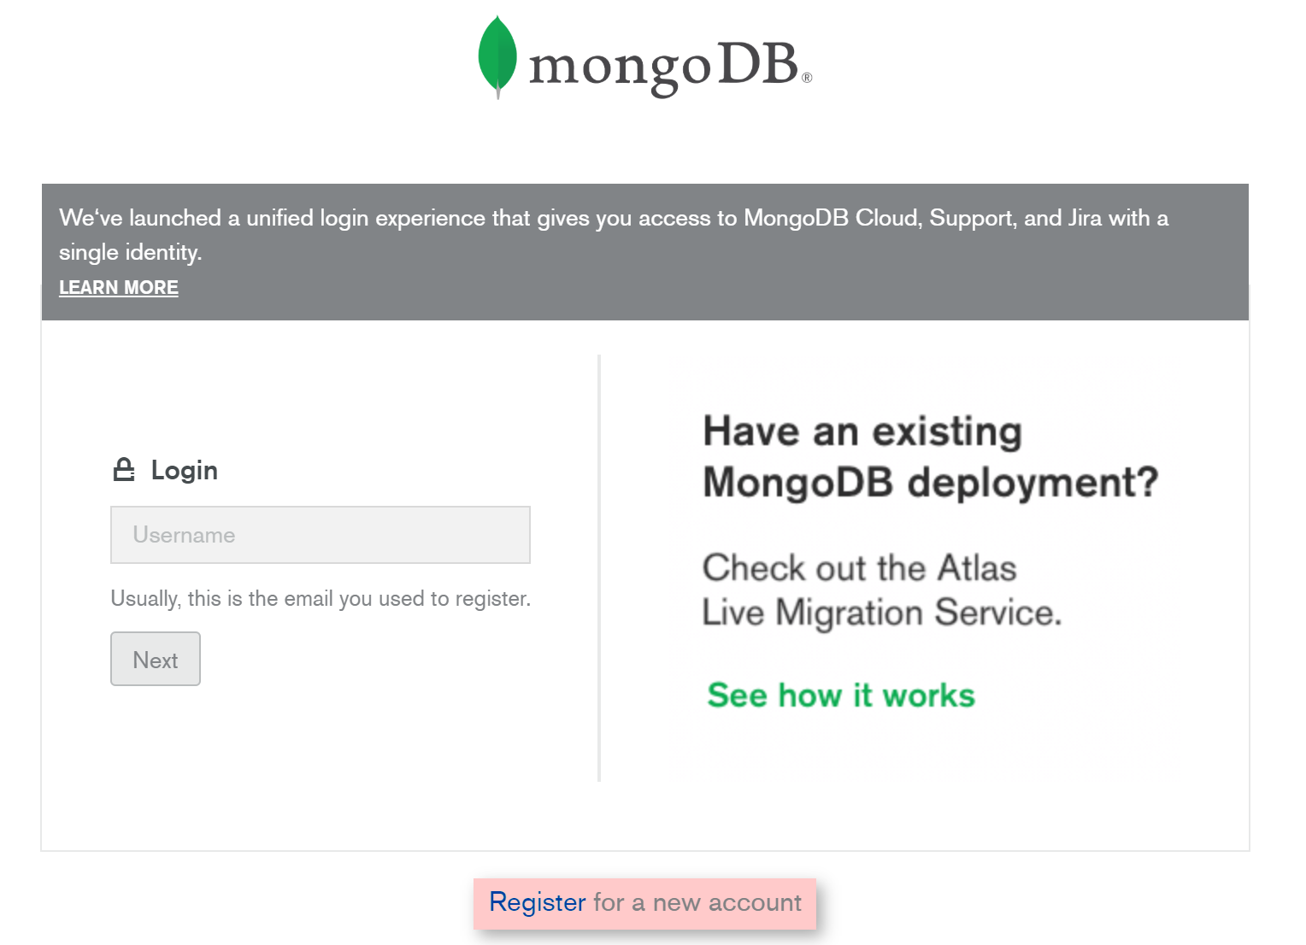
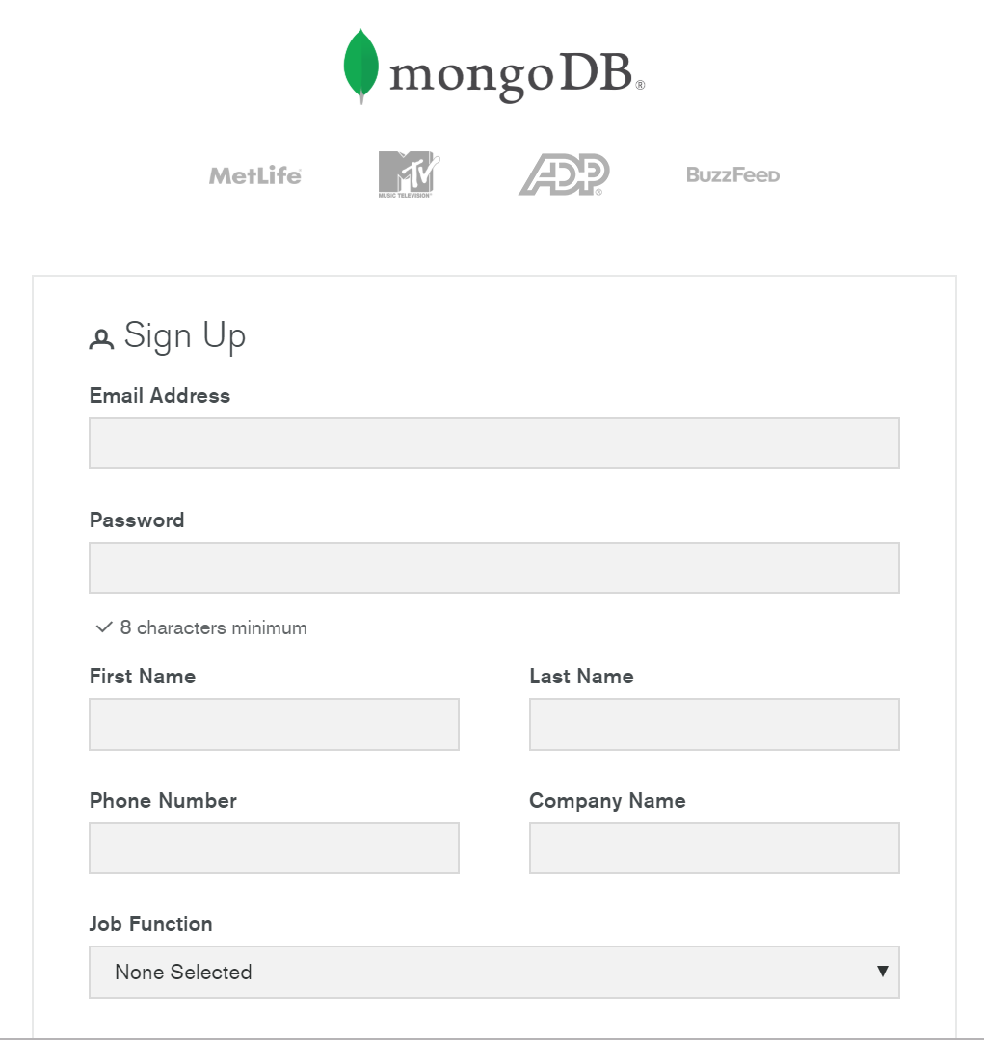

2.2 Create a Cluster

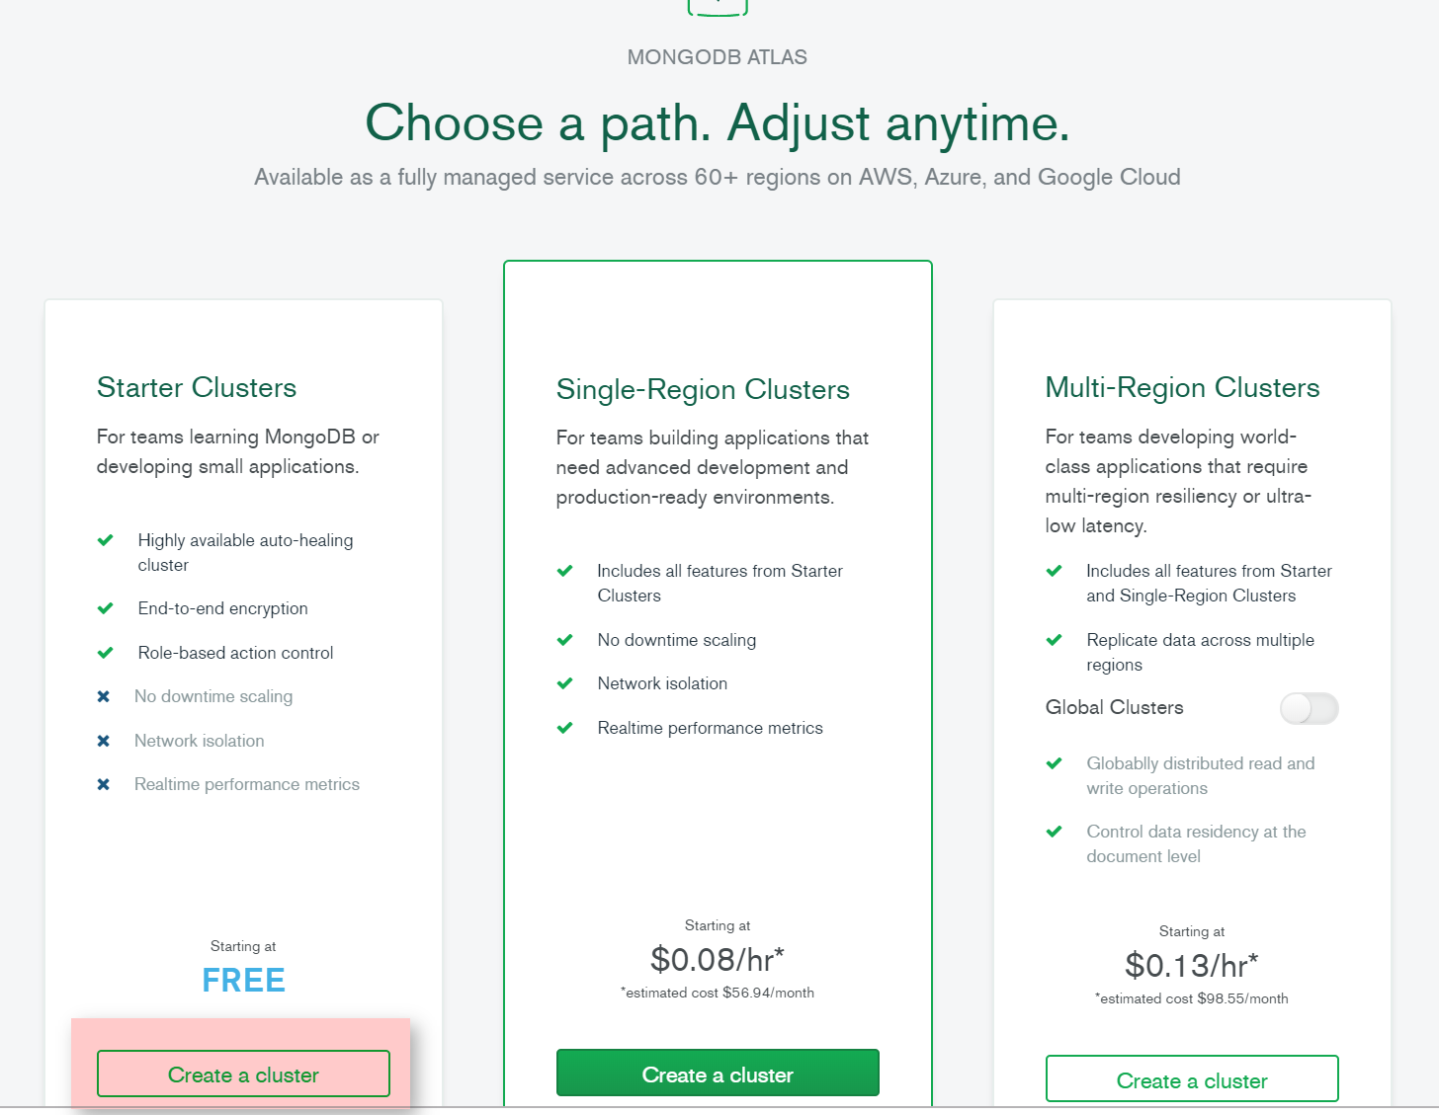

Select Cloud Provider and Region and Click “Create Cluster”
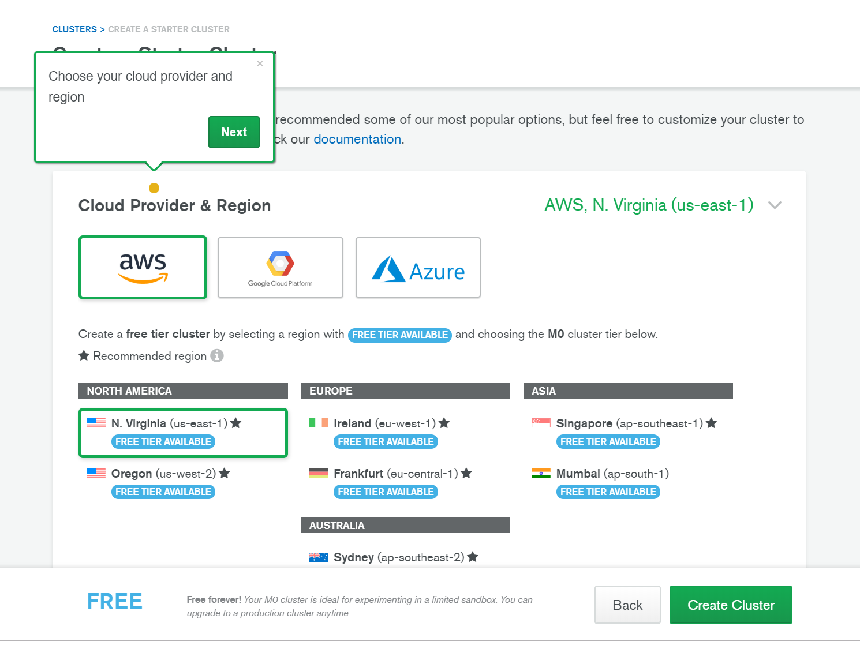
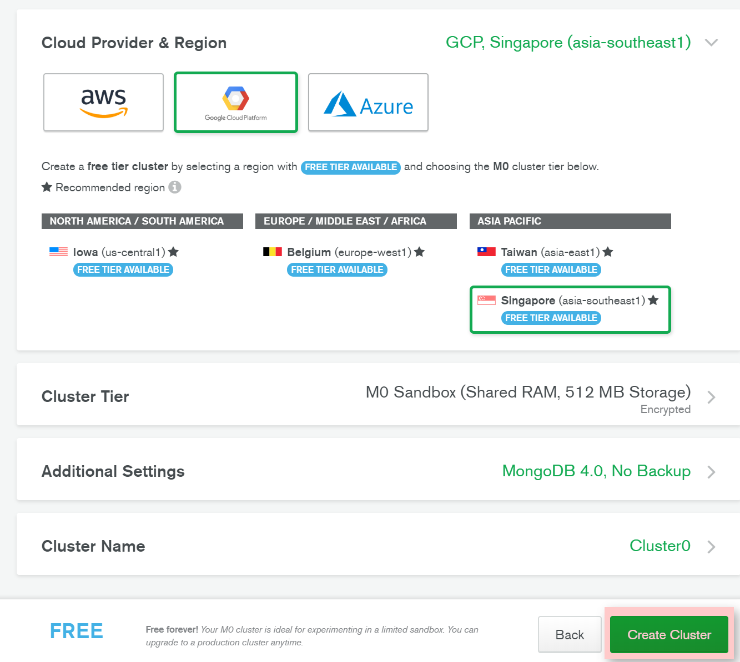

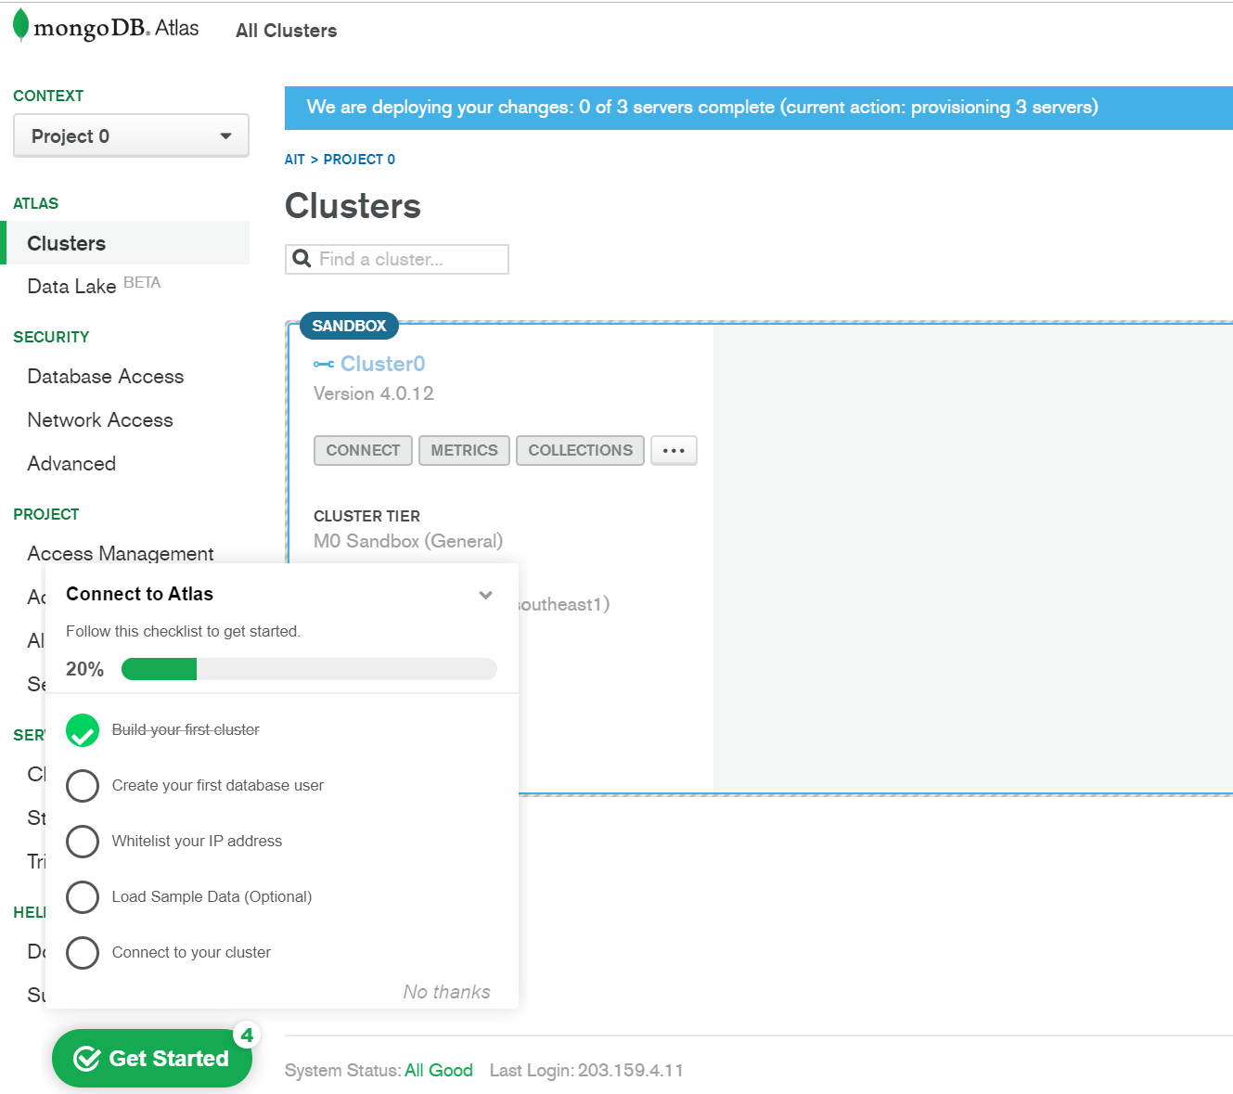

2.3 Create your first database user

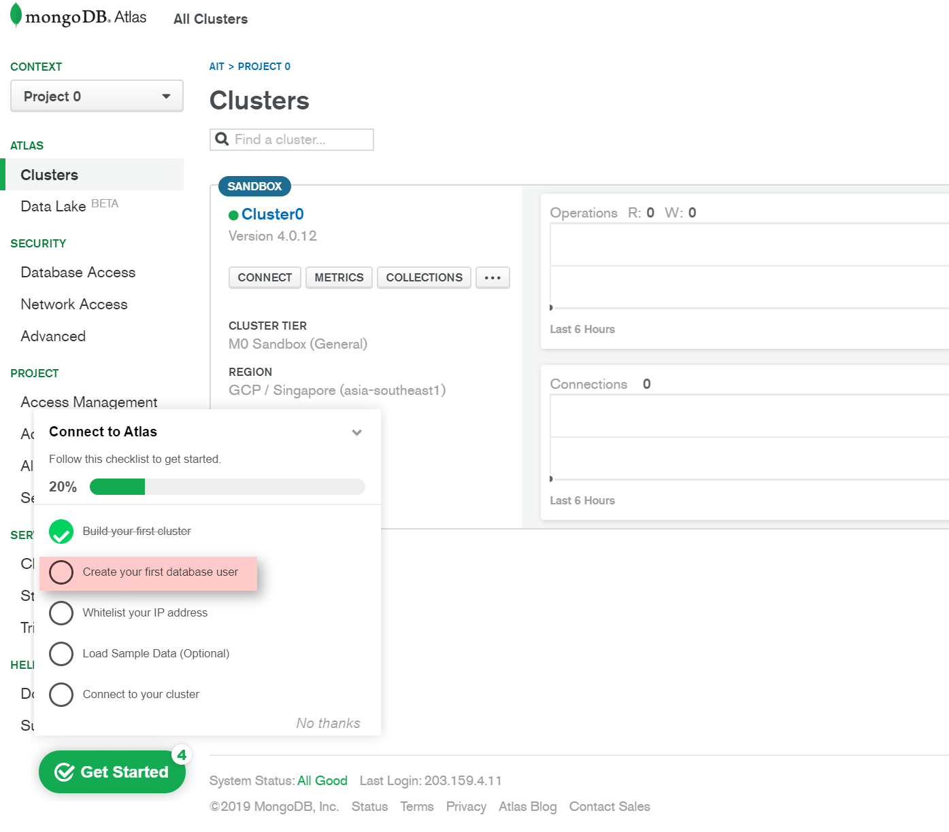

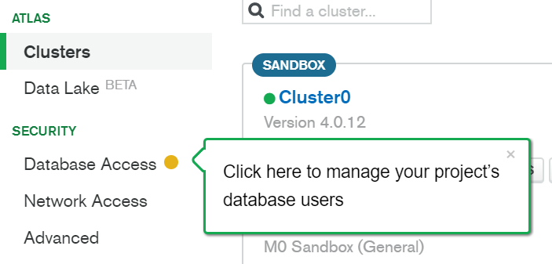
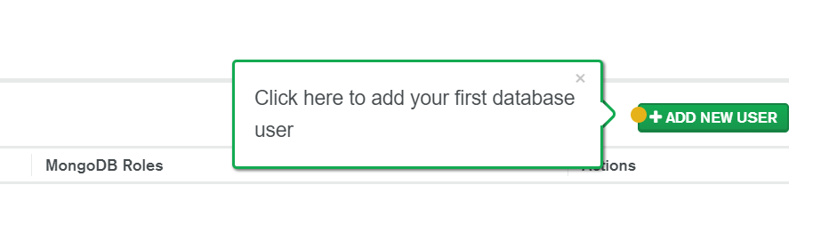
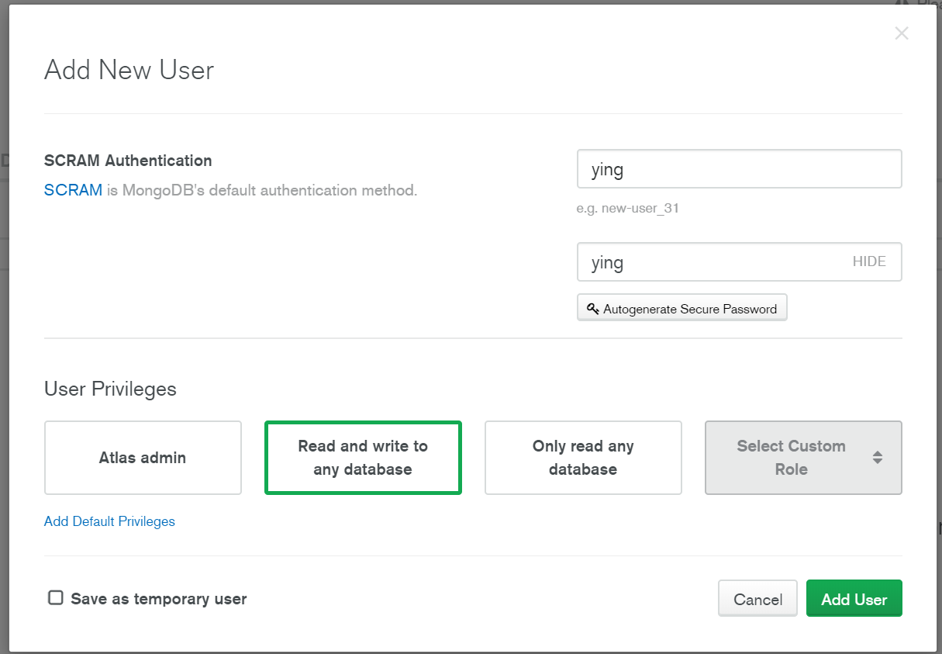

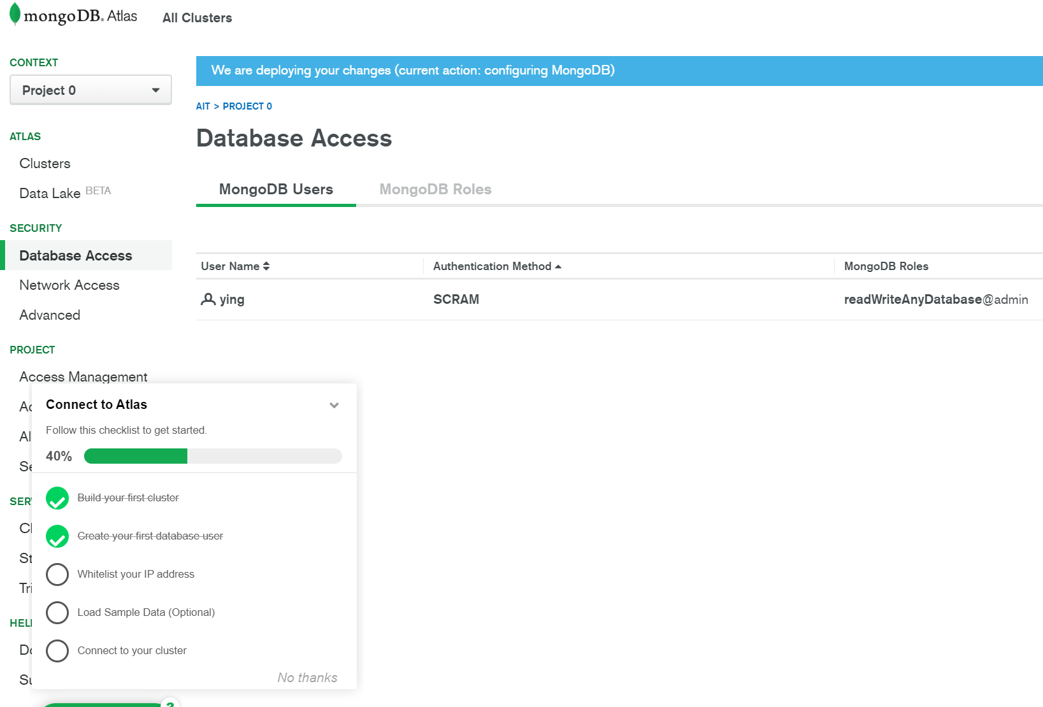

  - Allow Hosts that can access the Cluster

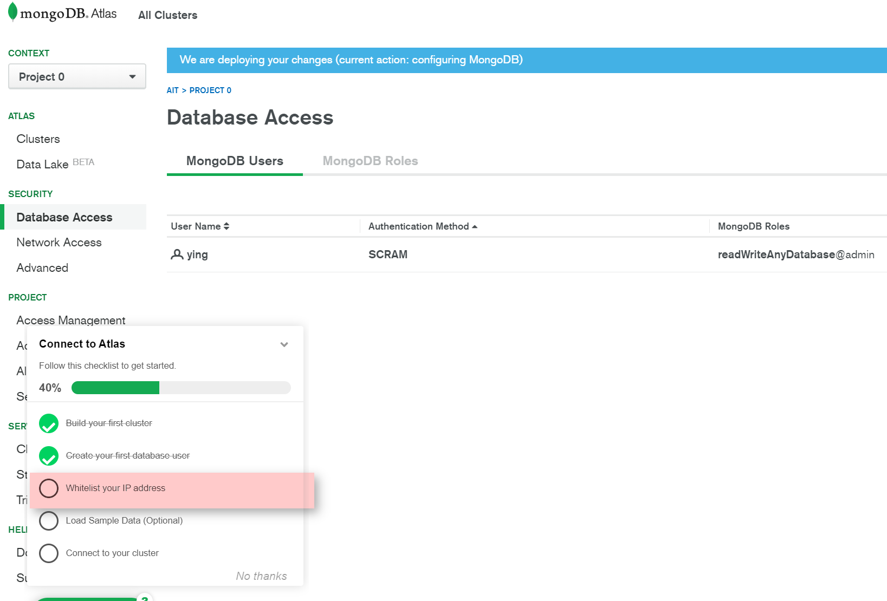

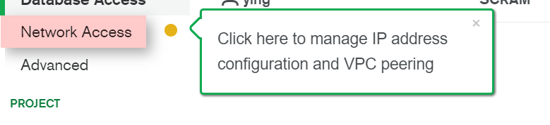
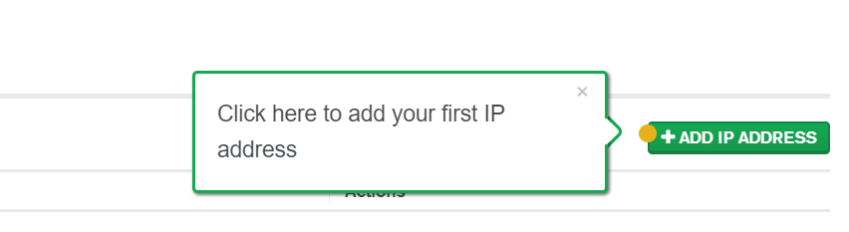

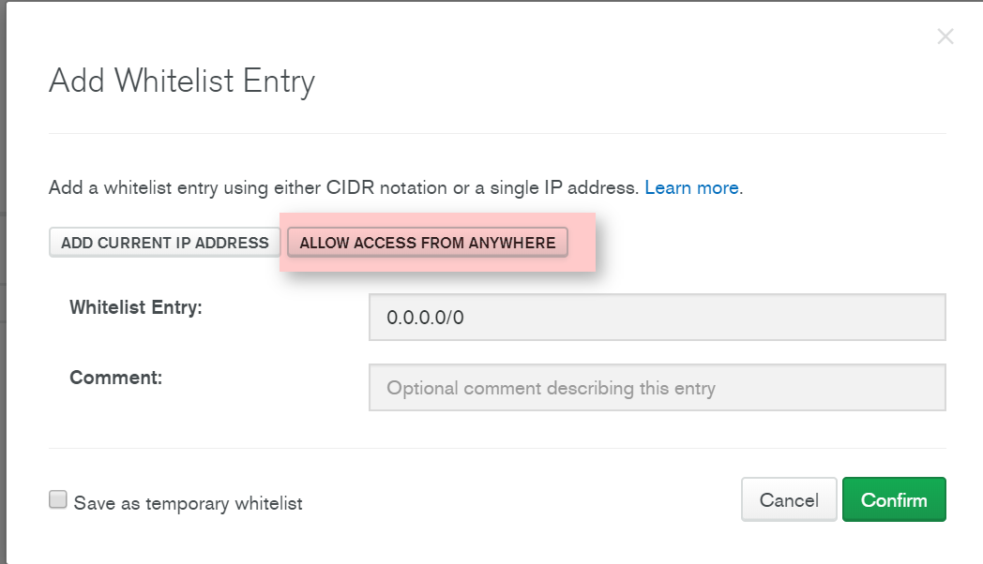

  - (Optional) Load Sample DB
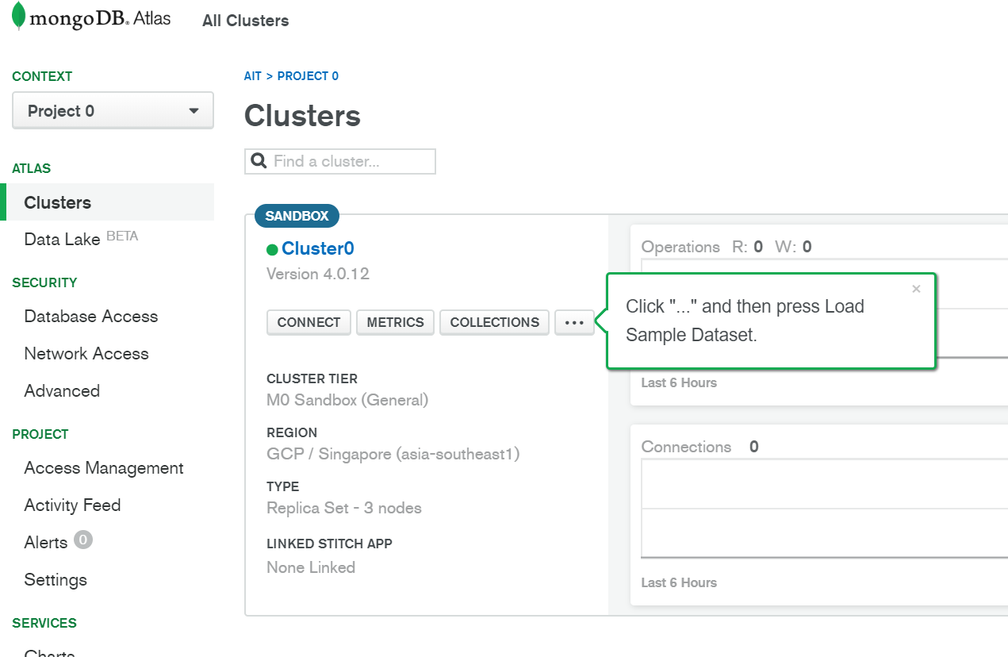

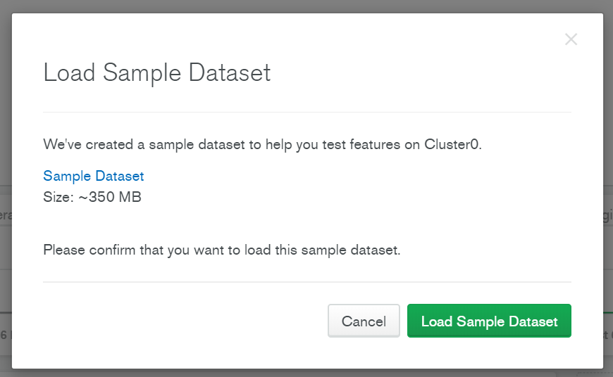

  - Create Database in Mongo Atlas

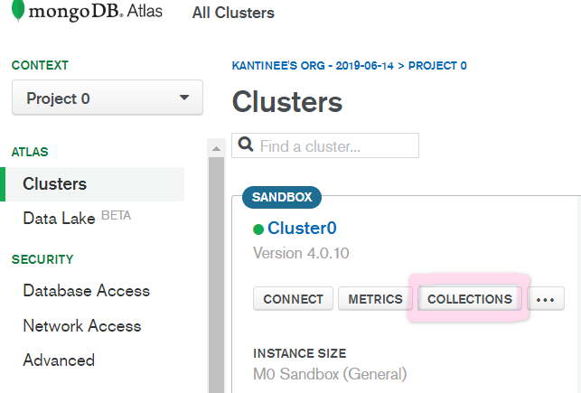

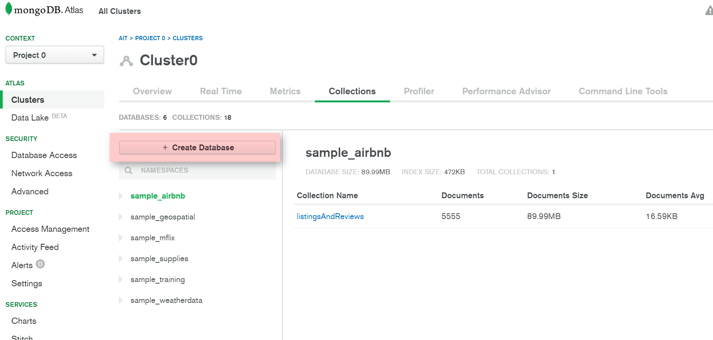

Create Database name =shop101 and Collection name = customer.
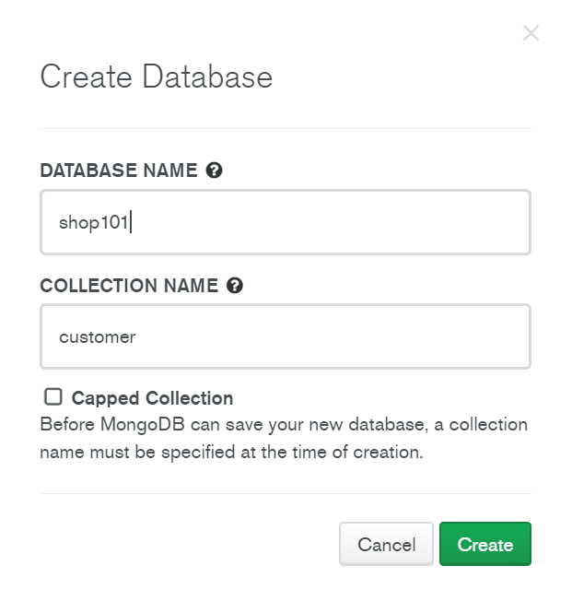

  - Connect to the Cluster using the User. There are 3 methods to connect: Mongo Shell, Your App and Mongo Compass.

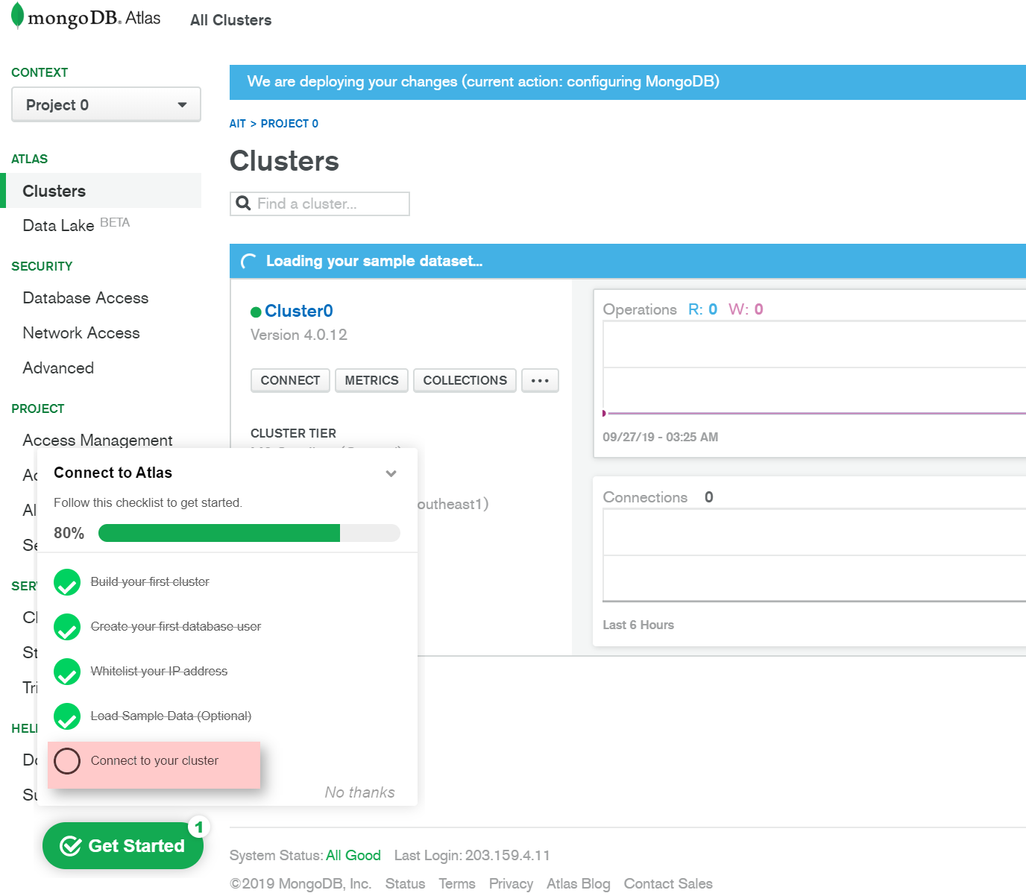

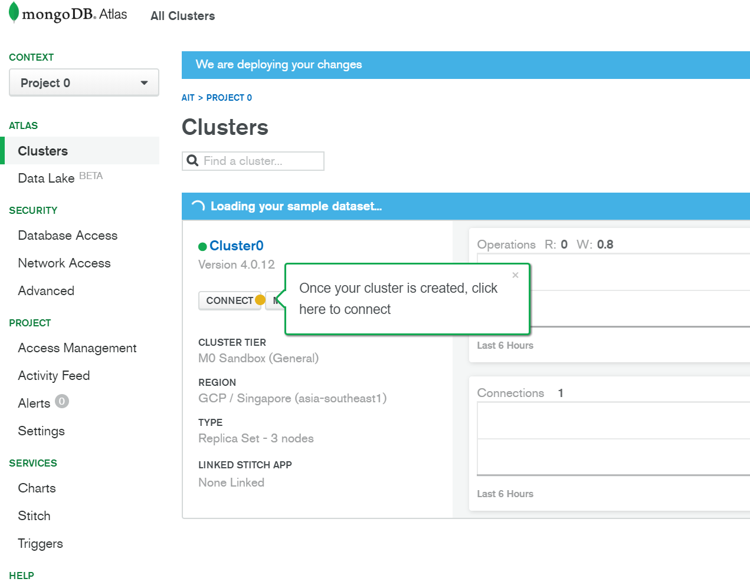

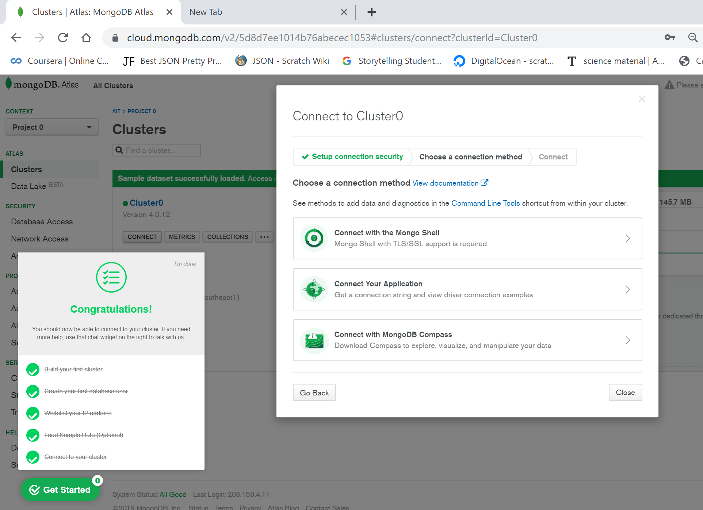

Install Shell or Compass and using the connection string to connect. Example of Connection string: mongodb+srv://ying:<password>@cluster0-dfi1d.gcp.mongodb.net/<database name>
In this tutorial we will use Shell

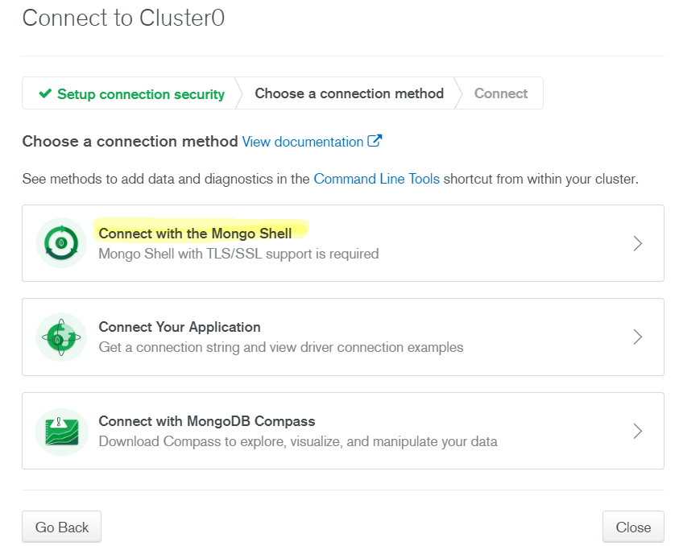
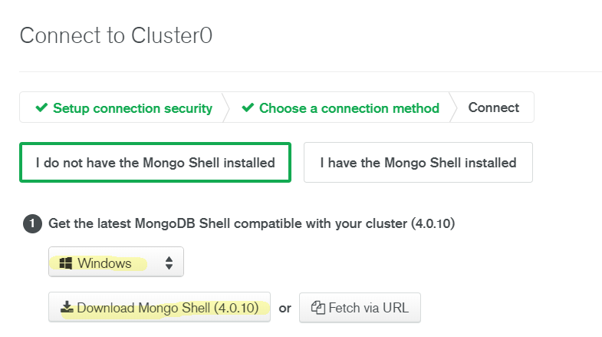

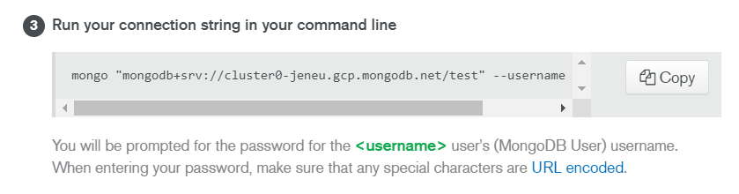
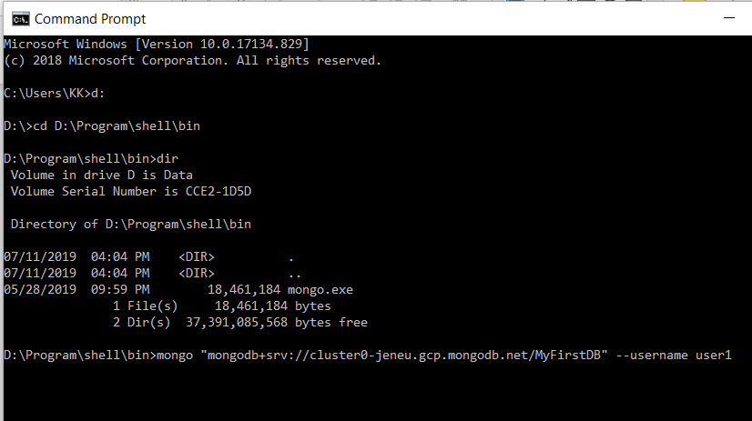

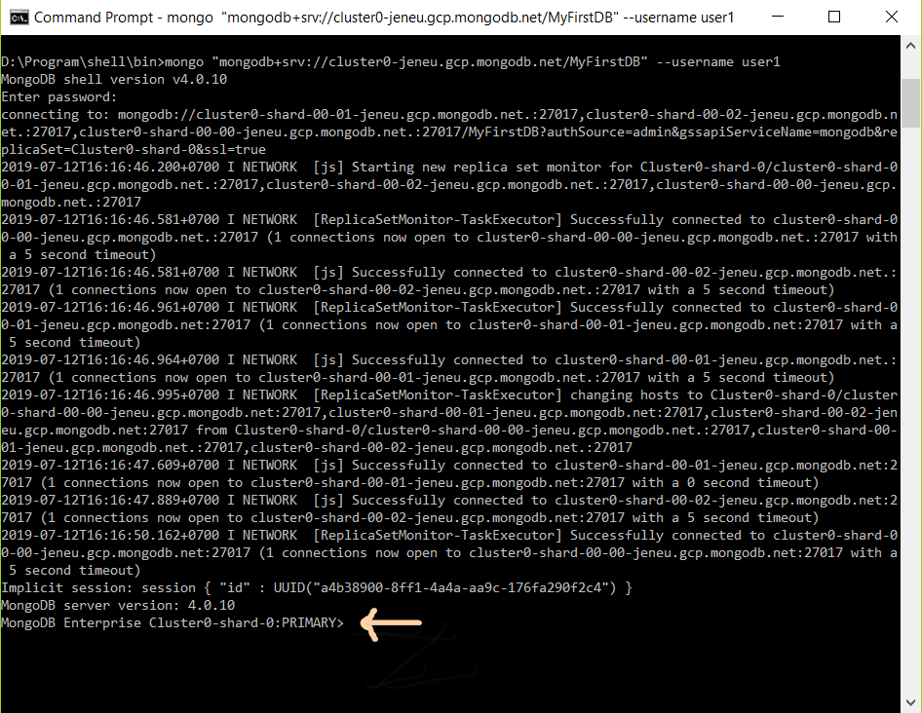

mongo "mongodb+srv://cluster0-jeneu.gcp.mongodb.net/<database name=shop101>" --username <username>

Insert, Update, Delete Document
You can do DDL operation in Mongo Atlas, Mongo Compass or Mongo Shell.
3.1 Insert customers in “shop101” database using Mongo Atlas
Click “Collection” -> click “customer” -> click “Insert Document”
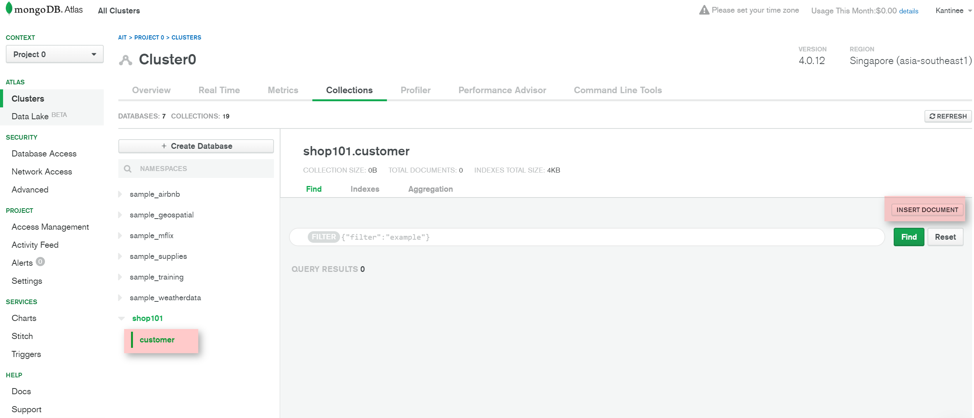

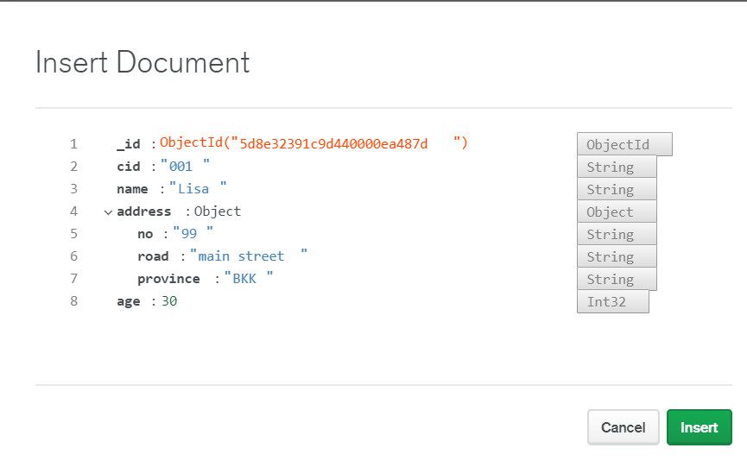
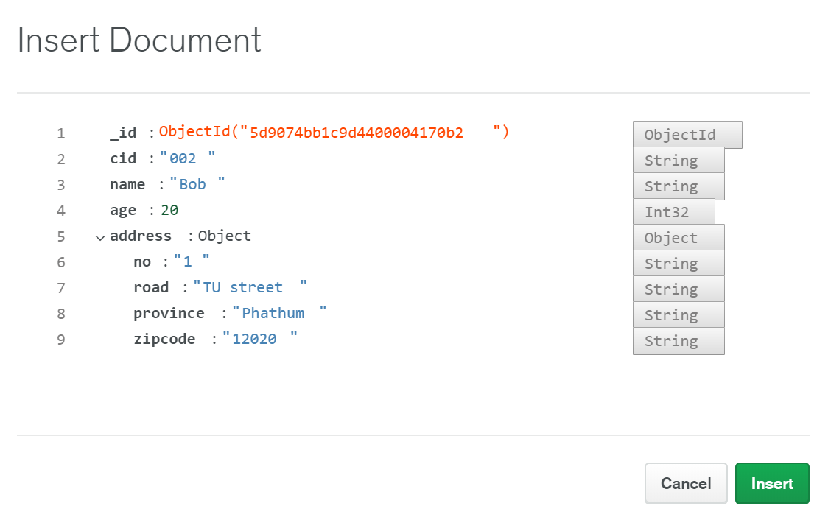
3.2 Insert inventory using Mongo Shell
Get connection string from Atlas = (mongo "mongodb+srv://cluster0-dfi1d.gcp.mongodb.net/shop101" --username ying)
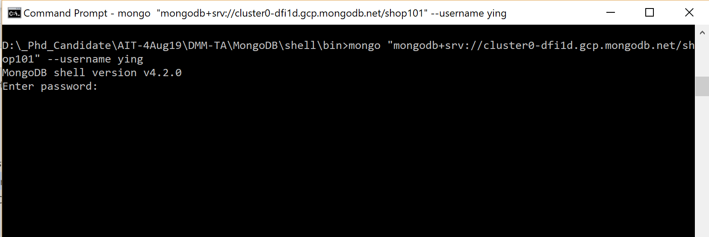

Insert Command
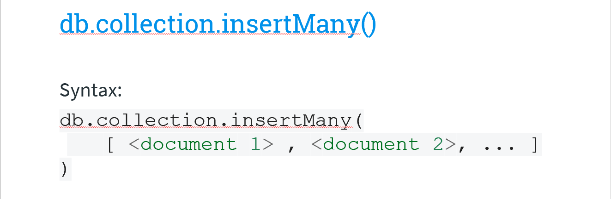

db.inventory.insertOne(
{ item: "canvas", qty: 100, price: 500, tags: ["cotton"], size: { h: 28, w: 35.5, uom: "cm" } })
db.inventory.insertMany([
{ item: "pen", qty: 25, price: 200, tags: ["red"], size: { h: 14, w: 1, uom: "cm" } },
{ item: "mat", qty: 85, price: 99, tags: ["gray"], size: { h: 27.9, w: 35.5, uom: "cm" } },
{ item: "mousepad", qty: 25, price: 29, tags: ["gel", "blue"], size: { h: 19, w: 22.85, uom: "in" } }
])

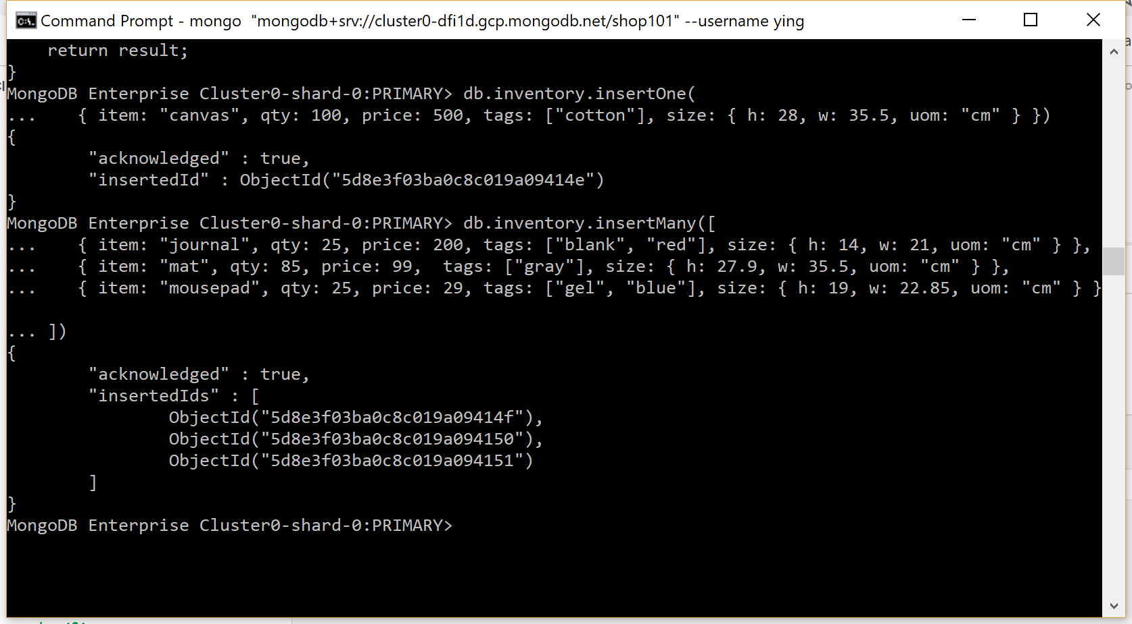
Verify
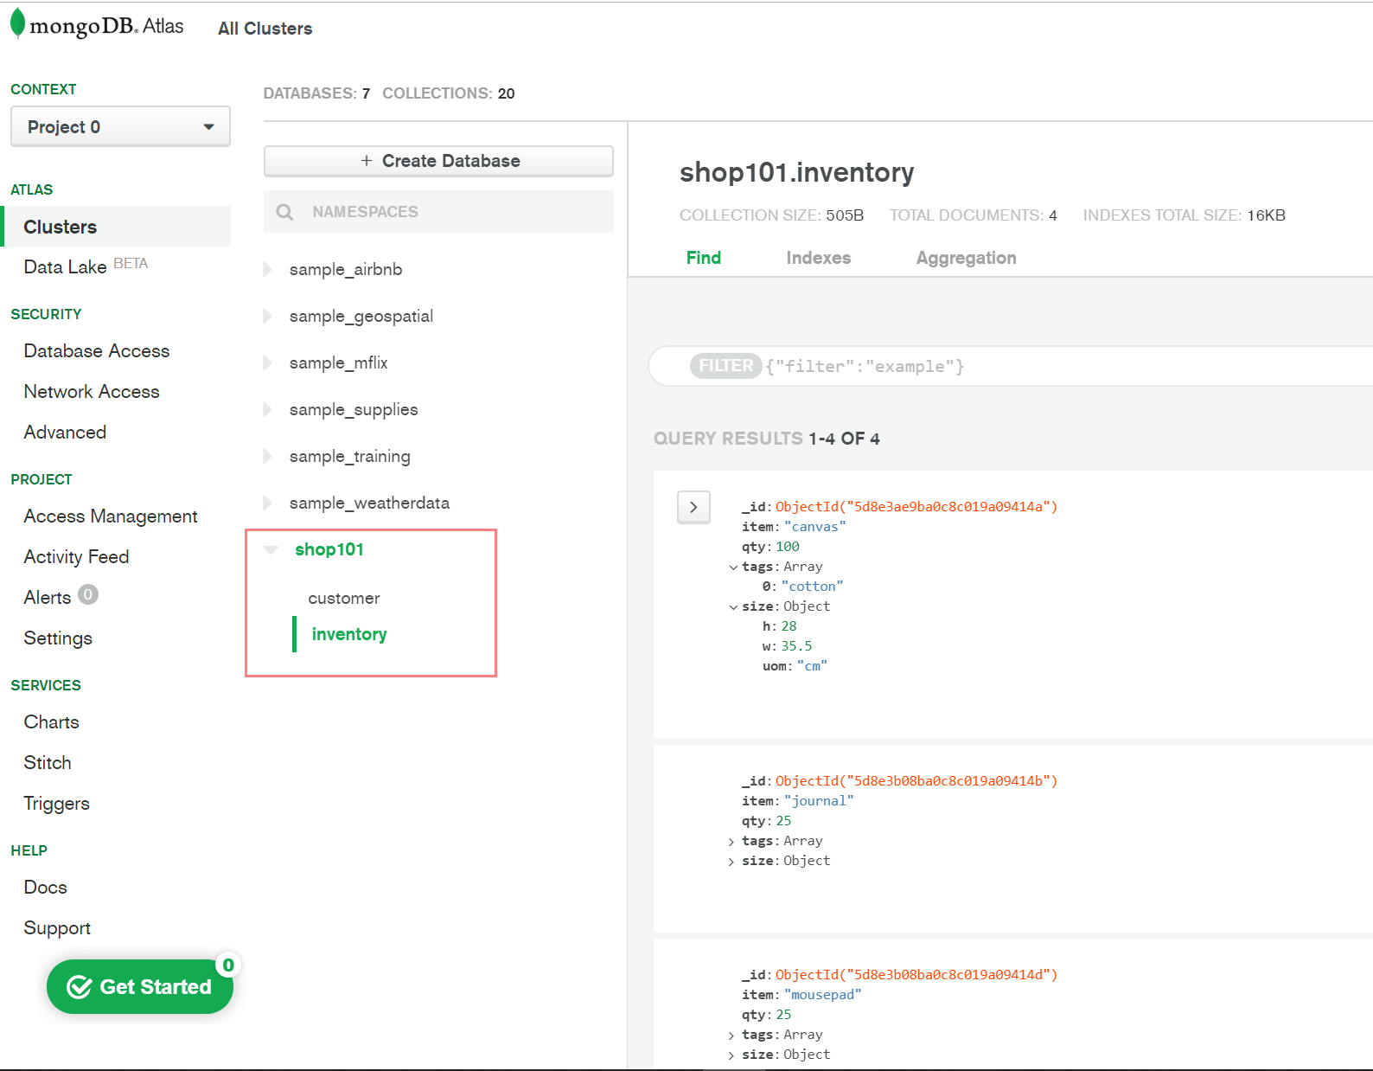

Note: if you want to UPDATE or DELETE:
@Atlas you can click the document and click small buttons on the right corner.
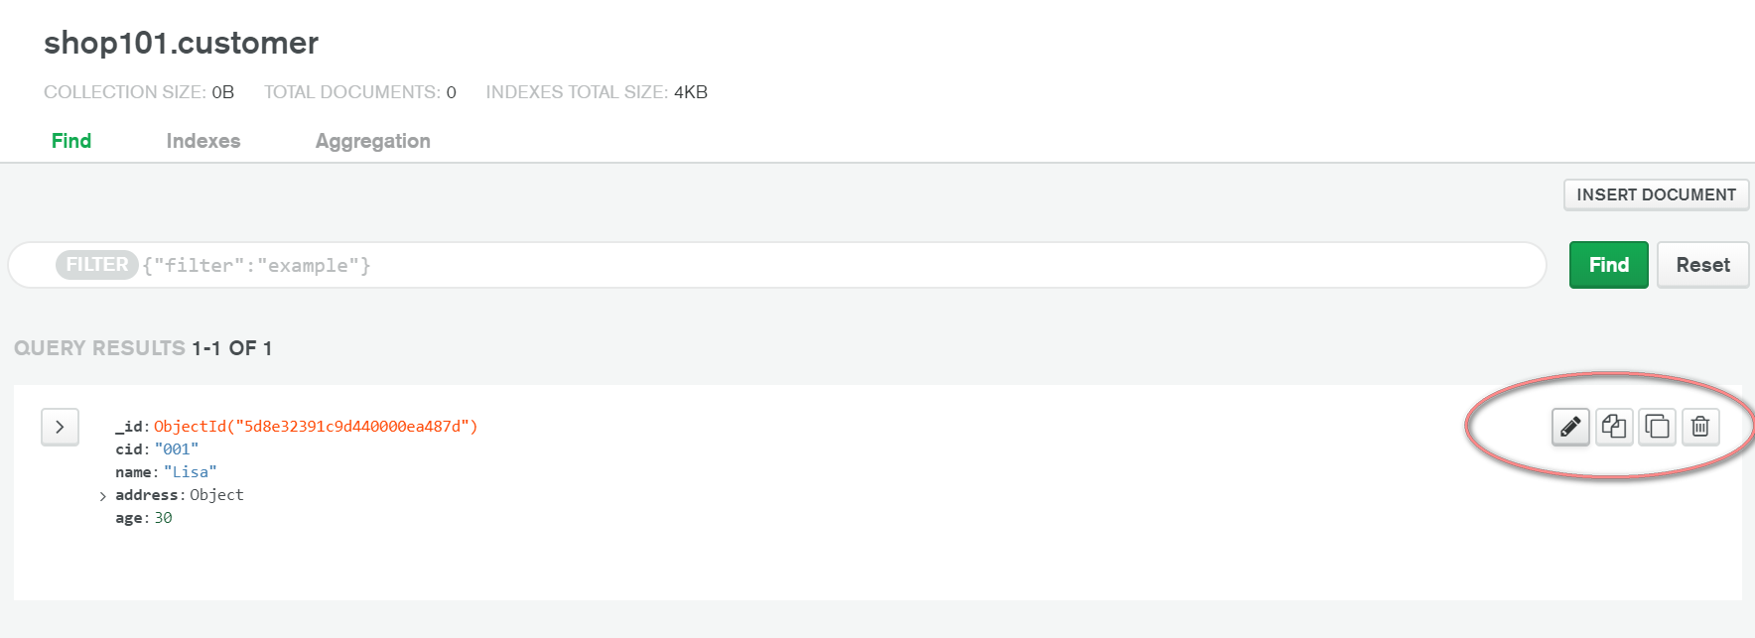
(@Shell see more command in https://docs.mongodb.com/manual/crud/. )
3.4 Insert sales in “shop101” database using Mongo Shell

db.sales.insertOne(
{ item: [{pid: "canvas", qty: 1, price: 500},{pid: "pen", qty: 1, price: 200}], customer:"Lisa" , total:700 , couponused:true })
db.sales.insertOne(
{ item: [{pid: "mousepad", qty: 1, price: 29}], customer:"Bob" , total:29, couponused:true })
db.sales.insertOne(
{ item: [{pid: "mat", qty: 1, price: 99}], customer:"Bob" , total:99, couponused:false })

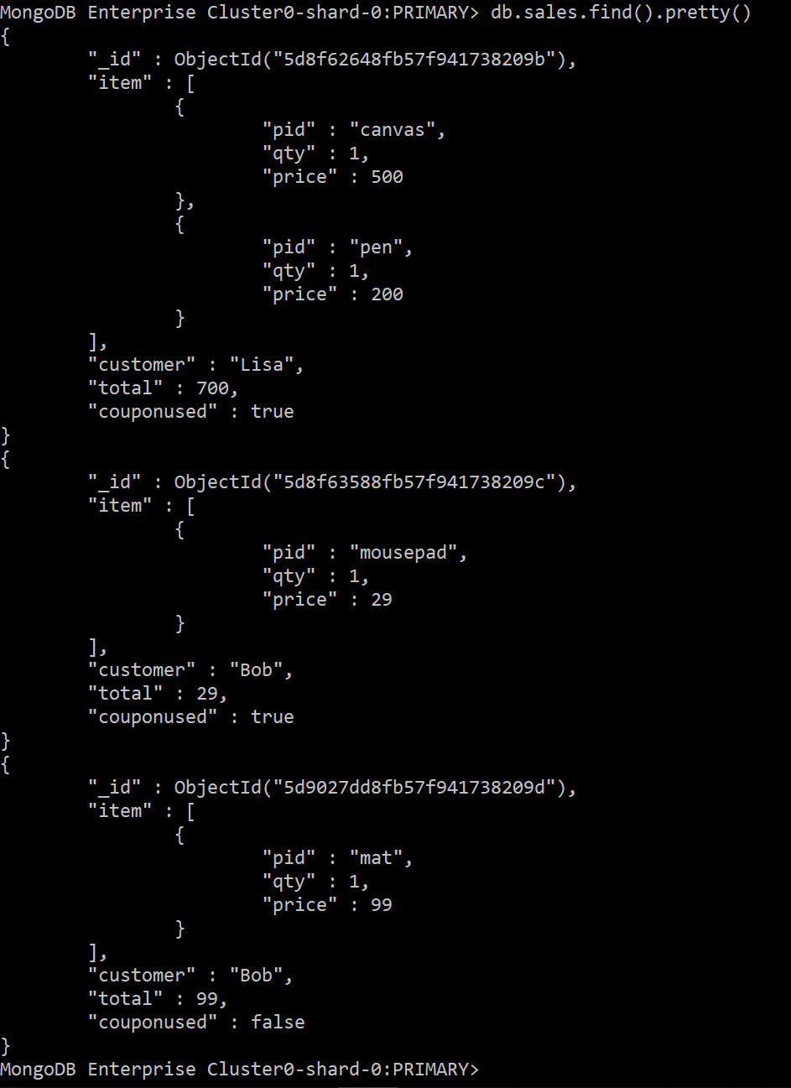

3.5 Update customer add status field
Alter table customer  add status char(1)  +  Update customer  set status =”A” | db.customer.updateMany(  { },  {$set: {status: “A”}}  )
Update customer  set status =”I”  where name =”Lisa” | db.customer.updateMany(  {name:”Lisa” },  {$set: {status: “I”}}  )

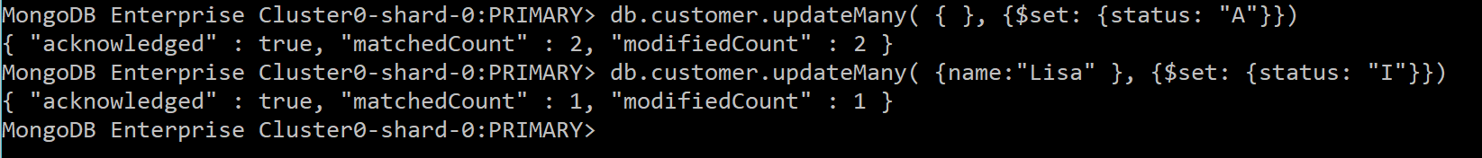

Query Data
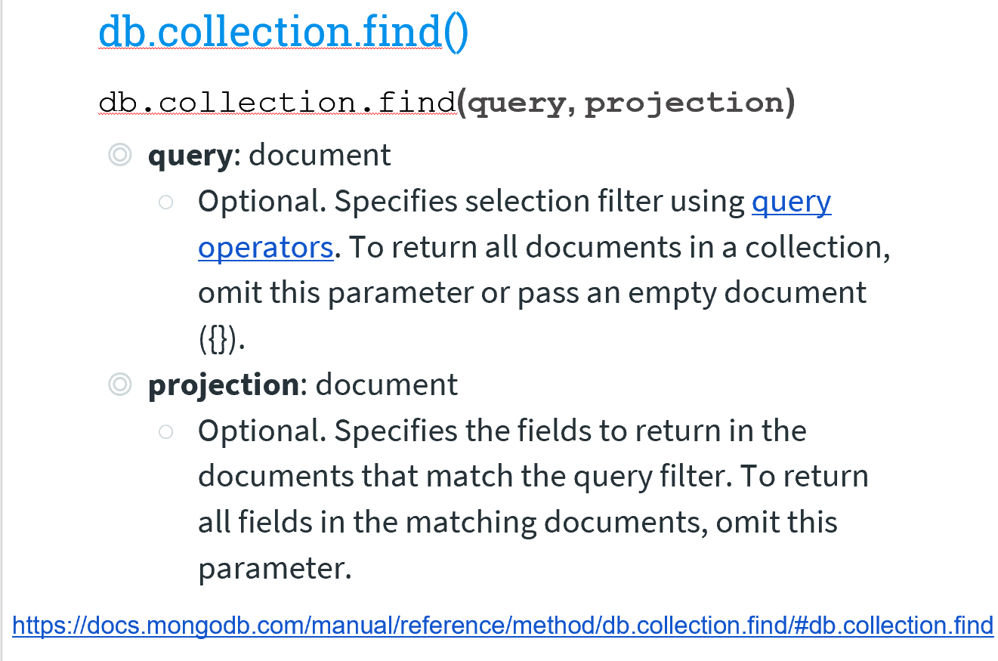
Note: pretty() - displays the results in a formatted way.
  - Select

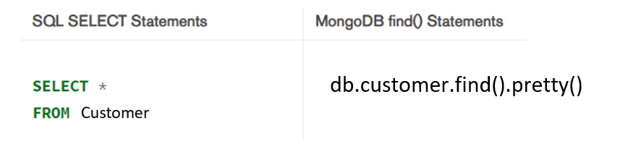
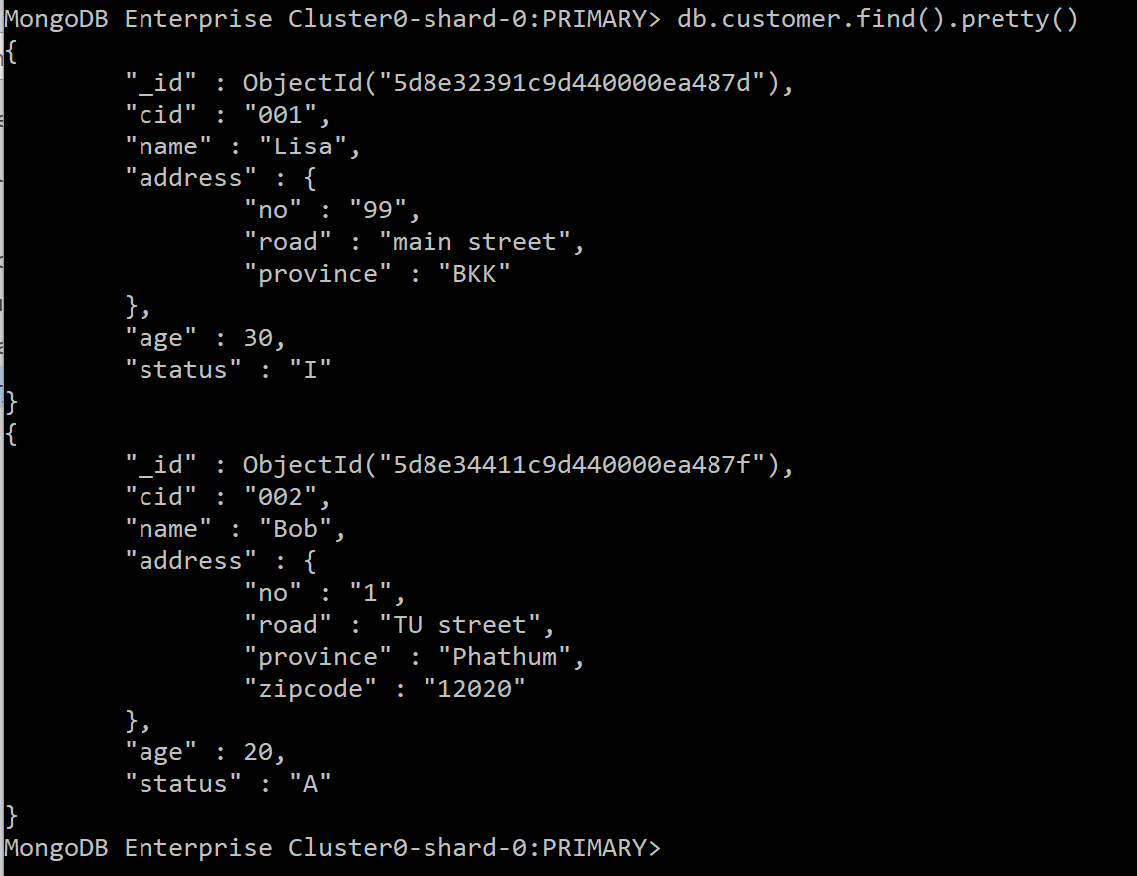

- Projection (return some fields)
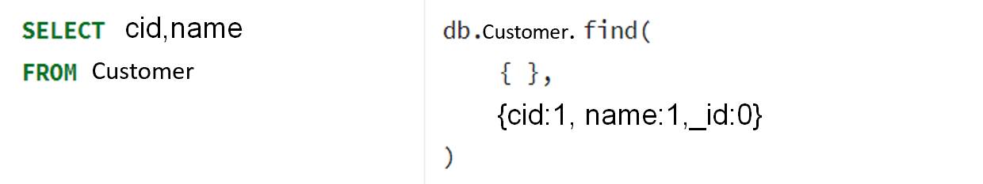
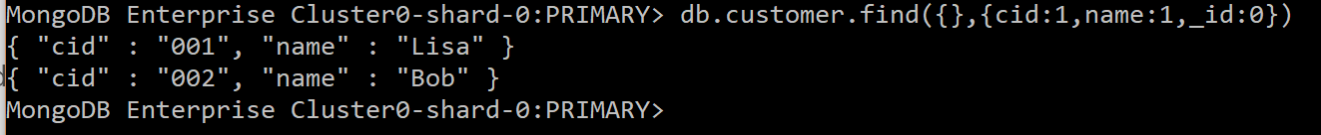

  - Order by
Select * from customer order by name | db.customer.find().sort({name:1})
Select * from customer order by name desc | db.customer.find().sort({name:-1})
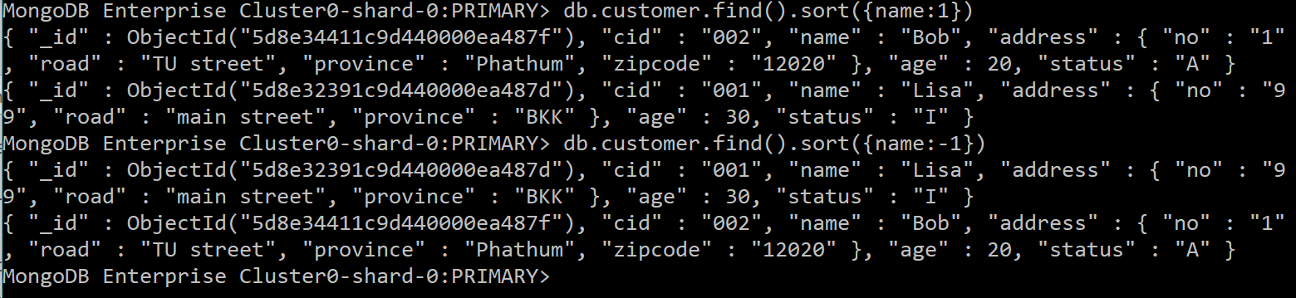

  - Where condition
    - =, !=, >,<, <=,>=
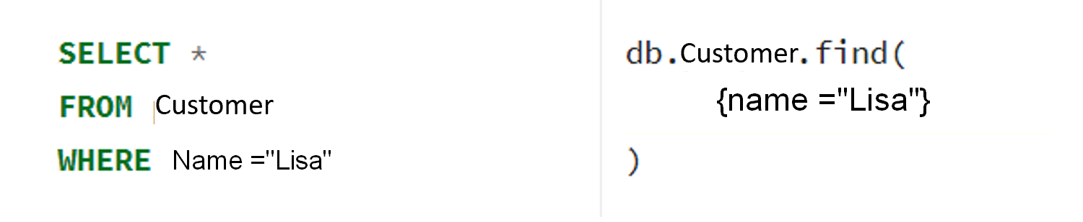
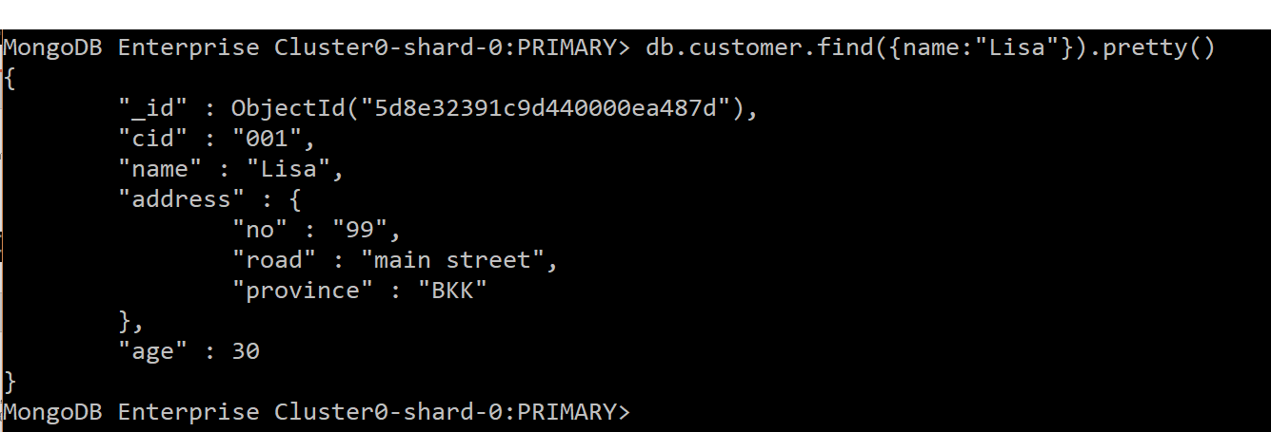
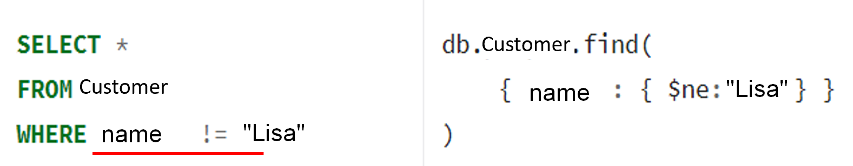
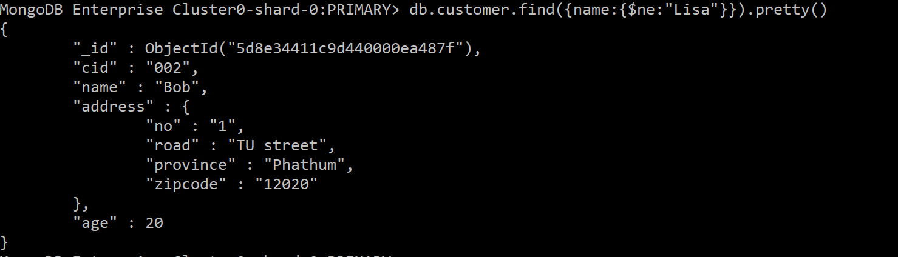

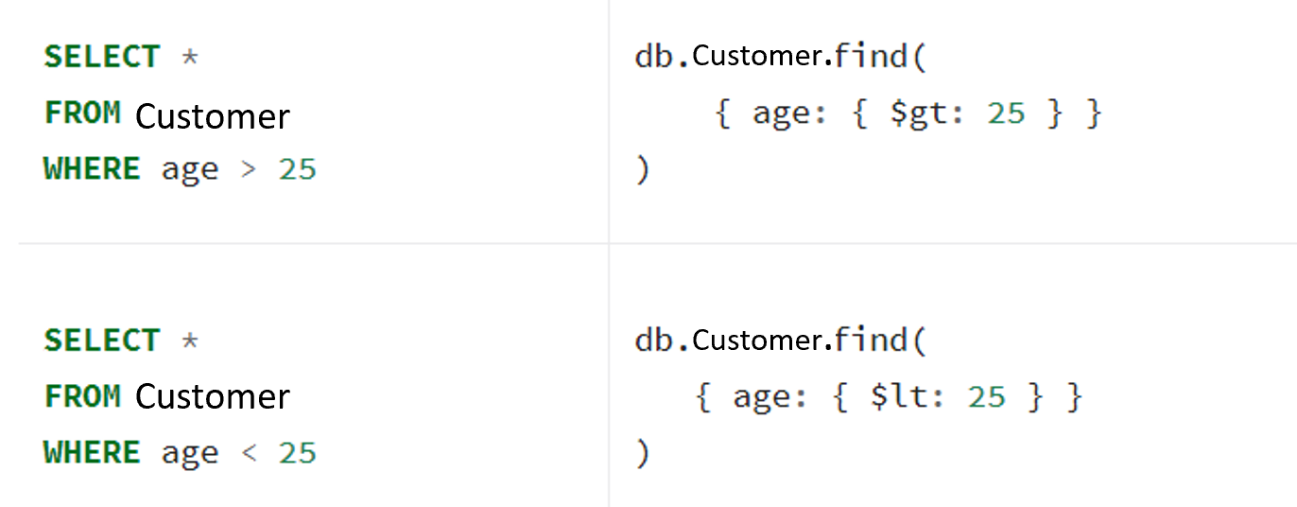
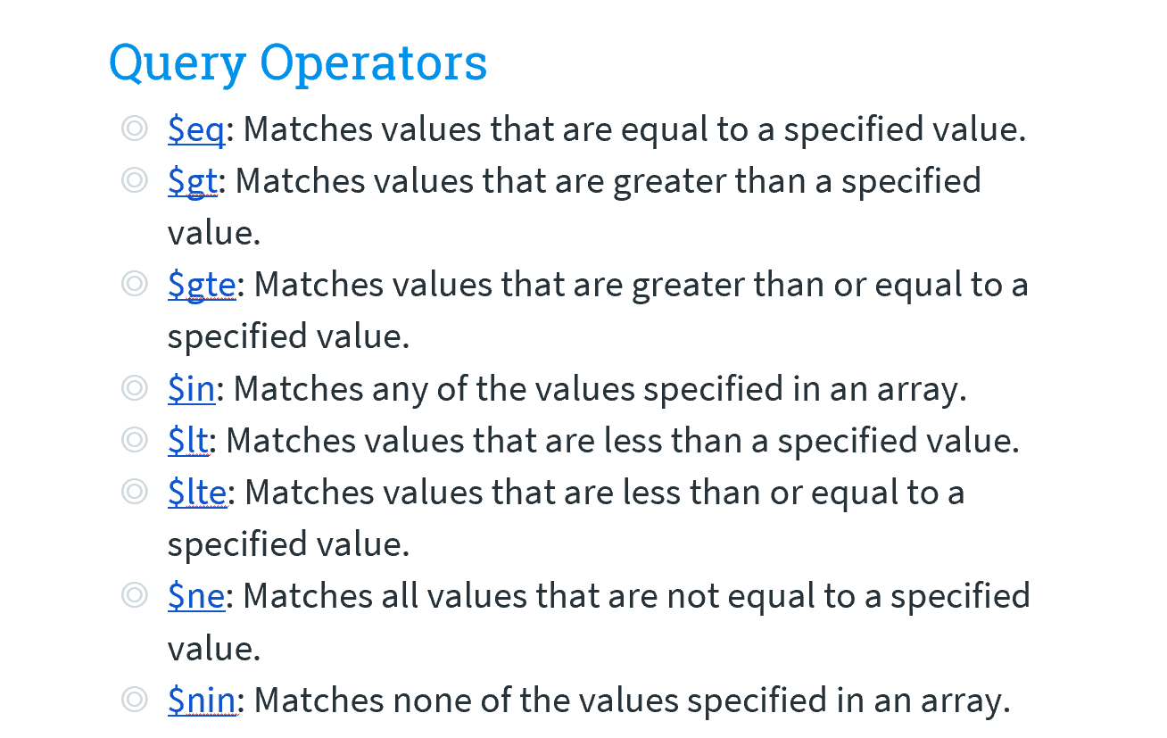

    - AND

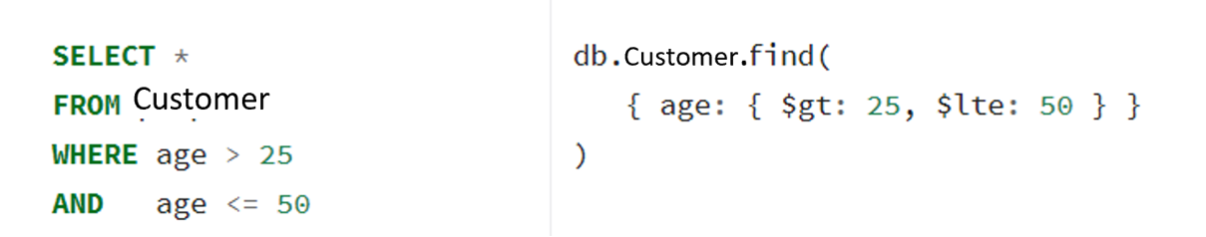
db.customer.find({$and : [{status: "A"}, {age:20}]})

    - OR
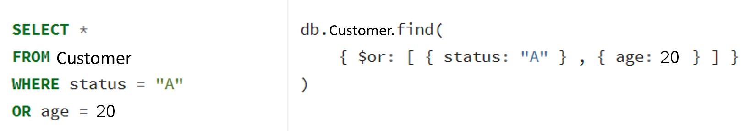
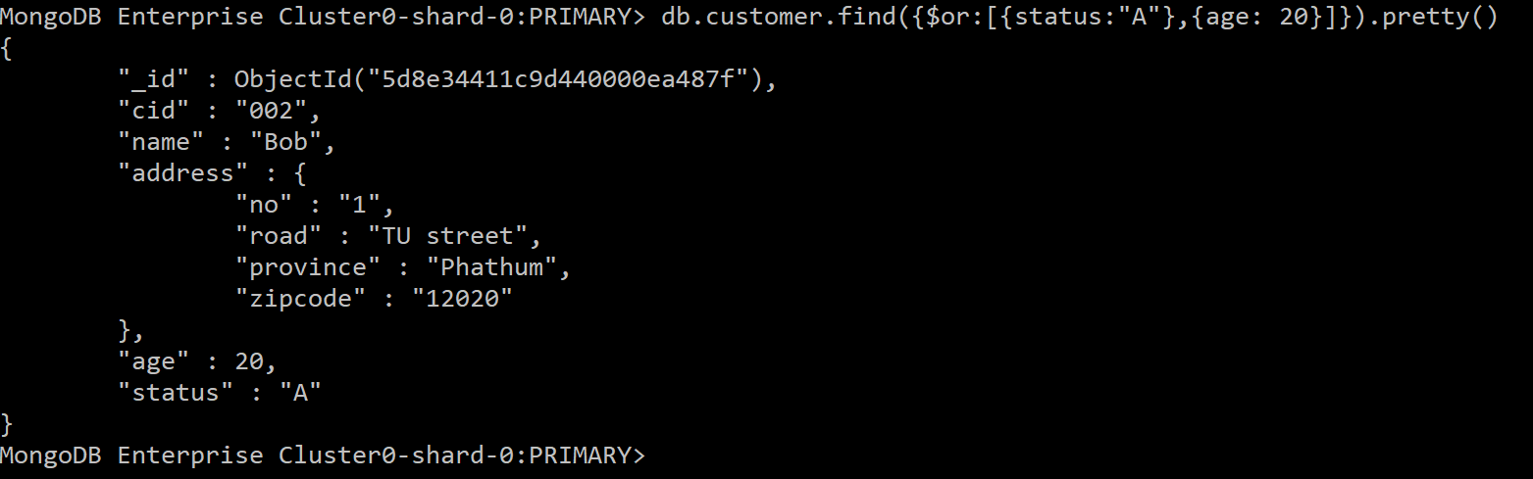

    - LIKE
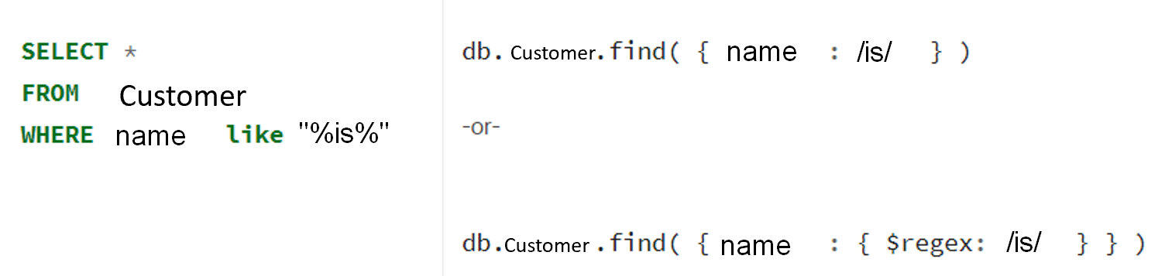
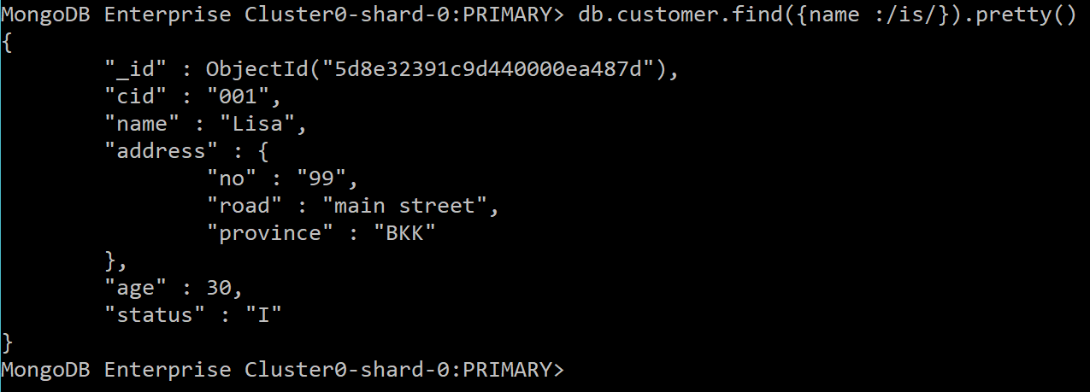

    - IN
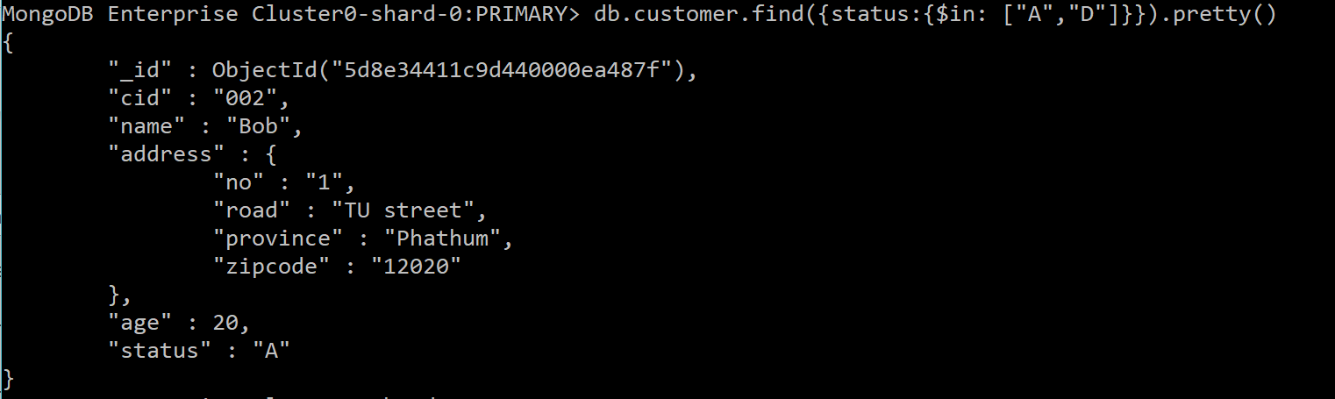

    - Exists
Returns all the documents from the customer collection where zipcode field does not exists:
db.customer.find( {
address.zipcode: { $exists: false }
} )

  - Query on Nested field
Uses dot notation to access fields in an embedded document:
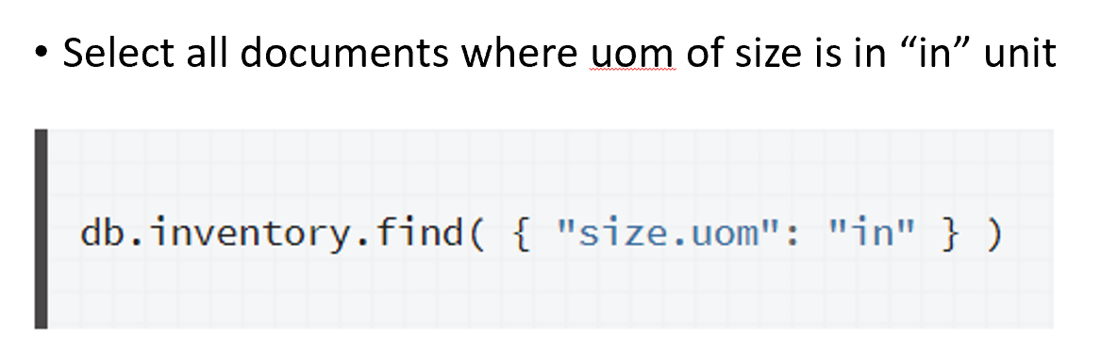
- selects items where their height less than 15 CM.
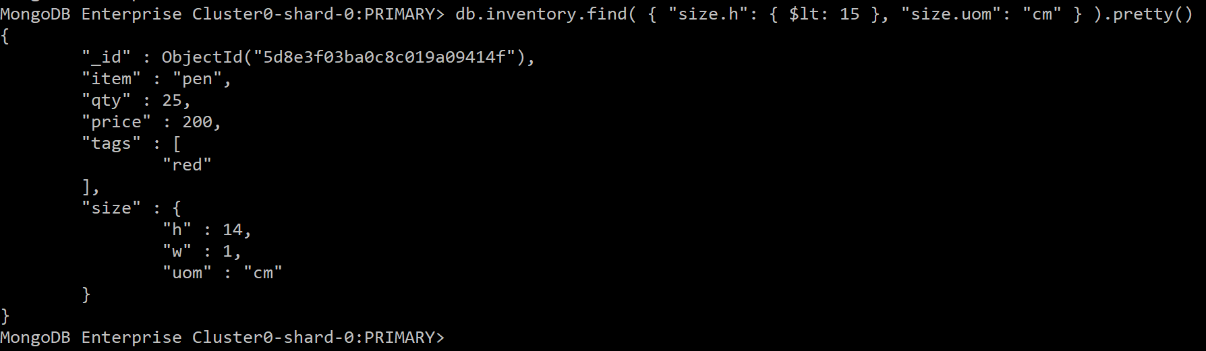
.AGGREGATE
  - Aggregate
Aggregation operations group values from multiple documents together and can perform a variety of operations on the grouped data to return a single result.
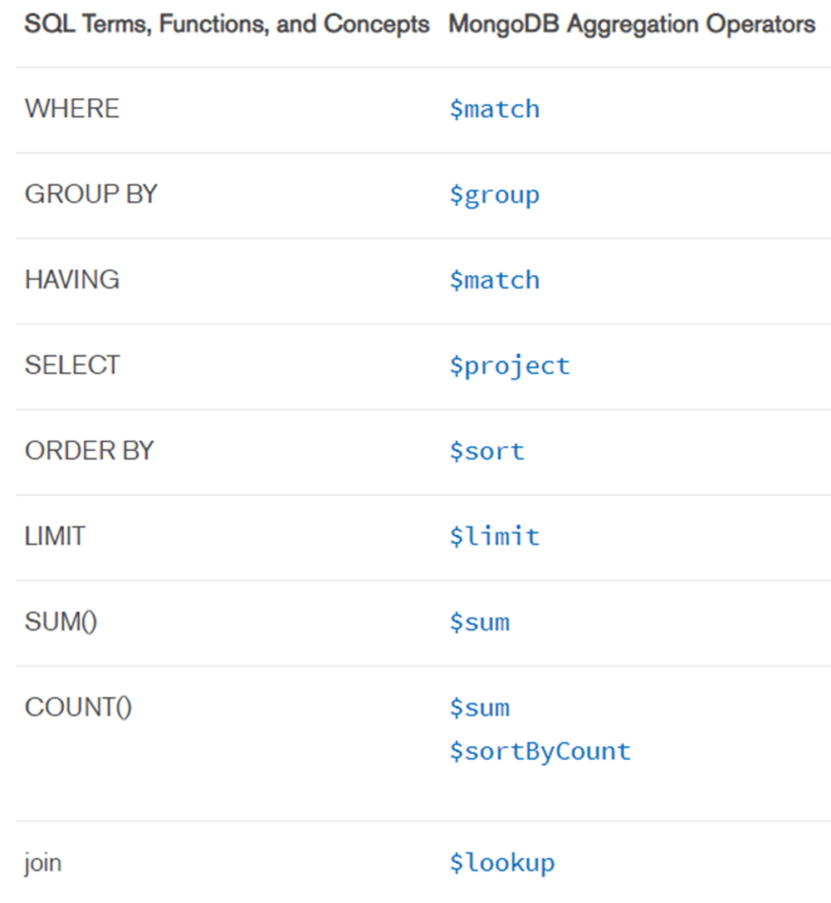

Example
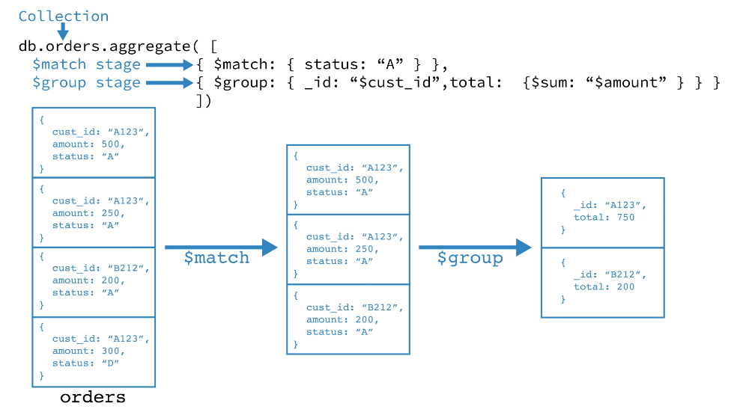
    - Sum
db.sales.aggregate([ { $match: { couponused:true } },
{ $group: { _id: "$customer", total: { $sum: "$total" } } }
])
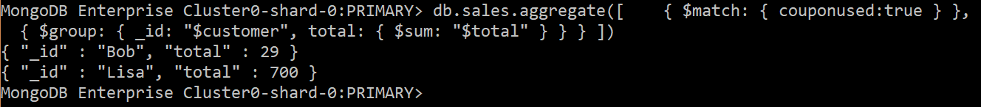
All sales record:

db.sales.aggregate([
{ $group: { _id: "$customer", total: { $sum: "$total" } } }
])
    - Count

Note .FIND() also has COUNT() function
    - Average, Min, Max
db.sales.aggregate([
{ $group: { _id: "$customer", average: { $avg: "$total" } } }
])
db.sales.aggregate([
{ $group: { _id: "$customer", minimum: { $min: "$total" } } }
])
db.sales.aggregate([
{ $group: { _id: "$customer", maximum: { $max: "$total" } } }
])

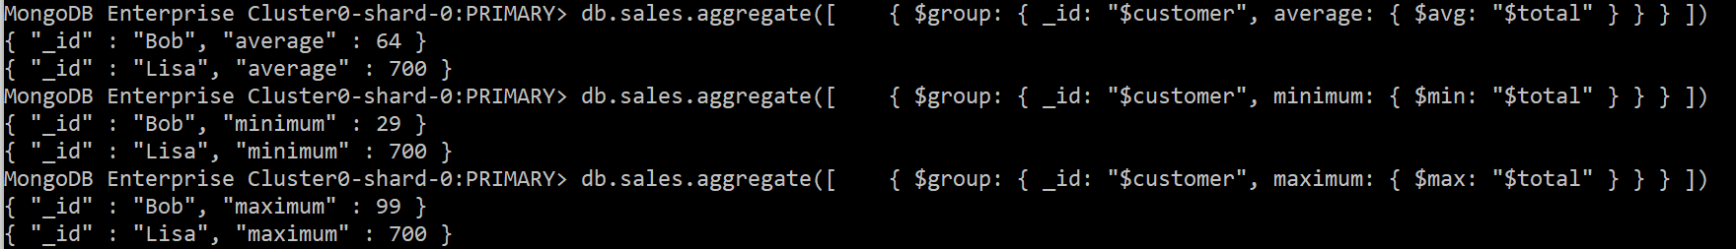
    - Having
db.sales.aggregate([{ $group: { _id: "$customer", total: { $sum: "$total" } } } ,
{$match: {total: {$gt: 150 }}}
])
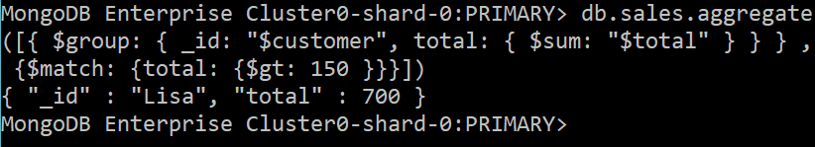
    - Sort and Limit
db.sales.aggregate([
{$group:{_id:"$customer",total: {$sum:"$total"}}},
{ $sort: { total: -1 } }
])
db.sales.aggregate([
{$group:{_id:"$customer",total: {$sum:"$total"}}},
{ $sort: { total: -1 }},
{$limit:1}
])
  - Join
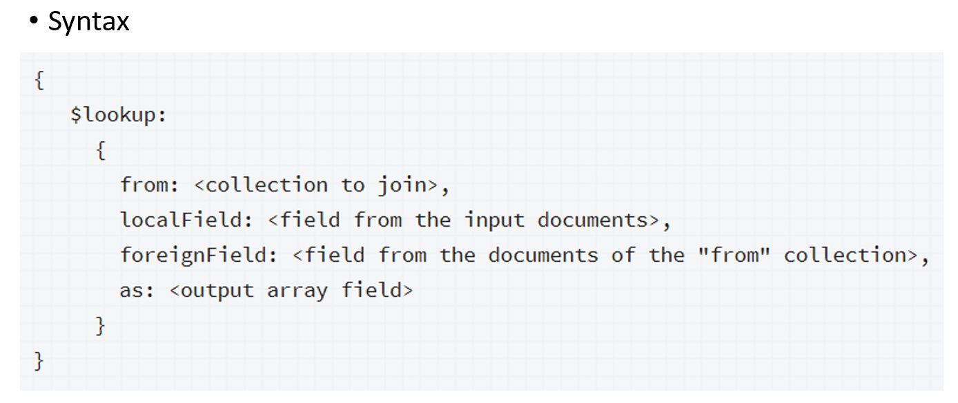
Example from https://docs.mongodb.com/manual/reference/operator/aggregation/lookup/index.html#lookup-single-equality :
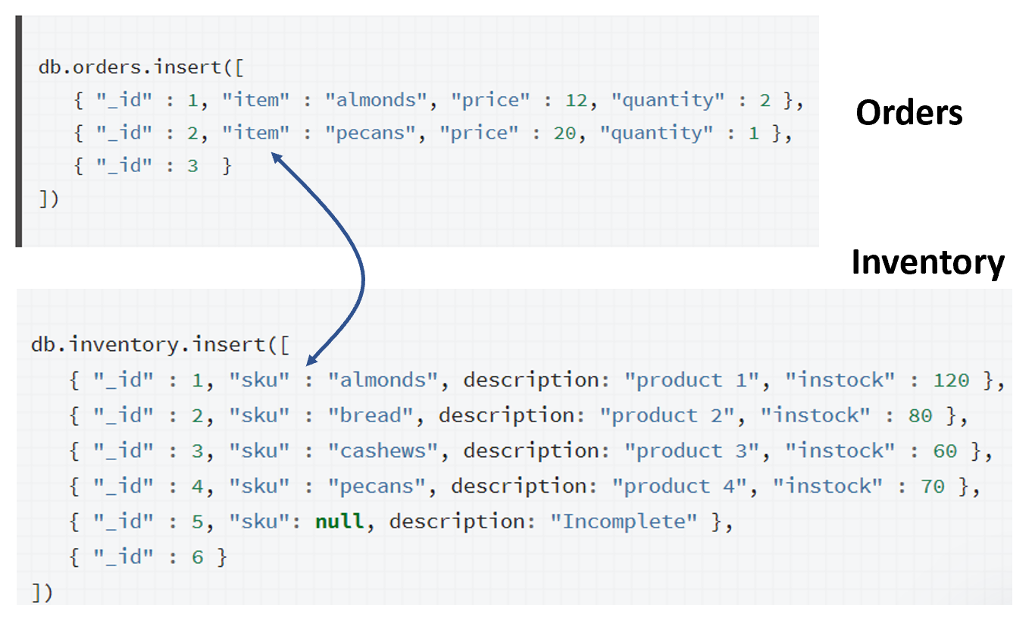
Command:
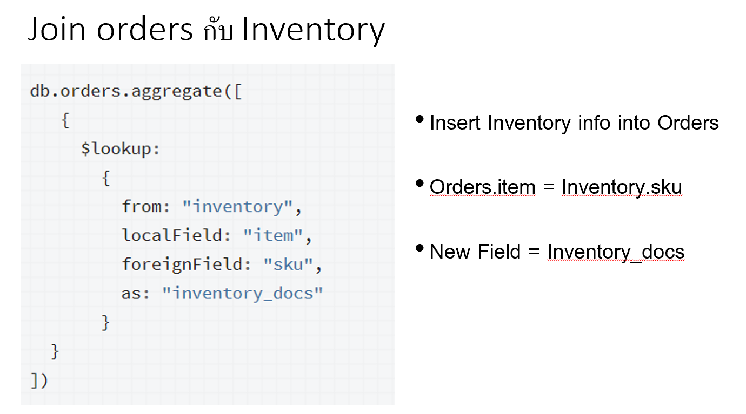
Result:
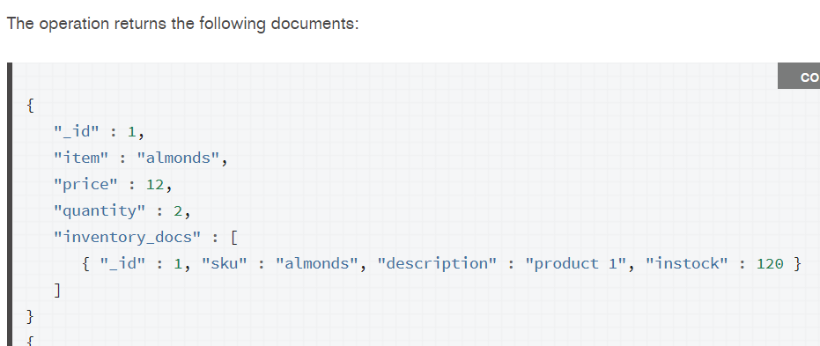
Try our database:
- Include customer info into sale
db.sales.aggregate([
{
$lookup:
{
from: "customer",
localField: "customer",
foreignField: "name",
as: "cust_info"
}
}
]).pretty()

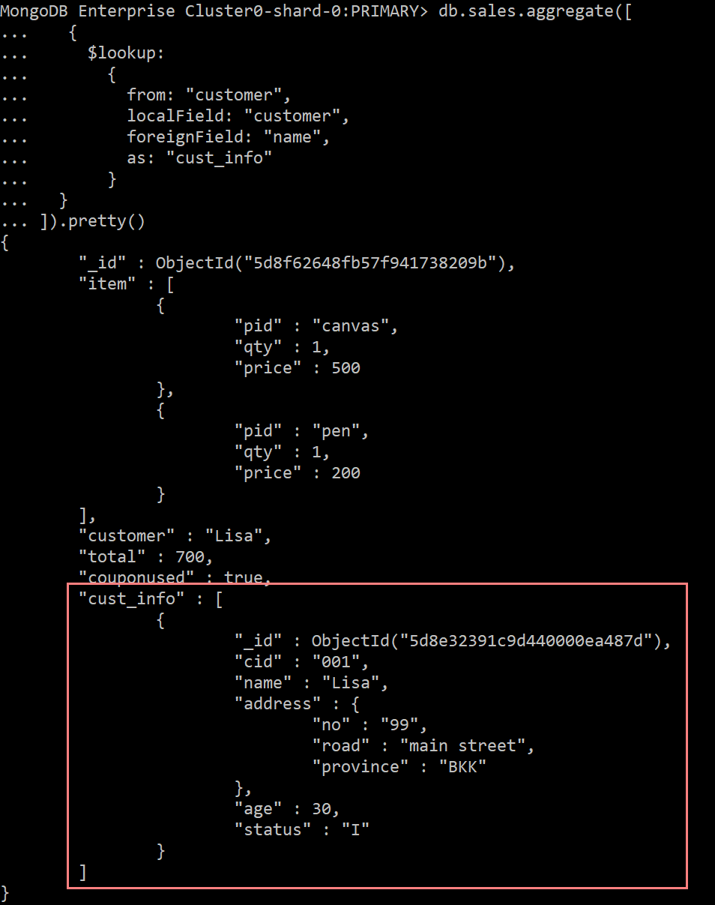
- Include the info under customer in sale
db.sales.aggregate([
{
$lookup:
{
from: "customer",
localField: "customer",
foreignField: "name",
as: "customer.info"
}
}
])
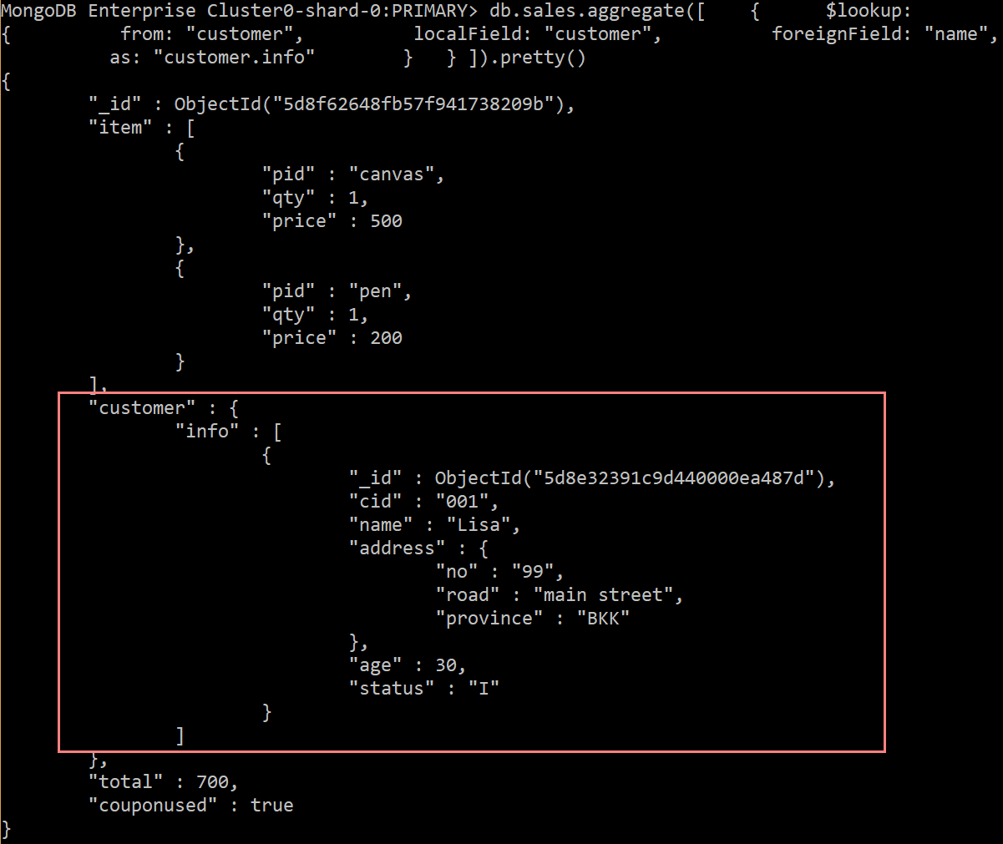
Reference:
https://docs.mongodb.com/manual/crud/
https://docs.mongodb.com/manual/
https://docs.mongodb.com/manual/reference/sql-comparison/#examples
https://docs.mongodb.com/manual/reference/operator/aggregation/lookup/index.html#lookup-single-equality

Lab Assignment
- Install Mongo Shell and connect to RDBProject database using the below command
mongo "mongodb+srv://dmmcluster.f1uoi.gcp.mongodb.net/RDBProject" --username st_dmm
- Convert your Peer-review feedback into the below JSON format and insert into feedback collection
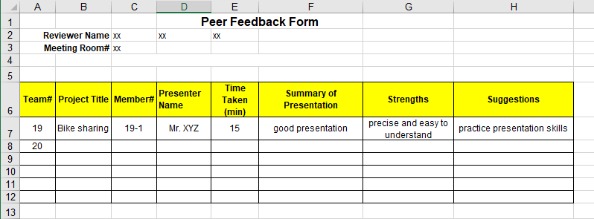
{
"member_id": "19-1",
"presenter_name": "Mr. XYZ",
"project_id" : "19",
"project_name": "Bike sharing",
"summary_of_presentation": "the presentation was well prepared and_ ",
"strengths": [ "precise", "easy to understand" ],
"suggestions": ["practice presentation skills" ]
…
}
… means you can add any other information because NOSQL is schemaless.
- Insert the peer review into the feedback table in the database.
- Write MongoDB command to retrieve the following information, capture the running screen and the returned result.
[TASK1] List your presentation feedback reviewed by friends.
[TASK2] How many strengths are provided in total?
[TASK3] What is the average number of suggestion for a reviewer?
Submission System: Google Classroom
Total TASKS: 3

