Dataset Overview and Methodology

Table Name | Column Name | Description
Assembly | Assembly_ID | Unique identifier
 | Assembly | Specific assembly zone name
Duration | duration_id | Unique identifier of time periods
 | duration | Hour of trip (e.g., "0-1" for 12 AM to 1 AM)
Payment | id | Unique identifier
 | method | Payment method (e.g., Cash, UPI, Credit Card)
Trip Details | tripid | Unique identifier of trips
 | loc_from | Source Location code
 | searches | Trip request count
 | searches_got_estimate | Got an estimated price (1 = user gets an estimate, 0 = does not get an estimate)
 | searches_for_quotes | Searched for drivers after estimate (1 - searched, 0 - not searched)
 | searches_got_quotes | Got quotes (1 = Driver allotted, 0 = not allotted)
 | customer_not_cancelled | Whether customer cancelled or not (1 = Not cancelled)
 | driver_not_cancelled | Whether driver cancelled or not (1 = Not cancelled)
 | otp_entered | (1 = OTP entered, 0 = not entered)
 | end_ride | Whether ride was completed (1 = Completed)
Trips | tripid | Links to Trip Details
 | faremethod | Payment method ID, links to Payment table
 | fare | Fare amount
 | loc_from | Location ID of source
 | loc_to | Location ID of destination, links to Assembly table
 | driverid | Driver ID
 | custid | Customer ID
 | distance | Distance in KM from source to destination
 | duration | Unique identifier of time periods like duration_id

Namma Yatri Performance Analysis Report

Table Relationships
Trips [Duration] | Duration [id]
Trips [Payment] | Payment [id]
Trips [loc_from] | Assembly [ID]
Trips [tripid] | Trip_Details [tripid]
Trip_Details [loc_to] | Assembly [ID]
Trip_Details [loc_from] | Assembly [ID]

Calculated Metrics Used in the Analysis
The following calculated fields were used in the analysis:
- Average fare per km
- Average conversion rate
- Average rides per hour
- Percentage of customers who received an estimate
- Percentage of customers who received quotes
- Percentage of customers who searched for quotes
- Percentage of rides completed after receiving quotes
- Percentage of rides canceled by customers
- Percentage of rides canceled by drivers
- Total revenue and total successful rides
- Correlation between total revenue and average fare per km by customer ID
- Correlation between total revenue and completed rides by customer ID
- Correlation between total revenue and total distance traveled by customer ID

Revenue Performance
- Total revenue for Namma Yatri was 7,51,343.
- Revenue is positively correlated with the number of successful rides and the distance traveled.
  - Correlation between successful rides and revenue: 0.88
  - Correlation between distance traveled and revenue: 0.81
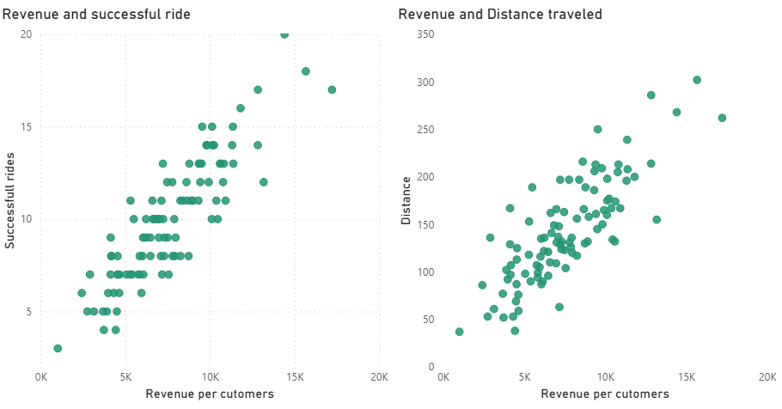
- The highest revenue occurs between 00:00 and 01:00, which also has the highest number of successful rides.

The highest-revenue time zones are:
- 00-01
- 06-07
- 22-23
- 13-14
- 12-13
The lowest-revenue time zones are:
- 08-09
- 20-21
- 23-24
- 03-04
- 04-05

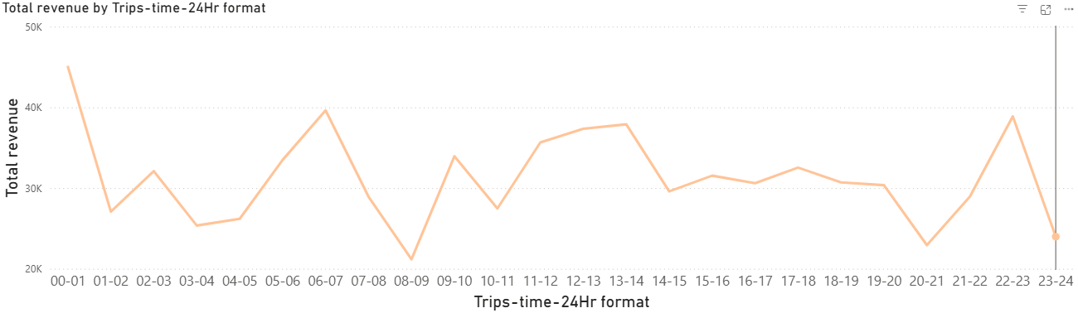
Namma Yatri loses revenue during peak hours but gains revenue from late-night travelers and casual afternoon trips.

Conversion Rate and Demand Patterns
A strong conversion rate above 50% appears to support revenue generation.
The average conversion rate is 45.49%.
Conversion rate = successful rides / total searches.

The top requested pickup zones are:
- Mahadevpura
- Ramanagaram
- Gandhi Nagar
- Yeshwantpur
- Dasarahalli

Payment Method Preferences

- There is no significant difference in the popularity of the payment methods.
- Credit card is the most popular method, with a 26.65% share.
- Debit card and UPI each account for 24.72%.
- Cash is the least popular method, with a 23.91% share.
- Customers who use the service more frequently prefer debit cards and credit cards.
- Customers who use the service less frequently prefer UPI and cash.

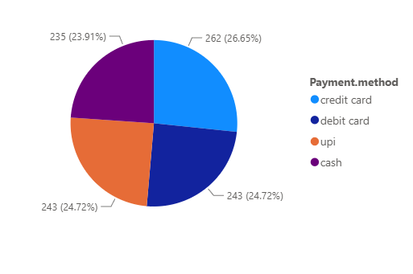

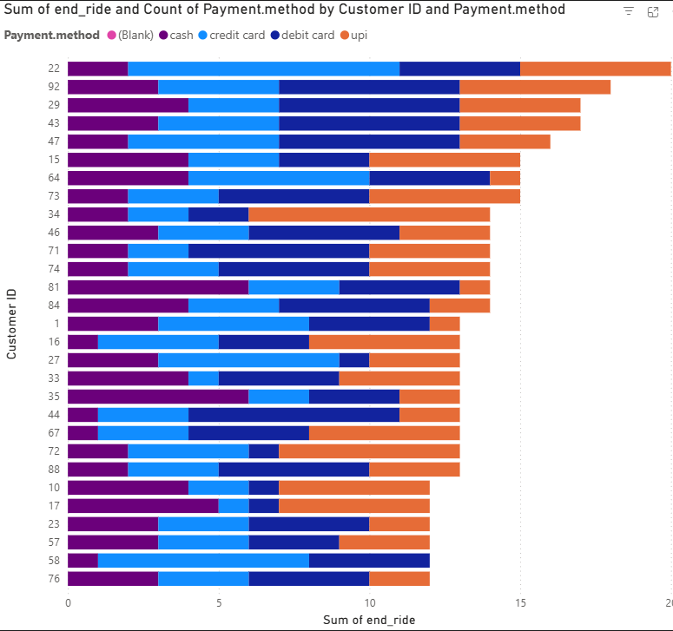

Pickup Zone Performance
For the highest-revenue time zones, the most active pickup zones are:
- Basavanagudi
- Gandhi Nagar
- Bangalore South
- Chickpet
- Shivaji Nagar

For the lowest-revenue time zones, the most active pickup zones are:
- Ramanagaram
- Govindraj Nagar
- Rajarajeshwarinagar
- Yeshwantpur
- Bangalore South

During other time periods, the following pickup zones remain the most active:
- Yeshwantpur
- Bommanahalli
- Hebbal
- Malleshwaram
- Dasarahalli

Completed Trips by Pickup Zone
The top five pickup zones by completed trips are:
- Ramanagaram
- Yeshwantpur
- Bangalore South
- Dasarahalli
- Gandhi Nagar

The main factors contributing to higher trip completion are a strong conversion rate and low cancellation rates from both customers and drivers.
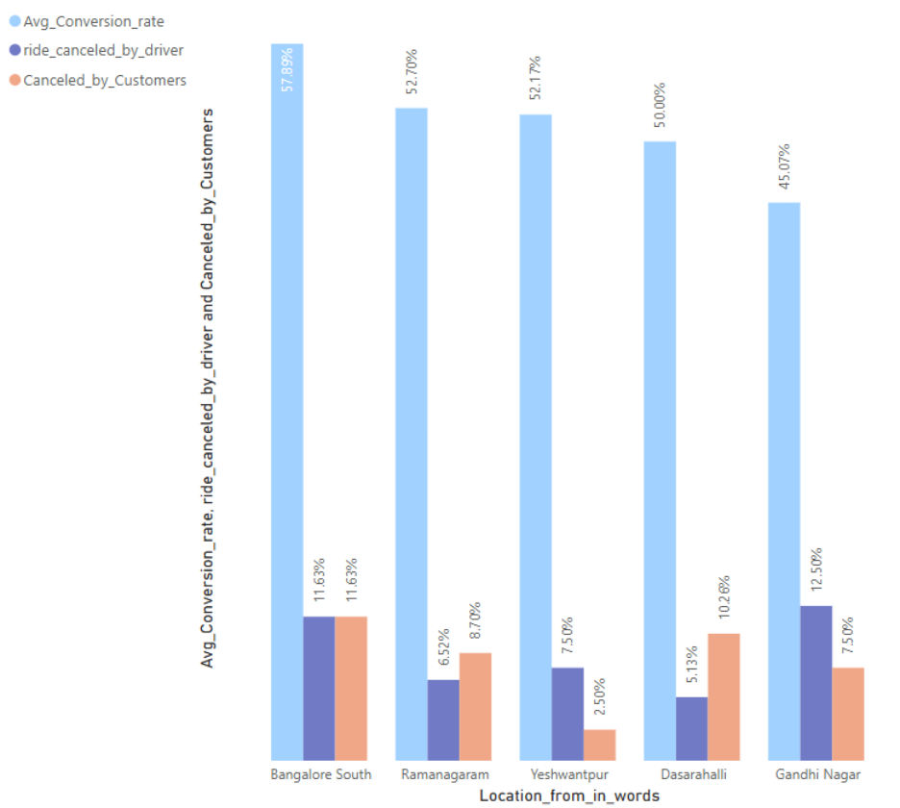

Revenue by Pickup Zone
Source | Revenue
Bangalore South | 30,295
Yeshwantpur | 29,035
Hebbal | 28,097
Rajarajeshwarinagar | 26,509
Ramanagaram | 26,225

Drivers canceled 10.73% of total rides.
Customers canceled 12.29% of rides after receiving quotes.
After receiving quotes, 76.98% of rides were completed successfully.

The percentage of customers who completed rides after searching for quotes is 67.56%.
Duration is available only for successful trips, so this ratio cannot be visualized by time zone.

Operational Indicators for Regional Analysis
- Average conversion rate
- Percentage of customers who got an estimate
- Percentage of customers who searched for quotes
- Percentage of customers who got quotes
- Percentage of rides canceled by customers
- Percentage of rides canceled by drivers
These parameters can be filtered by source location for regional analysis.
This analysis helps visualize conversion rates, cancellation rates, fare-estimation issues, and quote availability by customer source location. These insights can support better resource allocation.

Time Zone Patterns and Operational Efficiency
- There is a drop in rides during the morning and evening rush hours, which suggests office travelers, school students, and college students may not be using the service frequently during these periods.
- There are spikes in late-night travel from 10 pm to 11 pm and 12 am to 1 am, likely linked to nightlife travel.
- There are also spikes in travel and revenue from 11 am to 2 pm.
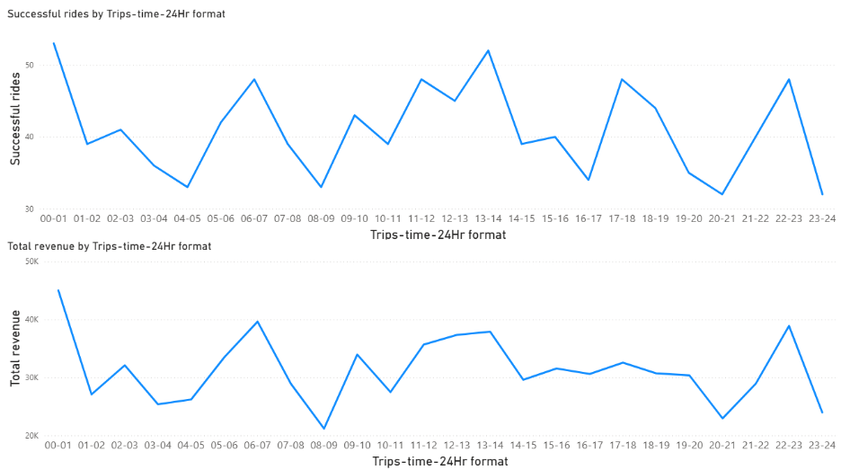

Based on the observations above, Namma Yatri’s peak periods for trips and revenue are 11:00 am to 2:00 pm, 10:00 pm to 11:00 pm, and 12:00 am to 1:00 am.
- To improve operational efficiency, Namma Yatri should identify the most common pickup-to-destination routes during peak hours.

Time slot | Source of travel | Count of successful rides
11am to 12pm | Chamrajpet | 5
11am to 12pm | Yeshwantpur | 5
12pm to 01pm | Vijay Nagar | 4
12pm to 01pm | Chamrajpet | 3
12pm to 01pm | Hebbal | 3
12pm to 01pm | Kanakapura | 3
12pm to 01pm | Rajarajeshwarinagar | 3
12pm to 01pm | Shivajinagar | 3
01pm to 02pm | Bangalore South | 4
01pm to 02pm | Byatarayanapura | 4
01pm to 02pm | Devanahalli | 3
01pm to 02pm | Jayanagar | 3
01pm to 02pm | Magadi | 3
01pm to 02pm | Mahadevapura | 3
01pm to 02pm | Shivajinagar | 3
01pm to 02pm | Vijay Nagar | 3
10pm to 11pm | Other Assemblies | 4
10pm to 11pm | Pulakeshinagar | 3
10pm to 11pm | C. V. Raman Nagar | 3
10pm to 11pm | Magadi | 3
12pm to 01am | Dasarahalli | 4
12pm to 01am | Chamrajpet | 3
12pm to 01am | Gandhi Nagar | 3
12pm to 01am | Hoskote | 3
12pm to 01am | Padmanabhanagar | 3
12pm to 01am | Sarvagnanagar | 3

The table above shows the most active pickup locations by time zone. To improve operational efficiency, Namma Yatri should allocate additional resources to these regions during the corresponding peak periods.

Recommendations
- Namma Yatri is losing revenue during peak hours.
- Successful rides are declining during peak hours.
- Namma Yatri should position itself as a reliable, punctual, and affordable service to increase successful rides during peak periods.
- On average, drivers cancel 10.73% of rides and customers cancel 12.29% of rides.
- In locations such as Mahadevpura, Anekal, and Magadi, driver cancellations exceed 20%; these areas should be investigated and targeted with driver incentives or operational improvements.
- In locations such as C. V. Raman Nagar, Doddaballapur, and Jayanagar, customer cancellations exceed 20%; improving service reliability in these areas can help increase customer satisfaction.
