E-Commerce Power BI Dashboard – Project Documentation
Problem Statement
Quick commerce platforms generate large volumes of transactional data but lack structured insights into revenue performance, delivery efficiency, discount impact, and product demand.

Without analytical dashboards:
Business Gap Impact
No net revenue visibility Profit leakage
Delivery delays untracked Poor customer experience
Discount performance unclear Revenue loss
Product demand unknown Stock mismanagement
City contribution hidden Weak expansion strategy

Project Objectives

Objective Description
Monitor total & net revenue Financial performance tracking
Track delivery status Service efficiency
Analyze product categories Demand planning
Measure discount impact Profit optimization
Evaluate city performance Regional growth

Dataset Structure:

Summary

Attribute Value
Rows 11,600
Columns 15
Data Type Transaction-level
Model Single flat table
Relationships None

Column Description (Updated)

Column Name Description
Order_ID Unique order identifier
Company Platform name
City Customer location
Customer_Age Age of customer
Order_Value Gross order amount
Discount_Applied Discount flag (0/1)
Net_Revenue Order_Value after discount
Delivery_Time_Min Delivery duration
Distance_km Distance traveled
Items_Count Number of items
Product_Category Product type
Payment_Method Payment mode
Customer_Rating Feedback score
Delivery_Status On Time / Late

Data Model Design

Feature Description
Structure Single fact table
Reason Simple learning project
Performance Fast calculations
Scalability Can convert to star schema later

Key Calculated Columns & Measures

Calculated Columns

Column Logic
Net_Revenue Order_Value – Discount amount
Delivery_Status Based on delivery time threshold

DAX Measures

Measure Formula Logic
Total Revenue SUM(Order_Value)
Net Revenue SUM(Net_Revenue)
Total Orders COUNT(Order_ID)
Average Order Value Total Revenue / Orders
Avg Delivery Time AVERAGE(Delivery_Time_Min)
On-Time Orders Filter Delivery_Status = On Time
Late Orders Filter Delivery_Status = Late
Discounted Orders Discount_Applied = 1

Dashboard Pages Breakdown
Page 1 – Sales Overview

Visual Purpose

KPI Cards Total Revenue, Net Revenue, Orders, AOV
Bar Chart Revenue by Product Category
Area Chart Revenue by City
Donut Chart Orders by Payment Method
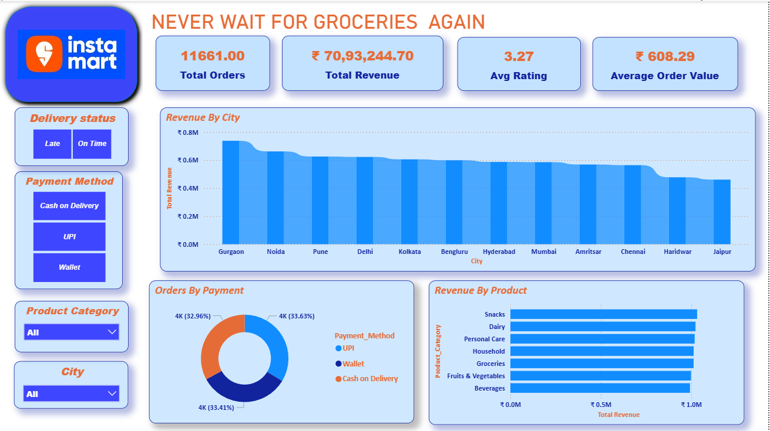
Page 2 – Delivery Performance

Visual Purpose

KPI Cards On-Time vs Late Orders
Line/Area Chart Avg Delivery Time by City
Map Regional delivery performance
Donut Chart Delivery status ratio

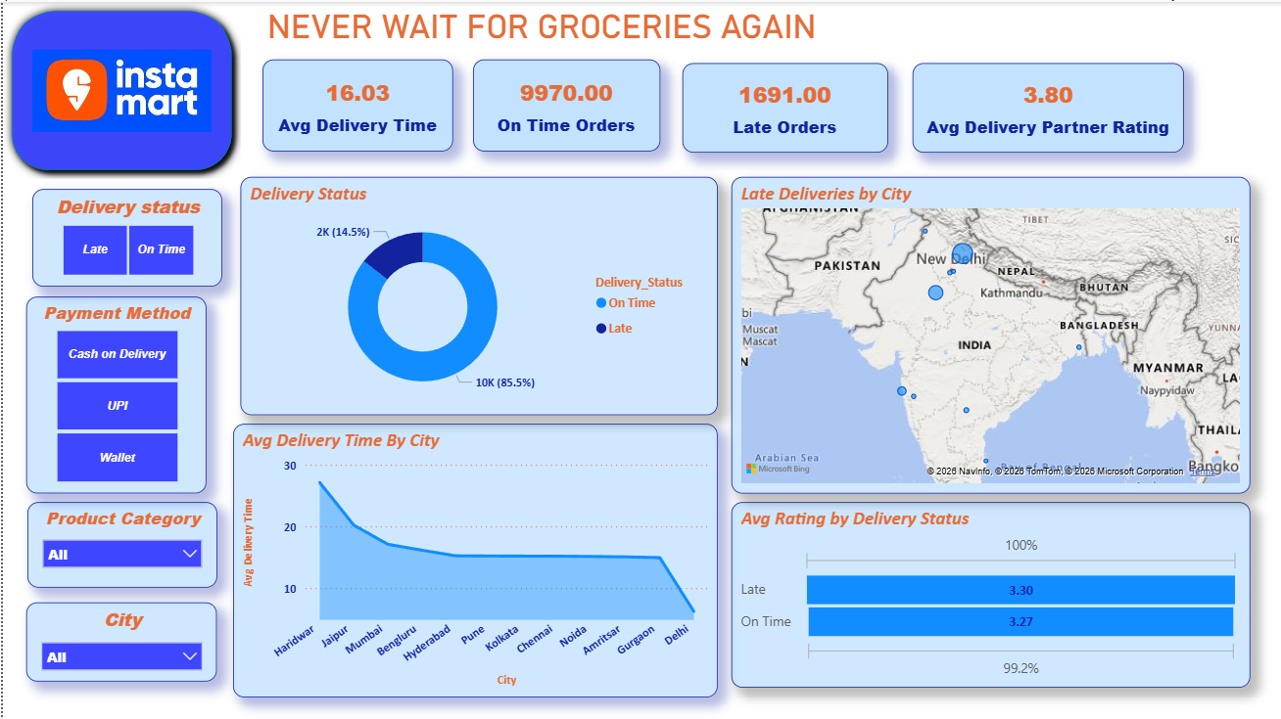

Page 3 – Product & Discount Insights
Visual Purpose
Bar Chart Orders by Category
Line Chart Avg Order Value by Category
Donut Chart Discount impact
Table Revenue, Net Revenue, Orders per category
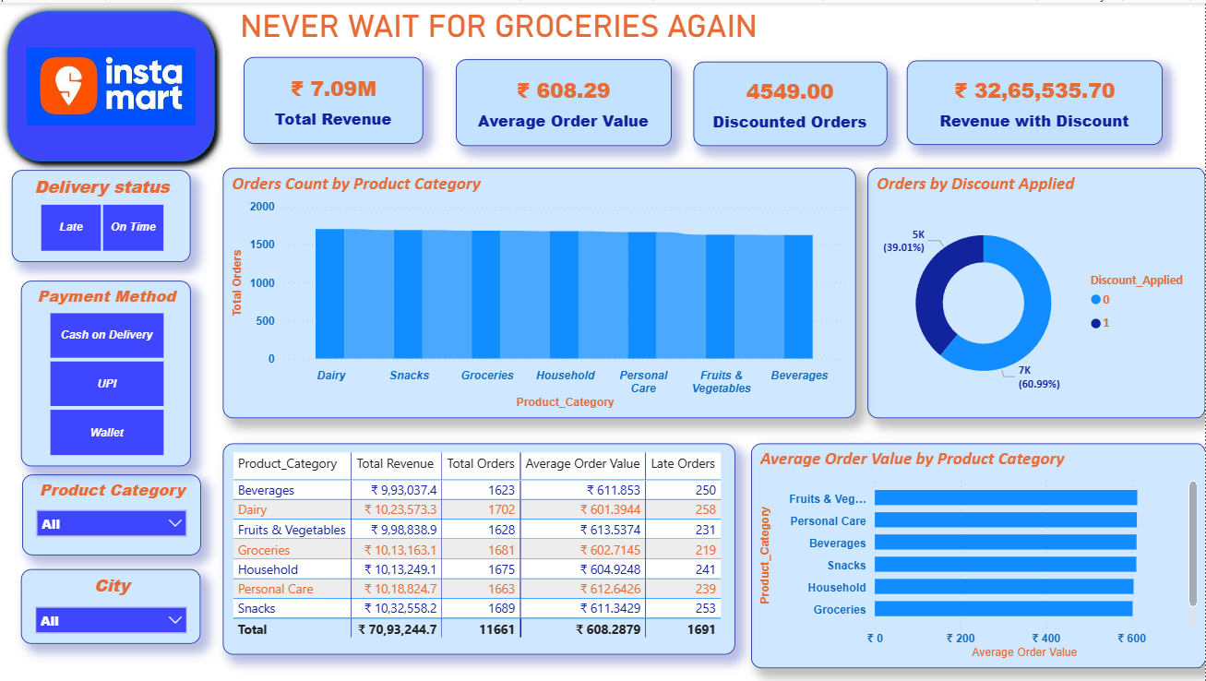

Top Business Insights

Insight
1 Metro cities generate majority of revenue
2 Grocery and household items dominate sales
3 Discounts increase order volume
4 Late deliveries rise with distance
5 Net revenue is significantly lower during heavy discount periods
Dashboard Users

User Type Benefit
Business Managers Revenue tracking
Operations Teams Delivery improvement
Marketing Teams Promotion strategy
Supply Chain Inventory planning
Regional Leads City performance

Business Impact

✔ Revenue transparency
✔ Operational efficiency
✔ Reduced delivery delays
✔ Better discount control
✔ Data-driven decisions

Future Enhancements

Enhancement Value
Date dimension Trend analysis
Profit metrics Margin tracking
Forecasting Predictive insights
Star schema Enterprise scaling
Real-time data Live monitoring
Final Conclusion

This Power BI project converts transactional data into a comprehensive analytics solution by:

• Using calculated business metrics
• Applying DAX measures
• Designing multi-page dashboards
• Delivering actionable insights

