DBMS Project Report

Ambar Pal, 2014012
Harshvardhan Kalra, 2014043

Functional Dependencies:
There are no functional dependencies since every table has got a different primary key

ER Diagram:
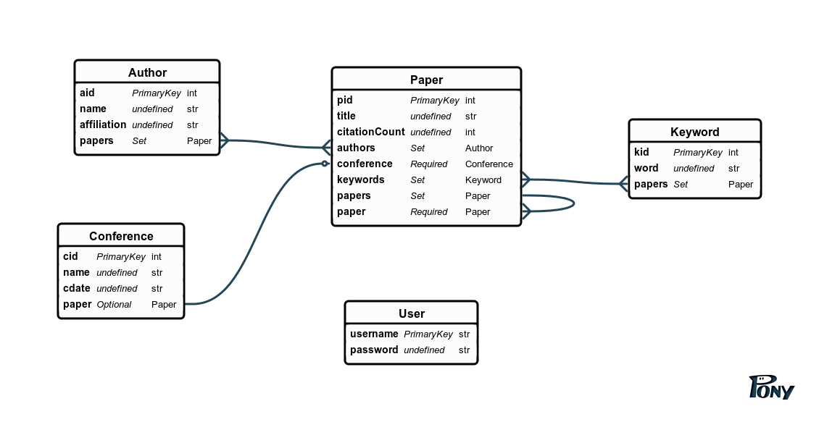
Relational Schema:
