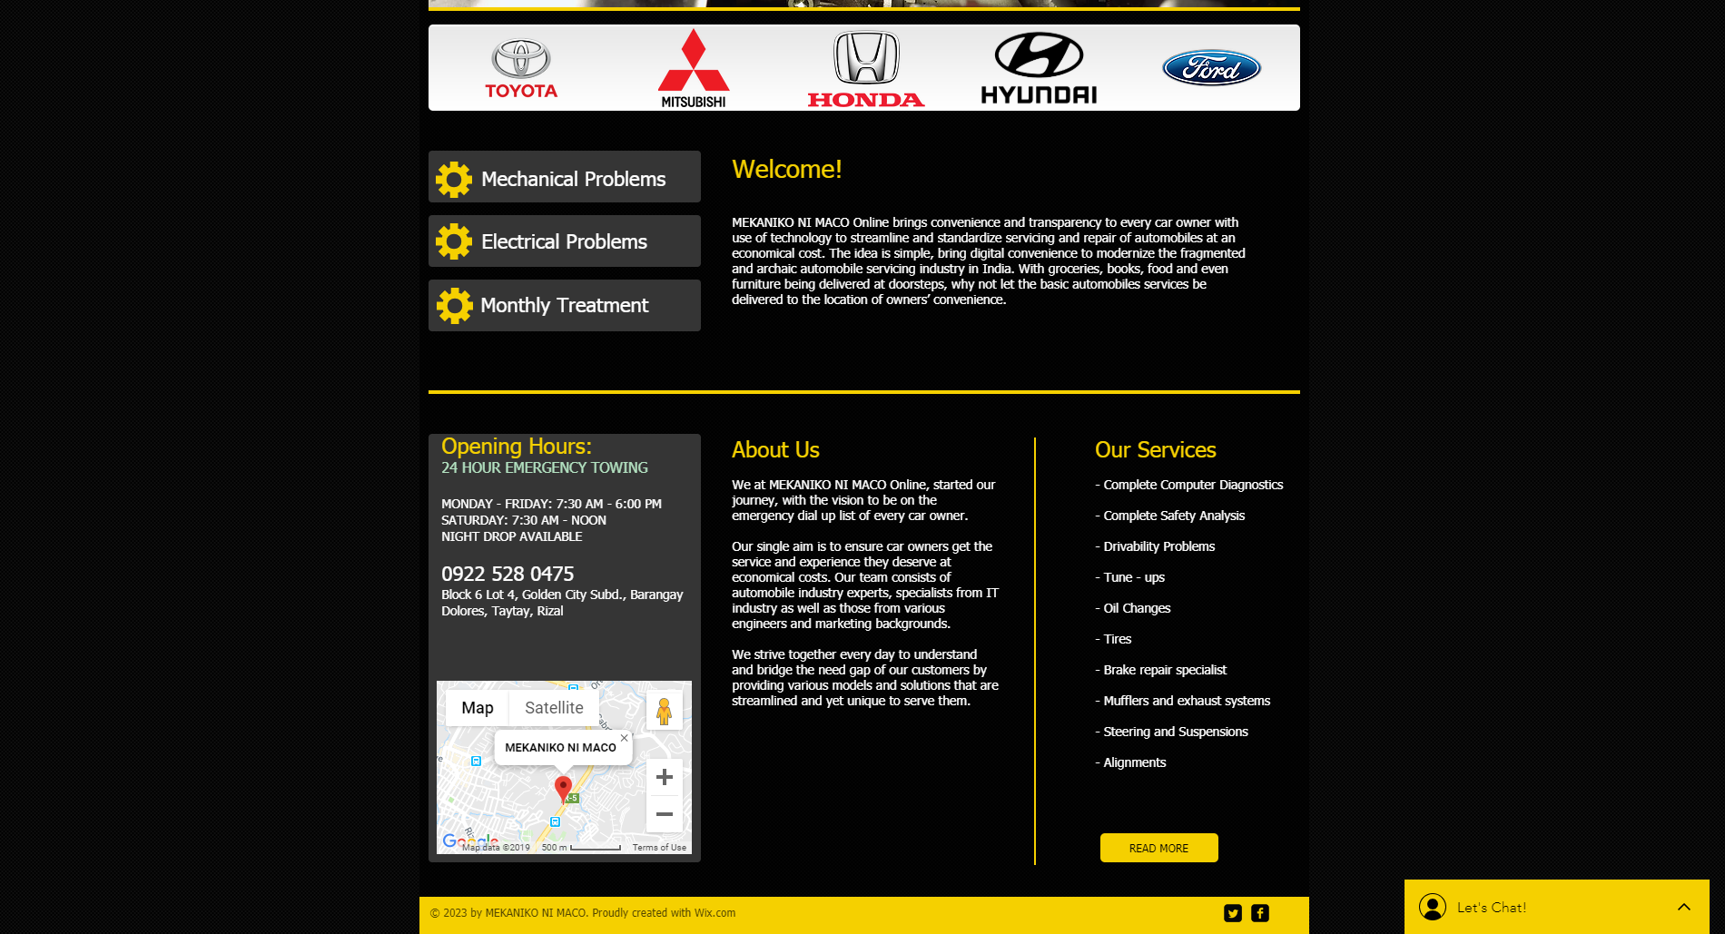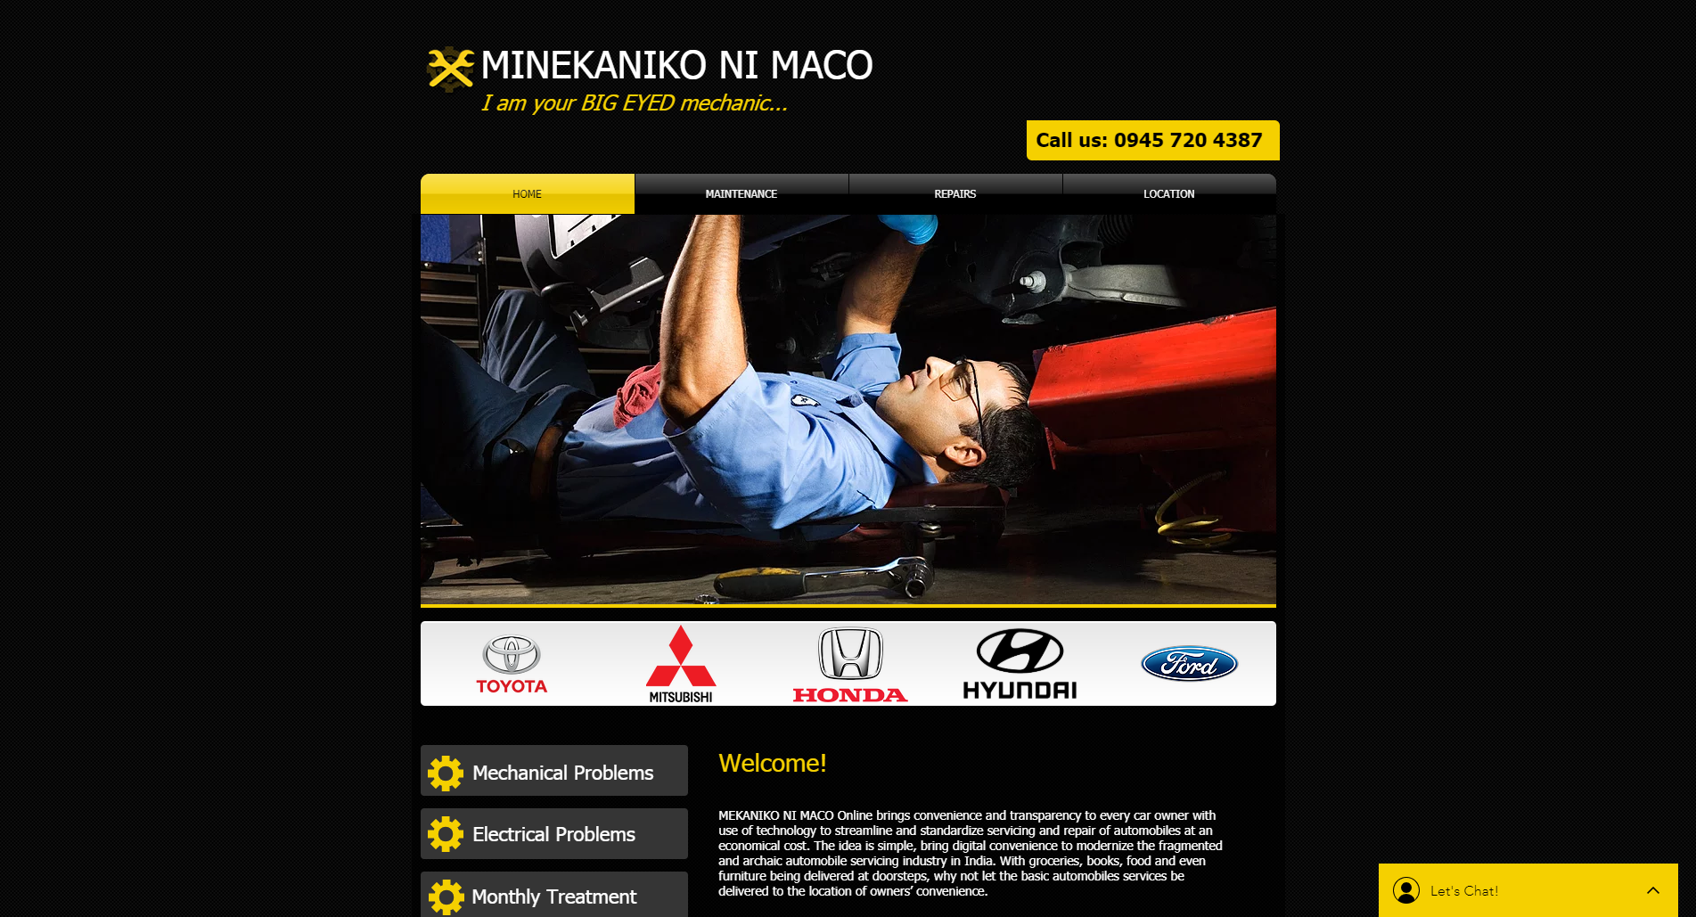

This is the home of the site. This is where you can see the basic information and services of the website. This will guide you on how to navigate the website properly.

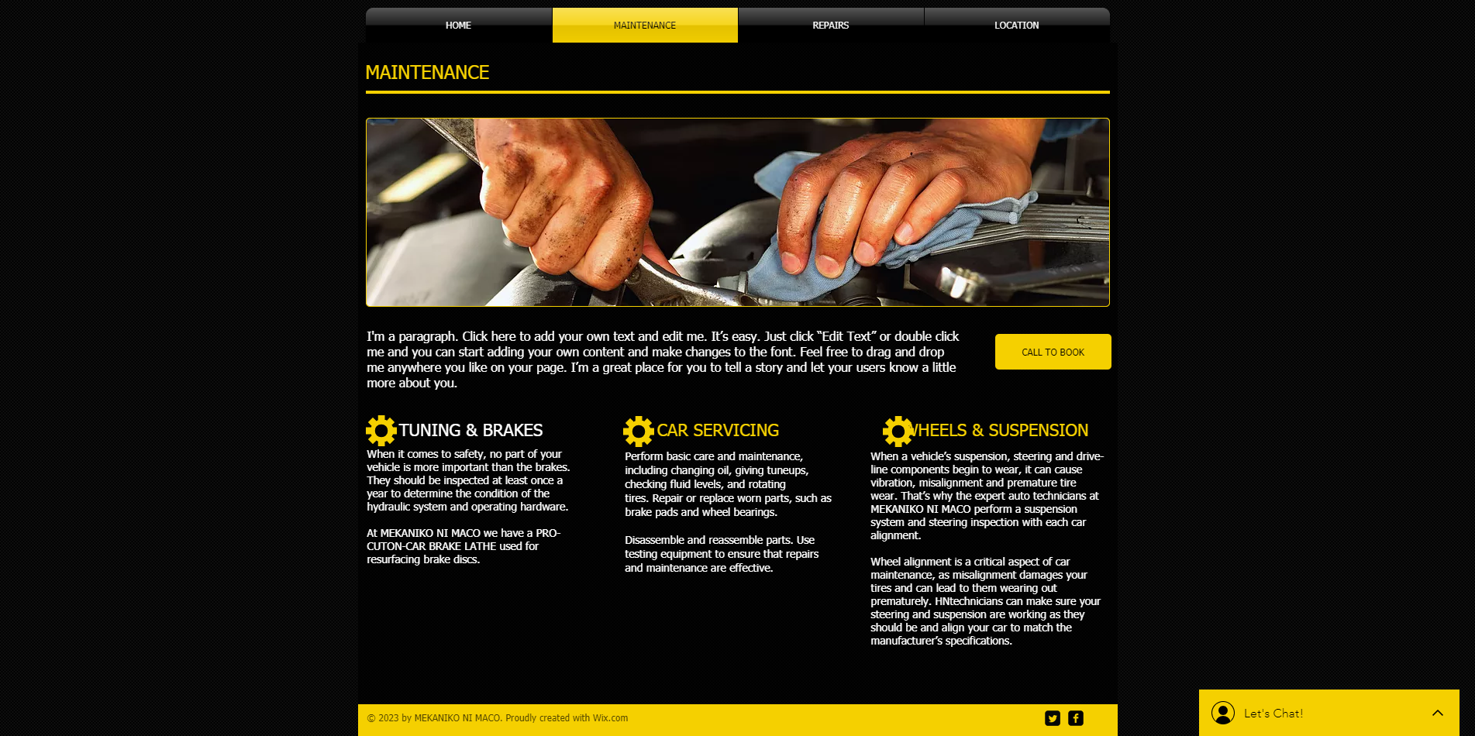

This part is where you can see the basic information about the services offered in the website.

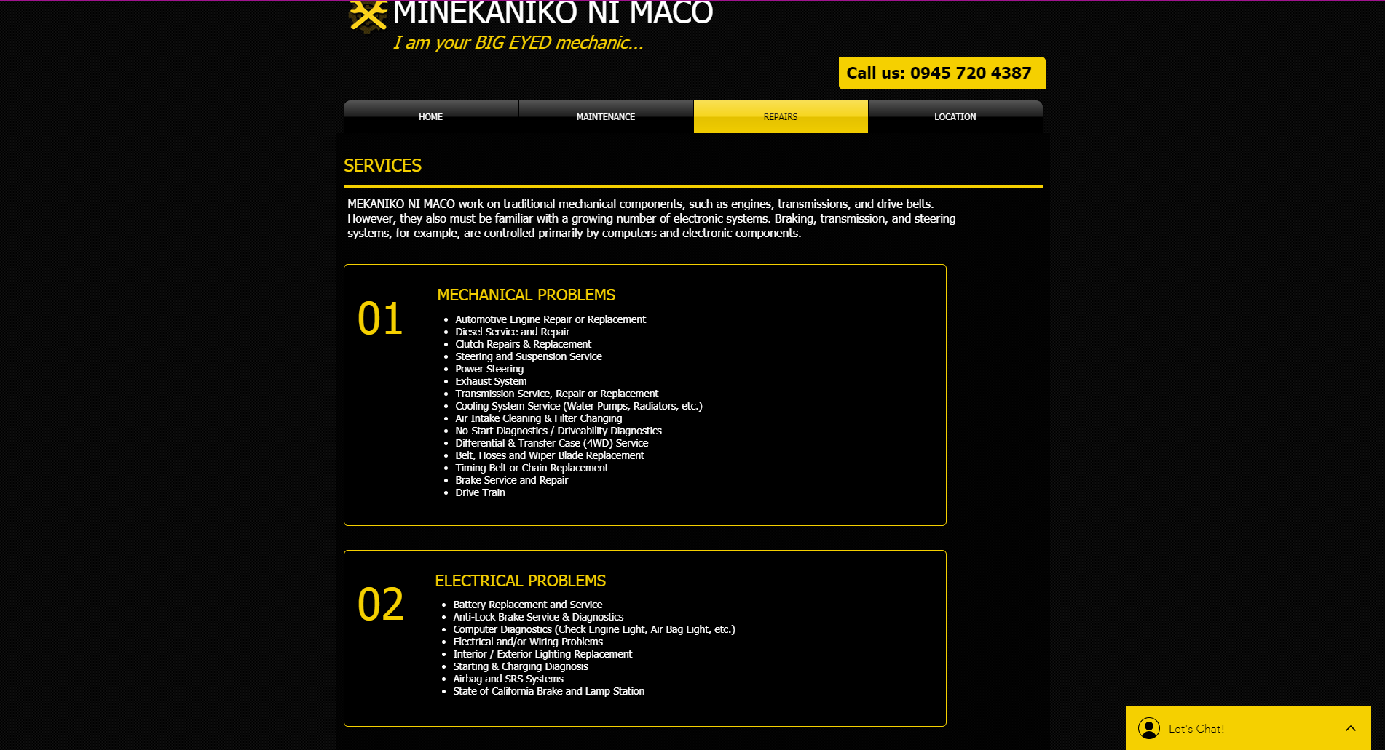

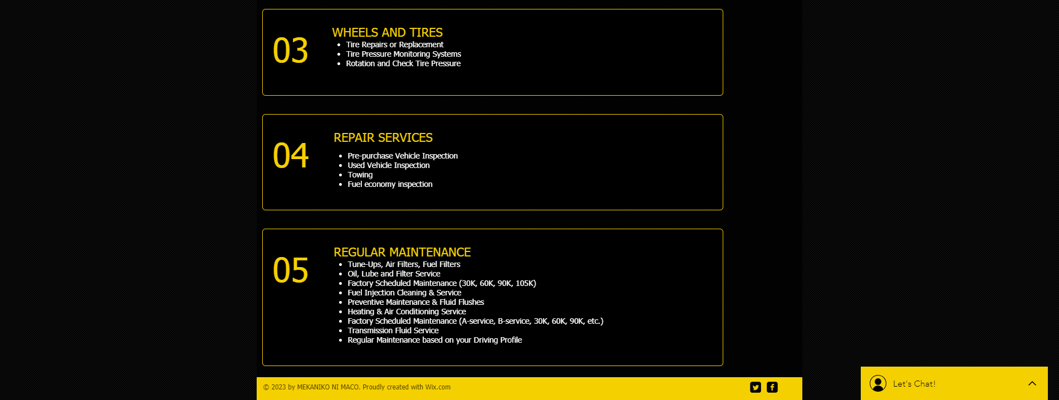

In this part gives you all the information about the services offered. Also in this you can find the appropriate service you need to fix your car.

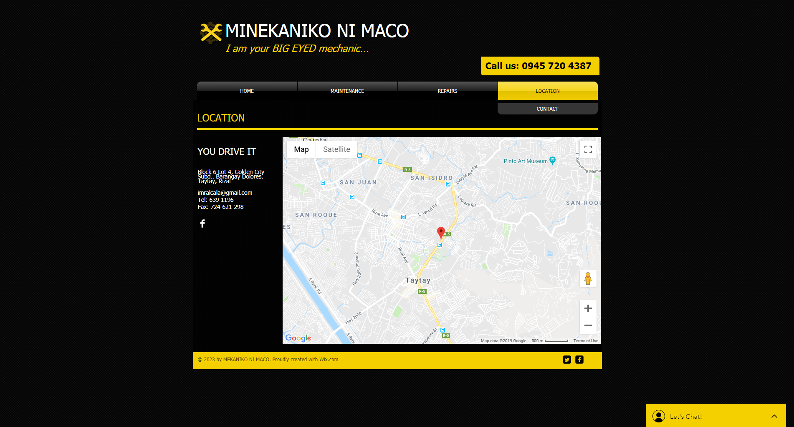

This part gives you the idea where the website is located and how can you contact it.

To sum it up. I created this website for drivers who have difficulties fixing or maintaining their car. By having this platform, they can easily maintain or even got their car fixed.