Azure Hub-Spoke Network Architecture with Security, Grafana Dashboards, Monitoring & Smart Alerts Implementation

Architecture Diagram:
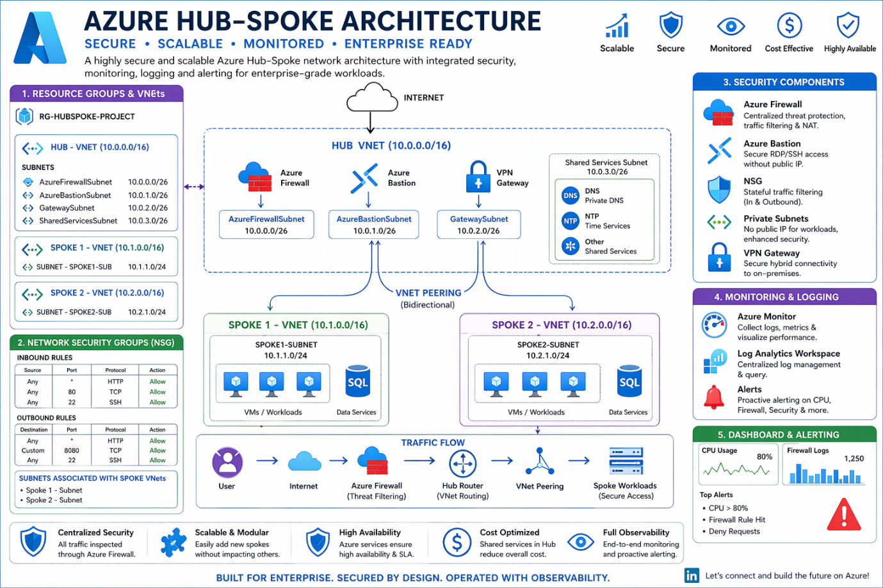

Work Flow Diagram:
Implementation Steps
Step 1: Create Resource Groups
- RG-Hubspoke-Project – Central India

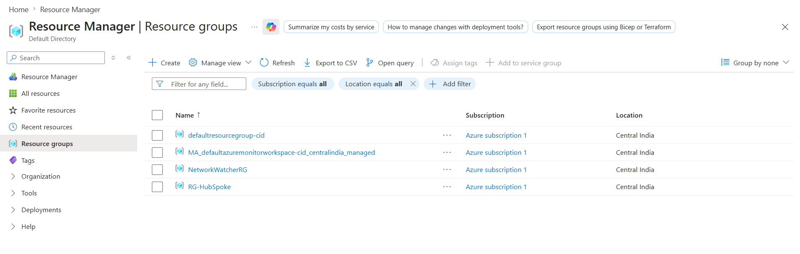
Step 2: Create VNets
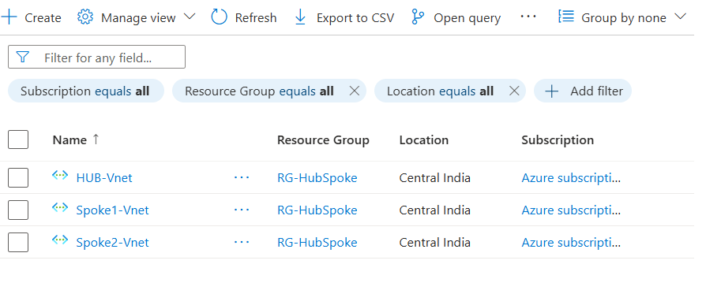
Hub-VNet
- Region: Central India
- Address Space: 10.0.0.0/16
Subnets:
- AzureFirewallSubnet → 10.0.0.0/26
Range: 10.0.0.0 – 10.0.0.63
- AzureBastionSubnet → 10.0.1.0/24
Range: 10.0.1.0 – 10.0.1.255

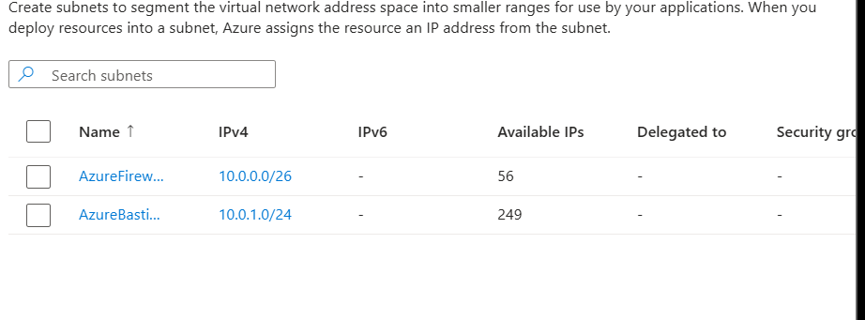
Spoke1-VNet
- Region: Central India
- Address Space: 10.1.0.0/16
Subnet:
- spoke1-sub → 10.1.1.0/24
Spoke2-VNet
- Region: Central India
- Address Space: 10.2.0.0/16
Subnet:
- spoke2-sub → 10.2.1.0/24

Step 3: Peerings
Hub ↔ Spoke1
- Allow VNet access
- Allow forwarded traffic
Hub ↔ Spoke2
- Allow VNet access
- Allow forwarded traffic
Spoke1 ↔ Spoke2
- Allow VNet access
- Allow forwarded traffic

Step 4: Create Spoke VMs
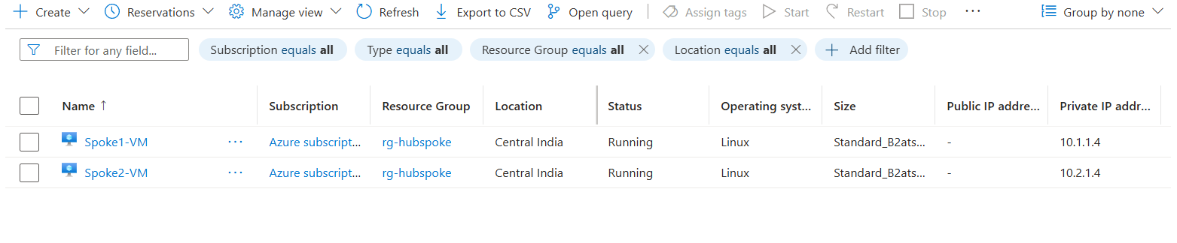
Spoke1-VM
- Region: Central India
- Ubuntu Image
- Connect V-Net to networking
Public IP:
- Enable temporarily for installing software
- Then remove Public IP

Spoke2-VM
- Region: Central India
- Ubuntu Image
- Connect V-Net to networking
Public IP:
- Enable temporarily for installing software
- Then remove Public IP

Step 5: Add Security
5.1 Deploy Azure Firewall
- Click Firewall → Create
Basic Tab
- RG: RG-HubSpoke-Project
- Name: FW-Hub
- Region: Same
- Firewall SKU: Standard
- Virtual Network: Select Use Existing
- Public IP: Create New
- Name: FW-publicIP
Click OK → Review + Create

Go to Firewall Rules
- Click Add Rule Collections
- Select Network Rules
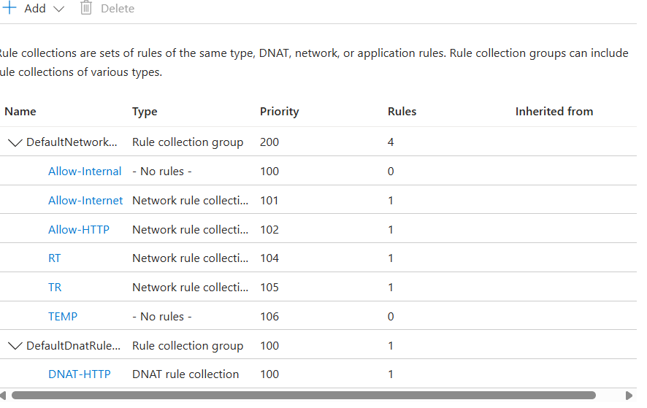
Internal Rule
- Name: Allow-Internal
- Type: Network
- Priority: 104
- Action: Allow
- Group: Default Network Rule Collection Group
Name | Type | Source | Protocol | Port | Destination Type | Destination
Allow-Internet | IP | 10.1.1.4 | TCP | 80,443 | IP | *

HTTP Rule
- Name: Allow-HTTP
- Type: Network
- Priority: 102
- Action: Allow
- Group: Default Network Rule Collection Group
Name | Type | Source | Protocol | Port | Destination Type | Destination
Allow-HTTP | IP | * | TCP | 80 | IP | *

Proxy Server
Rule Details
- Name: RT
- Type: Network
- Priority: 104
- Action: Allow
- Group: Default Network Rule Collection Group
Name | Type | Source | Protocol | Ports | Destination Type | Destination
RT | IP | 10.1.0.0/16 | TCP | 8080 | IP | 10.2.0.0/16

Reverse Rule
Name | Type | Source | Protocol | Ports | Destination Type | Destination
TR | IP | 10.2.0.0/16 | Any | * | IP | 10.1.0.0/16

DNAT Rule
- Name: DNAT-HTTP
- Type: DNAT
- Priority: 100
- Action: Allow
- Group: Default DNAT Rule Collection Group
Name | Type | Source | Protocol | Ports | Destination Firewall IP
DNAT-HTTP | IP | * | TCP | 80 | 74.225.233.159
Translation
Translated Type | Address | Port
IP | 10.1.1.4 | 80
Step 5.2: Network Security Group
Create Spoke1 NSG (or already created)
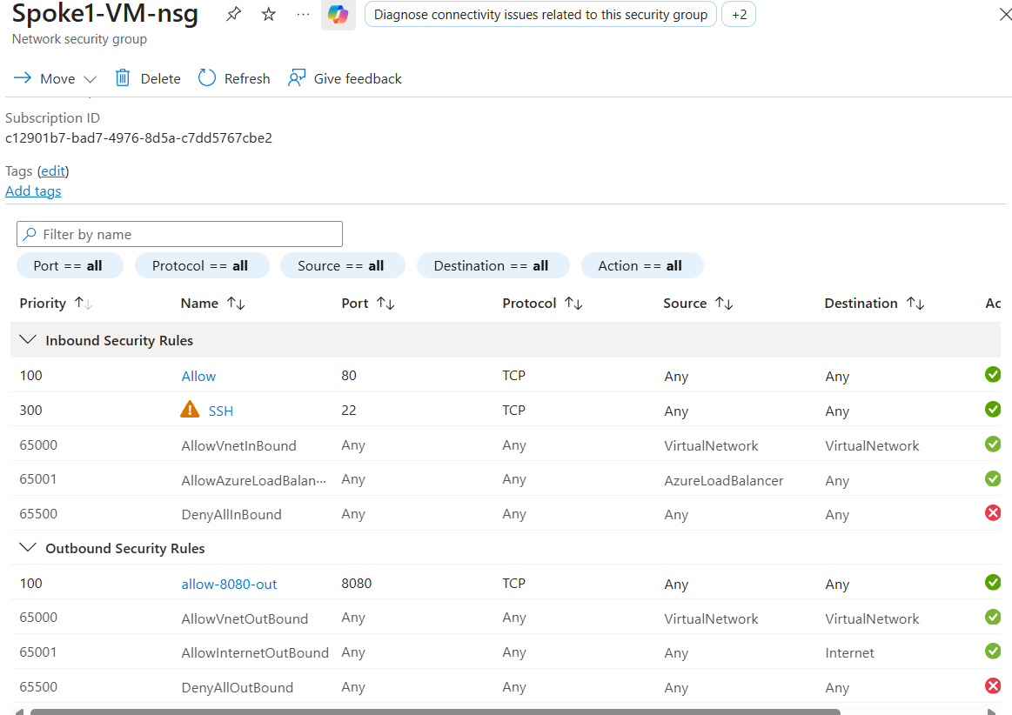
Add Inbound Rules
Source | Port | Destination | Service | Range | Protocol | Action
Any | * | Any | HTTP | 80 | TCP | Allow
Any | * | Any | SSH | 22 | TCP | Allow

Add Outbound Rule
Source | Port | Destination | Service | Port No | Protocol | Action
Any | * | Any | Custom | 8080 | TCP | Allow
Subnet (Important) : Associate with Spoke1-Subnet

Create Spoke2 NSG (or already created)
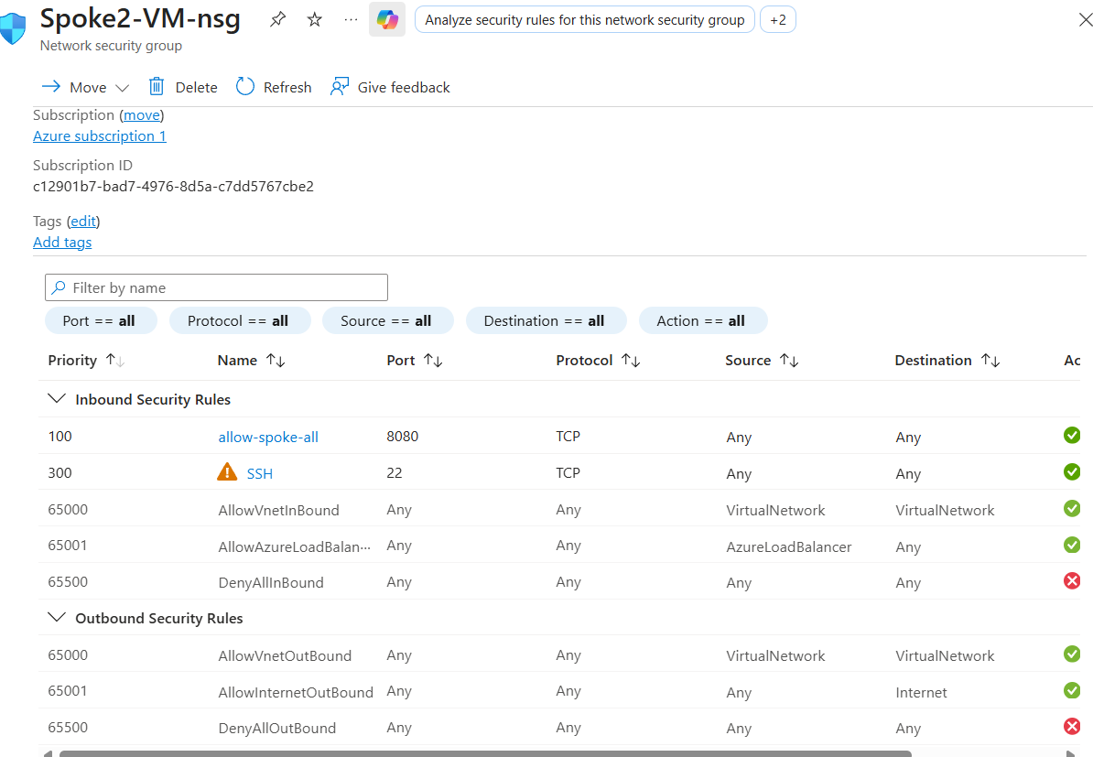
Add Inbound Rules
Source | Port | Destination | Service | Range | Protocol | Action
Any | * | Any | Custom | 8080 | TCP | Allow
Any | * | Any | SSH | 22 | TCP | Allow
Subnet (Important)
Associate with Spoke2-Subnet
Step 6: Create Bastion
Create
- Name: Bastion-Hub
- RG: RG-HubSpoke-Project
- Region: Central India
- Virtual Network: Hub-VNet
- Subnet: AzureBastionSubnet
- Public IP: Create New → Bastion-PIP
- SKU: Standard
Click Review + Create
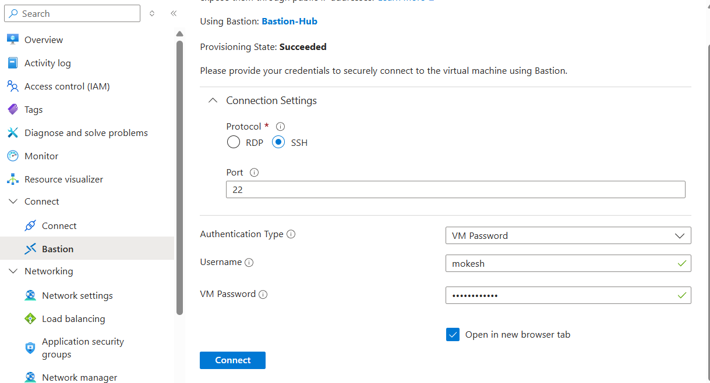

Step 7: Install Software in Both Spokes
Use MobaXterm login with Spoke1-VM

Install NGINX in Spoke1
sudo su
apt update
apt install nginx -y

Install Tomcat in Spoke2
ssh mokesh@10.2.1.4:8080
login
apt update
apt install default-jdk -y
apt install tomcat10

Test Connectivity
- Test connection on 22 and 8080 ports.
- When successfully connected:
- First remove IP configuration from Spoke1
- Then delete the Public IP
Important: Do not delete Public IP directly.
- Repeat the same process for Spoke2 also.
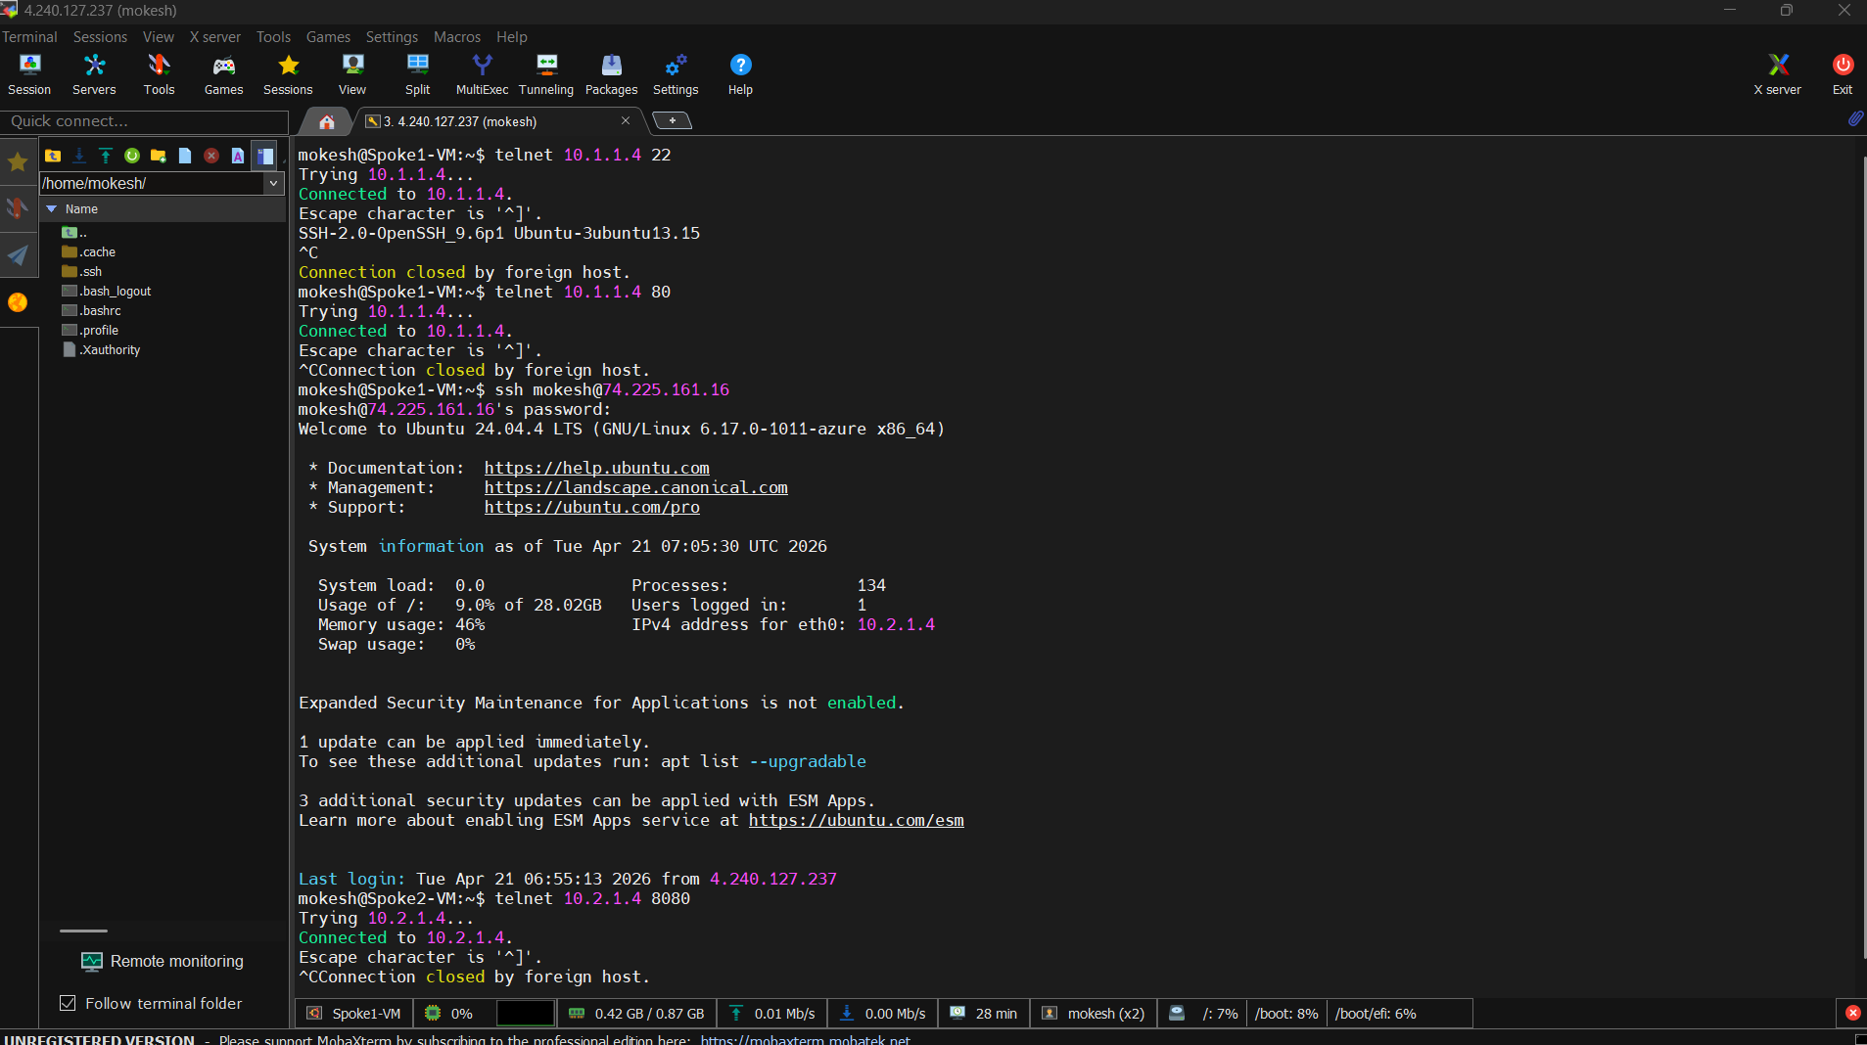

Step 8: Login Bastion → Spoke1-VM
Connect to VM
ssh username@spoke1-private-ip
Update System
sudo apt update -y
sudo apt upgrade -y
Network Connectivity Check
ip a
ping -c 4 8.8.8.8
Install Web Server
apt install nginx -y
Start & Enable NGINX
sudo systemctl start nginx
sudo systemctl enable nginx
sudo systemctl status nginx
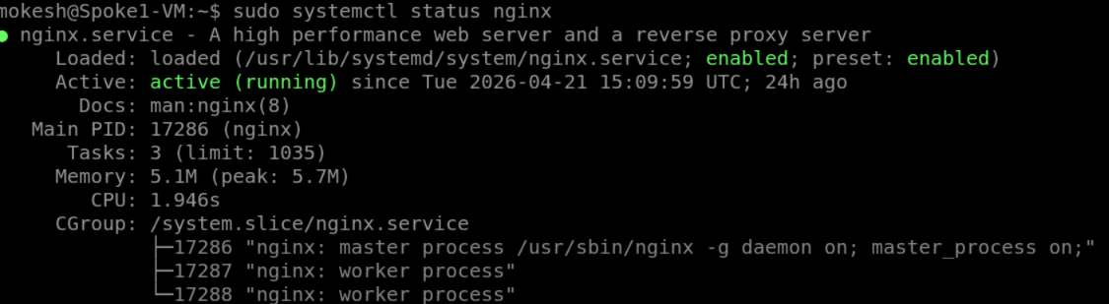
Check Service Locally
curl http://localhost
Output: HTML code
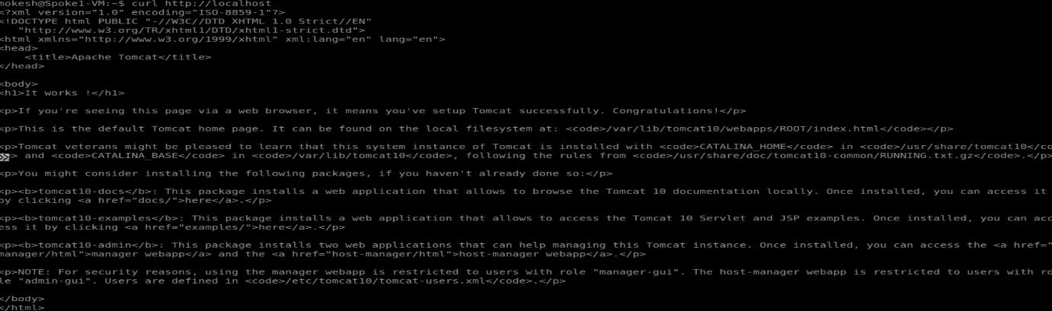

Check Port Listening
sudo ss -tulnp | grep 80
Output: Listen :80 user: nginx

Firewall Check
sudo ufw status
Output: Active
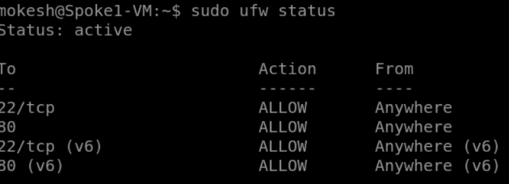

Final Command (Run in Spoke1)
curl http://10.2.1.4:8080
Output: HTML page with Tomcat information
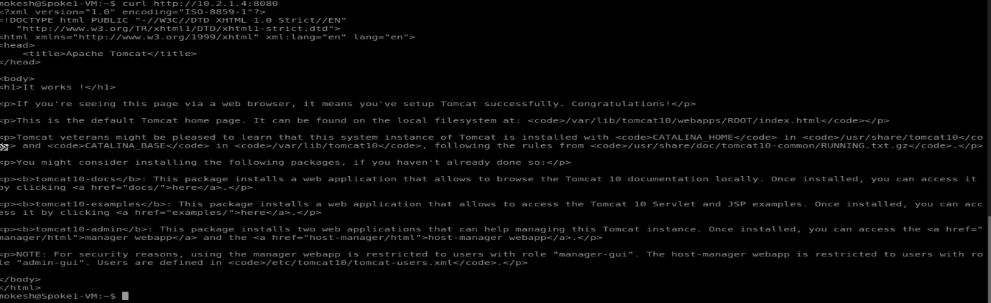

Login Into Bastion Through Spoke2-VM
Connect VM
ssh username@spoke2-private-ip
Update System
sudo apt update -y
sudo apt upgrade -y
Install Java
sudo apt install tomcat -y
tomcat -version
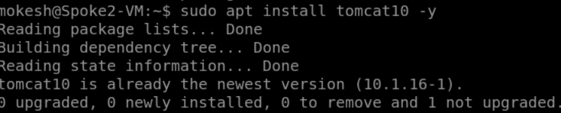
Check Running Application
ps -ef | grep java
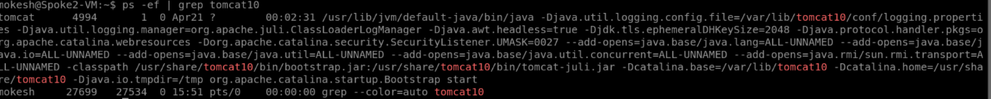
Check Application Port
sudo ss -tulnp | grep 8080
Output: Listen *:8080 user: java

Test Backend Locally
curl http://localhost:8080
Output: HTML file
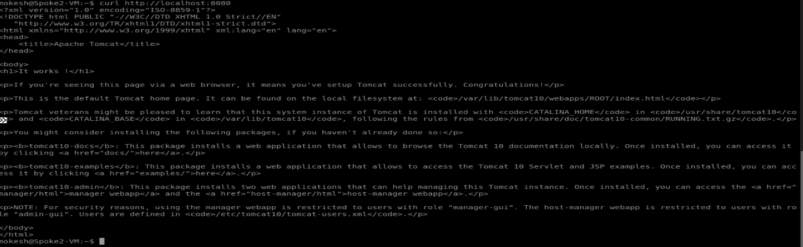

Final Output
Run this in Chrome or any browser:
http://74.225.233.159
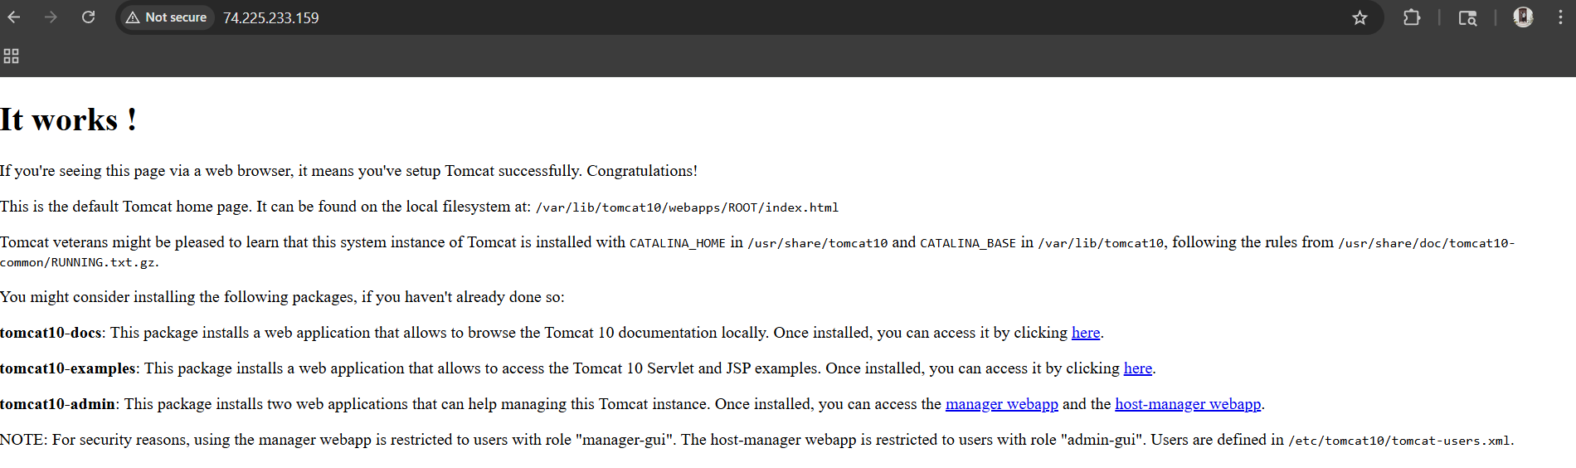

Step 9: Monitoring Using Azure Monitor + Log Analytics
Create Log Analytics Workspace
- Name: LAW-HubSpoke
- RG: RG-HubSpoke-Project
- Region: Central India
Click Review + Create
Step 9.1 Install / Enable Azure Monitor Agent on Linux VMs
Attached Azure Monitor Agent (AMA) to:
- Spoke1-VM (Linux)
- Spoke2-VM (Linux)
Used for:
✅ Performance metrics collection
✅ Syslog / system logs
✅ VM health monitoring
✅ Alert rule integration
✅ Log Analytics data ingestion
Azure Portal Path:
Virtual Machine → Monitoring → Insights / Monitoring → Enable
or
VM → Extensions + Applications
You may see:
- Azure Monitor Linux Agent
or
- Azure Monitor Agent(Windows)
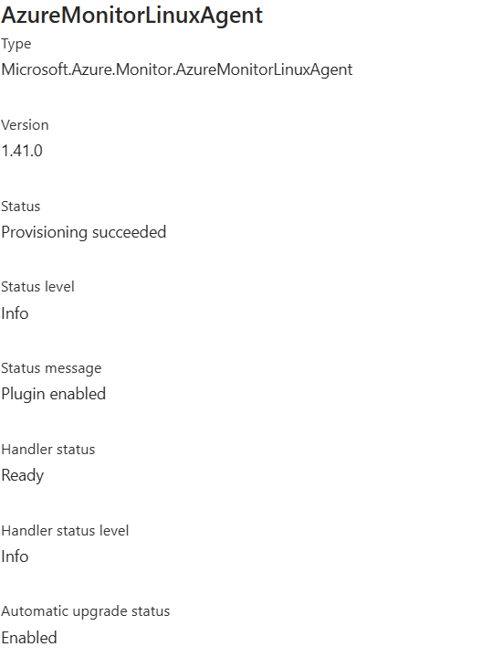

Step 9.2
Go to Spoke1-VM
- Open Monitor
- Enable Enhanced Monitoring
- Configure and Enable
Repeat the same steps in Spoke2-VM also.
Step 9.3: Connect Azure Firewall Logs
Open:
Firewall → FW-Hub → Monitoring → Diagnostic Settings

Add Diagnostic Setting
- Name: FW-Logs
Select Logs
- Application Rule Log ✓
- Network Rule Log ✓
- DNS Proxy Log ✓

Destination
- Send to Log Analytics Workspace ✓
Select:
- LAW-HubSpoke
Click Save

Step 9.4: Alert
Open:
VM → Monitor → Azure Monitor
Create Alert

Create Alert Scope
Select Resource:
- RG-HubSpoke-Project
- Location: Central India
Refine Scope
Type | Location
VM | Central India
Click Apply

Condition
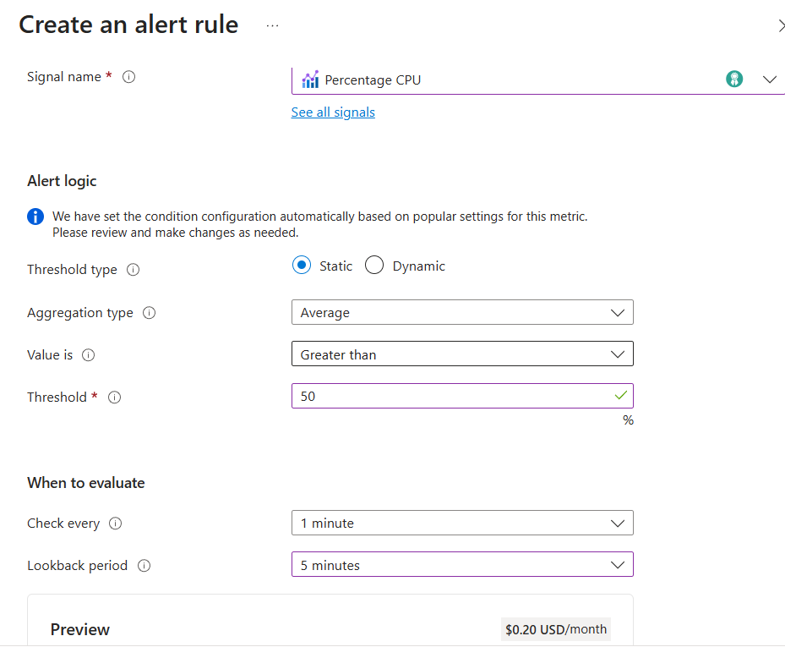
- Signal Name: Percentage CPU

Alert Logic
- Threshold: Static
- Aggregation: Average
- Operator: Greater Than
- Threshold Value: 50%

When to Evaluate
- Check every: 1 minute
- Lookback period: 5 minutes

Action
Select Action:
- Use quick actions

Details
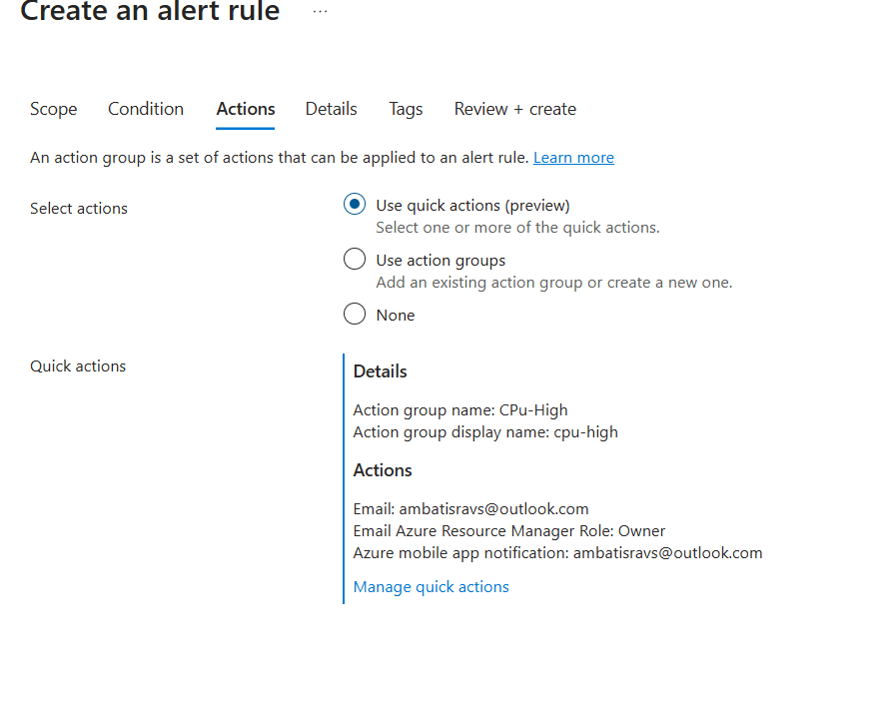
- Name: CPU
- Alert Name: CPU-High
- Email: ---
- Role: Owner
- Notification: ---
Click Save
Details
- Alert Rule Name: CPU-High
Click Review + Create
Azure Monitor Alert Rule
From docs:
- CPU alert when threshold exceeded
- Email notification configured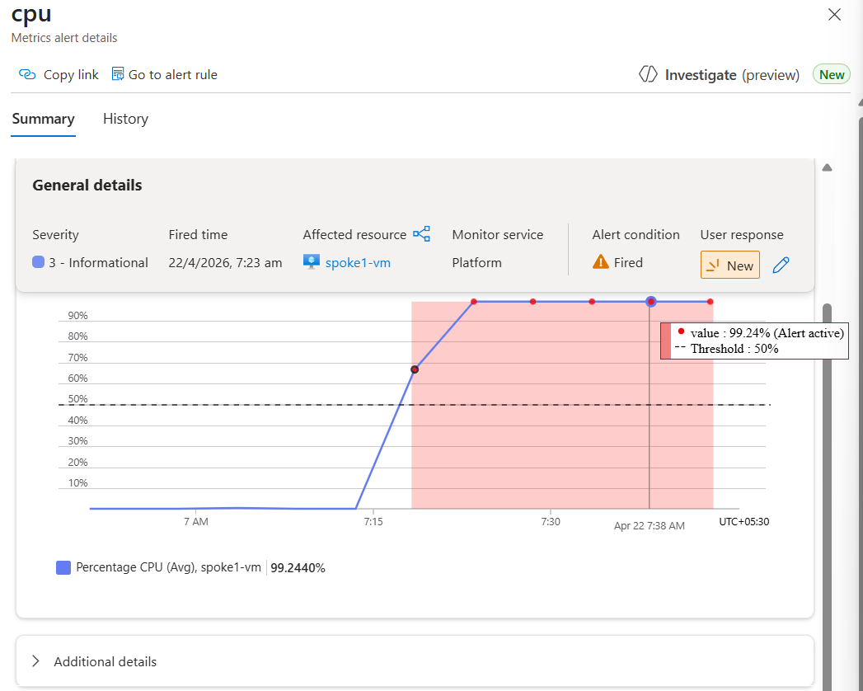

When Remove the CPU Workload
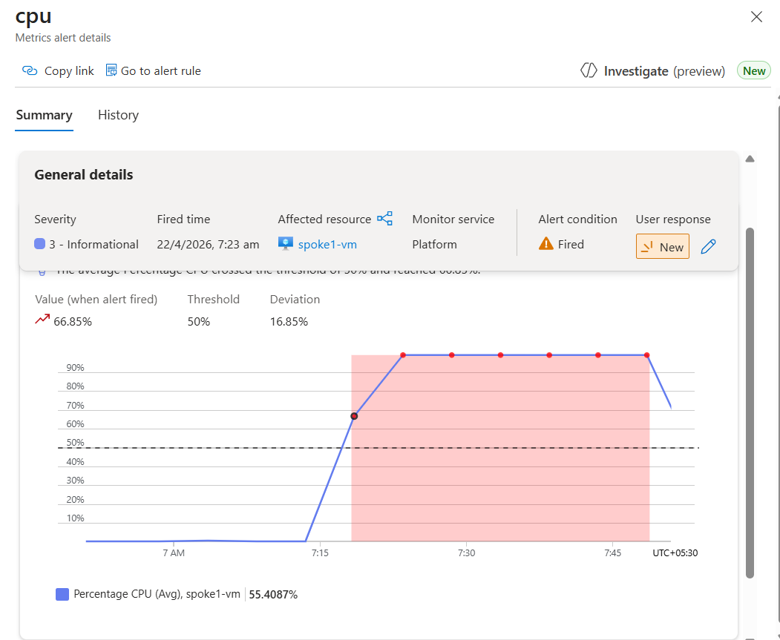
When CPU goes above 50%, you receive an email alert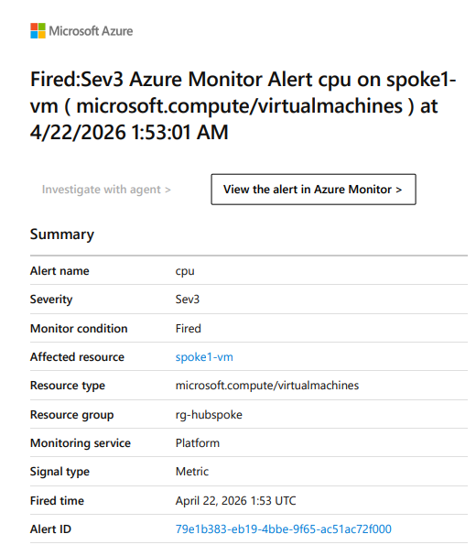

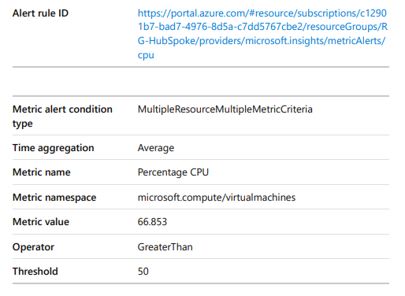

Another Alert for Firewall
Create scope same as first alert.

Refine Scope
Type | Region
Firewall | Central

Condition
- Signal: Custom Log Search
Click Add Query
AzureDiagnostics
| where Category == "AzureFirewallNetworkRule"
| where msg_s contains "Deny"
Continue editing alert.

Action
Use same details as CPU alert.

Details
- Rule Name: Firewall Alert
Click Review + Create
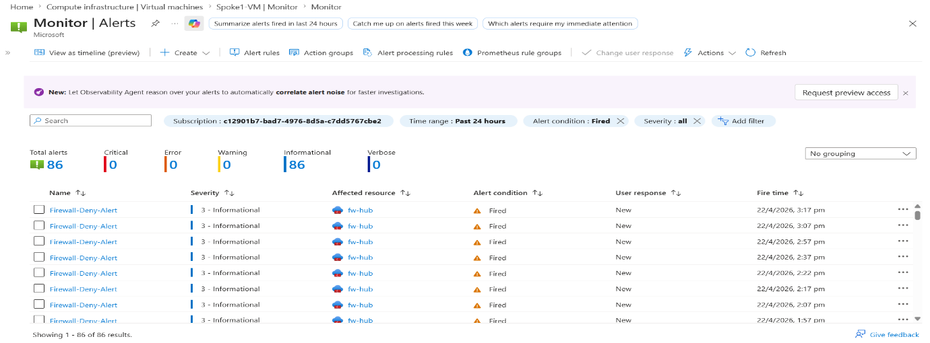
Same Firewall also gets email alert.
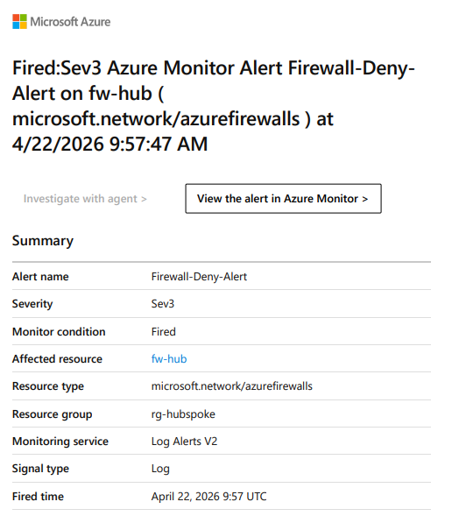
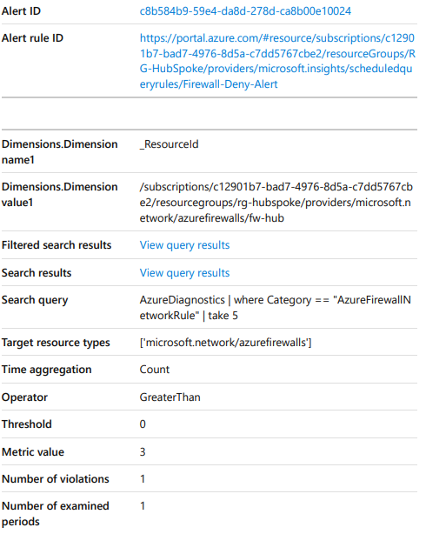

Step 9.5: Metrics
Open:
Metrics → New Chart

Select Scope
Browse
- Type: VM
- Region: Central India
Scope
- Select RG-HubSpoke-Project

Refine Scope
- Type: VM
- Region: Central India
Click Apply

Select Metric
Examples:
- Available Memory Bytes
- Memory Percentage
- CPU Credits Consumed
- CPU Credits Remaining

Chart Types Available
- Line Chart
- Bar Chart
- Scatter Chart
- Grid
Memory Percentage Metrics (Line Chart)
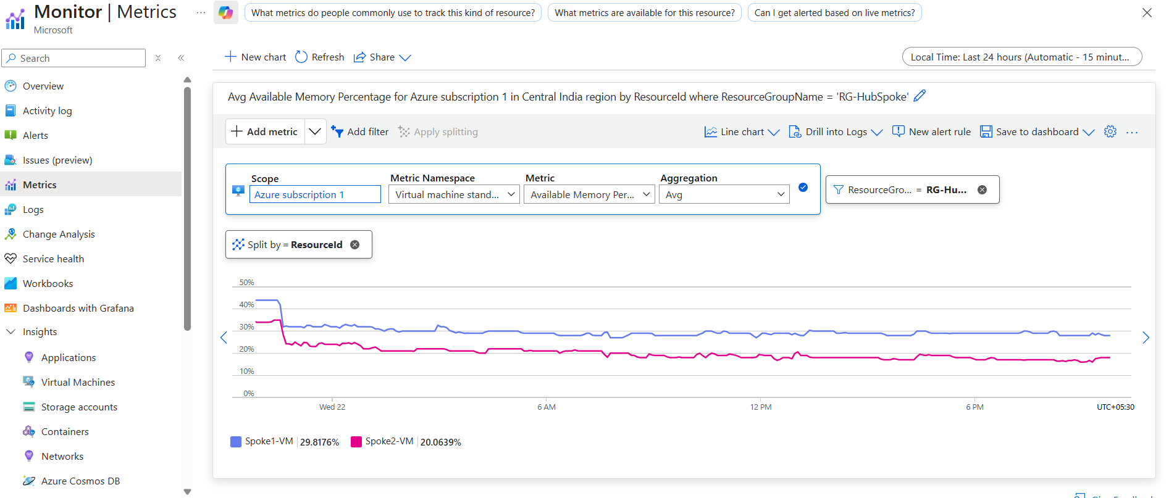
CPU Credits Consumed (Bar Chart )
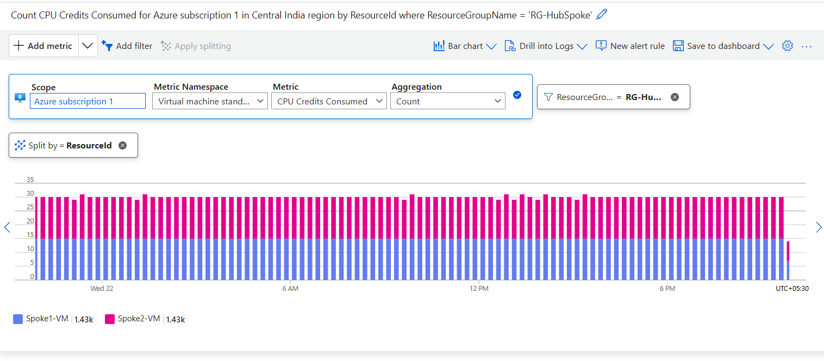

Step 9.6: Dashboard
Dashboard with Grafana
- Add Visualization

Data Source
- Resource: Spoke1-VM
- Metric Namespace: (not specified)
- Metric: Percentage CPU
- Aggregation: Average
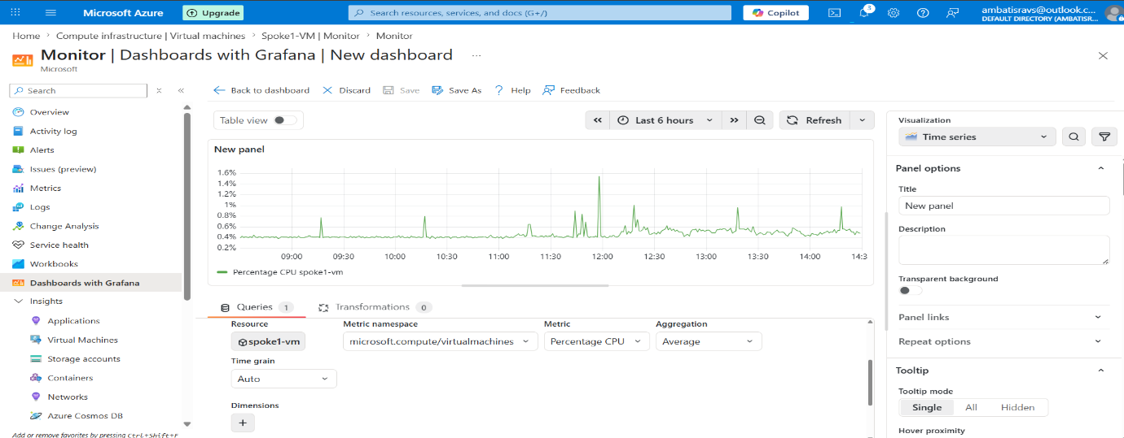

In Spoke1-VM (CPU Load Testing)
yes > /dev/null &
yes > /dev/null &
yes > /dev/null &
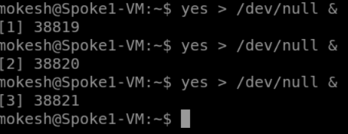
Use to create CPU spike/load for testing.
Stop CPU Load
killall bash Used to stop/delete spike load.
Logs Queries
1. Heartbeat
Heartbeat
| take 5
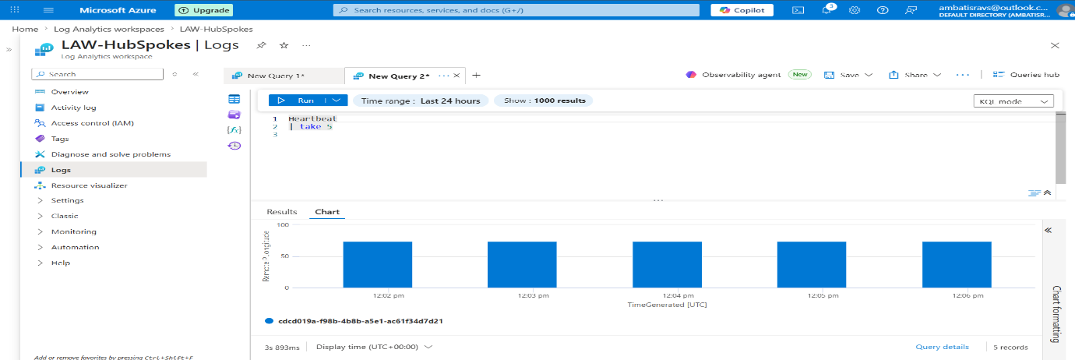
2. Azure Diagnostics
AzureDiagnostics
| limit 10
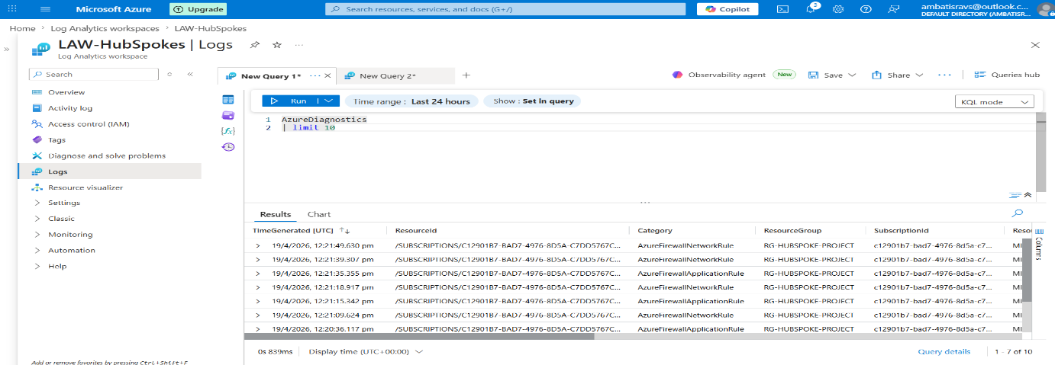

3. Show Firewall Logs
AzureDiagnostics
| where Category == "AzureFirewallNetworkRule"
| take 20
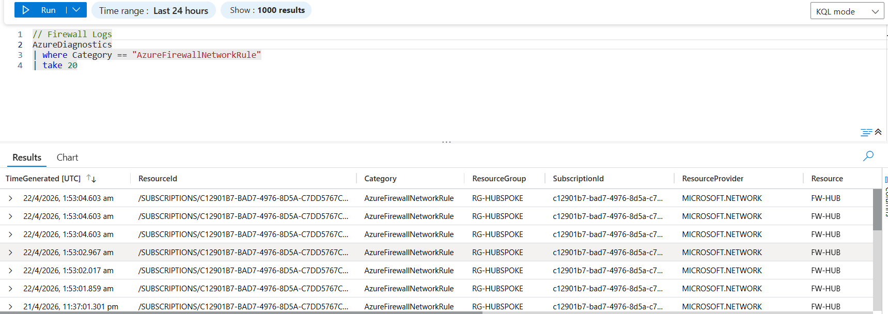

4. Count Deny Requests
AzureDiagnostics
| where Category == "AzureFirewallNetworkRule"
| where msg_s contains "Deny"
| summarize Count = count()
Output / Result
0
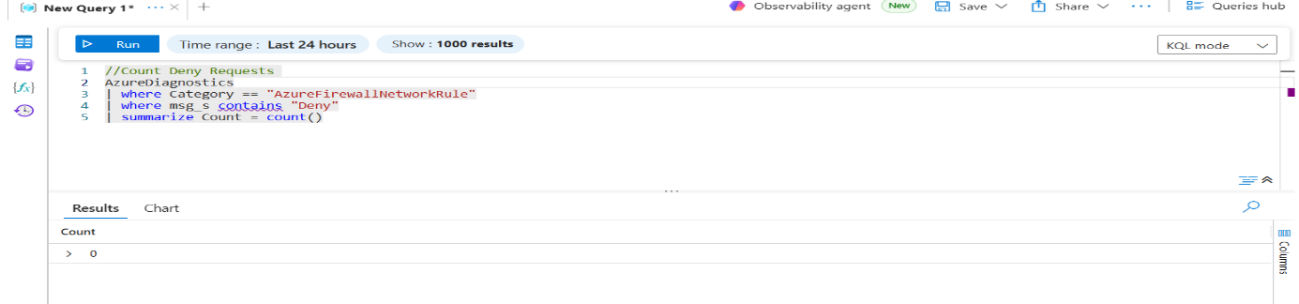

5. Recent Logs
AzureDiagnostics
| where TimeGenerated > ago(10m)
| where Category == "AzureFirewallNetworkRule"
| take 10

