# Springboard Data Science Career Track

# Capstone Project II Milestone Report

# Facial Expression Recognition.

Rahul Ambati

June 2018

1. Introduction.
2. Approach.
   1. Data Acquisition and Wrangling.
   2. Data Exploration.

3. Future Work.

# Introduction.

Human facial expressions are complex. We are well trained in reading different expressions, just a few years old baby can tell the difference between happy and sad. As we grow up we see more than happy or sad expressions, we see surprise, fear, anxiety and many more.

A question arises can a computer do the same, recognizing facial expressions of a person?

Intention:

If a person can understand facial expression through experience and training so can the computer. Intention is to create a computer model which can be useful in predicting or recognizing a person’s facial expression.

Client:

Any application who wants to know a person facial expression before and after an event or activity.

Example of potential clients be, **Retail** which can be used to evaluate customer interests or in **Healthcare** to see patients emotional state or in **Entertainment** to monitor audience’s expressions during an entertaining performance.

# Approach.

The problem states to recognize facial expression of a person, so to solve the problem a model is to be found or created to predict or classify a person’s facial expression.

# Data Acquisition and Wrangling.

The data has been acquired from Kaggle dataset [Facial Expression Recognition Challenge](https://www.kaggle.com/c/challenges-in-representation-learning-facial-expression-recognition-challenge).

The dataset consists of expression, image, test category. And the dataset is clean, no cleaning was necessary.

# Data Exploration.

There are 7 facial expressions/emotions classified in the dataset.

* + 1. *Angry*
    2. *Disgust*
    3. *Fear*
    4. *Happy*
    5. *Sad*
    6. *Surprise*
    7. *Neutral*

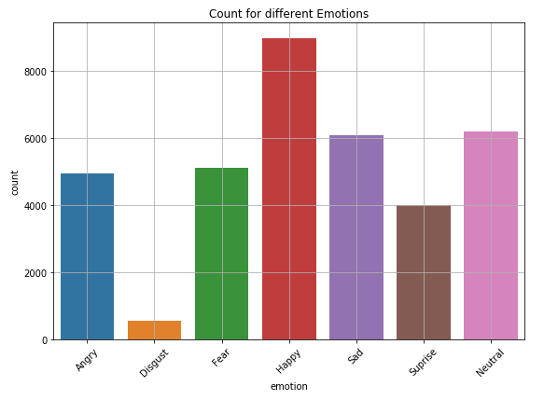

Figure 1. Number of samples for each emotion/expression.

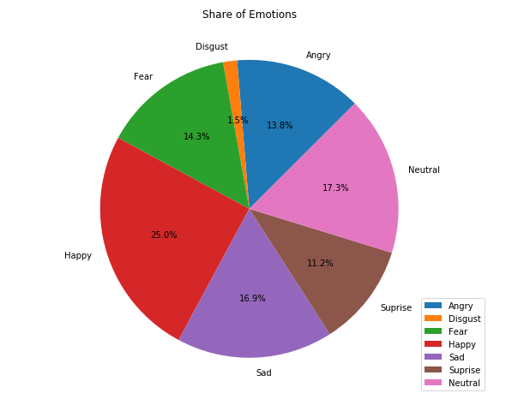

Figure 2. Share of each expression/emotion in the dataset.

From the above figures we see the *Disgust* has less number of examples.

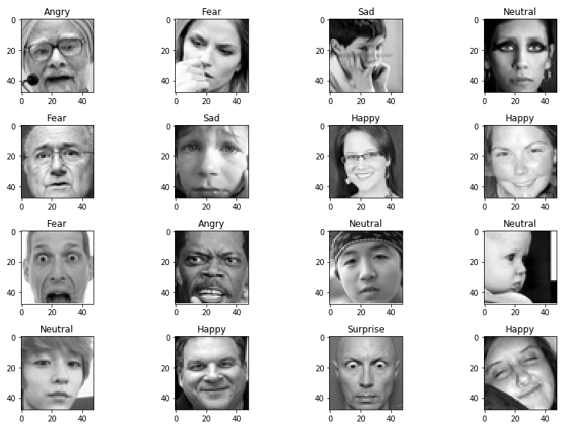

Figure 3. Sample images with expressions.

Image are 48x48 grayscale pixels.

# Future Work.

Different Models will be build using neural networks. Keras will be used to build the neural network architecture. Convolution Neural Networks are used for images.

Modeling and Analysis are the next step and will be providing with findings, ideas and recommendations.