### **Java Class Structure (Camera and IP Camera)**

### **1. Java Class Structure (Camera and IP Camera)**

* **Camera (Abstract Class)**: Define shared attributes and methods that all camera types will have. For example, methods like startRecording(), stopRecording(), and getStream().

public abstract class Camera {

protected String model;

protected String ipAddress;

// Constructor

public Camera(String model, String ipAddress) {

this.model = model;

this.ipAddress = ipAddress;

}

// Abstract method to get video stream

public abstract void getStream();

// Concrete method

public void startRecording() {

System.out.println("Recording started...");

}

public void stopRecording() {

System.out.println("Recording stopped...");

}

}

* **IP Camera (Concrete Class)**: This class extends Camera and implements any specific behavior or details related to IP cameras.

public class IPCamera extends Camera {

// Constructor

public IPCamera(String model, String ipAddress) {

super(model, ipAddress);

}

@Override

public void getStream() {

// Logic to connect to the IP camera and fetch the video stream

System.out.println("Streaming from IP Camera at: " + ipAddress);

}

// You can also add IP-camera specific methods here, like authentication, etc.

}

### 

### 

### 

### 

### 

### 

### 

### 

### 

### **2. Web Application (home.jsp and Dashboard)**

* You can create a DashboardServlet that interacts with the camera objects (like IPCamera) and pass the relevant data to your JSP pages for rendering.

Example Servlet code:

java

Αντιγραφή κώδικα

@WebServlet("/dashboard")

public class DashboardServlet extends HttpServlet {

protected void doGet(HttpServletRequest request, HttpServletResponse response) throws ServletException, IOException {

Camera camera = new IPCamera("Model XYZ", "192.168.1.1");

request.setAttribute("camera", camera);

RequestDispatcher dispatcher = request.getRequestDispatcher("/dashboard.jsp");

dispatcher.forward(request, response);

}

}

In dashboard.jsp, you can display the camera info or its streaming status:

<%@ page import="yourpackage.Camera" %>

<%@ page import="yourpackage.IPCamera" %>

<html>

<body>

<h2>Camera Dashboard</h2>

<p>Camera Model: ${camera.model}</p>

<p>IP Address: ${camera.ipAddress}</p>

<p>Status: Streaming from camera...</p>

</body>

</html>

### **3. Modularity and Extensibility**

* For **modularity**, ensure that each class is responsible for a specific task. The Camera class handles common logic, and the IPCamera class handles specific logic for IP cameras.
* You can add more camera types by creating new classes (like AnalogCamera or WirelessCamera) that extend Camera.

### **4. SQL Integration**

* If you want to store camera details in a database, you can create a CameraDAO class that handles database operations like saving or fetching camera data.

public class CameraDAO {

public Camera getCameraDetails(int cameraId) {

// SQL code to fetch camera details from the database

}

public void saveCamera(Camera camera) {

// SQL code to save camera details to the database

}

}

This approach will ensure that your system remains modular and easily extensible. Let me know if you'd like further details or examples!

It sounds like you're aiming for a hybrid version of home.jsp and dashboard.jsp, with encapsulation of the Camera class (and its extension IPCamera) that interacts with the user data via the existing UserDAO.

Here’s a suggested approach to integrating everything into a single flow:

### 

### 

### **1. Encapsulation in the Combined Model**

You can use the Camera and IPCamera classes as part of the business logic passed between the dashboard.jsp and home.jsp. The hybrid approach could involve defining a model or DTO (Data Transfer Object) that encapsulates both user and camera information.

#### **Camera Class (abstract)**

java

Αντιγραφή κώδικα

public abstract class Camera {

protected String model;

protected String ipAddress;

public Camera(String model, String ipAddress) {

this.model = model;

this.ipAddress = ipAddress;

}

public abstract void startStream();

public void stopStream() {

System.out.println("Stream stopped");

}

public String getModel() {

return model;

}

public String getIpAddress() {

return ipAddress;

}

}

#### **IP Camera Class (concrete)**

public class IPCamera extends Camera {

public IPCamera(String model, String ipAddress) {

super(model, ipAddress);

}

@Override

public void startStream() {

System.out.println("Streaming from IP Camera at: " + ipAddress);

}

}

### **2. User and Camera Model Integration**

You can create a class that integrates both user and camera information, for example, DashboardModel.

public class DashboardModel {

private User user;

private Camera camera;

public DashboardModel(User user, Camera camera) {

this.user = user;

this.camera = camera;

}

public User getUser() {

return user;

}

public Camera getCamera() {

return camera;

}

}

This model can be populated by the DashboardServlet and passed to both home.jsp and dashboard.jsp.

### **3. Dashboard Servlet (Controller)**

In your DashboardServlet, you can retrieve user data using UserDAO and create a DashboardModel that includes both the user and the camera details.

java

Αντιγραφή κώδικα

@WebServlet("/dashboard")

public class DashboardServlet extends HttpServlet {

protected void doGet(HttpServletRequest request, HttpServletResponse response) throws ServletException, IOException {

// Retrieve user from UserDAO (existing code)

UserDAO userDao = new UserDAO();

User user = userDao.getUserById(1); // Assume user ID = 1 for simplicity

// Create Camera object (for example, IPCamera)

Camera camera = new IPCamera("Model XYZ", "192.168.1.1");

// Encapsulate user and camera in DashboardModel

DashboardModel dashboardModel = new DashboardModel(user, camera);

// Pass the model to JSP

request.setAttribute("dashboardModel", dashboardModel);

RequestDispatcher dispatcher = request.getRequestDispatcher("/home.jsp");

dispatcher.forward(request, response);

}

}

### **4. Home JSP (View)**

In home.jsp, you can access the DashboardModel and display both user and camera details.

jsp

Αντιγραφή κώδικα

<%@ page import="yourpackage.User" %>

<%@ page import="yourpackage.Camera" %>

<%@ page import="yourpackage.DashboardModel" %>

<html>

<body>

<h2>Welcome, ${dashboardModel.user.name}</h2>

<h3>Camera Model: ${dashboardModel.camera.model}</h3>

<p>IP Address: ${dashboardModel.camera.ipAddress}</p>

<p>Status: Streaming...</p>

</body>

</html>

### **5. Modular Integration**

* **Encapsulation**: The DashboardModel encapsulates both user and camera objects, ensuring that both pieces of data can be passed around efficiently.
* **Modular**: You maintain modularity by keeping Camera abstract, IPCamera concrete, and the business logic in a separate servlet or controller. The DashboardModel can evolve as you add more functionality, like additional camera types or user data.

### **6. UserDAO Integration**

Since you already have UserDAO, you can easily retrieve and pass user details along with the camera object to the JSP page, providing a dynamic and integrated view.

If you'd like, I can help further customize or refine this approach based on specific needs (e.g., adding more camera types, handling form submissions, etc.).

##### 

You're building a complex and robust system, and I can definitely help you structure the database and plan out how to implement features like time-limited footage storage and the integration of **MotionEyeOS** with your setup. Here's how I would approach it:

### **1. Database Structure for Your Use Case**

Given that you have users, cameras, footage, settings, and logs, we need to extend your current database design to support **MotionEyeOS integration**, **camera settings**, and **dynamic storage management** (like rotating storage). Let's break it down.

#### **Entities in the Database**

* **User Accounts (user_accounts)**: Stores the user credentials and roles (e.g., admin, regular user).
* **Camera Settings (camera_settings)**: Stores settings related to the cameras being used.
* **Recorded Footage (recorded_footage)**: Tracks the footage files, including their timestamps and duration.
* **Log Data (log_data)**: Stores logs related to user actions (e.g., camera settings updated).
* **Storage Management (storage_management)**: Manages rotating footage storage (e.g., storageFootageOne, storageFootageTwo).

Here's how we can extend your database to support these:

#### **Camera Settings Table**

This table links cameras to users. We can add fields to hold the camera's streaming URL, model, or other camera-specific details.

sql

Αντιγραφή κώδικα

CREATE TABLE `camera_settings` (

`camera_id` INT(11) NOT NULL AUTO_INCREMENT,

`user_id` INT(11) NOT NULL,

`streaming_url` VARCHAR(255) NOT NULL, -- For MotionEyeOS stream URL or similar

`camera_model` VARCHAR(50),

`camera_name` VARCHAR(255), -- User's custom camera name (from user_subtitles)

PRIMARY KEY (`camera_id`),

FOREIGN KEY (`user_id`) REFERENCES `user_accounts`(`user_id`) ON DELETE CASCADE

);

#### **Storage Management Table**

For the rotating storage system (storageFootageOne, storageFootageTwo), we create a new table to track which storage is active, and when the footage should be swapped:

sql

Αντιγραφή κώδικα

CREATE TABLE `storage_management` (

`storage_id` INT(11) NOT NULL AUTO_INCREMENT,

`storage_name` VARCHAR(50) NOT NULL, -- e.g., "storageFootageOne", "storageFootageTwo"

`is_active` TINYINT(1) NOT NULL, -- 1 if active, 0 if inactive

`start_time` TIMESTAMP NOT NULL DEFAULT CURRENT_TIMESTAMP,

`end_time` TIMESTAMP, -- When the storage should be swapped out (1 week after start)

PRIMARY KEY (`storage_id`)

);

#### **Recorded Footage Table**

You can continue using the recorded_footage table, but now we'll include the storage_id so that we can associate recorded footage with the correct storage.

sql

Αντιγραφή κώδικα

CREATE TABLE `recorded_footage` (

`footage_id` INT(11) NOT NULL AUTO_INCREMENT,

`timestamp` TIMESTAMP NOT NULL DEFAULT CURRENT_TIMESTAMP,

`camera_id` INT(11) NOT NULL,

`file_path` VARCHAR(255) NOT NULL,

`duration` DOUBLE DEFAULT NULL,

`storage_id` INT(11) NOT NULL, -- Reference to storage management

PRIMARY KEY (`footage_id`),

FOREIGN KEY (`camera_id`) REFERENCES `camera_settings`(`camera_id`),

FOREIGN KEY (`storage_id`) REFERENCES `storage_management`(`storage_id`)

);

#### **Log Data for Camera Changes**

This is the same as what you already have. This log table tracks all changes related to camera settings or footage.

sql

Αντιγραφή κώδικα

CREATE TABLE `log_data` (

`log_id` INT(11) NOT NULL AUTO_INCREMENT,

`timestamp` TIMESTAMP NOT NULL DEFAULT CURRENT_TIMESTAMP,

`user_id` INT(11) NOT NULL,

`event_type` VARCHAR(50) NOT NULL,

`details` TEXT DEFAULT NULL,

PRIMARY KEY (`log_id`),

FOREIGN KEY (`user_id`) REFERENCES `user_accounts`(`user_id`)

);

### **2. Time-Limited Footage and Storage Swap Logic**

You can implement this in two ways:

1. **Using triggers** to handle storage rotation.
2. **Using an external scheduler or cron job** to manage the footage rotation.

#### **Rotating Storage Logic with Triggers**

To rotate storage every week, you could create a **BEFORE INSERT** trigger that checks whether the footage should be inserted into the active storage. If it's past the defined time limit (one week), it should rotate.

sql

Αντιγραφή κώδικα

DELIMITER $$

CREATE TRIGGER `rotate_storage_footage` BEFORE INSERT ON `recorded_footage`

FOR EACH ROW BEGIN

-- Check if current storage is past its time limit and needs to be swapped

DECLARE new_storage_id INT;

DECLARE active_storage INT;

-- Get the active storage (i.e., where footage is being recorded)

SELECT `storage_id` INTO active_storage

FROM `storage_management`

WHERE `is_active` = 1

LIMIT 1;

-- If the active storage is older than a week, swap to the next storage

SELECT `storage_id` INTO new_storage_id

FROM `storage_management`

WHERE `is_active` = 0

LIMIT 1;

-- Swap the storage

UPDATE `storage_management` SET `is_active` = 1 WHERE `storage_id` = new_storage_id;

UPDATE `storage_management` SET `is_active` = 0 WHERE `storage_id` = active_storage;

-- Assign the new storage ID to the footage

SET NEW.storage_id = new_storage_id;

END

$$

DELIMITER ;

#### **External Scheduler (Cron Job)**

Alternatively, you could write a script to run every day (or week) using cron jobs or a scheduled task. This script would check the storage_management table to see which storage has been active for over a week and swap the storage accordingly.

### **3. MotionEyeOS Integration**

**MotionEyeOS** can be integrated into your system by configuring it to stream to a URL that your cameras will access. In the database, you can store the streaming URL in the camera_settings table, which can be updated dynamically via your web interface.

* **Camera Streaming URL**: You can store the IP camera’s RTSP/MJPEG URL (e.g., http://192.168.1.100:8081) for each camera in the camera_settings table.
* You can create a **MotionEyeOS web app** to allow users to configure their camera streams directly from the user interface.

### **4. Overall Workflow**

* **User Login**: User logs in via user_accounts.
* **Camera Setup**: The user configures their camera in camera_settings, including setting a custom name from user_subtitles.
* **Streaming**: MotionEyeOS streams the video to the configured URL, which is recorded in the recorded_footage table.
* **Storage Rotation**: Every week, a trigger or scheduled task swaps the active storage, moving footage from one storage set to the next.
* **Log Events**: Every time a user interacts with the system (e.g., changes settings, uploads footage), log data is stored in the log_data table.

### **5. Suggestions and Forward Thinking**

* **Data Redundancy**: Consider adding redundancy or backup mechanisms for storing footage, especially if you plan to scale. Cloud storage or offsite backups can be integrated as secondary storage.
* **User Permissions**: You could extend the user_accounts table to support finer-grained permissions, allowing users to manage their own footage but not interfere with other users' footage.
* **Security**: Make sure to encrypt sensitive data such as hashed_password and any potential camera credentials.

This approach will give you a modular, scalable solution that can evolve as you add new features like multi-camera setups, enhanced footage management, or cloud-based storage. Let me know if you'd like to explore specific parts of this design in more detail!

To design a robust database for your CCTV system incorporating all the features and considerations you mentioned, including user accounts, camera settings, storage management, and a week-based footage rotation system, we need to organize the schema carefully. Here's a detailed approach that outlines the database structure, tables, foreign keys, triggers, and other features based on your requirements:

### **Database Structure Overview**

1. **User Management**:
   * **user_accounts**: For login and registration.
   * **user_subtitles**: To store custom camera names (subtitles).
2. **CCTV Management**:
   * **camera_settings**: Stores settings for each camera, including which user owns it.
   * **recorded_footage**: Stores metadata for each recorded footage (with timestamps).
   * **storage_management**: Manages different storage units for video footage (storageFootageOne, storageFootageTwo).
   * **log_data**: Logs events like camera settings changes, footage creation, user actions.
3. **Camera Interaction**:

Your current database schema for **CCTV_DB_Management** looks well-organized and comprehensive, but there are some areas where improvement, optimization, and attention to best practices could help enhance the design. Here's a detailed analysis, comparison with your previous model, and suggestions for improvements:

### **1. User Accounts Table (**user_accounts**)**

**Password Complexity Check:**

* + The hashed_password complexity check using REGEXP for special characters is a good security measure, but it might not fully address password strength (e.g., ensuring upper/lowercase, numbers, and symbols).
  + **Recommendation:** Consider using a more robust password hashing function (e.g., bcrypt, Argon2) at the application layer. Also, ensure that password hashes are being salted and not directly stored as plain hashes.

**Admin Role:**

* + The admin_role column is a boolean flag, which is fine, but it could be extended for better flexibility if your application scales.
  + **Recommendation:** A role_id that links to a separate roles table (for more granular role management) could be more scalable. The roles table would define the different roles (e.g., admin, moderator, user), and the user_accounts table would reference this role_id.

### **2. Camera Settings Table (**camera_settings**)**

* **Foreign Key to User Accounts:**
  + The camera_settings table has a foreign key to user_accounts, which makes sense for associating users with specific cameras.
  + **Recommendation:** If multiple users can manage the same camera, consider creating a junction table (e.g., camera_user_associations) that would allow many-to-many relationships between users and cameras.

### **3. Recorded Footage Table (**recorded_footage**)**

**Data Retention Policy:**

* + You're implementing a trigger to delete footage older than one year. This is a great way to manage storage and ensure compliance with data retention policies.
  + **Recommendation:** Consider storing a retention_period or expiration_date for each footage record so that you can manage data more dynamically. Having a field like archived BOOLEAN or deleted_at TIMESTAMP would allow for logical deletion (soft delete).

**Indexes:**

* + You’ve added indexes on camera_id and timestamp, which is excellent for query performance, especially if you’re frequently querying footage based on these columns.
  + **Recommendation:** Depending on your query patterns, you might want to consider additional indexing on user_id or composite indexes (e.g., camera_id, timestamp) if you often query footage by both.

### **4. Log Data Table (**log_data**)**

**Logging User Account Modifications:**

* + You're logging user account modifications using a trigger, which is a good auditing approach.
  + **Recommendation:** You might want to extend the trigger to capture updates or deletions on the user_accounts table as well, not just insertions. Consider creating separate event types for UPDATE and DELETE.

**Additional Audit Data:**

* + You might want to add more specific details for audit logs, such as IP address, user agent (browser/device info), or session ID for traceability.
  + **Recommendation:** Add optional fields like ip_address, user_agent, or session_id to log_data to enhance audit information.

### **5. Remote Assistance Logs Table (**remote_assistance_logs**)**

* **Foreign Key Relationships:**
  + You’ve added foreign key relationships for both user_id and admin_id, which is great for ensuring data integrity.
  + **Recommendation:** Ensure that the admin_id is indeed representing an admin user. You may also want to create a roles table for better tracking of user roles in both user_accounts and remote_assistance_logs.

### **6. Triggers:**

**Automatic Deletion of Outdated Footage:**

* + The trigger for deleting footage older than 1 year is a good idea, but it could be more flexible.
  + **Recommendation:** Consider adding a retention_period column to recorded_footage to specify when footage should be deleted (instead of a fixed one-year policy). This way, you can handle footage differently for different cameras or users.

**Trigger Logging for Camera Settings and User Accounts:**

* + Triggers are implemented for logging actions on user_accounts and camera_settings, which is a great way to ensure auditing.
  + **Recommendation:** Similar to the log_data table, consider adding a trigger for recorded_footage modifications (e.g., adding new footage, updates). For instance, you might want to log when footage is flagged for deletion or retention.

### **7. Database Optimizations and Best Practices:**

**Indexes:**

* + You're indexing camera_id and timestamp on recorded_footage, which is excellent for querying footage quickly.
  + **Recommendation:** As mentioned earlier, consider composite indexes on frequently queried columns. For example, camera_id and timestamp together, if often used together in queries.

**Normalization:**

* + The schema is relatively normalized, but in certain cases, like logging and remote assistance, it may be worth checking whether some columns (e.g., details in log tables) are too large for efficient storage.
  + **Recommendation:** You might want to split larger text-based fields (like details) into separate tables if they grow large or if you need to keep logs for a long period.

**Backup and Disaster Recovery:**

* + You may want to ensure that important tables (such as user_accounts, log_data, recorded_footage) have a backup strategy, especially in a production environment.
  + **Recommendation:** Set up regular database backups and ensure transactional integrity for critical operations.

### **8. Security Considerations:**

**Password Storage:**

* + You’re storing hashed passwords, which is a good practice, but ensure you’re using a secure hashing algorithm (bcrypt, Argon2) that can protect against brute-force attacks.
  + **Recommendation:** Ensure that the password is hashed at the application layer before storing in the database (don’t store plain text or weak hashes like MD5 or SHA1).

**Access Control:**

* + The permissions field in user_accounts is a string field. You might want to consider normalizing this into a separate table for more granular access control (e.g., different permission levels per user).
  + **Recommendation:** Implement a **permissions** table and a **user_permissions** join table to give more flexibility in managing access rights across the system.

### **9. Data Privacy & Compliance:**

* **Retention and Access Control:**
  + Depending on the jurisdiction and use case (e.g., GDPR or CCPA), you might need to ensure that personal data (e.g., footage, logs) is handled in compliance with data privacy laws.
  + **Recommendation:** You can add features for **data anonymization**, **data encryption**, and **explicit user consent** for footage storage, if applicable.

### **Summary of Recommendations:**

1. **Enhance Password Security** – Use bcrypt or Argon2 for hashing passwords and move the password complexity check to the application level.
2. **Role Management** – Move from a boolean admin_role to a more flexible roles table to handle multiple roles.
3. **Flexible Data Retention** – Introduce a dynamic retention period for footage rather than a fixed 1-year rule.
4. **Log More Data** – Capture more information in logs (e.g., IP addresses, user agents) for traceability and compliance.
5. **Improve Query Performance** – Add composite indexes and optimize queries for high-performance systems.
6. **Backup Strategy** – Set up a reliable backup and disaster recovery plan for critical data like footage and user logs.

EXISTING Database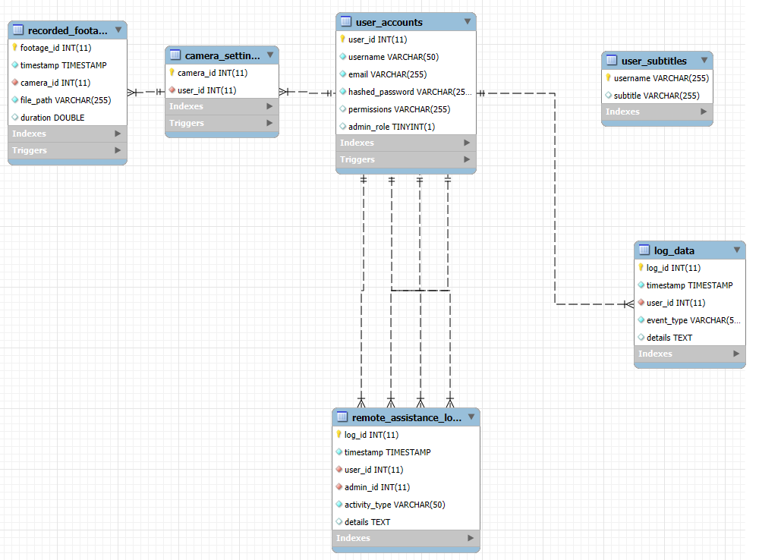

ExtendingDatabase