Lesson 04 Demo 01
Installing GitHub Copilot in Visual Studio Code

Objective: To install and configure GitHub Copilot in VS Code for AI-powered coding assistance

Tools required: Visual Studio Code (VS Code)

Prerequisites: GitHub account

Steps to be followed:
- Install the Python extension in VS Code
- Sign in to GitHub
- Enable GitHub Copilot
- Verify the functionality of Copilot

Step 1: Install the Python extension in VS Code
  - Launch the VS Code application on your system
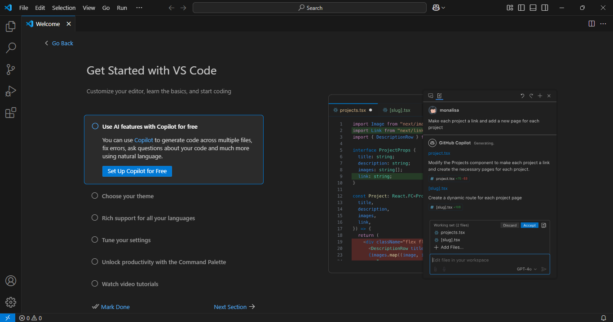

Note: If you do not have VS Code installed, download it from
https://code.visualstudio.com/

  - Click on the Extensions icon (or press Ctrl + Shift + X), type GitHub Copilot in the search bar, and select the GitHub Copilot extension as shown below:
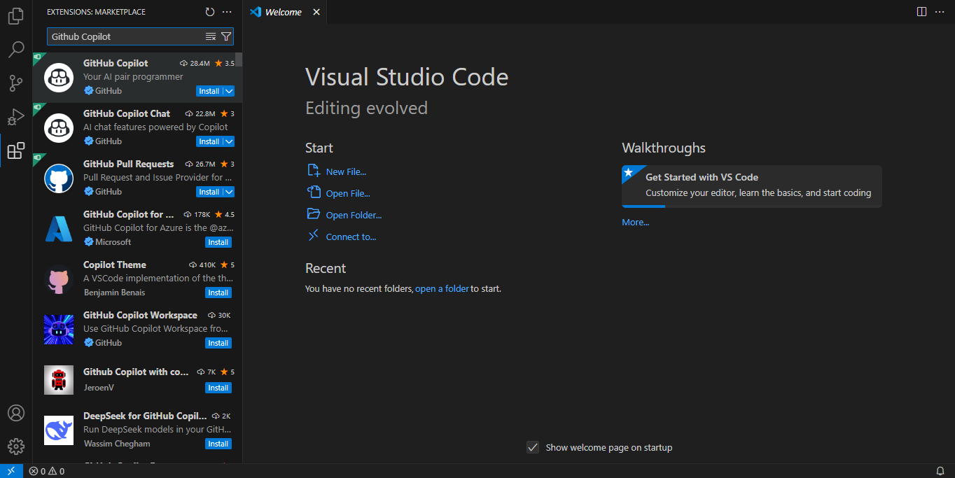

  - Click on Install to enable GitHub Copilot in VS Code
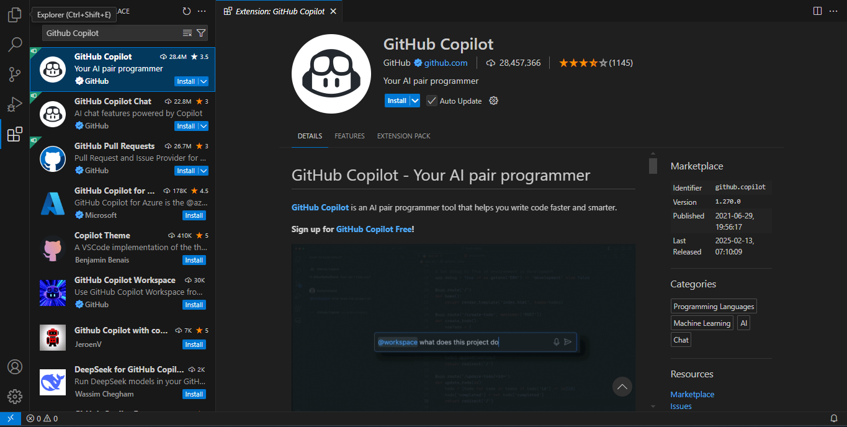

Step 2: Sign in to GitHub

  - After installation, click on Sign in to Use Copilot
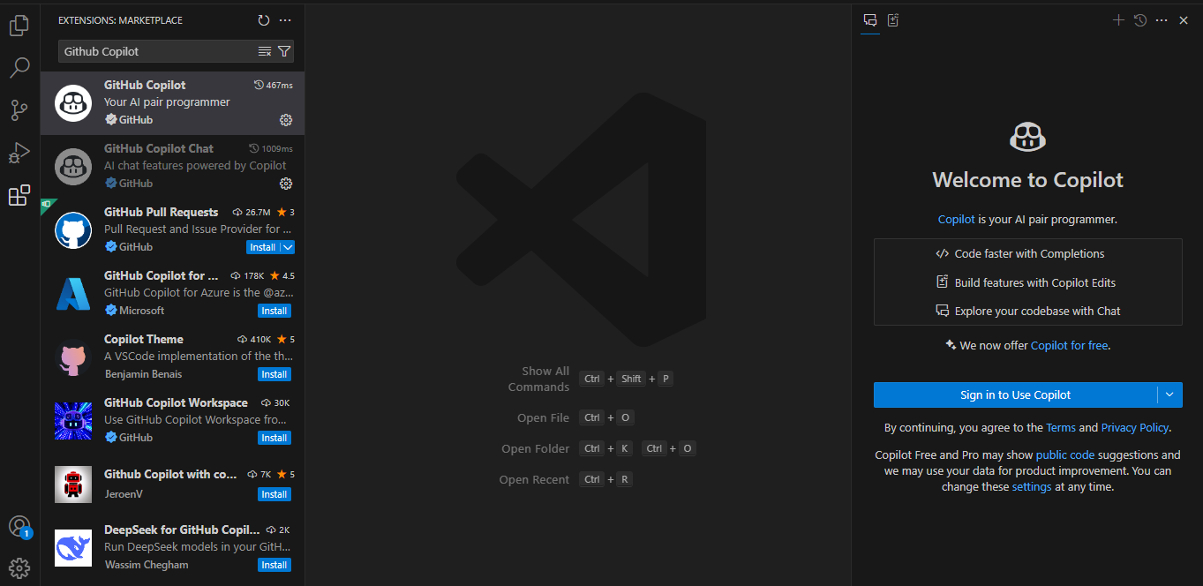

  - Sign in to your GitHub account using your credentials
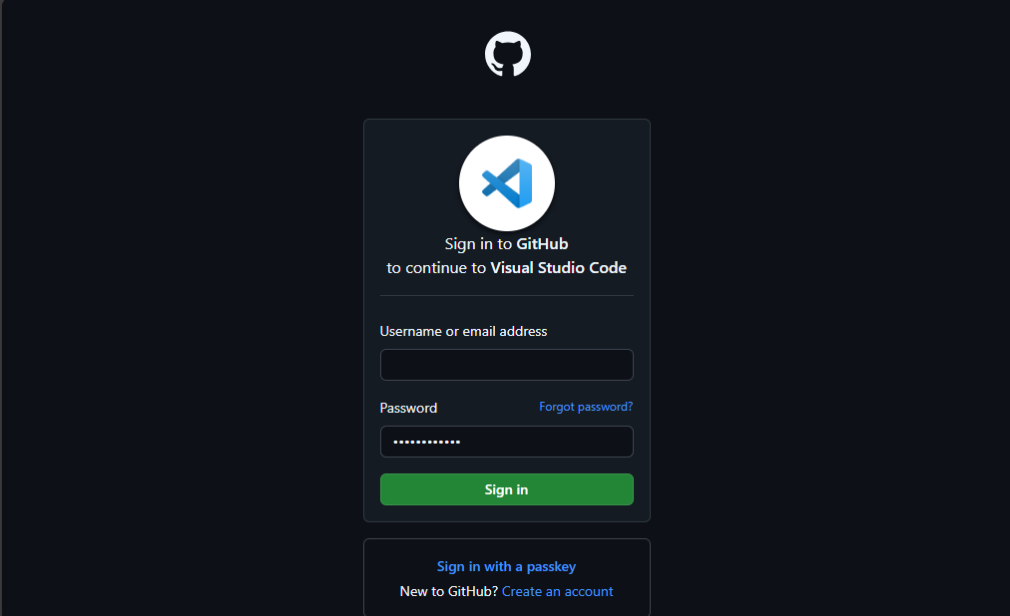

Step 3: Enable GitHub Copilot

  - Once signed in, navigate to Settings and click on GitHub Copilot
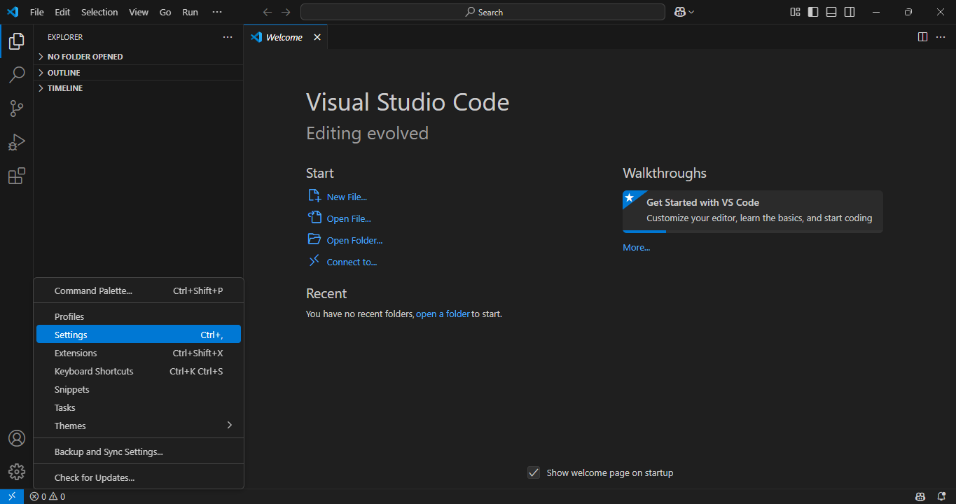
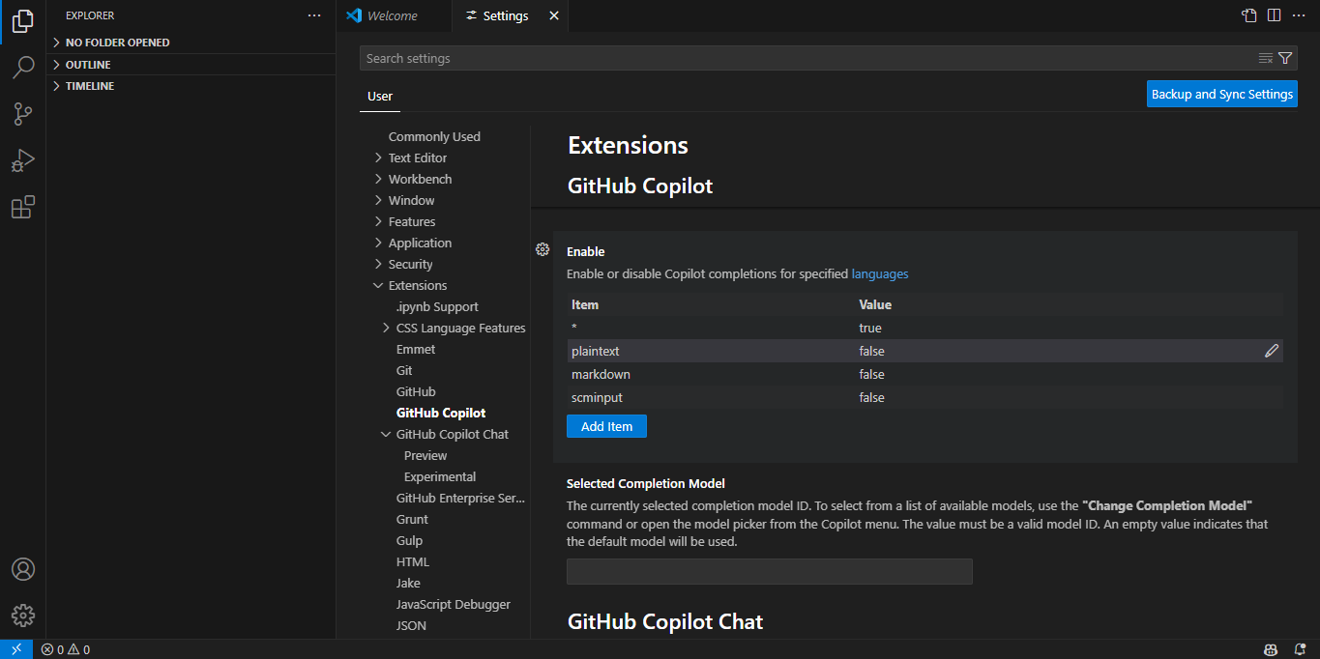

  - Enable plaintext by changing its value to true
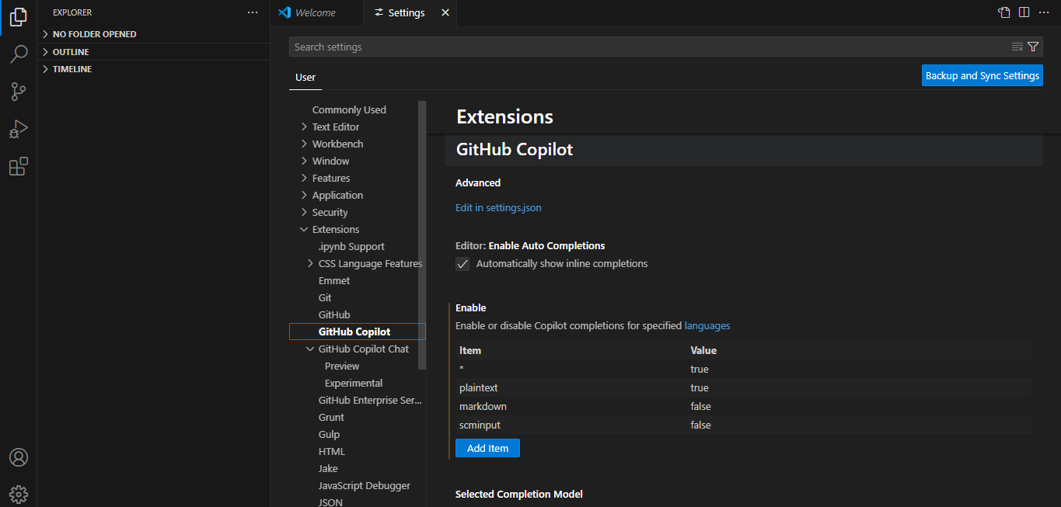

Step 4: Verify the functionality of Copilot

  - Click on File and then New File… to open a new Python file
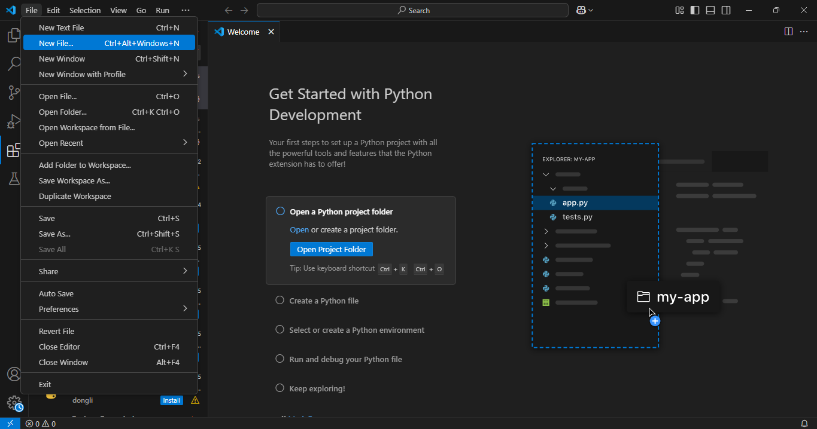

  - In the name bar, select the Python File option and a new Python file named Untitled-1 will open
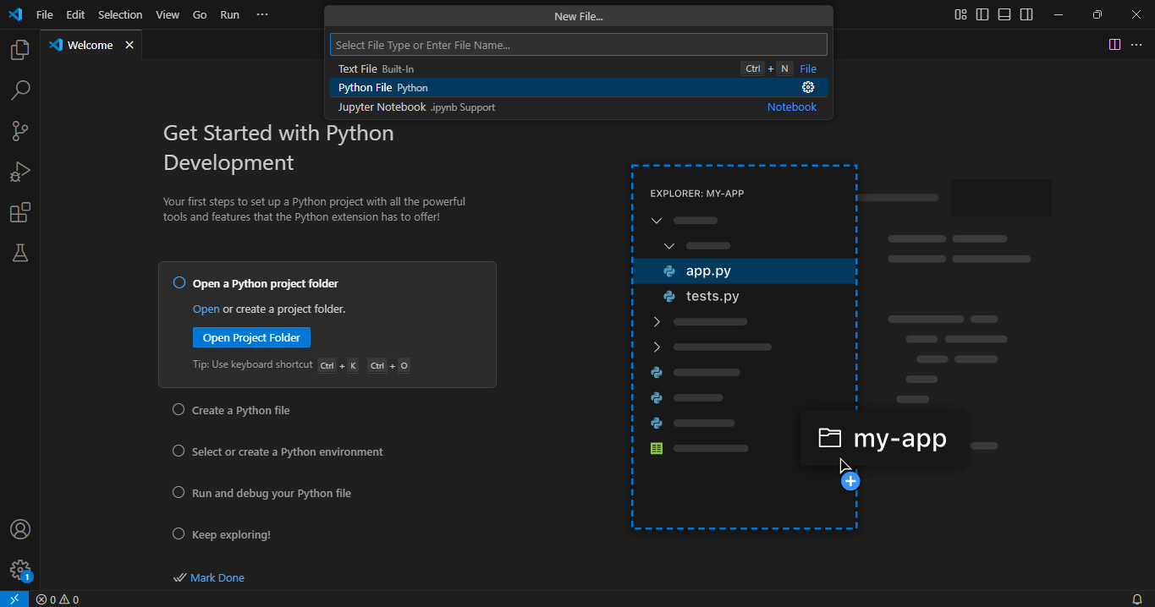

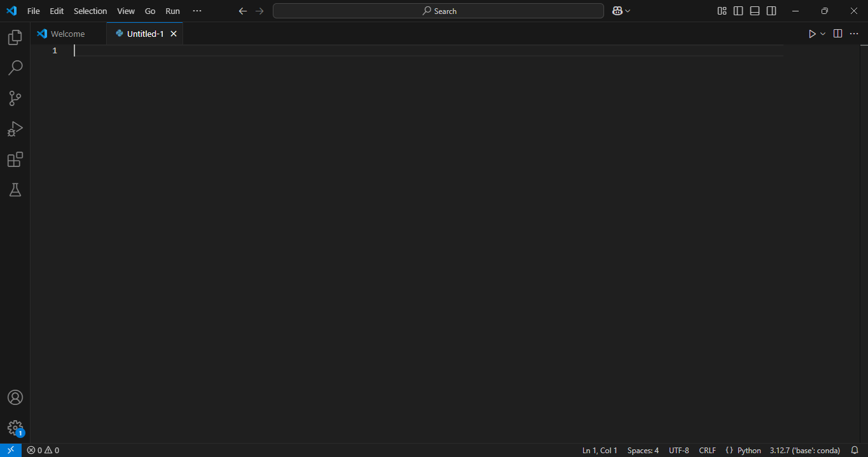

  - Start typing a function, and Copilot should suggest code completions
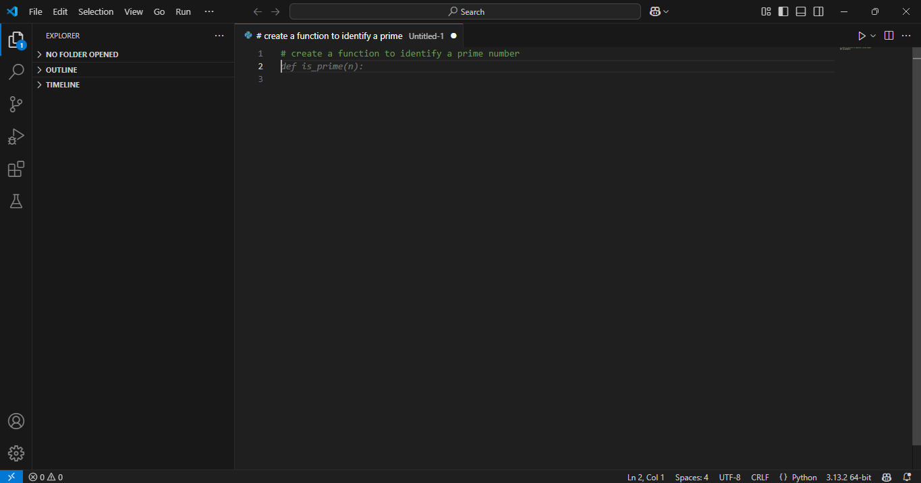

By following these steps, you have successfully installed and configured GitHub Copilot in VS Code. You can now leverage AI-powered coding assistance to boost productivity, reduce repetitive tasks, and enhance code quality.

