Lesson 04 Demo 02
Customizing Copilot Settings in VS Code

Objective: To modify GitHub Copilot settings in VS Code for better control, accuracy, and efficiency in AI-assisted coding

Tools required: Visual Studio Code (VS Code) and GitHub Copilot extension

Prerequisites: GitHub Copilot should be installed and enabled in VS Code

Steps to be followed:
- Open VS Code settings
- Navigate to the Copilot configurations page
- Enable or disable Copilot for specific languages
- Adjust AI suggestions behavior

Step 1: Open VS Code settings

- Launch VS Code

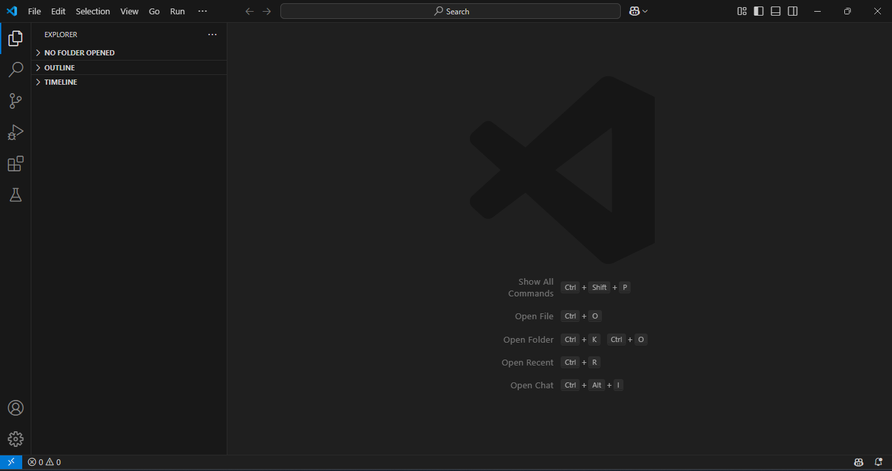

- Click on File → Preferences → Settings (or press Ctrl + ,)

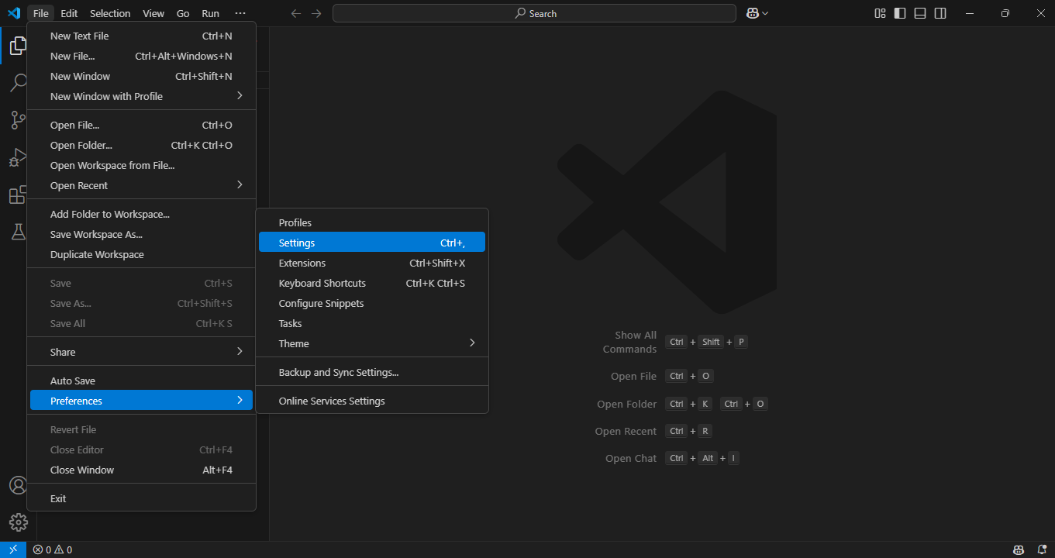

Step 2: Navigate to the Copilot configurations page

  - In the Settings search bar, type GitHub Copilot

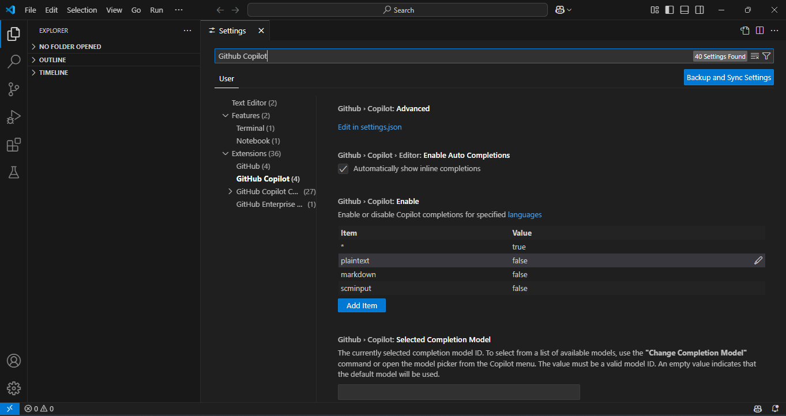

  - Click on GitHub Copilot to view available customization options

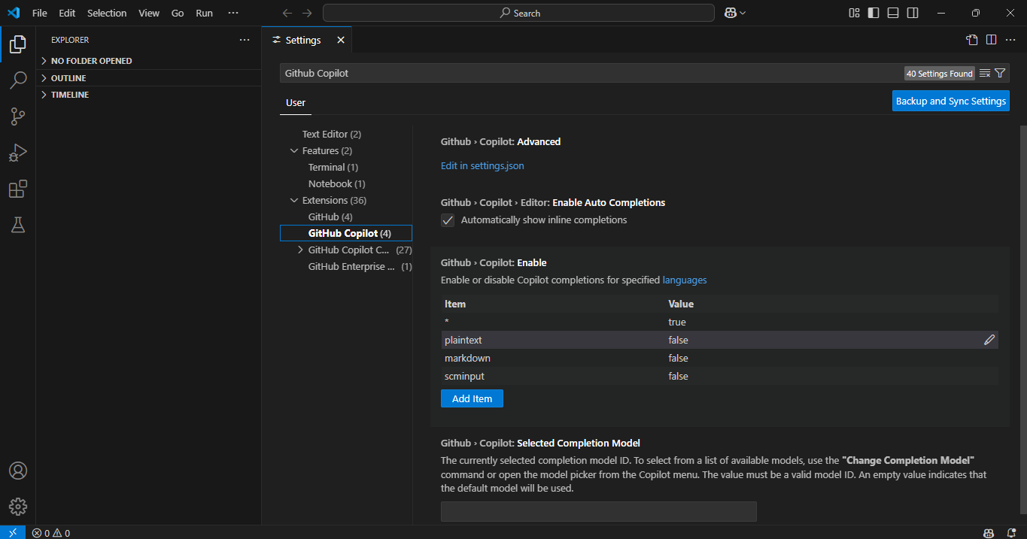

Step 3: Enable or disable Copilot for specific languages

  - Under Github › Copilot: Enable, you can enable or disable Copilot completions for specified languages

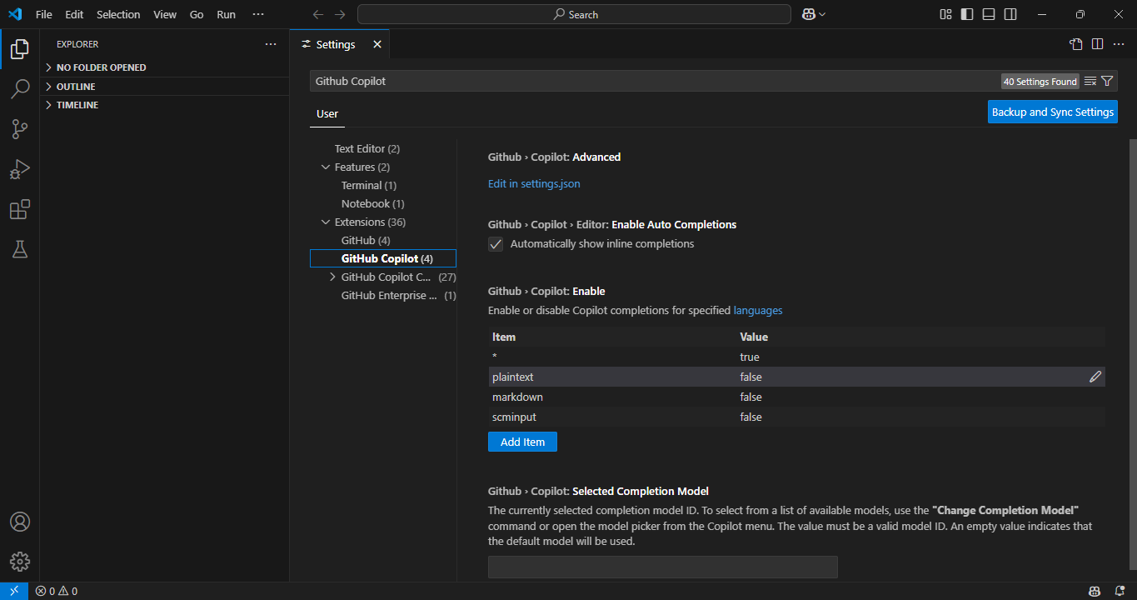

Step 4: Enable or disable auto inline completions

  - Under Github › Copilot › Editor: Enable Auto Completions, enable or disable the option to show or hide inline completions (AI comment suggestions)

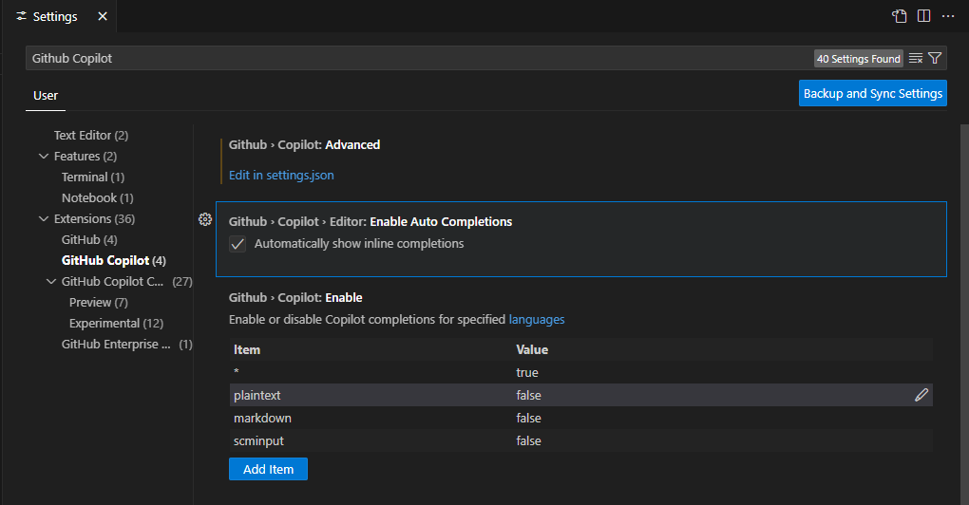

By completing these steps, you have successfully customized GitHub Copilot settings in VS Code. This allows you to enable or disable Copilot for specific programming languages, control when and how AI-powered suggestions appear, and fine-tune Copilot’s behavior. These adjustments create a more personalized coding experience. Experimenting with different settings, such as language preferences and visibility options, will help optimize Copilot’s assistance. This ensures a more efficient, accurate, and controlled AI-powered development workflow.

